How to access the management GUI on Palo Alto FW

Step 1: Connect the RJ45 cable to mgmt. port of the firewall and connect it to PC

Add these details in the ethernet properties

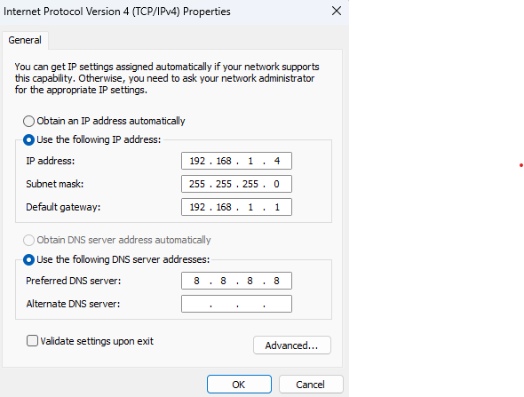

Step 2: Login with the credentials

Default is : admin/admin

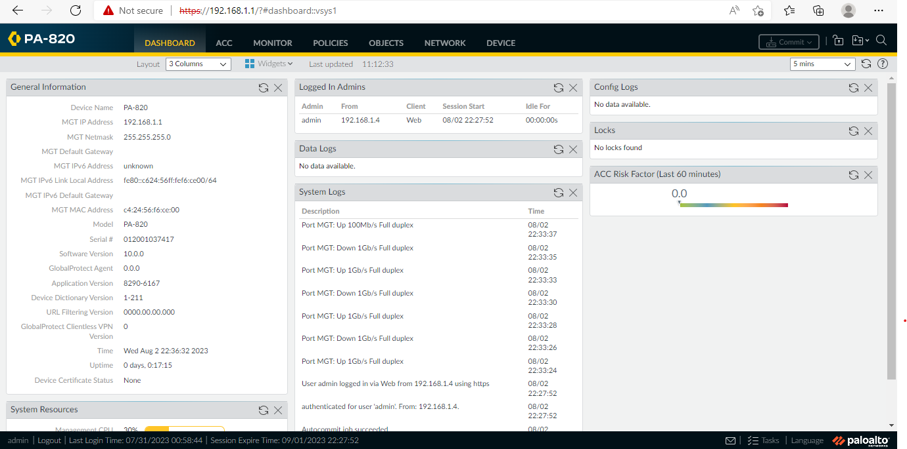

Step 3: To access the internet in FW Please follow these steps:

First: Create zones LAN and WAN with Type Layer 3

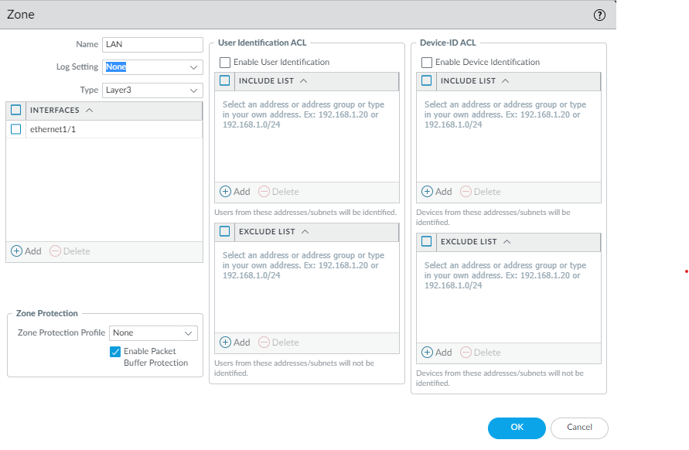

Second: Create interface for LAN with layer3 type and Choose virtual router as default and Security Zone as a LAN .

Click on IPv4 and choose DHCP and enter LAN IP address.

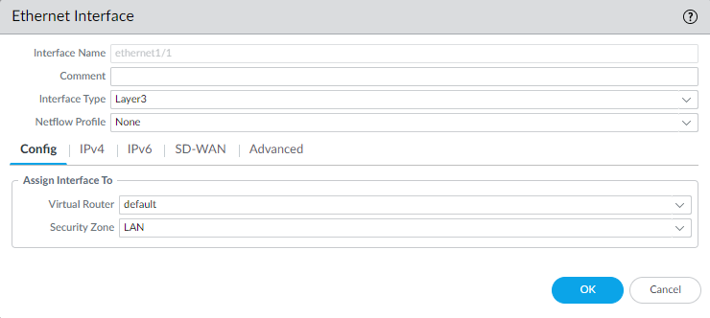

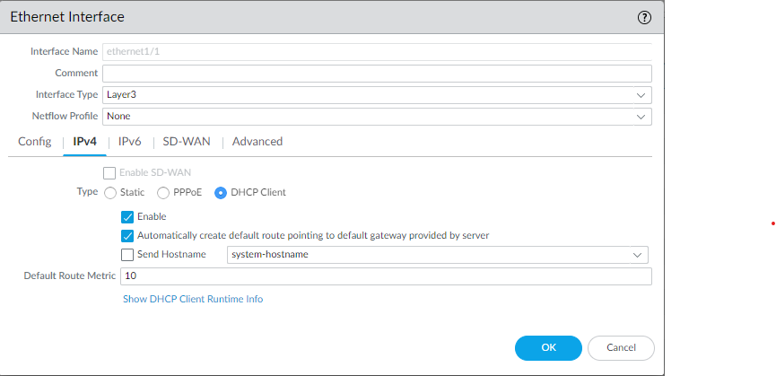

Third: Create WAN interface with Layer 3 type and choose vrouter as default and security zone as WAN. Click on ipv4 and enter the ip address as static given by the ISP.

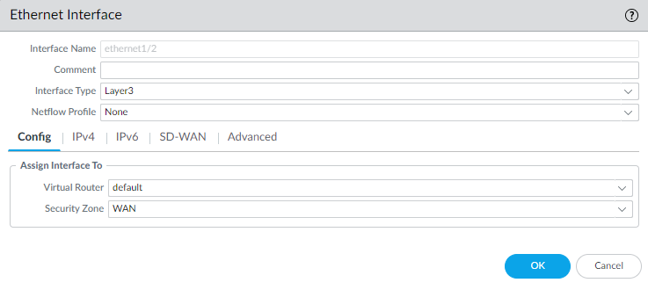

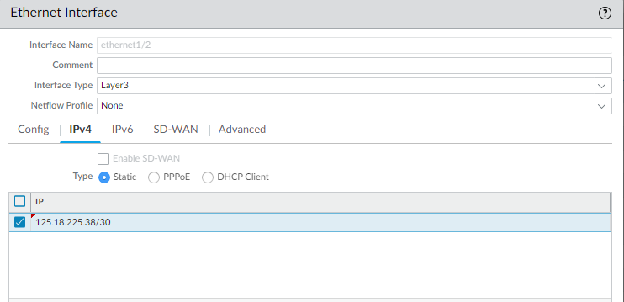

STEP 4: Create Virtual route in virtual router

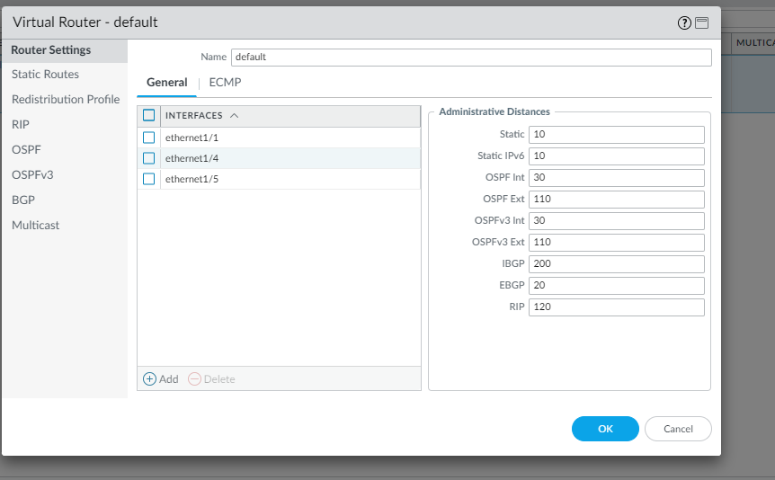

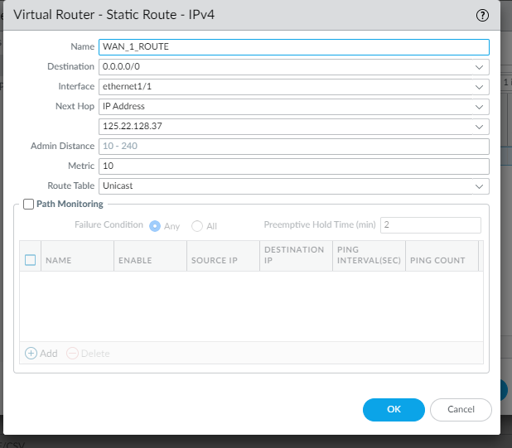

STEP 5: Create a MGMT profile

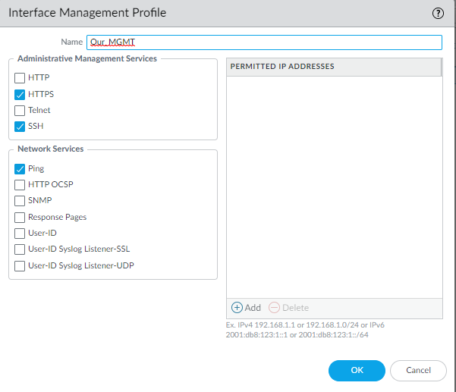

STEP 6: Create DHCP server

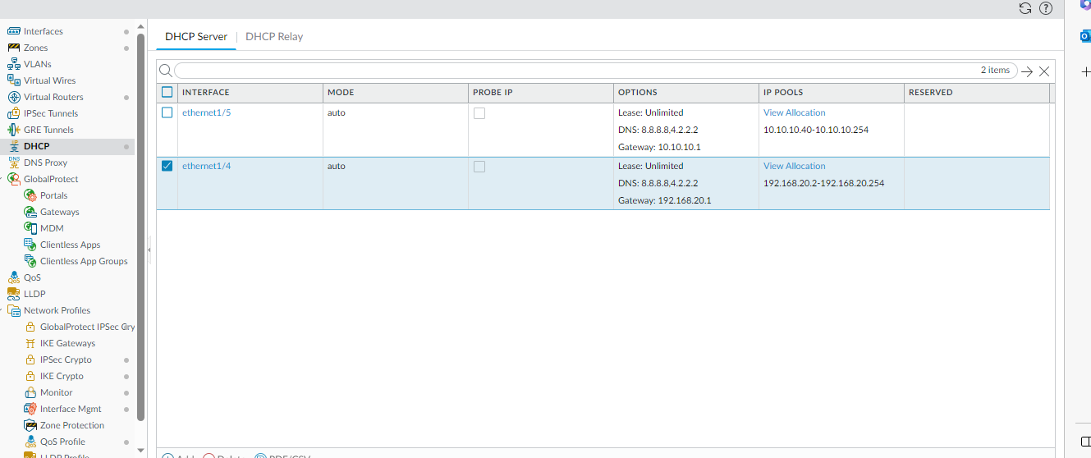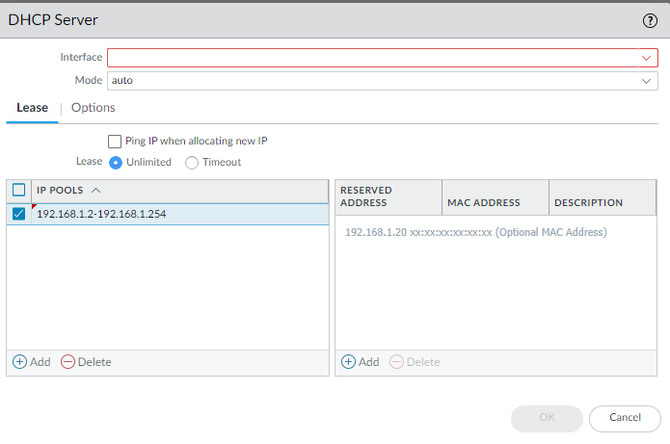

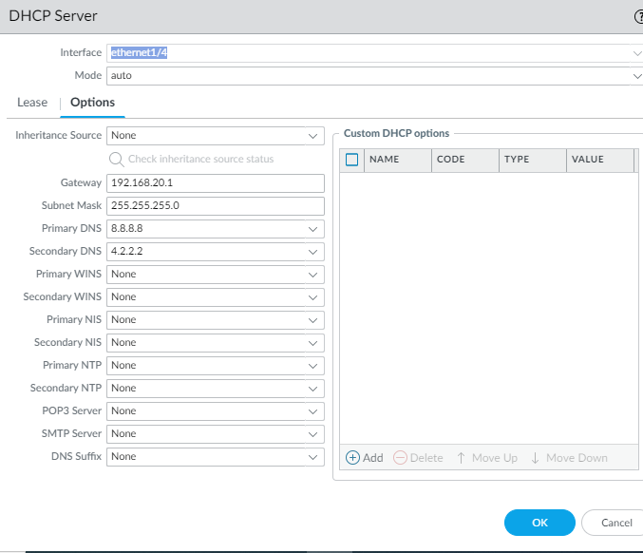

STEP 7: Create security rule in policies

Choose src zone as LAN and dst zone as WAN.

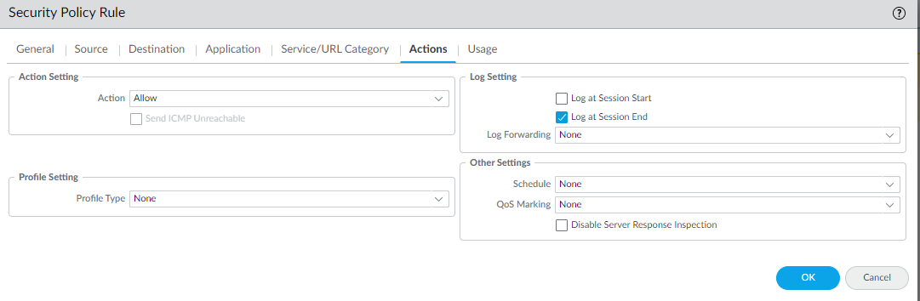

STEP 8: Create NAT rule

