How to Reset the FW

1. Connect the console cable with USB cable
2. Open the control panel 🡪 Device and printers
3. Double click on MCP2221
4. Click on hardware and check the serial com number
5. Open putty and click on serial and write com number

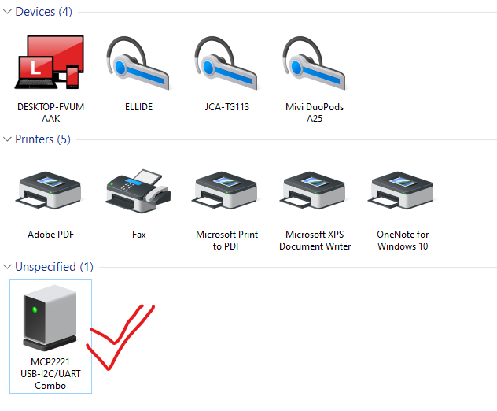

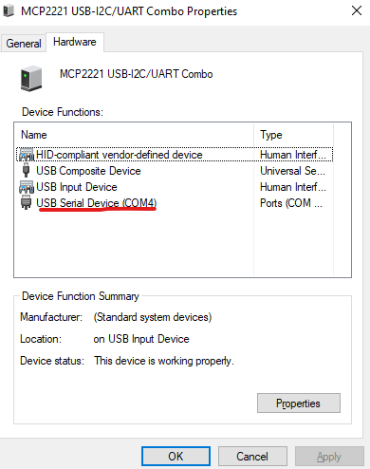

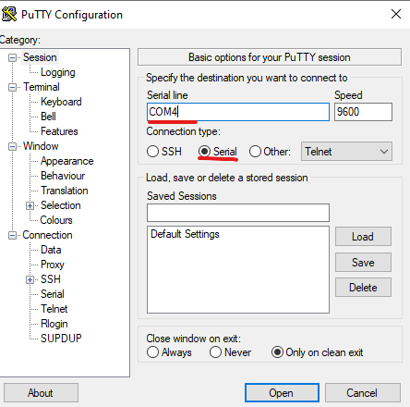

* **Case 1. Without an Admin Password**

If you do not know the **admin** account password, you must first place the firewall in **maintenance mode**.  
  
Note: If running PAN-OS 6.0 and above, review the following link to perform SSH into Maintenance Mode: [How to SSH into Maintenance Mode](https://knowledgebase.paloaltonetworks.com/KCSArticleDetail?id=kA10g000000ClQVCA0).

**▶ Steps**

1) Connect the Console cable, which is provided by Palo Alto Networks, from the "Console" port to a computer, and use a terminal program (9600,8,n,1) to connect to the Palo Alto Networks device.  
  
**NOTE**: A USB-to-serial port will have to be used if the computer does not have a 9-pin serial port.  
  
2) Power on to reboot the device.  
  
3) During the boot sequence, the screen should look like this:  
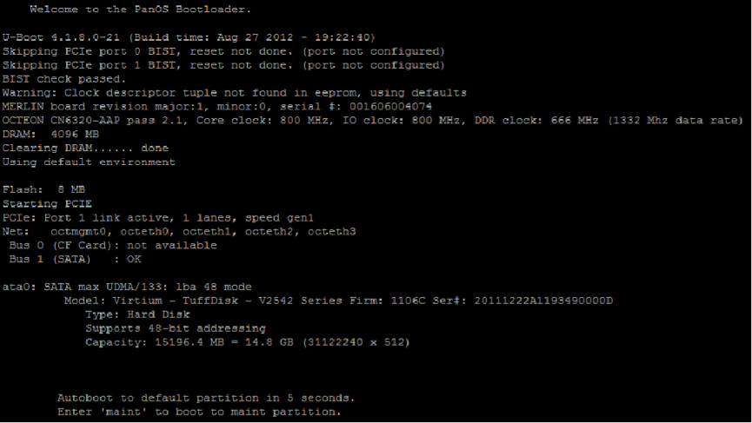  
  
1) Type **maint** to enter maintenance mode.  
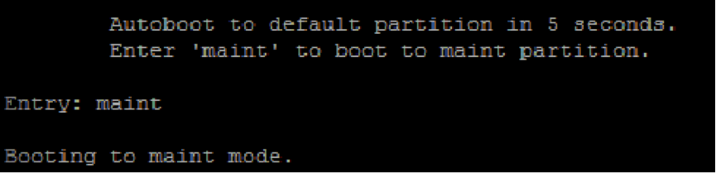  
  
2) **PAN-OS 7.1 NOTE**: When performing this on PAN-OS 7.1, you will see a "CHOOSE PANOS" screen with the following options: **PANOS (maint-other)**, **PANOS (maint)** or **PANOS (sysroot0)**. Please choose **PANOS (maint)**. Press enter to continue.  
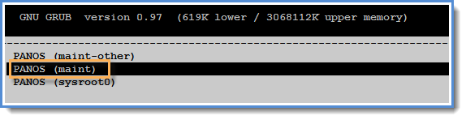PAN-OS 7.1 GNU GRUB boot menu.  
  
3) Once in maintenance mode, the following is displayed, please press **enter** to continue:  
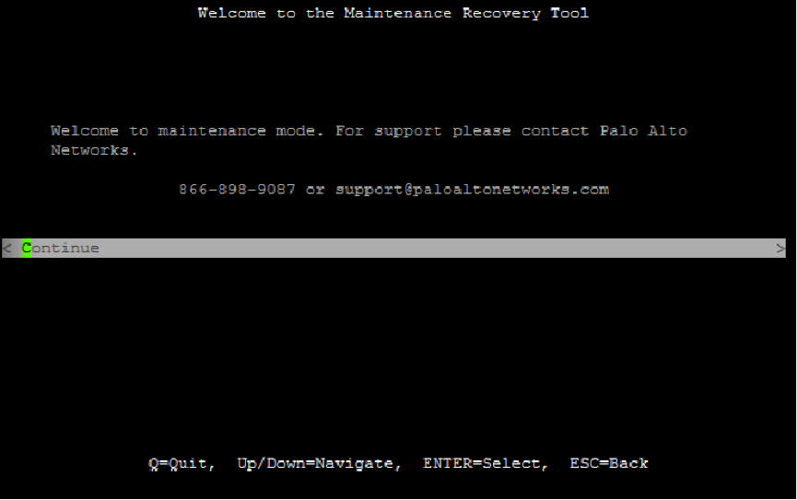  
  
4) Arrow down to **Factory Reset** and press **Enter** to display the menu:  
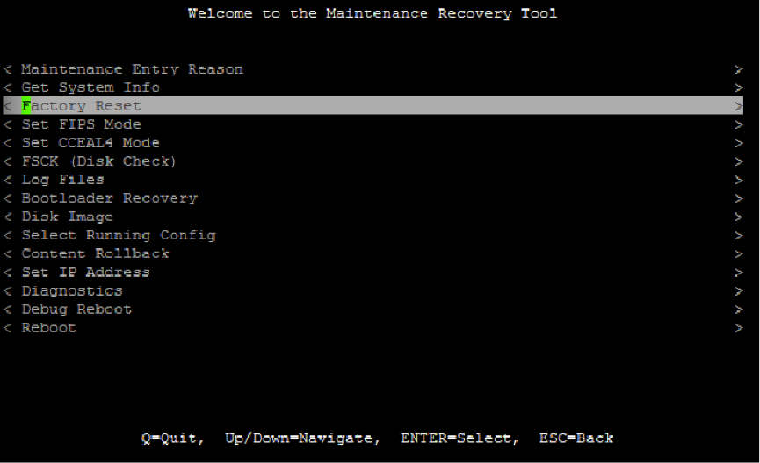  
  
5) You will see the Image that will be used to perform the factory reset. Select **Factory Reset** and press **Enter** again:  
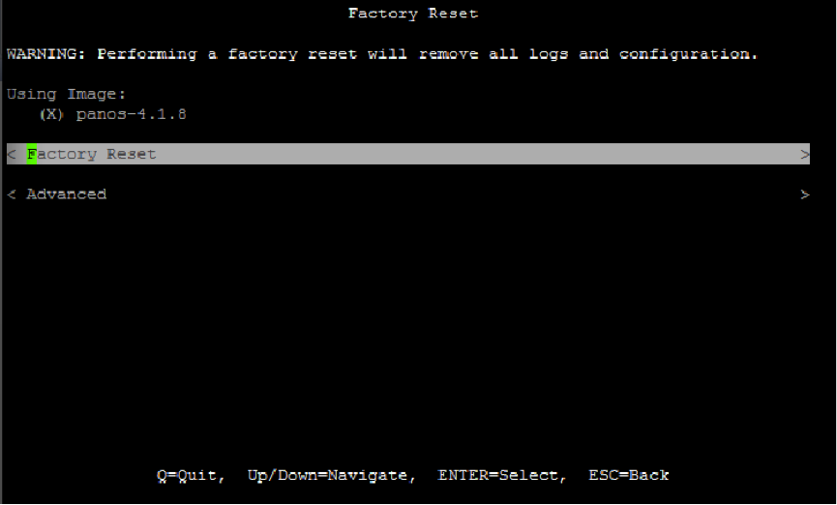  
  
6) The unit will reboot when complete. Please be aware that it may take several minutes before the autocommit to complete and allow the admin/admin login to work properly.

* **Case 2. With an Admin Password**

If you know the **admin** account password, you can use the CLI command **debug system maintenance-mode**.

**▶ Steps**

1) Connect the Console cable, which is provided by Palo Alto Networks, from the "Console" port to a computer, and use a terminal program (9600,8,n,1) to connect to the Palo Alto Networks device.  
  
**NOTE**: A USB-to-serial port will have to be used if the computer does not have a 9-pin serial port.  
  
2) Enter your login credentials.

3) Enter the following CLI command:

**debug system maintenance-mode**

The firewall will reboot in the **maintenance mode**.

4) When the firewall reboots, press Enter to continue to the **maintenance mode** menu.

Select **Factory Reset** and press Enter.

5) Select **Factory Reset** and press Enter again.

The firewall will **reboot** without any configuration settings. The default username and password to log in to the firewall is **admin**/**admin**.

* **Case 3. With an Admin Password to Remove all Logs and Restore the Default Configuration**

If you know the **admin** account password, you can use the CLI command **request system private-data-reset**. This command will not perform the same actions as a factory reset of the device from **Maintenance Mode**. Private-data-reset will not do a zero-ization of the data and will not erase the system disks. Performing a bit-level recovery procedure can still retrieve the data from the device. Also, all the content packages installed will remain with the same PAN-OS, but all the logs and saved configurations on the firewall will be cleared.

If you know the **admin** account password and want to remove all logs and restore the default configuration without erasing the system disks, you can use the CLI command:

**request system private-data-reset**  
Executing this command will remove all logs and configuration will revert back to factory defaults. The system will restart and then reset the data.  
  
Are you sure you want to continue? (y/n) (y or n)