Case Study Submission Template

- Name : Ankit Goel

- Employee Id : 1329642

- Email Id : a.go@tcs.com

- Git Repo URL for case-study :

https://github.com/ankit8917/casestudy_devops10.git

I have cloned your https://www.github.com/shubhamkushwah123/batch10.git to my github repo, created Dockerfile and Jenkinsfile in this repo and checked out this repo to create build pipeline in Jenkins .

I am using AWS EC2 machines as master (t2.medium) and worker (t2.micro) for deploying jar application via pipeline script in Jenkins.

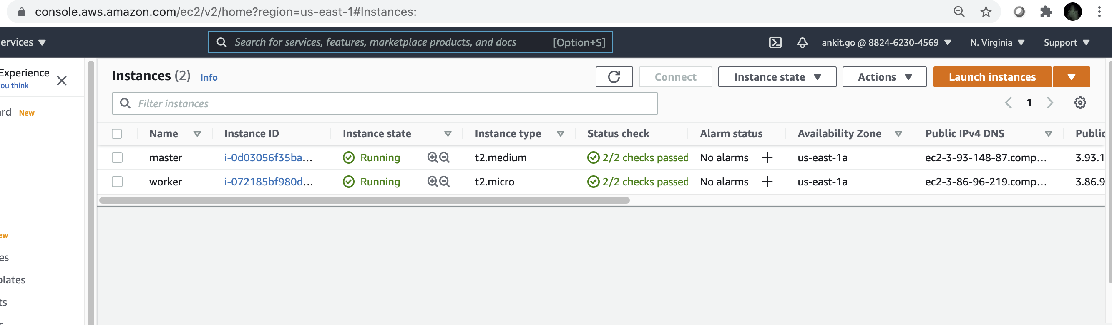

Jenkins is running on port 8080 on master node having case-study-pipeline project .

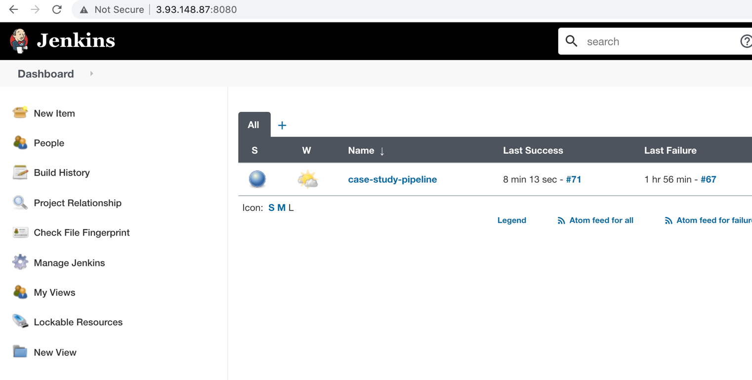

- Screenshot of Dockerfile being used in project and also available at git repo.

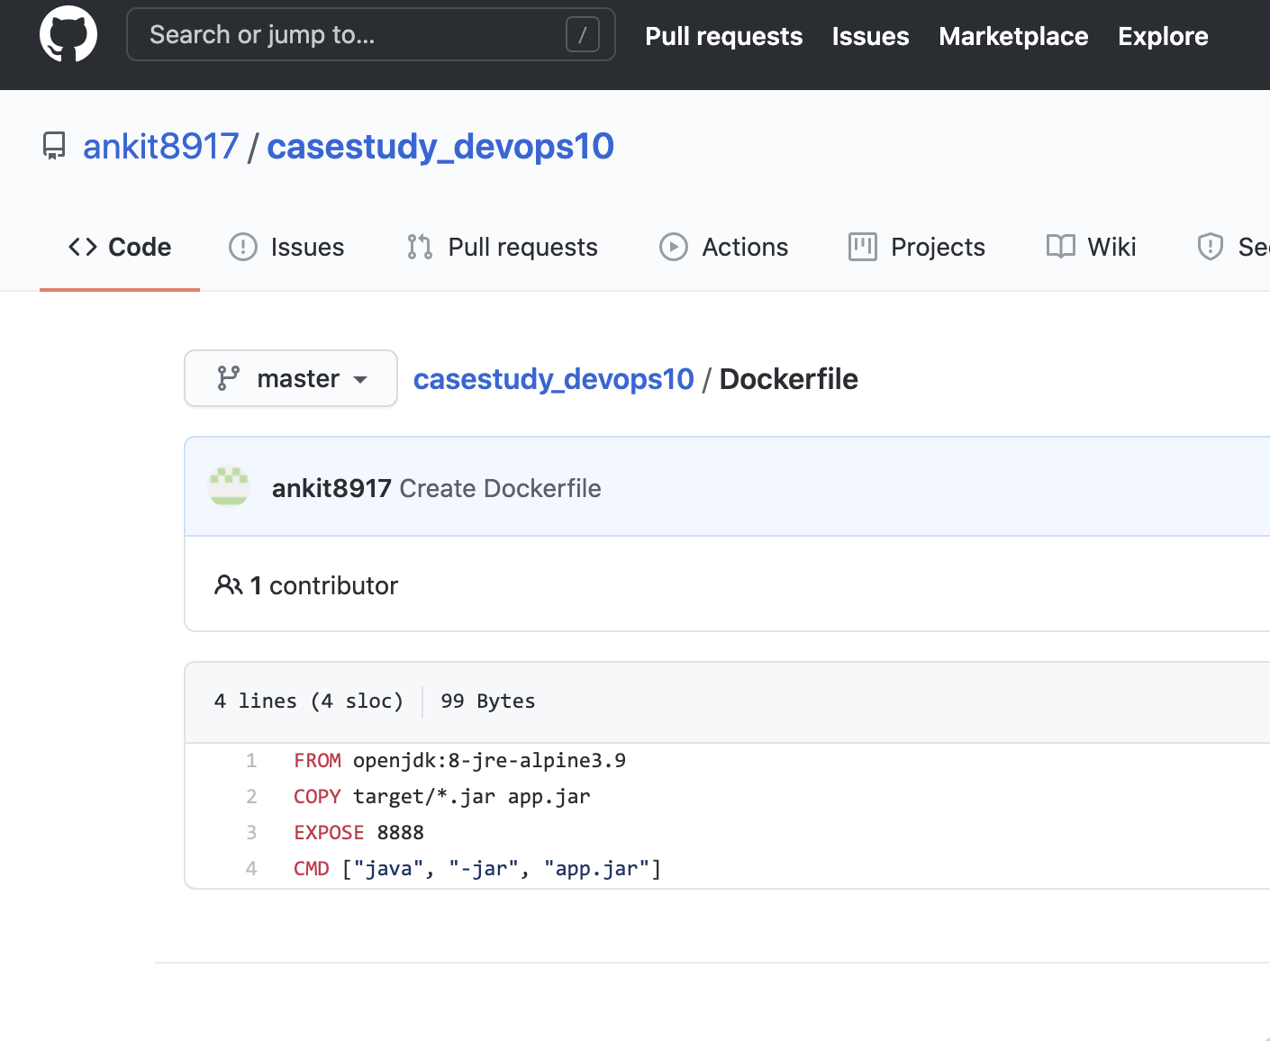

- Screenshot of Jenkinsfile and also available at given Git repo.
Link: https://github.com/ankit8917/casestudy_devops10.git

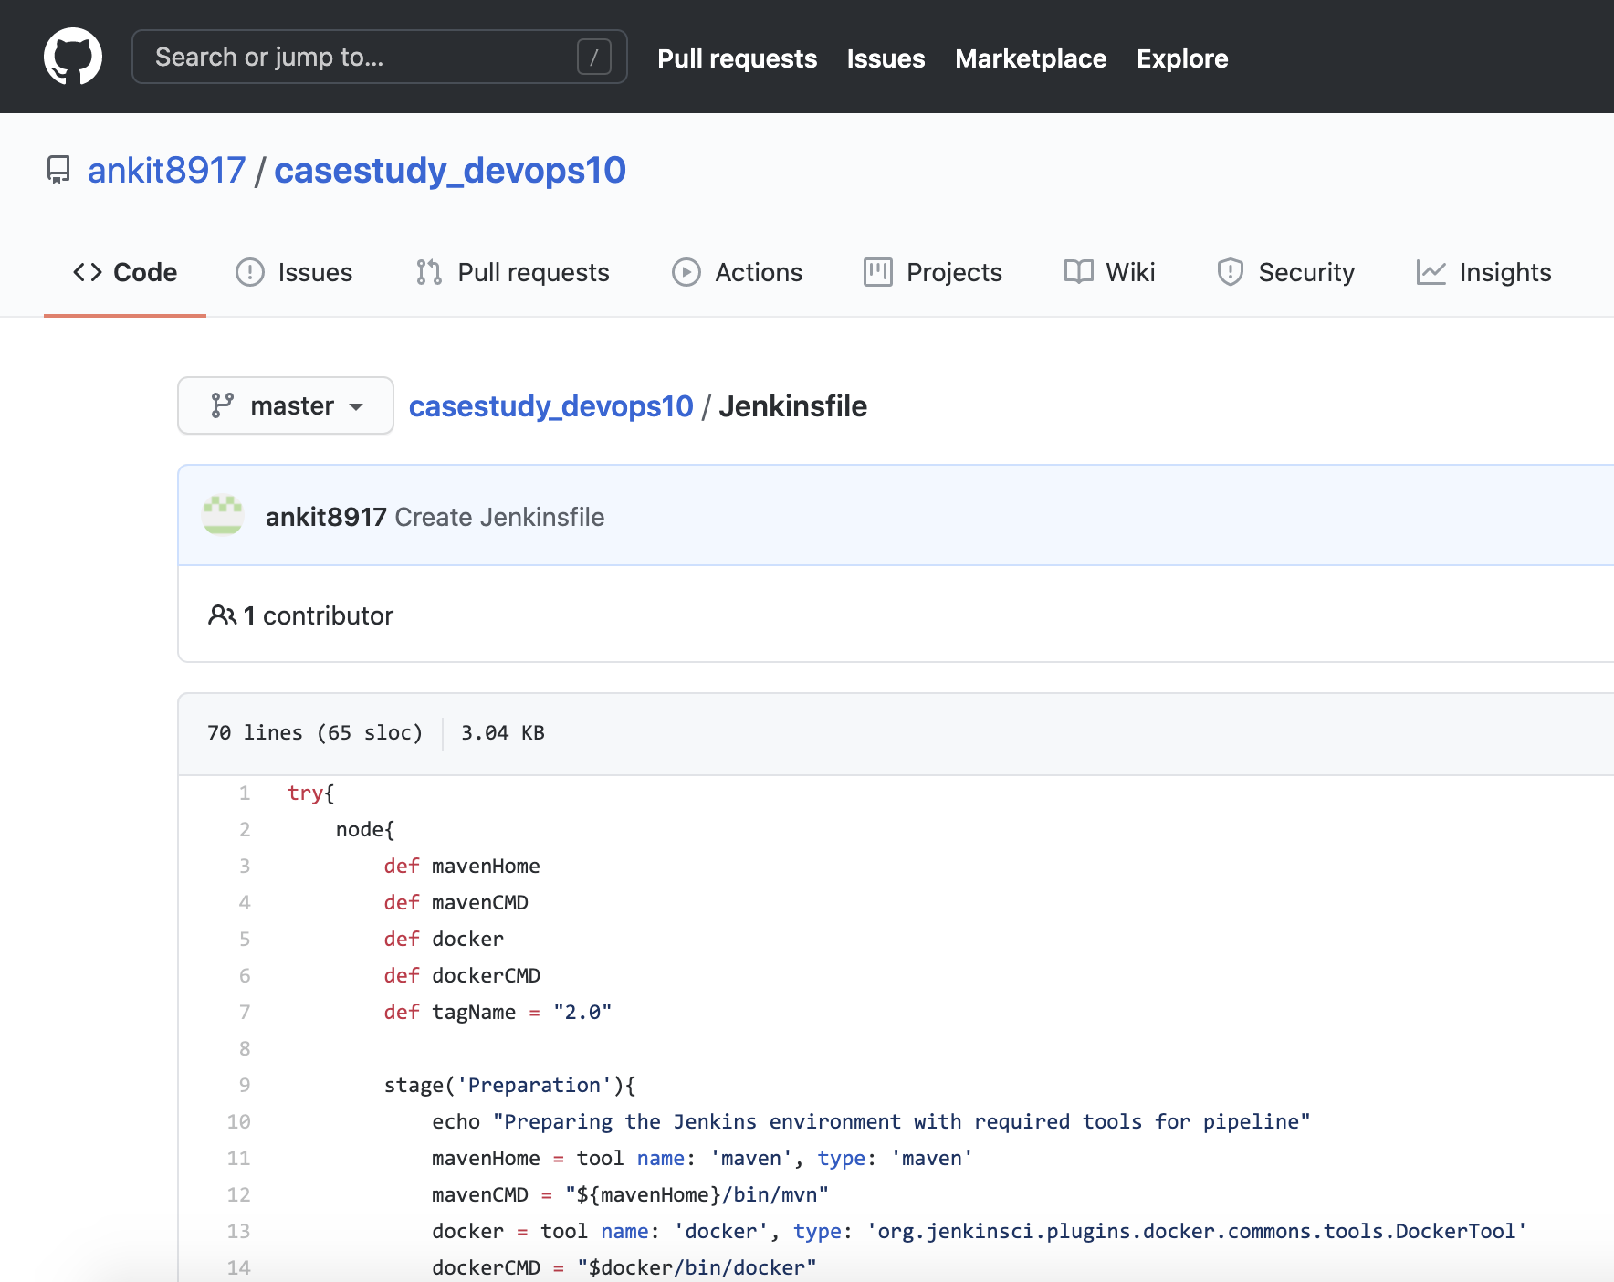

- Jenkins Log file by the name of jenkins-log.txt uploaded in the Repo given above.
Link: https://github.com/ankit8917/casestudy_devops10.git

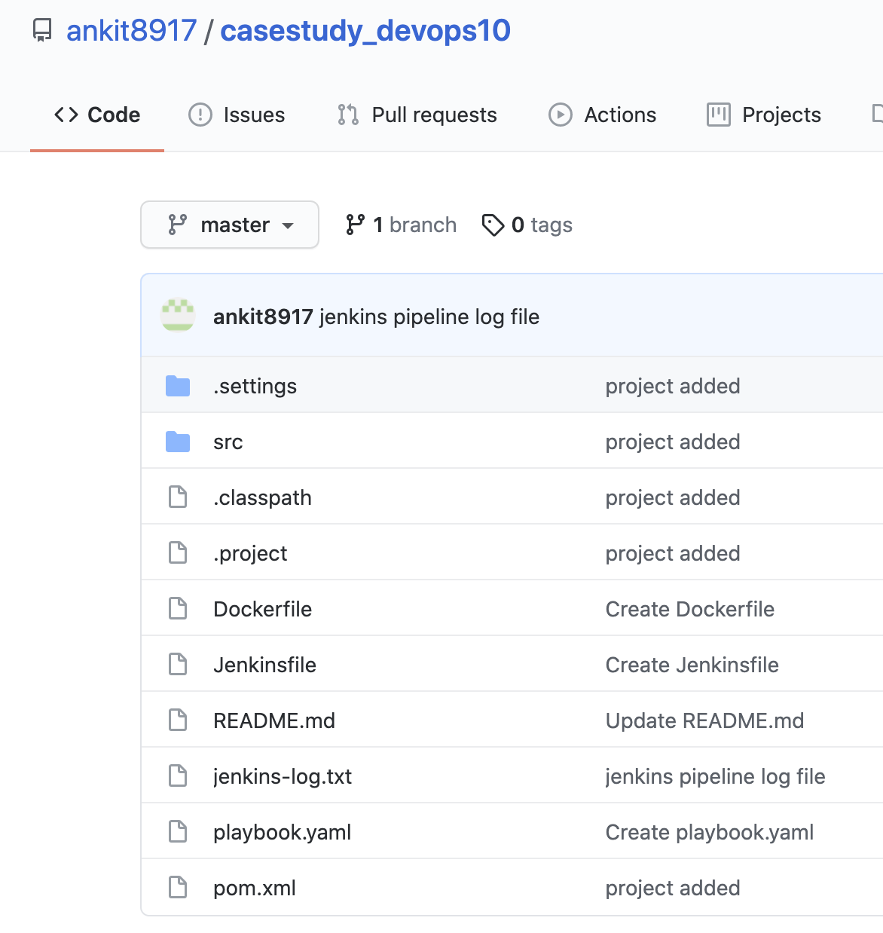

- Jenkins case-study-pipeline job status. (All boxes are green)

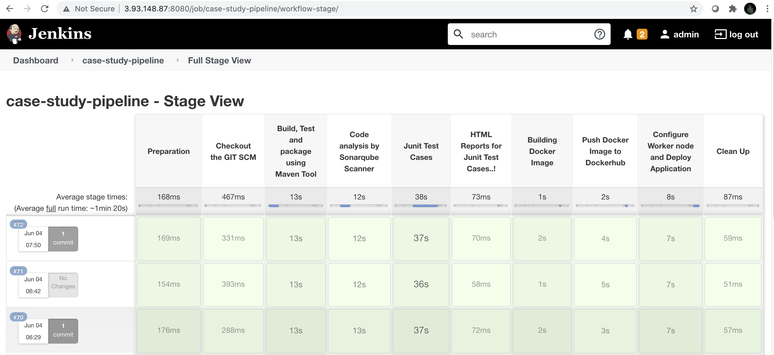

- Screenshots of email notification for the Jenkins build.

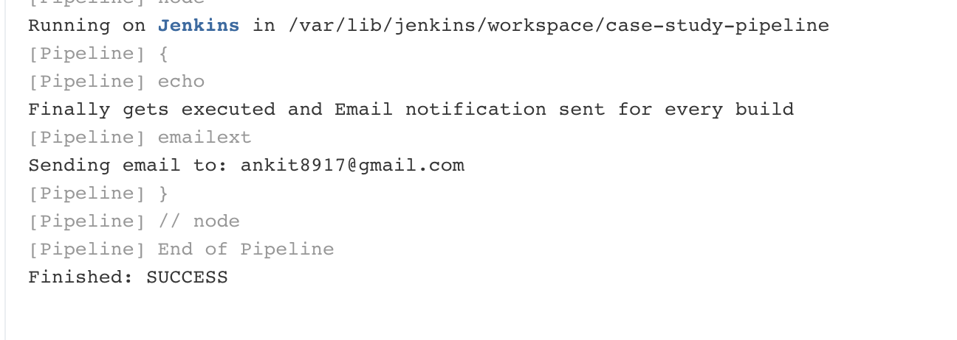
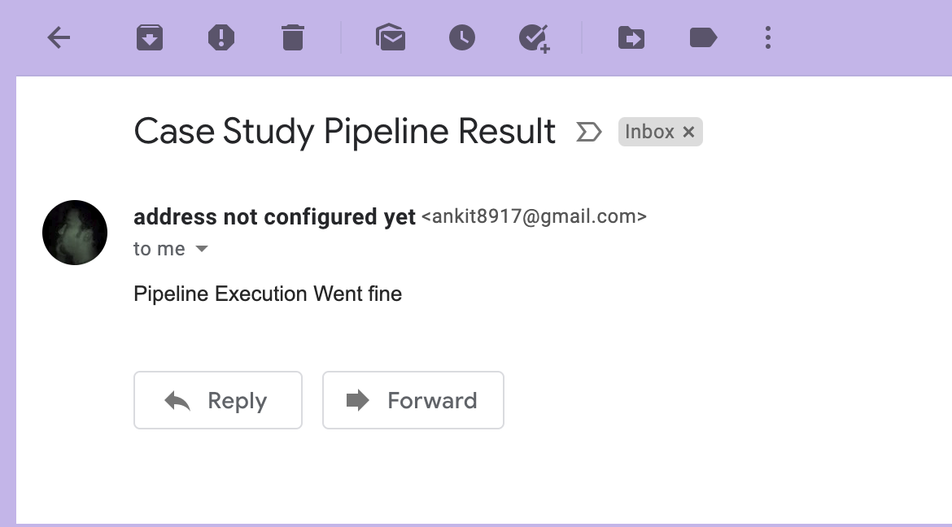

- Screenshot of the SonarQube Report.

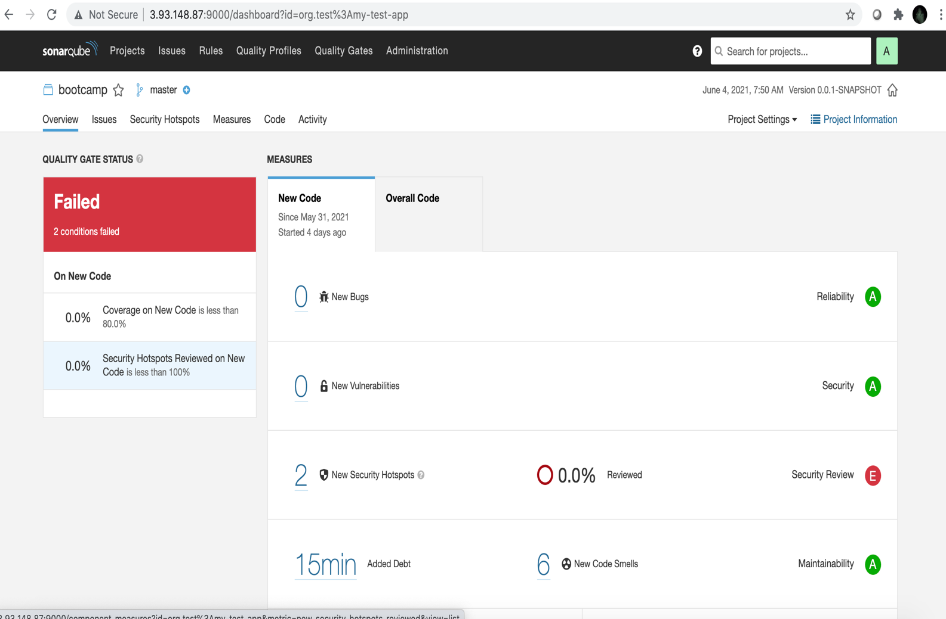

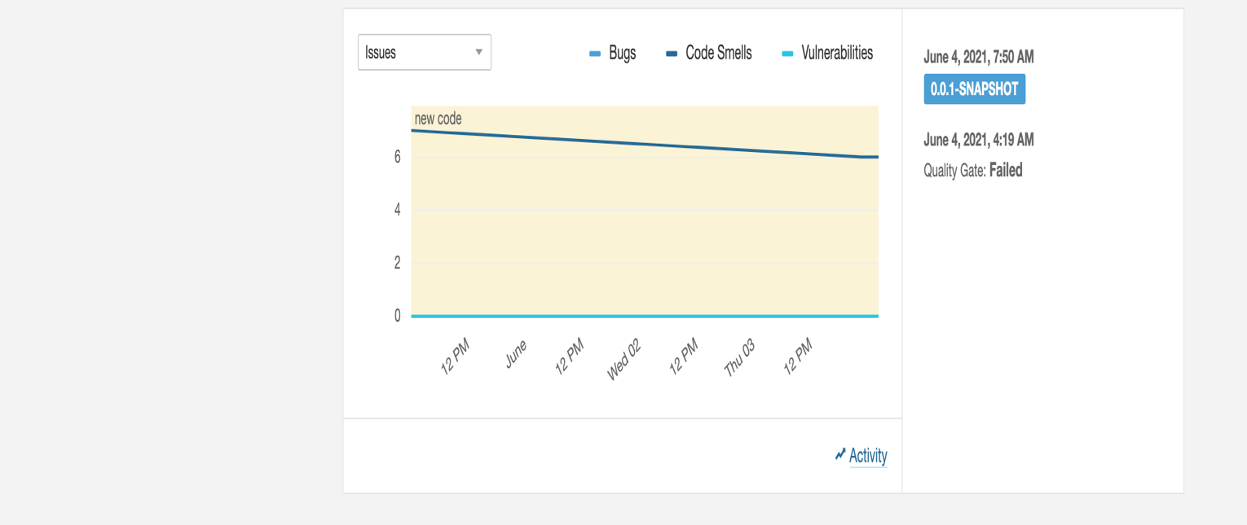

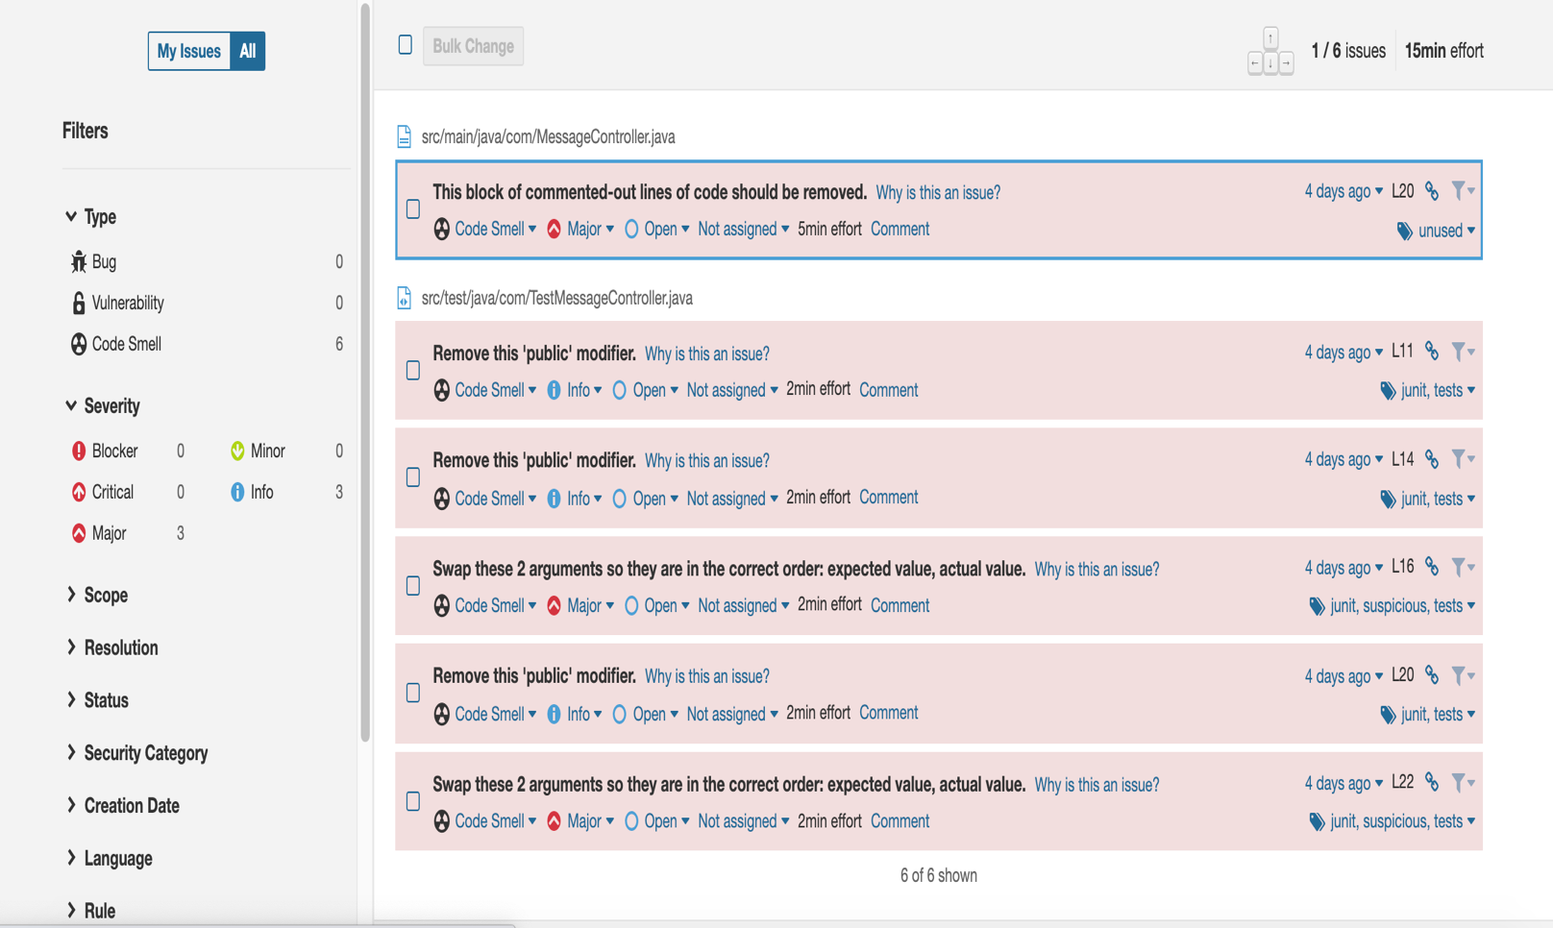

- Screenshot of your Ansible Playbook execution logs.

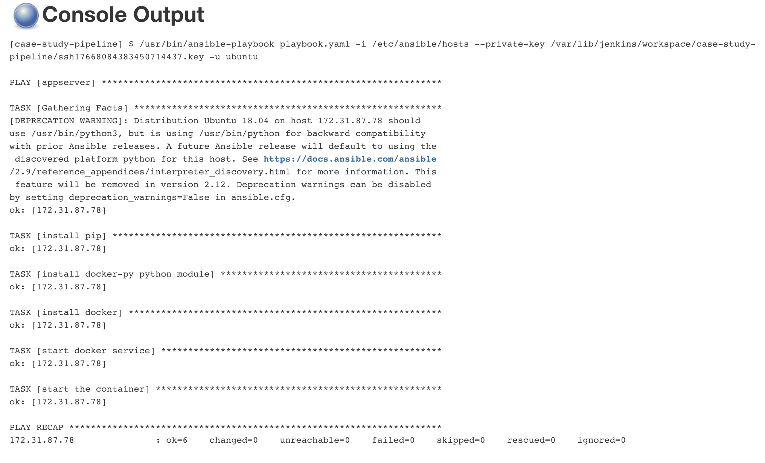

/etc/ansible/hosts file:

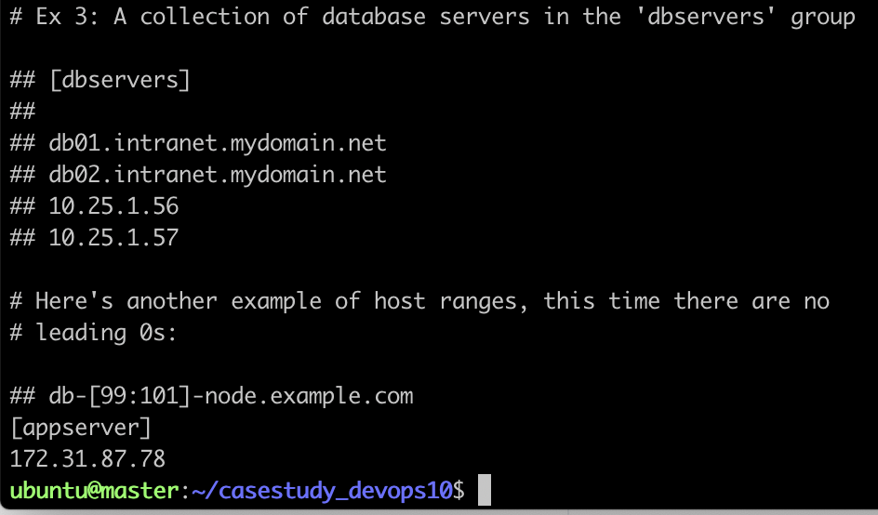

- Screenshot of the working application home page on AWS .

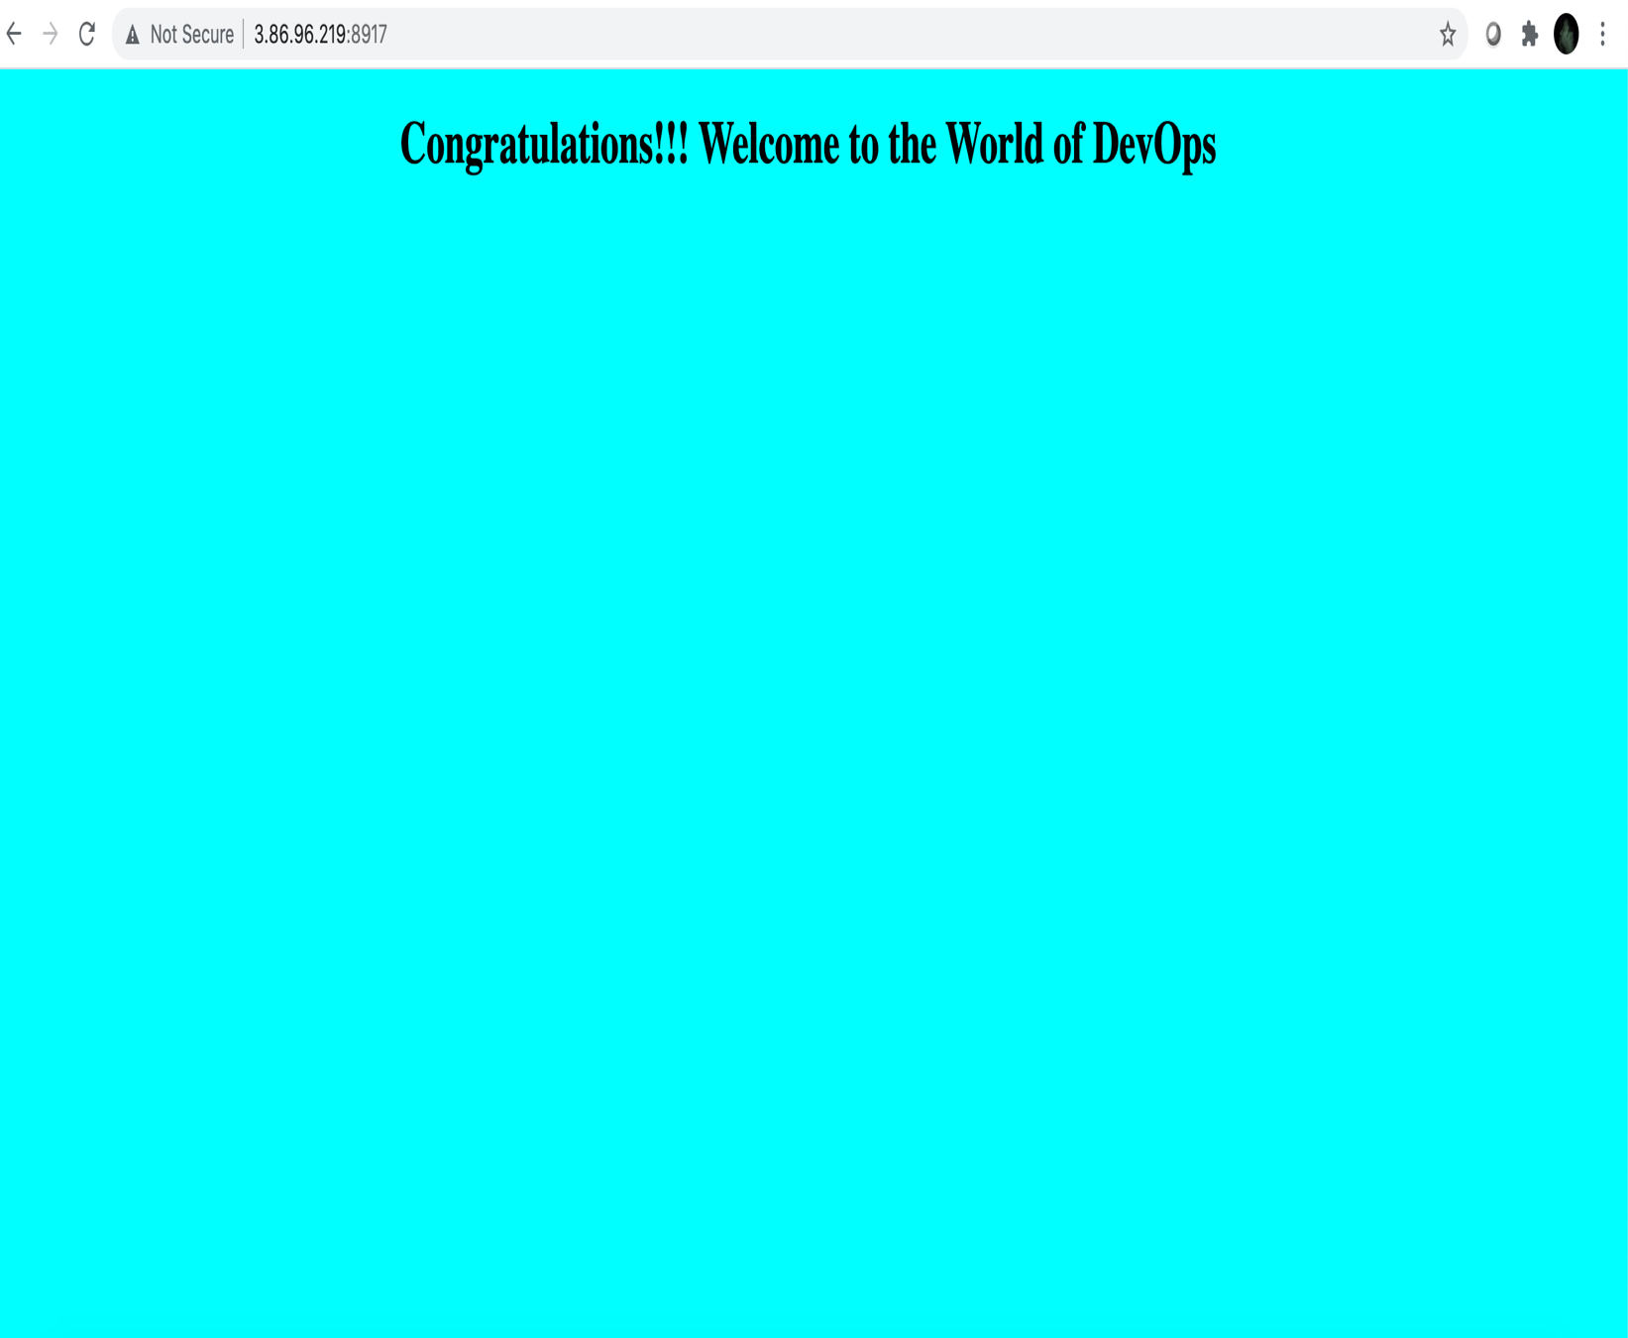

- Screenshot of the Git-hub webhook .

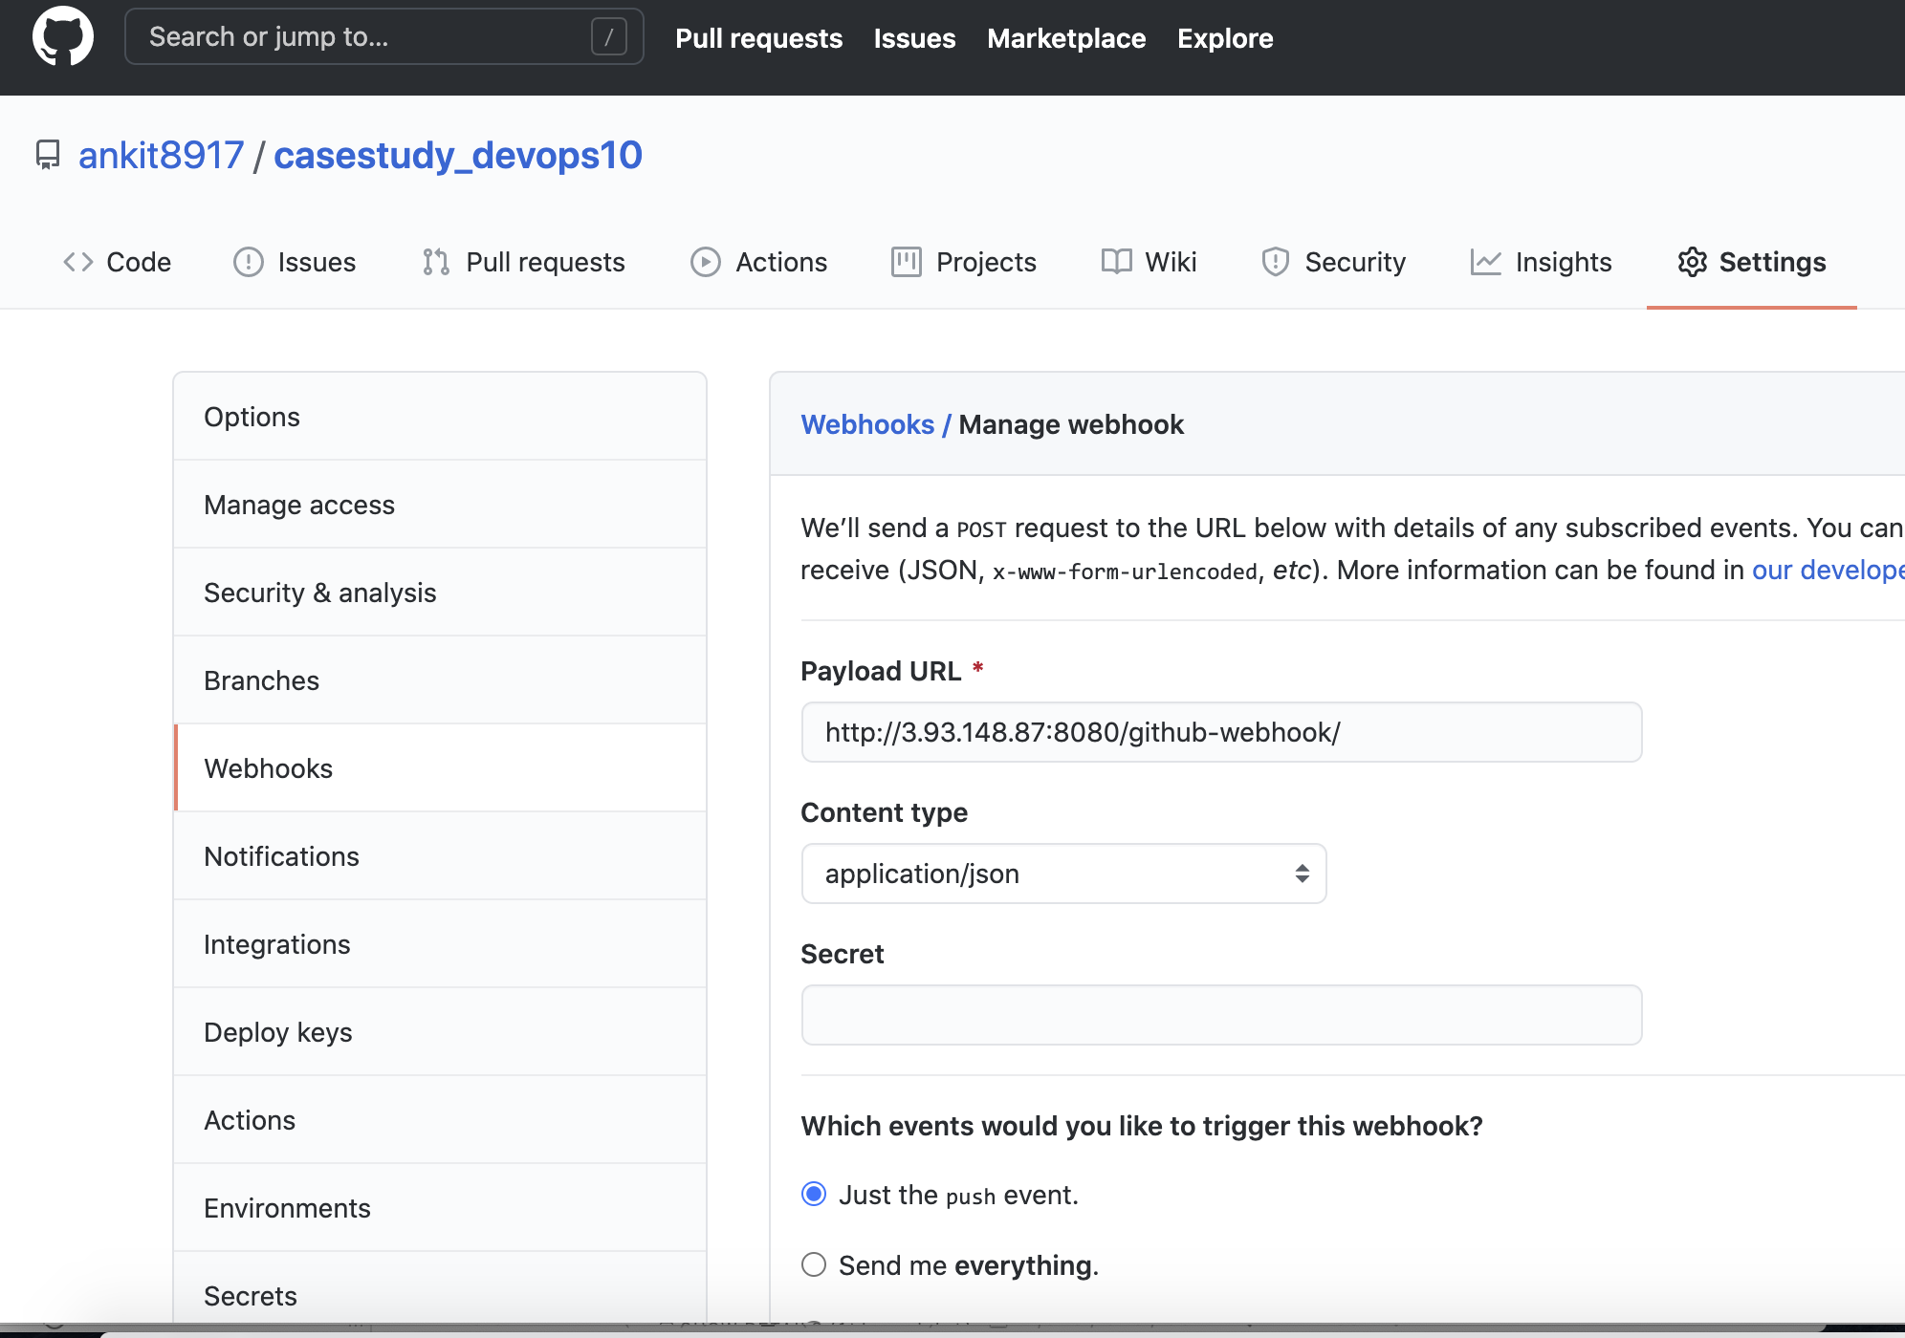

- Screenshot of the HTML report of junit cases.

