1. Docker Installed on AWS EC2 and enabled on the machine .

1. Created a Dockerfile with nginx as base image and copy the application to nginx location.

1. Build the Docker image and push it to Docker HUB .

docker pull ankit8917/my-nginx:v1.0 : To Pull image from Dockerhub.

1. Run Docker Container from this image with name web2 as below .

# docker run --name web2 -dit -p 80:80 ankit8917/my-nginx:v1.0

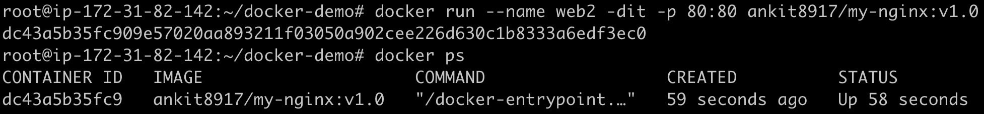

1. Application is accessible on prot 80 on EC2 public IP .

<http://3.83.140.43:80>

1. Docker Compose file:

1. Running Application via docker-compose on port 8080.

1. Both containers are running as service with the help on docker-compose.

1. Connected to runinng mysql container with root user and password.

1. Created test table having attribute id, name and age .

