IS Mini Project
Tweets Classification using skleaarn library

Code:

import cPickle
import numpy as np
from sklearn.svm import SVR

data = cPickle.load(open('numpyfulldata.p','rb'))
training_data=data[:40000]
test_data =data[40001:]
inputdata=[]
outputdata=[]
for a in training_data:
inputdata.append(a[0])
outputdata.append(a[1])
testinputdata=[]
testoutputdata=[]
for a in test_data:
testinputdata.append(a[0])
testoutputdata.append(a[1])

from sklearn import svm

clf = svm.SVC(gamma=0.0000002, C=100)
clf.fit(inputdata, outputdata)
i=len(testinputdata)
j=0
ct=0
while j<i:
x=clf.predict(list(testinputdata[j]))
y=testoutputdata[j]
if x==y:
ct=ct+1
#print str(clf.predict(testinputdata[j]))+ " -- "+str(testoutputdata[j]) +" "+str(j)
j=j+1
ct=ct*1.0
print(ct/len(testinputdata)*100)

Output:
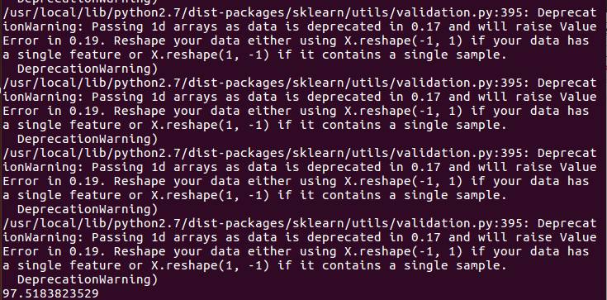

Contributions:

Rishikesh 48:
- Extracted Tweets using query search
- Used Tweets from 2011 to 2015

Ankit 56:
- Converted Tweets into numerical format for machine learning
- Eg: Indian Farmers are facing various problems including lack of water supply ,techniques etc => gets converted to a key value pair
647364 22436 1222 1000 978 965 674 543 = 56565

Pratik 65:
- Developed Code which is using processed data to train and test network using sklearn library of python
- Giving accuracy of 97.51%

