**Q1.WPF Databinding**

A music library maintains an application to display the list of Albums available in its library. It also has option to add new albums arriving to the library. Create a WPF application which add new album details and also to displays the added list of albums in following output format:

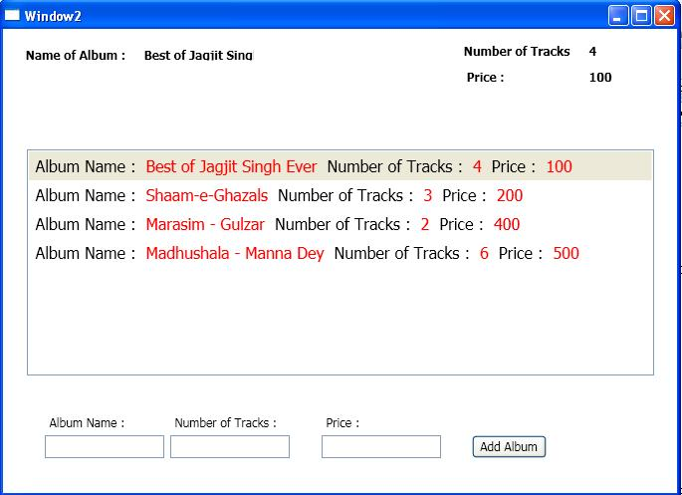

**Tasks:**

1. Display the list of Albums with their details **“AlbumName”**,**”NumberOfTracks”** and **“Price”.**
2. It should also add and display new Album details from user-input to the album collections.
3. When user selects any of the albums in the list displayed, that particular album details should reflect in the display at the top.

**Assumptions and Hints:**

1. Create the “Album” class having property field **“AlbumName”**, **”NumberOfTracks”** and **“Price”** which has to be displayed in the above control. [Hint: use DataTemplate binding with the ListBox]