**VISITORS CHECK-IN AND CHECK-OUT SYSTEM**

## **instructions and Assumptions**

* Assume that the application is a single user system. So no explicit user management or security related implementation required.
* **The UI must be implemented using Windows Form**
* **Data access logic and entities has to be implemented using ADO.NET**
* Should follow the guidelines related to naming conventions, database schema objects naming and defining, programming practices.
* Should make use of stored procedures wherever appropriate for the database operation to improve the efficiency and maintainability.
* **Share the query for stored procedure, table creation, and data insertion etc., used in the application, through a text or SQL file.**
* **Methods should also cover the negative/exception flows for the completeness. Proper exception funneling and propagation should be done**

**Requirements**

**Visitors Check-In and Check-Out:** This application is to keep track of the visitors coming in and going out in an IT park. Users, the security officer should be able to enter visitor’s details for checking-in the IT Park and then signing out the visitors when they leave the IT Park after their work.

The home page should contain links to

**a) Visitor In**

**b) Visitor Out**

**What to implement:**

**Screen 1: Visitor Check-In**

When the visitor comes to the security gate following details are captured from the visitor for his/her checking-in and provide a visitor id to the visitor.

**First Name:** First name of the visitor

**Last Name:** Last name of the visitor

**Company:** The company name who the visitor is representing i.e. from which company they have come.

**Visiting:** To which company in the IT Park the visitor has come for the work.

**Type of ID**: ID type the visitor is handing over to security staff like PAN card, voterid, Driving license etc

**ID Number:** Identification number for their ID Type

**Vehicle Number:** Vehicle number if the visitor has come by vehicle.

**Contact Number:** Visitor mobile number

**Purpose of Visit:** The purpose of visiting the company like for training, meeting etc

**Validations:**

1. All the fields are mandatory except vehicle number.
2. Vehicle number is of two part separated by hyphen (-) e.g. **KA06-EQ7546** where first part has first two characters and then 2- digits and second part has first two characters and then 4-digits.
3. The contact number should contain exactly 10 digits as per mobile number.

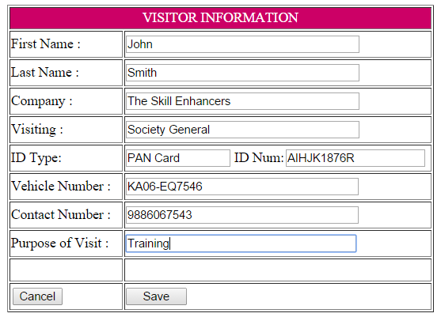

**Flow:**

Security person collects all the above details from visitor and enter into the form above and clicks “**Save**”. On successfully saving the details into database along with status as “**Signed In**” and “**Check-In**” time is recorded as current time , a unique visitor id is generated and the user is redirected to the home page, and the following message for e.g. is displayed there**: “The visitor’s details has been saved successfully with the visitor id 152”**. This unique id will be given to the visitor which will be used during check-out time. “**Cancel**” button redirects to home page.

**Screen 2: Visitor Check-Out**

This screen displays all the visitors currently checked-in inside the IT Park on the current date. It is used to search the visitor details when they come for check-out. It has two options for searching **1) Search by Visitor ID** **2) Search by Name**.

Visitor hands over the visitor id at the security desk and security staff searches the details by entering the visitor id or Visitor’s name as below:

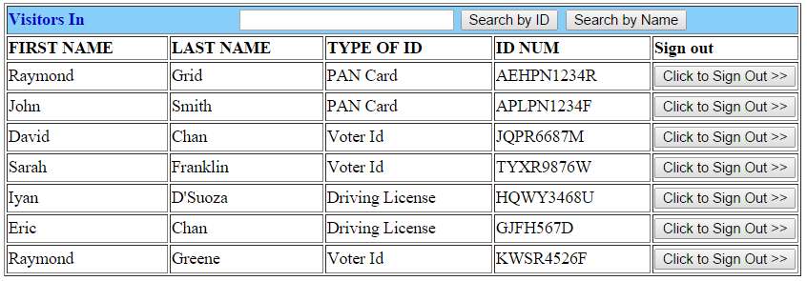

**Flow:**

Security staff enters either the name or the visitor id of the visitor and performs the search by clicking the corresponding button.

1. When search is performed by visitor id the following screen comes with the details of the visitor.

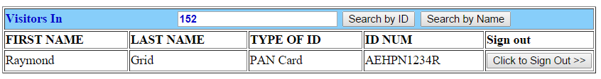

1. When search is performed by name either first name or last name or both. The following screen appears with all the visitors having the words in their names

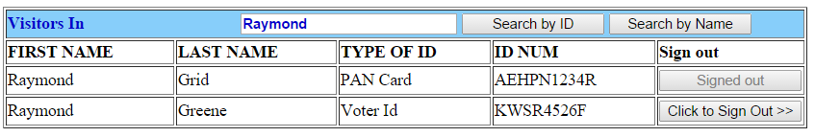.

Note: In all the searches, the “**Sign out**” status column should display “**Click to Sign Out>>”** if the visitor is still not signed out else it should display “**Signed Out**” with disabled button as shown in above figure.

Security staff can do sign out for the visitor by clicking the “**Sign out**” button and status of the visitor in database should also gets changed accordingly to “**Signed out**” and “**Check-Out**” time is recorded as current time.