As per observation:

**TABLE FORMATS WE HAVE: (FOR BILL OF MATERIAL TABLE)**

* QTY | DESCRIPTION
  + Format 1
* ITEM | QTY | DESCRIPTION
  + Format 2
* ITEM | QTY | DESCRIPTION | PART NUMBER
  + Format 3A
* ITEM | QTY. | PART NO. | DESCRIPTION
  + Format 3B
* ITEM | QTY. | PART NO. | DESCRIPTION | REV.
  + Format 4A
* ITEM | QTY | PART NUMBER | DESCRIPTION | REV
  + Format 4B
* ITEM | QTY | DESCRIPTION | MATERIAL | RELEASE | REV | PART NO.
  + Format 5

1)

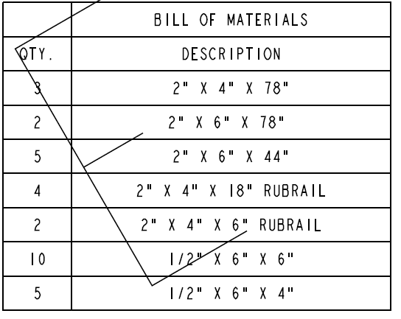

2)

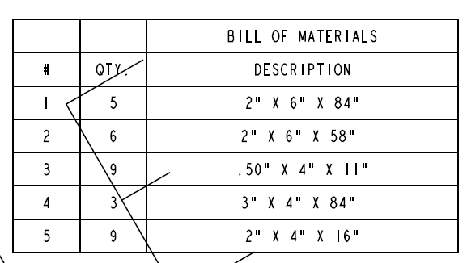

3)

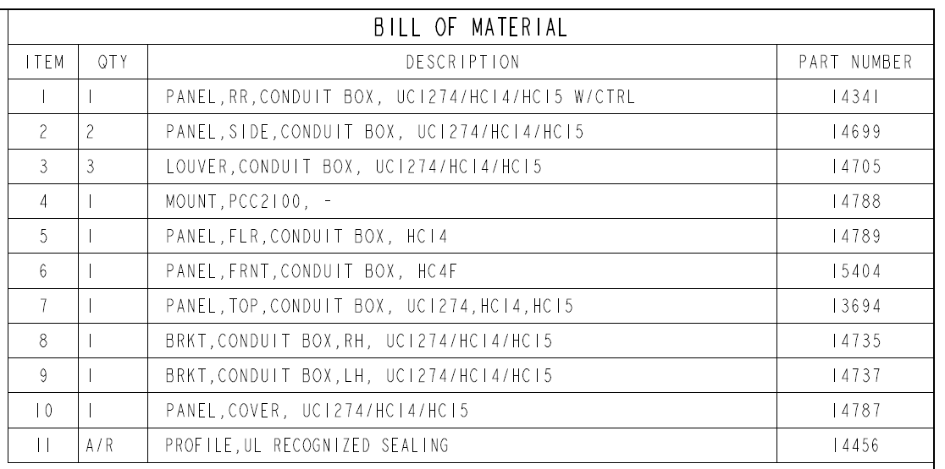

4)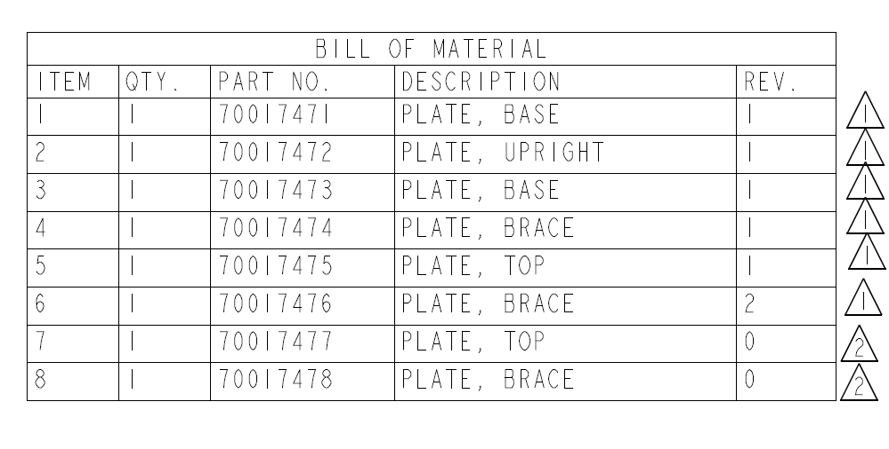

5)

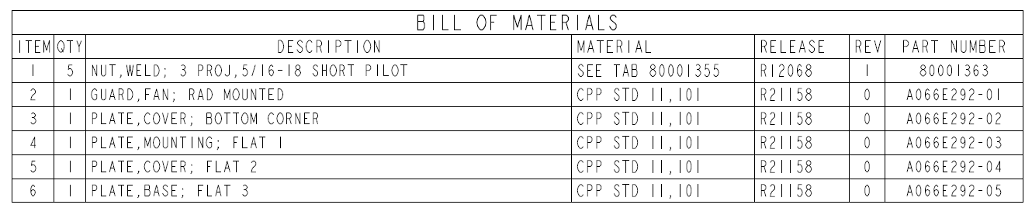

Based on the keywords I was using different templates. But the keywords are over-lapping.

I am getting output perfectly for some set of Pdfs. But for some pdfs the output is not in a perfect order. I think that’s why document understanding gets confused and for some set of pdfs it is not working.

**Previous Output**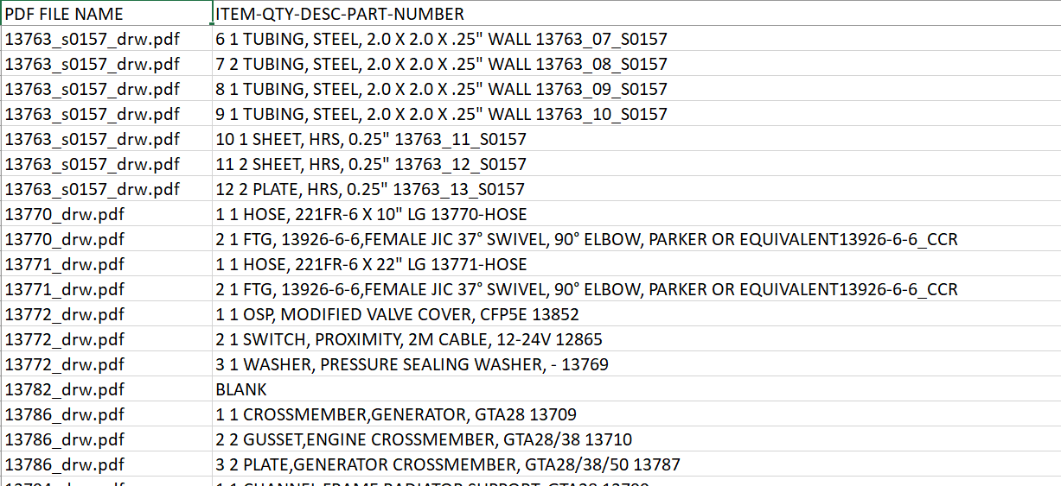

**Recent Output**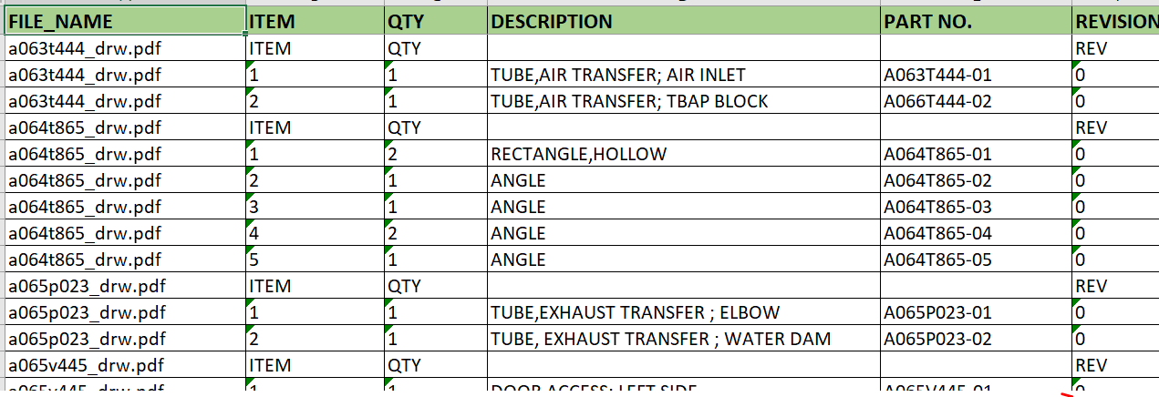

So, to overcome keywords overlapped problem:

* More keywords templates I am putting above

But Problem is there for multiple tables containing Pdfs.

And facing problem with keywords while creating Templates for some pdfs.

**COMMUNITY EDITION_ERROR:**

We only have 50 calls per 1 hr. permission.

