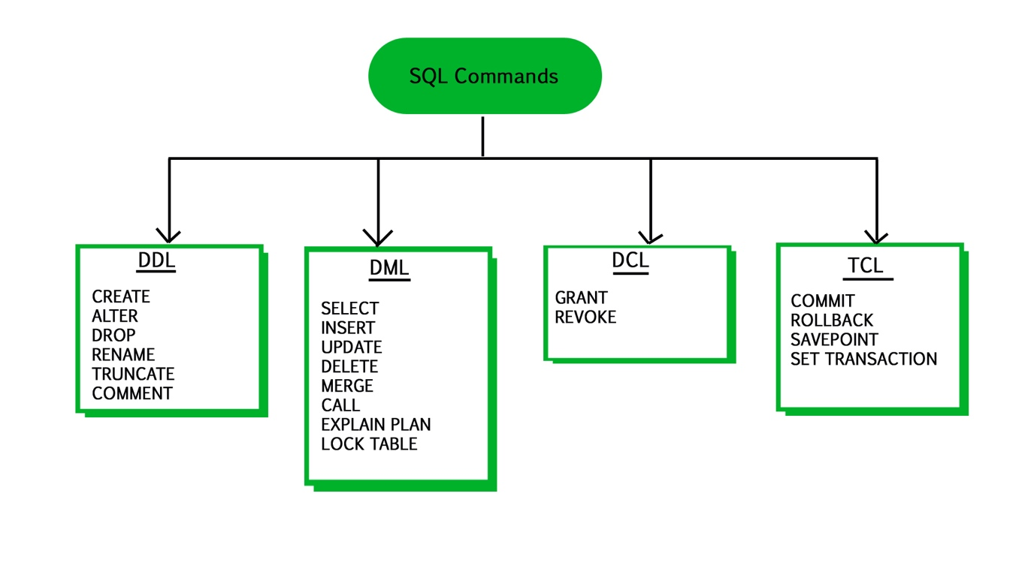

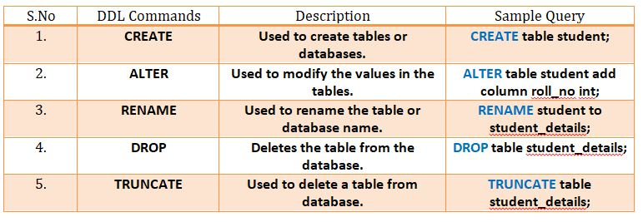

DROP DATABASE IF EXISTS `emp`;

CREATE DATABASE emp;

USE emp;

CREATE TABLE info

(

empid INT,

empfname VARCHAR(255),

age INT,

emailid VARCHAR(255)

);

INSERT INTO info(empid, empfname, age, emailid)

VALUES('1','ANKIT', '25', 'abc.com')

USE sql_store; #first we need to select the database

SELECT * FROM customers. # * denotes every column

-- WHERE customer_id = 1

ORDER BY first_name

2.

SELECT first_name, last_name, points FROM customers.

#points is a new column which is given based on the customer data, we can change the value of this column using arithmetic operation

-- SELECT * FROM customers

-- WHERE customer_id = 1

ORDER BY first_name

3.

SELECT first_name, last_name, points + 10 FROM customers

-- SELECT * FROM customers

-- WHERE customer_id = 1

ORDER BY first_name

4.

USE sql_store;

SELECT first_name, last_name, points+10, points *10+100 AS discount_factor FROM customers

#Using AS keyword, we are renaming the column points

-- SELECT * FROM customers

-- WHERE customer_id = 1

ORDER BY points DESC

#DESC denotes descending order

5.

UPDATE `sql_store`.`customers` SET `state` = 'VA' WHERE (`customer_id` = '1');

#UPDATES OUR DATA ON THE TABLE CUSTOMERS WHERE CUSTOMER ID = 1

6.

SELECT DISTINCT state FROM sql_store.customers;

#this doesn’t return any duplicate values. Only returns unique values

7.

EXERCISE

There is a table products. You need to return the name, unit price and a new column NEW PRICE which will be 1.1 time the unit price

Unit_price*1.1 = new price

8.

Operators in sql

>

>=

<

<=

=

!=

SELECT * FROM sql_store.customers

WHERE points > 2500

SELECT * FROM sql_store.customers

-- WHERE points > 2500;

-- WHERE state != 'CO'

WHERE birth_date > '1990-01-01'

-- WHERE birth_date > '1990-01-01' AND points > 1000

WHERE birth_date > '1990-01-01' OR points > 1000

WHERE birth_date > '1990-01-01' OR points > 1000 AND state = 'VA'

8. exercise

From order_items table, get the items for ORDER NO 6

Where the total price is greater than 30

SOL:

SELECT * FROM order_items

WHERE order_id = 6 AND unit_price * quantity > 30

9. IN OPERATOR- when you want to use a list of values

-- WHERE state IN ('VA', 'FL', 'GA')

WHERE state NOT IN ('VA', 'FL', 'GA')

10.

Return products with quantity in stock equal to 49,38,72

11. BETWEEN OPERATOR

where points BETWEEN 1000 AND 3000

12. LIKE OPERATOR

WHERE last_name LIKE 'b%'

WHERE last_name LIKE '%b%'

WHERE last_name LIKE '%y'

13. IS null operator – checks whether a place in table is empty/ null

WHERE phone IS NULL

14. ORDER BY first_name

For ascending order

ORDER BY first_name DESC

For descending order

15. sorting based on multiple values

ORDER BY state, first_name

16. sorting states in descending order and name in ascending

ORDER BY state DESC, first_name

17. exercise: on the table ORDER ITEMS where select items with order id = 2 and sort them based on their total price (no of items * price per unit) in descending order

SELECT *, quantity * unit_price AS total_price FROM order_items

WHERE order_id = 2

ORDER BY quantity * unit_price DESC

18. OFFSET AND LIMIT

LIMIT 6, 3

#here offset = 6 and limit is 3

19. EXERCISE:

GET THE TOP # LOYAL CUSTOMERS (who have the maximum points)

ORDER BY points DESC

LIMIT 3

20. INNER JOIN

SELECT order_id, first_name, last_name, orders.customer_id FROM sql_store.orders

JOIN Customers ON orders.customer_id = customers.customer_id

#name of the column through which you want to join the tables

20. EXERCISE: display the order id, product id and product name by joining order items and products

SELECT * FROM order_items

JOIN products ON order_items.product_id = products.product_id

21. joining if both the tables are in different databases(JOINING ACROSS DATABASES)

SELECT * FROM sql_store.order_items o

JOIN sql_inventory.products p ON o.product_id = p.product_id

22. In a database, we have multiple employees and there is given whom to report to. We are asked to find the name of the manager for each employee like who they have to report. Both the informations are given in **same table**.

USE sql_hr;

SELECT e.employee_id, e.first_name, m.first_name AS manager FROM sql_hr.employees e

JOIN employees m ON e.reports_to = m.employee_id

23. JOINING Multiple tables

SELECT o.order_id, o.order_date, c.first_name, os.name AS status FROM sql_store.orders o

JOIN customers c ON o.customer_id = c.customer_id

JOIN order_statuses os ON o.status = os.order_status_id

24. EXERCISE: join the tables CLIENTS, PAYMENT METHODS & PAYMENTS in SQL INVOICING database

USE sql_invoicing;

SELECT * FROM payments p

JOIN clients c ON p.client_id = c.client_id

JOIN payment_methods pm ON p.payment_method = pm.payment_method_id

25. JOINING MULTIPLE COLUMNS (compound join condition)

SELECT * FROM order_items oi

JOIN order_items_notes oin ON oi.order_id = oin.order_id AND oi.product_id = oin.product_id

26. IMPLICIT JOIN SYNTAX

SELECT * FROM orders o , customers c

WHERE o.customer_id = c.customer_id

27. OUTER JOINS (customers who have an order placed are returned. Now if we want to view all the customers who don’t have an order, we use outer join)

Types of OUTER JOIN

1. Left join – we get all the customers from customer table whether the condition is true or not
2. Right join- we get all the customers from orders table whether the condition is true or not

SELECT c.customer_id, o.order_id, c.first_name FROM customers c

JOIN orders o ON c.customer_id = o.customer_id

***LEFT JOIN***

SELECT c.customer_id, o.order_id, c.first_name FROM customers c

LEFT JOIN orders o ON c.customer_id = o.customer_id

#all the records on left tables are returned. Here left table is customers

***RIGHT JOIN***

SELECT c.customer_id, o.order_id, c.first_name FROM customers c

RIGHT JOIN orders o ON c.customer_id = o.customer_id

#all the records on orders table are returned whether the condition is true or not

28. USING CLAUES(works if both the column names with which you are joining have the same name)

SELECT * FROM orders o

JOIN customers c USING (customer_id)

Or

JOIN customers c ON c.customer_id = o.customer_id

29. UNIONS – combining rows from multiple tables

SELECT order_id, order_date, ‘ACTIVE’ AS status FROM orders

WHERE order_date >= ‘2019-01-01’

UNION

SELECT order_id, order_date, ‘ARCHIEVE’ AS status FROM orders

WHERE order_date < ‘2019-01-01’

30.different tables

SELECT first_name from customers

UNION

SELECT name from shippers

31.this throws an error. The number of columns while working with unions must be same

SELECT first_name, last_name from customers

UNION

SELECT name from shippers

32. INSERTING. A DATA INTO TABLE

INSERT INTO customers

VALUES (DEFAULT, ‘ANKIT’, ‘P’, ‘1995-01-06’, NULL/DEFAULT, ‘address’, ‘city’, ‘state’,DEFAULT )

OR

INSERT INTO customers (first_name, last_name, birth_date, address, city, state)

VALUES ( ‘ANKIT’, ‘P’, ‘1995-01-06’, ‘address’, ‘city’, ‘state’)

33. INSERTING MULTIPLE ROWS

INSERT INTO shippers (name)

VALUES (‘shipper1’), (‘shipper2’), (‘shipper3’)

34. UPDATING A data

UPDATE invoices

SET payment_total = 10, payment_date = ‘2019-04-05’

WHERE invoice_id = 1

35. SUBQUERY – a SELECT statement that is present within another select statement

UPDATE invoices

SET payment_total = invoice_total * 5, payment_date = due_date

WHERE client_id =

(SELECT client_id FROM clients WHERE name = ‘Myworks’)

36. DELETING rows

DELETE FROM invoices WHERE invoice_id = 1

36. using sub query for deleting rows

DELETE FROM invoices WHERE client_id = (

SELECT * FROM clients WHERE name = ‘Myworks’

)

37.

