EXPLORATORY DATA ANALYSIS
REPORT DESIGN
Agribusiness Trends: FAOSTAT Producer-Price Data
Week 3 Internship Task
Prepared by: Ankit Sen
2026

1. Executive Summary
This report presents an exploratory data analysis (EDA) design and a review of the outputs generated from the FAOSTAT producer-price dataset for India. The supplied outputs include descriptive-statistics tables, annual summaries, commodity summaries, correlation results, an IQR-based potential-outlier file, and 18 visualizations. The purpose of EDA is to describe the dataset, identify patterns that merit further investigation, and develop evidence-based questions for agribusiness decision-making.
The Week 2 data-quality assessment reported 5,035 records covering 104 commodities from 1991 to 2025. In the supplied descriptive-statistics output, 465 records are reported for each of the three producer-price measures and 3,640 records for the producer price index. The 3,640 missing Unit values (72.29% of rows) are associated with index observations, for which a currency-per-tonne unit is not applicable.
The correlation summary reports high average year-value correlations for the local currency and index series, but these are descriptive associations, not proof of causes. The dataset is annual and India-wide in the supplied report, so it cannot directly measure monthly seasonality or regional variation. Findings should be interpreted with these limitations in mind.

2. Introduction and Objectives
Agricultural producer prices influence farm revenue, production planning, procurement, and market-risk assessment. EDA provides an initial way to understand historical price behaviour before more formal statistical modelling or business recommendations are made.
- Summarize the coverage, structure, and quality of the dataset.
- Describe the distribution and spread of reported agricultural values.
- Explore historical patterns by year, commodity, and measurement type.
- Identify unusual observations for review without automatically deleting them.
- Examine correlations carefully and distinguish association from causation.
- Translate supported findings into practical follow-up questions for agribusiness.

3. Dataset Description
The dataset is the FAOSTAT producer-price file used in the Week 2 task. Its fields include geographic area, commodity, year, measurement element, unit, reported value, and reporting flags. The four measurement elements listed in the Week 2 report are Producer Price (LCU/tonne), Producer Price (SLC/tonne), Producer Price (USD/tonne), and Producer Price Index (2014–2016 = 100).
Dataset characteristic | Reported description
Geographic coverage | India
Year range | 1991–2025
Distinct commodities | 104
Rows / columns | 5,035 / 16 (Week 2 report)
Exact duplicate rows | 0 (Week 2 report)
Measurement types | Three price-per-tonne measures and one price index
The supplied descriptive-statistics CSV contains 465 records for each price-per-tonne element and 3,640 for the price index. These are counts in the exported summary, not a claim that every commodity has a complete annual series.

4. Methodology
- Load the source CSV and standardize column names and text whitespace.
- Inspect dimensions, data types, missing-value counts, duplicate records, and year coverage.
- Calculate mean, median, standard deviation, minimum, and maximum separately by measurement type.
- Use histograms to inspect distributions and line charts to inspect annual patterns.
- Compare commodities only within the same measurement element and a clearly stated period.
- Use the interquartile range (IQR) rule to flag potential outliers for investigation.
- Calculate year-value correlations by commodity or measurement type only when there are enough observations.
- Export summary tables and charts to support a reproducible report.
The IQR rule flags values below Q1 − 1.5 × IQR or above Q3 + 1.5 × IQR. It is a screening method, not a test that a record is wrong. Any exclusion or correction should require checking source notes, reporting flags, units, and historical context.

5. Data Quality Assessment
The Week 2 report found 3,640 missing values in the Unit column, equal to 72.29% of rows and approximately 4.52% of all cells. The supplied missing-value summary reproduces the 3,640 missing Unit values. The report explains that these belong to producer price index records, so filling them with LCU, SLC, or USD would incorrectly label the measurement.
The Week 2 assessment also reported zero exact duplicate rows, no missing Year or Value values, and no negative or zero values in Value. These are previously reported checks; they should be rerun against the exact file used for the Week 3 charts if a final reproducibility audit is required.

6. Descriptive Statistics
The supplied descriptive-statistics table provides the following summary. Values must be interpreted within their own measurement type and unit; price levels and index values are not directly comparable.
Measurement | Records | Mean | Median | Std. dev. | Minimum | Maximum
Producer Price (LCU/tonne) | 465 | 15,736.97 | 11,310.00 | 18,029.44 | 373.00 | 158,080.00
Producer Price (SLC/tonne) | 465 | 15,736.97 | 11,310.00 | 18,029.44 | 373.00 | 158,080.00
Producer Price (USD/tonne) | 465 | 414.56 | 323.30 | 488.96 | 12.80 | 3,910.60
Producer Price Index (2014-2016 = 100) | 3640 | 72.27 | 60.15 | 41.50 | 3.35 | 215.29
The producer price index has a mean of 72.27 and median of 60.15 in the supplied output. The mean exceeds the median, suggesting that some larger index values may pull the mean upward. This should be confirmed by inspecting the distribution chart and quantiles. The reported LCU and SLC summaries are numerically identical in the supplied file; this should be checked against the source dataset and measurement definitions before making substantive interpretations.

7. Visualization Plan and Results
- Missing-value bar chart: identifies columns with incomplete fields.
- Histograms: describe the distribution and spread of each measurement type.
- Line charts: show annual changes for selected commodities within each measurement type.
- Bar charts: compare commodity medians for the same measurement and overlapping period.
- Correlation plots/tables: summarize the direction and strength of linear association between year and value.
- Wheat case-study line chart: examines the available historical LCU-per-tonne series.
Figure 1. Missing values by column.
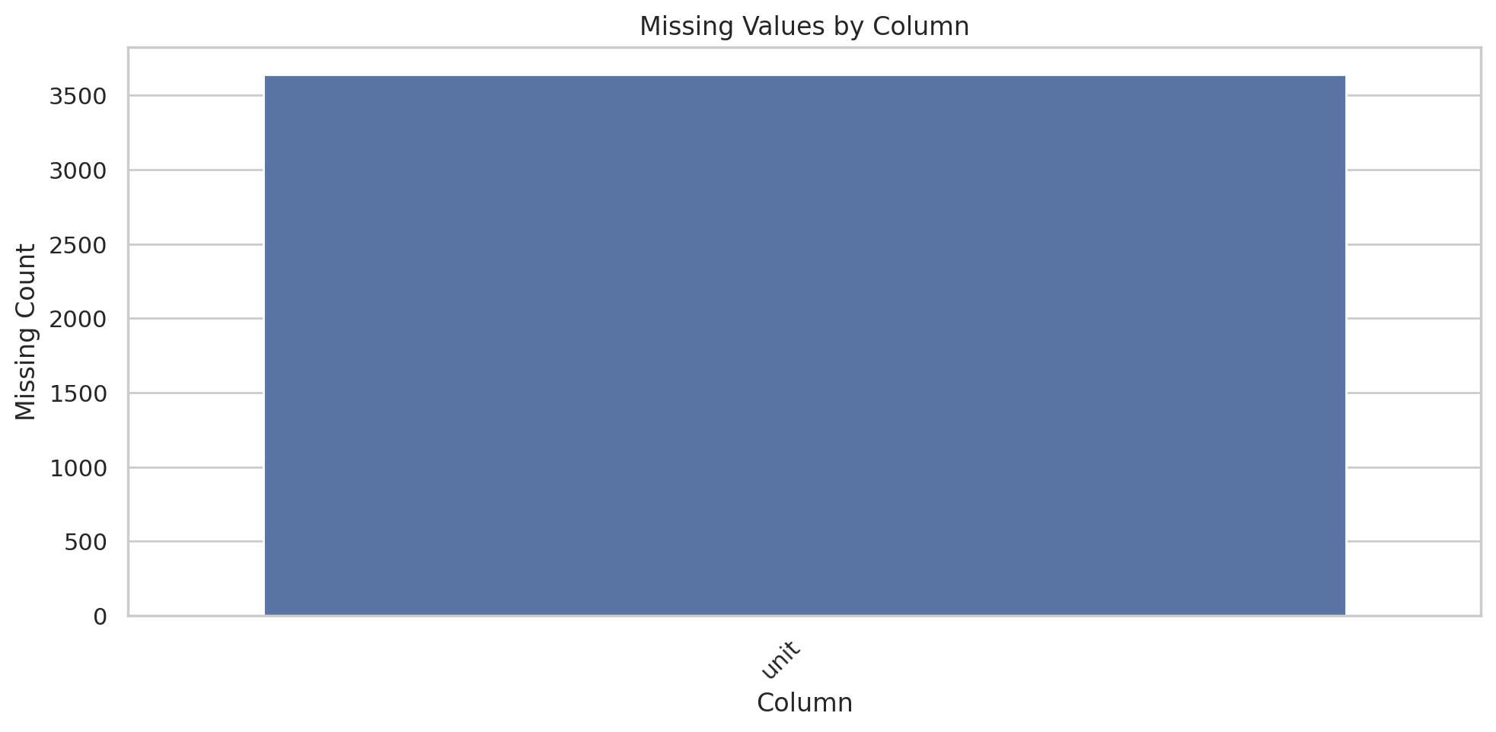
Figure 2. Distribution of producer prices in LCU per tonne.
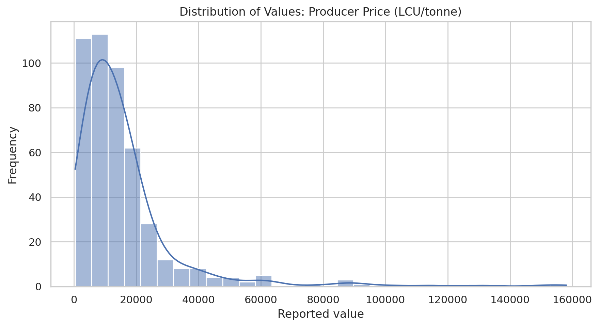
Figure 3. Distribution of producer price index values.
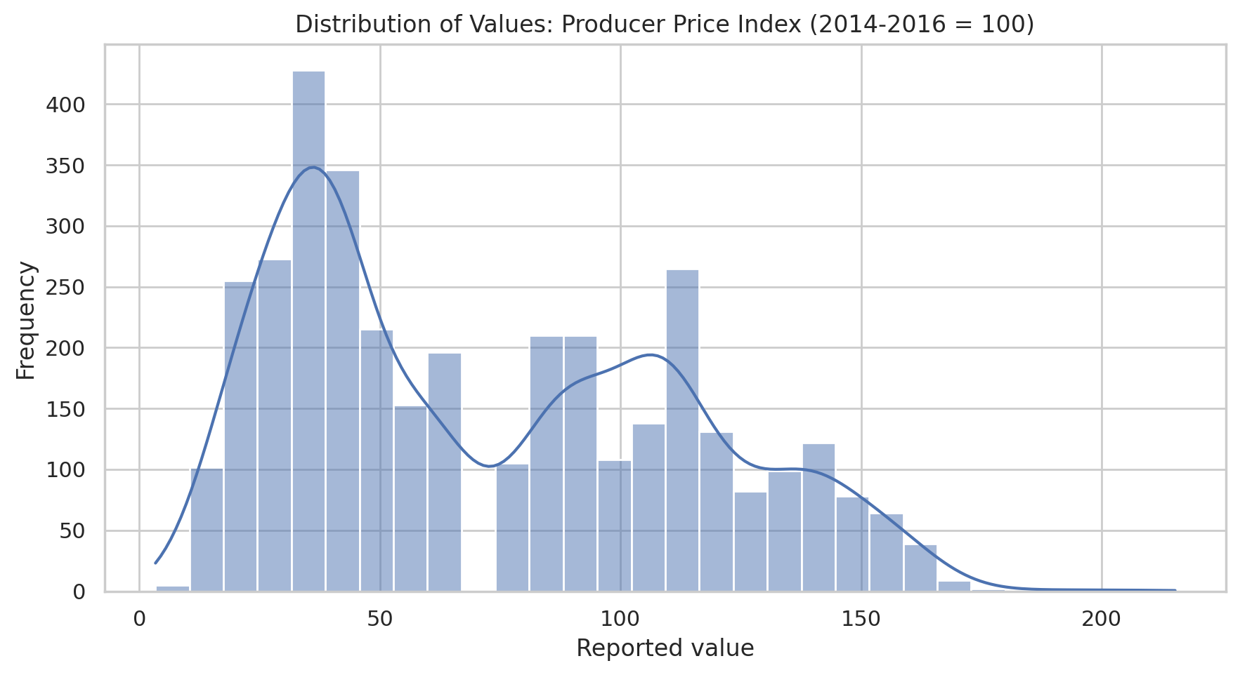
Figure 4. Annual trends for selected commodities in LCU per tonne.
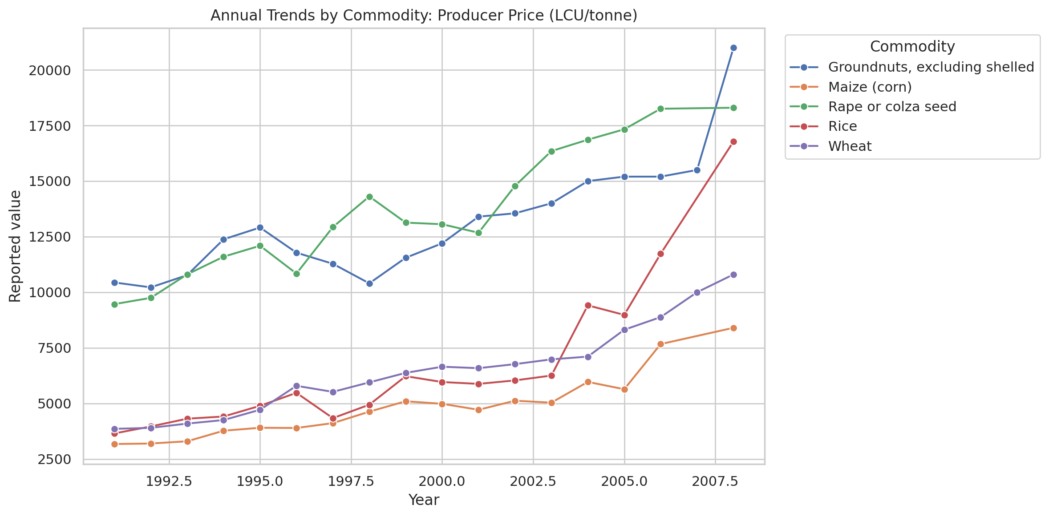
Figure 5. Commodity comparison for the price index over the stated common period.
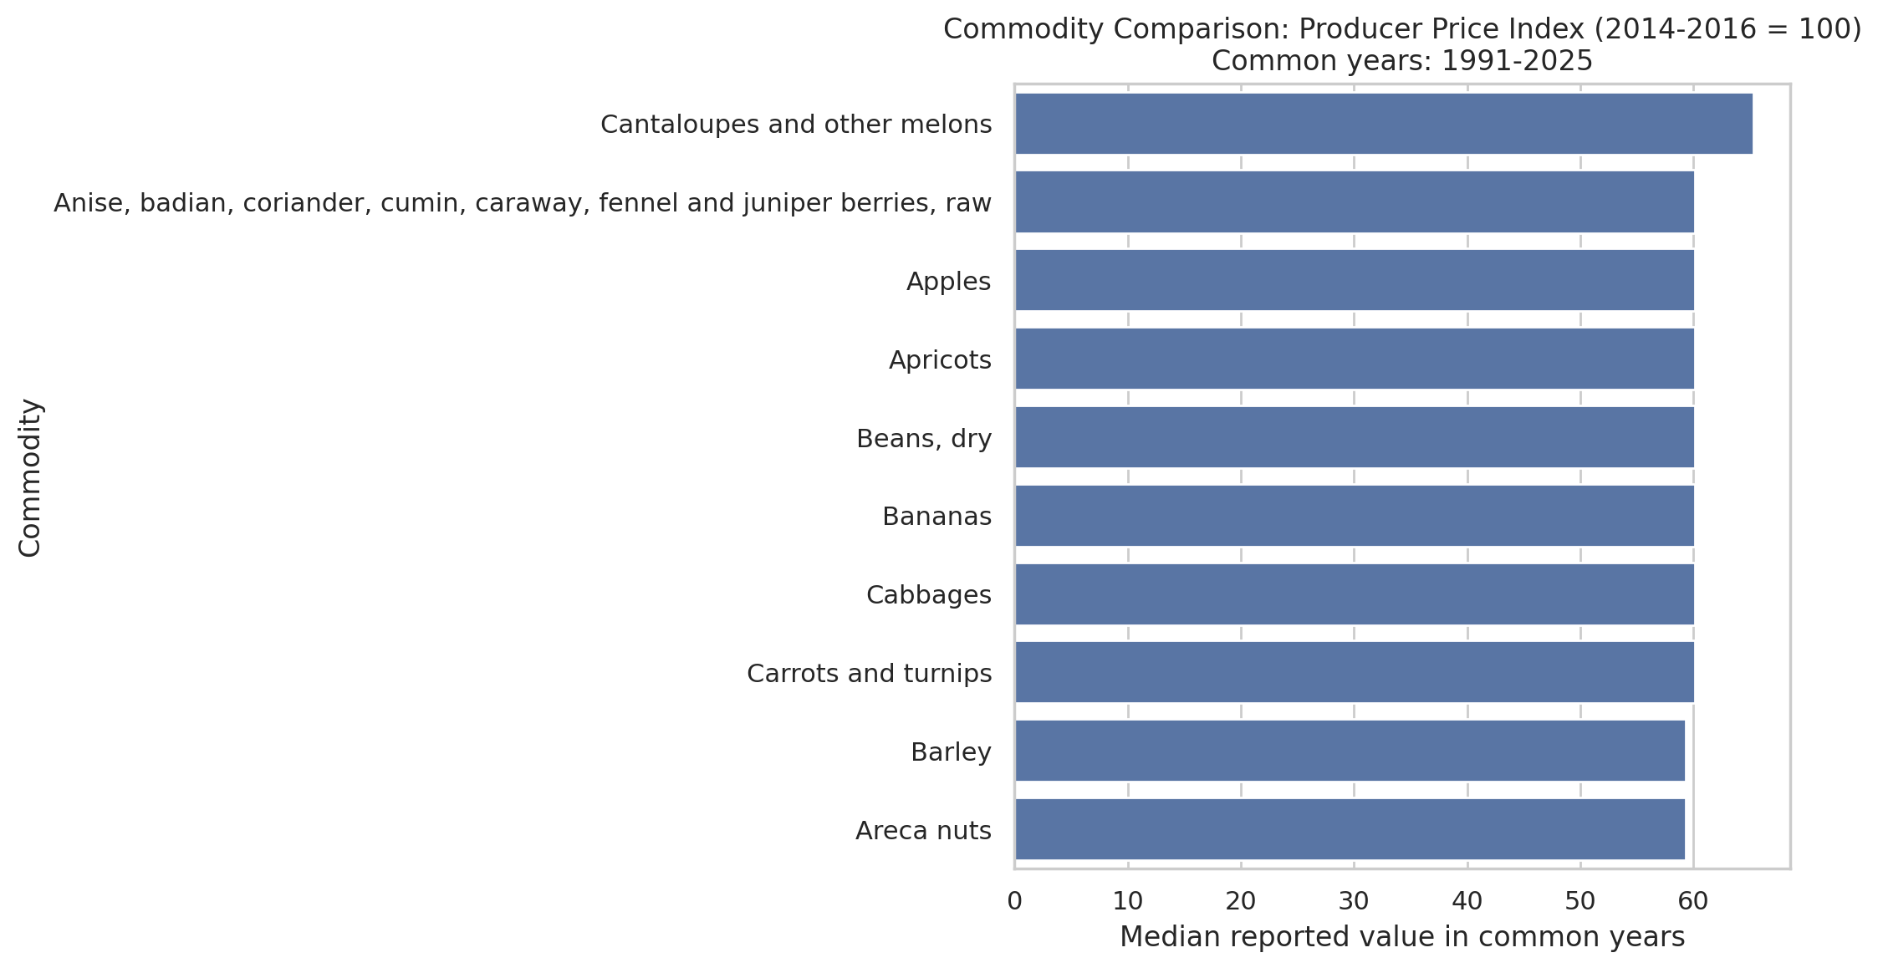
Figure 6. Wheat producer-price observations in LCU per tonne.
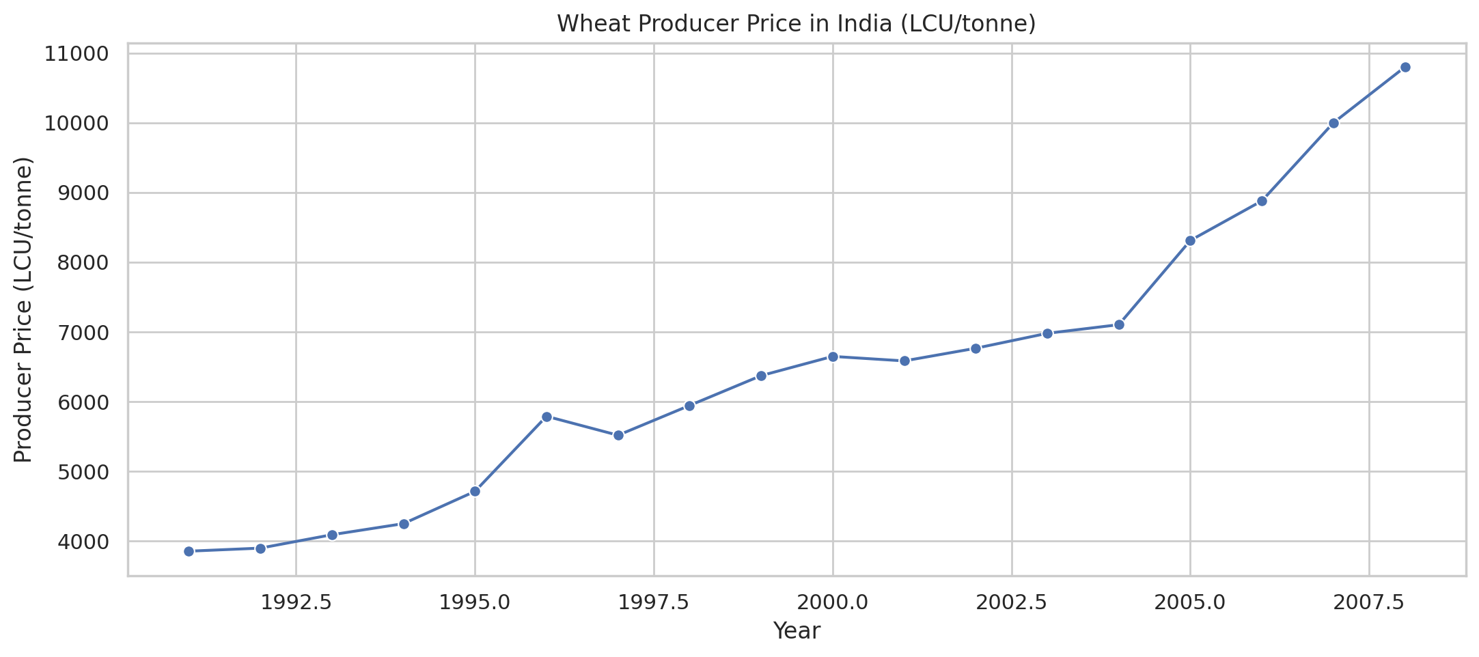

8. Time-Series and Commodity Analysis
The annual summary file contains grouped observations by measurement element and year. Time-series charts should be read with attention to gaps in coverage and changes in the measurement being reported. A missing observation must not be interpreted as a zero price. Where price-per-tonne records and index records cover different years, they should be presented as separate series.
The Week 2 report states that wheat has 89 observations across all measurement elements, with the LCU-per-tonne series reported from 1991 through 2008 and more recent records represented by the producer price index. The chart therefore supports a historical view of the available LCU series, but it does not provide a continuous absolute-price series through 2025.
Commodity comparisons are useful for identifying relative differences, but should use a consistent unit, measurement element, and time window. A comparison of index values can be more appropriate for relative price movement, while absolute price comparisons require careful consideration of units and commodity definitions.

9. Outlier Analysis
The supplied potential-outlier file contains 62 flagged records. These are observations outside the IQR thresholds within the groups used by the analysis. This does not establish that the records are erroneous. The flags should be checked against official reporting notes, unit consistency, neighbouring years, and plausible market events.
Examples of flagged observations from the supplied file:
item | element | year | value | Lower_Bound | Upper_Bound
Barley | Producer Price (LCU/tonne) | 2005 | 7,684.00 | 3,332.00 | 7,380.00
Barley | Producer Price (LCU/tonne) | 2006 | 8,193.30 | 3,332.00 | 7,380.00
Barley | Producer Price (LCU/tonne) | 2008 | 9,855.80 | 3,332.00 | 7,380.00
Groundnuts, excluding shelled | Producer Price (LCU/tonne) | 2008 | 21,000.00 | 6,243.75 | 19,853.75
Jute, raw or retted | Producer Price (LCU/tonne) | 2008 | 12,500.00 | 2,745.50 | 12,301.50
Lentils, dry | Producer Price (LCU/tonne) | 1991 | 6,737.00 | 9,741.88 | 18,754.88
Maize (corn) | Producer Price (LCU/tonne) | 2006 | 7,667.10 | 2,052.50 | 6,960.50
Maize (corn) | Producer Price (LCU/tonne) | 2008 | 8,400.00 | 2,052.50 | 6,960.50
Recommended handling: retain the original value, record the reason for any decision, and perform a sensitivity analysis if a verified error must be corrected or excluded.

10. Correlation Analysis
The supplied correlation summary aggregates commodity-level correlations between year and value. The results are shown below. These are descriptive summaries of linear association; they do not establish that time itself caused a price change.
Measurement | Commodity count | Mean correlation | Median correlation
Producer Price (LCU/tonne) | 30 | 0.86 | 0.90
Producer Price (SLC/tonne) | 30 | 0.86 | 0.90
Producer Price (USD/tonne) | 30 | 0.31 | 0.38
Producer Price Index (2014-2016 = 100) | 104 | 0.97 | 0.97
The index shows a high average commodity-level year-value correlation in the supplied summary. This can reflect broad upward or downward trends relative to the index base period, but correlations may be sensitive to series length, missing years, and outliers. Correlation analysis should use sufficiently long series and should not combine unrelated measurement types. If monthly price and production data become available, further analysis could examine seasonality and associations with supply or market conditions.

11. Agribusiness Implications and Recommendations
- Use historical price charts as a starting point for procurement and market monitoring, not as a standalone forecast.
- Track coverage gaps and distinguish missing observations from genuine zero values.
- Keep LCU, SLC, USD price measures, and index values separate unless a documented transformation is appropriate.
- Investigate flagged outliers against FAOSTAT metadata and reporting flags before changing any record.
- Add monthly mandi prices, production volumes, arrivals, rainfall, input costs, or policy dates to study seasonality and possible explanatory factors.
- For regional comparisons, obtain a dataset with state, district, or market-level coverage; the supplied FAOSTAT report is India-wide.
- Document the exact dataset version, cleaning steps, grouping rules, and chart generation code for reproducibility.

12. Limitations
- The supplied FAOSTAT data is annual, so it cannot identify monthly or seasonal patterns.
- The Week 2 report describes India-wide coverage and does not support state- or district-level conclusions.
- Absolute prices and index values represent different measurement concepts and should not be compared as if they shared a unit.
- Historical price patterns alone cannot identify causal drivers such as rainfall, input costs, policy changes, or global demand.
- Commodity series have unequal observation counts and different coverage periods.
- IQR flags identify statistical extremes, not necessarily data errors.

13. Conclusion
The supplied EDA outputs establish a useful starting point for exploring agricultural producer-price data. They provide descriptive summaries, annual trends, commodity comparisons, correlation summaries, and a list of potential outliers for further review. The most important analytical safeguards are to preserve meaningful missing values, separate measurement types, investigate rather than automatically remove outliers, and avoid causal claims unsupported by the data. More detailed agribusiness conclusions should be written only after inspecting each chart and validating the observations against the source dataset.

References
- Food and Agriculture Organization of the United Nations (FAO), FAOSTAT producer-price dataset used for the internship analysis.
- pandas documentation: https://pandas.pydata.org/docs/
- Matplotlib documentation: https://matplotlib.org/stable/
- Seaborn documentation: https://seaborn.pydata.org/

