Load the Dataset
from google.colab import drive
drive.mount('/content/gdrive/',force_remount=True)
Mounted at /content/gdrive/
import os
path = "/content/gdrive/MyDrive/Final_Project_Quant"
os.chdir(path)
!pip install prince
Requirement already satisfied: prince in /usr/local/lib/python3.10/dist-packages (0.11.0)
Requirement already satisfied: altair<6.0.0,>=4.2.2 in /usr/local/lib/python3.10/dist-packages (from prince) (4.2.2)
Requirement already satisfied: pandas<3.0.0,>=1.4.1 in /usr/local/lib/python3.10/dist-packages (from prince) (1.5.3)
Requirement already satisfied: scikit-learn<2.0.0,>=1.0.2 in /usr/local/lib/python3.10/dist-packages (from prince) (1.2.2)
Requirement already satisfied: entrypoints in /usr/local/lib/python3.10/dist-packages (from altair<6.0.0,>=4.2.2->prince) (0.4)
Requirement already satisfied: jinja2 in /usr/local/lib/python3.10/dist-packages (from altair<6.0.0,>=4.2.2->prince) (3.1.2)
Requirement already satisfied: jsonschema>=3.0 in /usr/local/lib/python3.10/dist-packages (from altair<6.0.0,>=4.2.2->prince) (4.3.3)
Requirement already satisfied: numpy in /usr/local/lib/python3.10/dist-packages (from altair<6.0.0,>=4.2.2->prince) (1.25.1)
Requirement already satisfied: toolz in /usr/local/lib/python3.10/dist-packages (from altair<6.0.0,>=4.2.2->prince) (0.12.0)
Requirement already satisfied: python-dateutil>=2.8.1 in /usr/local/lib/python3.10/dist-packages (from pandas<3.0.0,>=1.4.1->prince) (2.8.2)
Requirement already satisfied: pytz>=2020.1 in /usr/local/lib/python3.10/dist-packages (from pandas<3.0.0,>=1.4.1->prince) (2022.7.1)
Requirement already satisfied: scipy>=1.3.2 in /usr/local/lib/python3.10/dist-packages (from scikit-learn<2.0.0,>=1.0.2->prince) (1.10.1)
Requirement already satisfied: joblib>=1.1.1 in /usr/local/lib/python3.10/dist-packages (from scikit-learn<2.0.0,>=1.0.2->prince) (1.3.1)
Requirement already satisfied: threadpoolctl>=2.0.0 in /usr/local/lib/python3.10/dist-packages (from scikit-learn<2.0.0,>=1.0.2->prince) (3.2.0)
Requirement already satisfied: attrs>=17.4.0 in /usr/local/lib/python3.10/dist-packages (from jsonschema>=3.0->altair<6.0.0,>=4.2.2->prince) (23.1.0)
Requirement already satisfied: pyrsistent!=0.17.0,!=0.17.1,!=0.17.2,>=0.14.0 in /usr/local/lib/python3.10/dist-packages (from jsonschema>=3.0->altair<6.0.0,>=4.2.2->prince) (0.19.3)
Requirement already satisfied: six>=1.5 in /usr/local/lib/python3.10/dist-packages (from python-dateutil>=2.8.1->pandas<3.0.0,>=1.4.1->prince) (1.16.0)
Requirement already satisfied: MarkupSafe>=2.0 in /usr/local/lib/python3.10/dist-packages (from jinja2->altair<6.0.0,>=4.2.2->prince) (2.1.3)
!pip install yellowbrick
Requirement already satisfied: yellowbrick in /usr/local/lib/python3.10/dist-packages (1.5)
Requirement already satisfied: matplotlib!=3.0.0,>=2.0.2 in /usr/local/lib/python3.10/dist-packages (from yellowbrick) (3.7.1)
Requirement already satisfied: scipy>=1.0.0 in /usr/local/lib/python3.10/dist-packages (from yellowbrick) (1.10.1)
Requirement already satisfied: scikit-learn>=1.0.0 in /usr/local/lib/python3.10/dist-packages (from yellowbrick) (1.2.2)
Requirement already satisfied: numpy>=1.16.0 in /usr/local/lib/python3.10/dist-packages (from yellowbrick) (1.25.1)
Requirement already satisfied: cycler>=0.10.0 in /usr/local/lib/python3.10/dist-packages (from yellowbrick) (0.11.0)
Requirement already satisfied: contourpy>=1.0.1 in /usr/local/lib/python3.10/dist-packages (from matplotlib!=3.0.0,>=2.0.2->yellowbrick) (1.1.0)
Requirement already satisfied: fonttools>=4.22.0 in /usr/local/lib/python3.10/dist-packages (from matplotlib!=3.0.0,>=2.0.2->yellowbrick) (4.41.1)
Requirement already satisfied: kiwisolver>=1.0.1 in /usr/local/lib/python3.10/dist-packages (from matplotlib!=3.0.0,>=2.0.2->yellowbrick) (1.4.4)
Requirement already satisfied: packaging>=20.0 in /usr/local/lib/python3.10/dist-packages (from matplotlib!=3.0.0,>=2.0.2->yellowbrick) (23.1)
Requirement already satisfied: pillow>=6.2.0 in /usr/local/lib/python3.10/dist-packages (from matplotlib!=3.0.0,>=2.0.2->yellowbrick) (9.4.0)
Requirement already satisfied: pyparsing>=2.3.1 in /usr/local/lib/python3.10/dist-packages (from matplotlib!=3.0.0,>=2.0.2->yellowbrick) (3.1.0)
Requirement already satisfied: python-dateutil>=2.7 in /usr/local/lib/python3.10/dist-packages (from matplotlib!=3.0.0,>=2.0.2->yellowbrick) (2.8.2)
Requirement already satisfied: joblib>=1.1.1 in /usr/local/lib/python3.10/dist-packages (from scikit-learn>=1.0.0->yellowbrick) (1.3.1)
Requirement already satisfied: threadpoolctl>=2.0.0 in /usr/local/lib/python3.10/dist-packages (from scikit-learn>=1.0.0->yellowbrick) (3.2.0)
Requirement already satisfied: six>=1.5 in /usr/local/lib/python3.10/dist-packages (from python-dateutil>=2.7->matplotlib!=3.0.0,>=2.0.2->yellowbrick) (1.16.0)
!pip install pygam
Requirement already satisfied: pygam in /usr/local/lib/python3.10/dist-packages (0.9.0)
Requirement already satisfied: numpy<2.0.0,>=1.24.2 in /usr/local/lib/python3.10/dist-packages (from pygam) (1.25.1)
Requirement already satisfied: progressbar2<5.0.0,>=4.2.0 in /usr/local/lib/python3.10/dist-packages (from pygam) (4.2.0)
Requirement already satisfied: scipy<2.0.0,>=1.10.1 in /usr/local/lib/python3.10/dist-packages (from pygam) (1.10.1)
Requirement already satisfied: python-utils>=3.0.0 in /usr/local/lib/python3.10/dist-packages (from progressbar2<5.0.0,>=4.2.0->pygam) (3.7.0)
Requirement already satisfied: typing-extensions>3.10.0.2 in /usr/local/lib/python3.10/dist-packages (from python-utils>=3.0.0->progressbar2<5.0.0,>=4.2.0->pygam) (4.7.1)
!pip install dmba
Requirement already satisfied: dmba in /usr/local/lib/python3.10/dist-packages (0.2.4)
Requirement already satisfied: graphviz in /usr/local/lib/python3.10/dist-packages (from dmba) (0.20.1)
Requirement already satisfied: matplotlib in /usr/local/lib/python3.10/dist-packages (from dmba) (3.7.1)
Requirement already satisfied: numpy in /usr/local/lib/python3.10/dist-packages (from dmba) (1.25.1)
Requirement already satisfied: pandas in /usr/local/lib/python3.10/dist-packages (from dmba) (1.5.3)
Requirement already satisfied: scikit-learn in /usr/local/lib/python3.10/dist-packages (from dmba) (1.2.2)
Requirement already satisfied: scipy in /usr/local/lib/python3.10/dist-packages (from dmba) (1.10.1)
Requirement already satisfied: contourpy>=1.0.1 in /usr/local/lib/python3.10/dist-packages (from matplotlib->dmba) (1.1.0)
Requirement already satisfied: cycler>=0.10 in /usr/local/lib/python3.10/dist-packages (from matplotlib->dmba) (0.11.0)
Requirement already satisfied: fonttools>=4.22.0 in /usr/local/lib/python3.10/dist-packages (from matplotlib->dmba) (4.41.1)
Requirement already satisfied: kiwisolver>=1.0.1 in /usr/local/lib/python3.10/dist-packages (from matplotlib->dmba) (1.4.4)
Requirement already satisfied: packaging>=20.0 in /usr/local/lib/python3.10/dist-packages (from matplotlib->dmba) (23.1)
Requirement already satisfied: pillow>=6.2.0 in /usr/local/lib/python3.10/dist-packages (from matplotlib->dmba) (9.4.0)
Requirement already satisfied: pyparsing>=2.3.1 in /usr/local/lib/python3.10/dist-packages (from matplotlib->dmba) (3.1.0)
Requirement already satisfied: python-dateutil>=2.7 in /usr/local/lib/python3.10/dist-packages (from matplotlib->dmba) (2.8.2)
Requirement already satisfied: pytz>=2020.1 in /usr/local/lib/python3.10/dist-packages (from pandas->dmba) (2022.7.1)
Requirement already satisfied: joblib>=1.1.1 in /usr/local/lib/python3.10/dist-packages (from scikit-learn->dmba) (1.3.1)
Requirement already satisfied: threadpoolctl>=2.0.0 in /usr/local/lib/python3.10/dist-packages (from scikit-learn->dmba) (3.2.0)
Requirement already satisfied: six>=1.5 in /usr/local/lib/python3.10/dist-packages (from python-dateutil>=2.7->matplotlib->dmba) (1.16.0)
!pip install sktime
Collecting sktime
Downloading sktime-0.21.0-py3-none-any.whl (17.1 MB)
━━━━━━━━━━━━━━━━━━━━━━━━━━━━━━━━━━━━━━━━ 17.1/17.1 MB 22.2 MB/s eta 0:00:00
sktime)
Downloading Deprecated-1.2.14-py2.py3-none-any.whl (9.6 kB)
Requirement already satisfied: numpy<1.26,>=1.21.0 in /usr/local/lib/python3.10/dist-packages (from sktime) (1.25.1)
Requirement already satisfied: pandas<2.1.0,>=1.1.0 in /usr/local/lib/python3.10/dist-packages (from sktime) (1.5.3)
Requirement already satisfied: packaging in /usr/local/lib/python3.10/dist-packages (from sktime) (23.1)
Collecting scikit-base<0.6.0 (from sktime)
Downloading scikit_base-0.5.0-py3-none-any.whl (118 kB)
━━━━━━━━━━━━━━━━━━━━━━━━━━━━━━━━━━━━━━ 118.2/118.2 kB 11.0 MB/s eta 0:00:00
ent already satisfied: scikit-learn<1.4.0,>=0.24.0 in /usr/local/lib/python3.10/dist-packages (from sktime) (1.2.2)
Requirement already satisfied: scipy<2.0.0,>=1.2.0 in /usr/local/lib/python3.10/dist-packages (from sktime) (1.10.1)
Requirement already satisfied: wrapt<2,>=1.10 in /usr/local/lib/python3.10/dist-packages (from deprecated>=1.2.13->sktime) (1.14.1)
Requirement already satisfied: python-dateutil>=2.8.1 in /usr/local/lib/python3.10/dist-packages (from pandas<2.1.0,>=1.1.0->sktime) (2.8.2)
Requirement already satisfied: pytz>=2020.1 in /usr/local/lib/python3.10/dist-packages (from pandas<2.1.0,>=1.1.0->sktime) (2022.7.1)
Requirement already satisfied: joblib>=1.1.1 in /usr/local/lib/python3.10/dist-packages (from scikit-learn<1.4.0,>=0.24.0->sktime) (1.3.1)
Requirement already satisfied: threadpoolctl>=2.0.0 in /usr/local/lib/python3.10/dist-packages (from scikit-learn<1.4.0,>=0.24.0->sktime) (3.2.0)
Requirement already satisfied: six>=1.5 in /usr/local/lib/python3.10/dist-packages (from python-dateutil>=2.8.1->pandas<2.1.0,>=1.1.0->sktime) (1.16.0)
Installing collected packages: scikit-base, deprecated, sktime
Successfully installed deprecated-1.2.14 scikit-base-0.5.0 sktime-0.21.0
import math
import pandas as pd
import numpy as np
import matplotlib.pyplot as plt
import statsmodels.api as sm
import statsmodels.formula.api as smf
import patsy
import prince
import seaborn as sns
from pathlib import Path
from statsmodels.stats.outliers_influence import OLSInfluence
from pygam import LinearGAM, s, l
from pygam.datasets import wage
from dmba import stepwise_selection
from dmba import AIC_score
from sklearn.metrics import precision_recall_fscore_support
from sklearn.model_selection import train_test_split
from sklearn.linear_model import LogisticRegression, LinearRegression #, LogisticRegressionCV
from sklearn.tree import DecisionTreeClassifier
from sklearn.preprocessing import OrdinalEncoder
from sklearn.preprocessing import LabelEncoder
from sklearn.metrics import mean_absolute_error,classification_report, mean_squared_error, r2_score, accuracy_score, precision_score, recall_score, f1_score, roc_curve, roc_auc_score, confusion_matrix
from scipy import stats
from sklearn.tree import plot_tree
from sklearn import preprocessing
from sklearn.decomposition import PCA
from sklearn.cluster import KMeans
from sklearn.mixture import GaussianMixture
from scipy.cluster.hierarchy import linkage, dendrogram, fcluster
from scipy.stats import multivariate_normal
from matplotlib import cm
from matplotlib.colors import from_levels_and_colors
from statsmodels.stats import power
import matplotlib.pyplot as plt
plt.rcParams['lines.linewidth'] = 3
plt.rcParams['figure.figsize'] = [14.0, 6.0]
plt.rcParams['font.size']= 18
plt.style.available # Check what styles are available for Chart formats by visiting : https://matplotlib.org/stable/gallery/style_sheets/style_sheets_reference.html
plt.style.use('fivethirtyeight') # Assigning the FiveThirtyEight format, you can choose any of the names from the above link
crop_recom=pd.read_csv("Crop_recommendation.csv")
crop_recom.info()
<class 'pandas.core.frame.DataFrame'>
RangeIndex: 2200 entries, 0 to 2199
Data columns (total 8 columns):
# Column Non-Null Count Dtype
--- ------ -------------- -----
0 N 2200 non-null int64
1 P 2200 non-null int64
2 K 2200 non-null int64
3 temperature 2200 non-null float64
4 humidity 2200 non-null float64
5 ph 2200 non-null float64
6 rainfall 2200 non-null float64
7 label 2200 non-null object
dtypes: float64(4), int64(3), object(1)
memory usage: 137.6+ KB
crop_recom.shape
(2200, 8)
crop_recom.head()
N P K temperature humidity ph rainfall label
0 90 42 43 20.879744 82.002744 6.502985 202.935536 rice
1 85 58 41 21.770462 80.319644 7.038096 226.655537 rice
2 60 55 44 23.004459 82.320763 7.840207 263.964248 rice
3 74 35 40 26.491096 80.158363 6.980401 242.864034 rice
4 78 42 42 20.130175 81.604873 7.628473 262.717340 rice
# Loading the dataset as X and Y
X=crop_recom[['N','P','K','temperature','humidity','ph','rainfall']]
y=crop_recom['label']
y.unique()
array(['rice', 'maize', 'chickpea', 'kidneybeans', 'pigeonpeas',
'mothbeans', 'mungbean', 'blackgram', 'lentil', 'pomegranate',
'banana', 'mango', 'grapes', 'watermelon', 'muskmelon', 'apple',
'orange', 'papaya', 'coconut', 'cotton', 'jute', 'coffee'],
dtype=object)
#Let's convert the labels(type of crop) to binary
le = LabelEncoder()
y_encoded = le.fit_transform(crop_recom['label'].values)
print(y_encoded)
print(np.unique(y_encoded)) #Checking unique labels
[20 20 20 ... 5 5 5]
[ 0 1 2 3 4 5 6 7 8 9 10 11 12 13 14 15 16 17 18 19 20 21]
#Conversting back to the original
y_original = le.inverse_transform(y_encoded)
print(y_original)
['rice' 'rice' 'rice' ... 'coffee' 'coffee' 'coffee']
# Split the dataset into training and testing sets
X_train, X_test, y_train, y_test = train_test_split(X, y_encoded, test_size=0.3, random_state=0)
sns.pairplot(data=crop_recom,hue='label',palette='viridis')
<seaborn.axisgrid.PairGrid at 0x7d2ca7bd27d0>
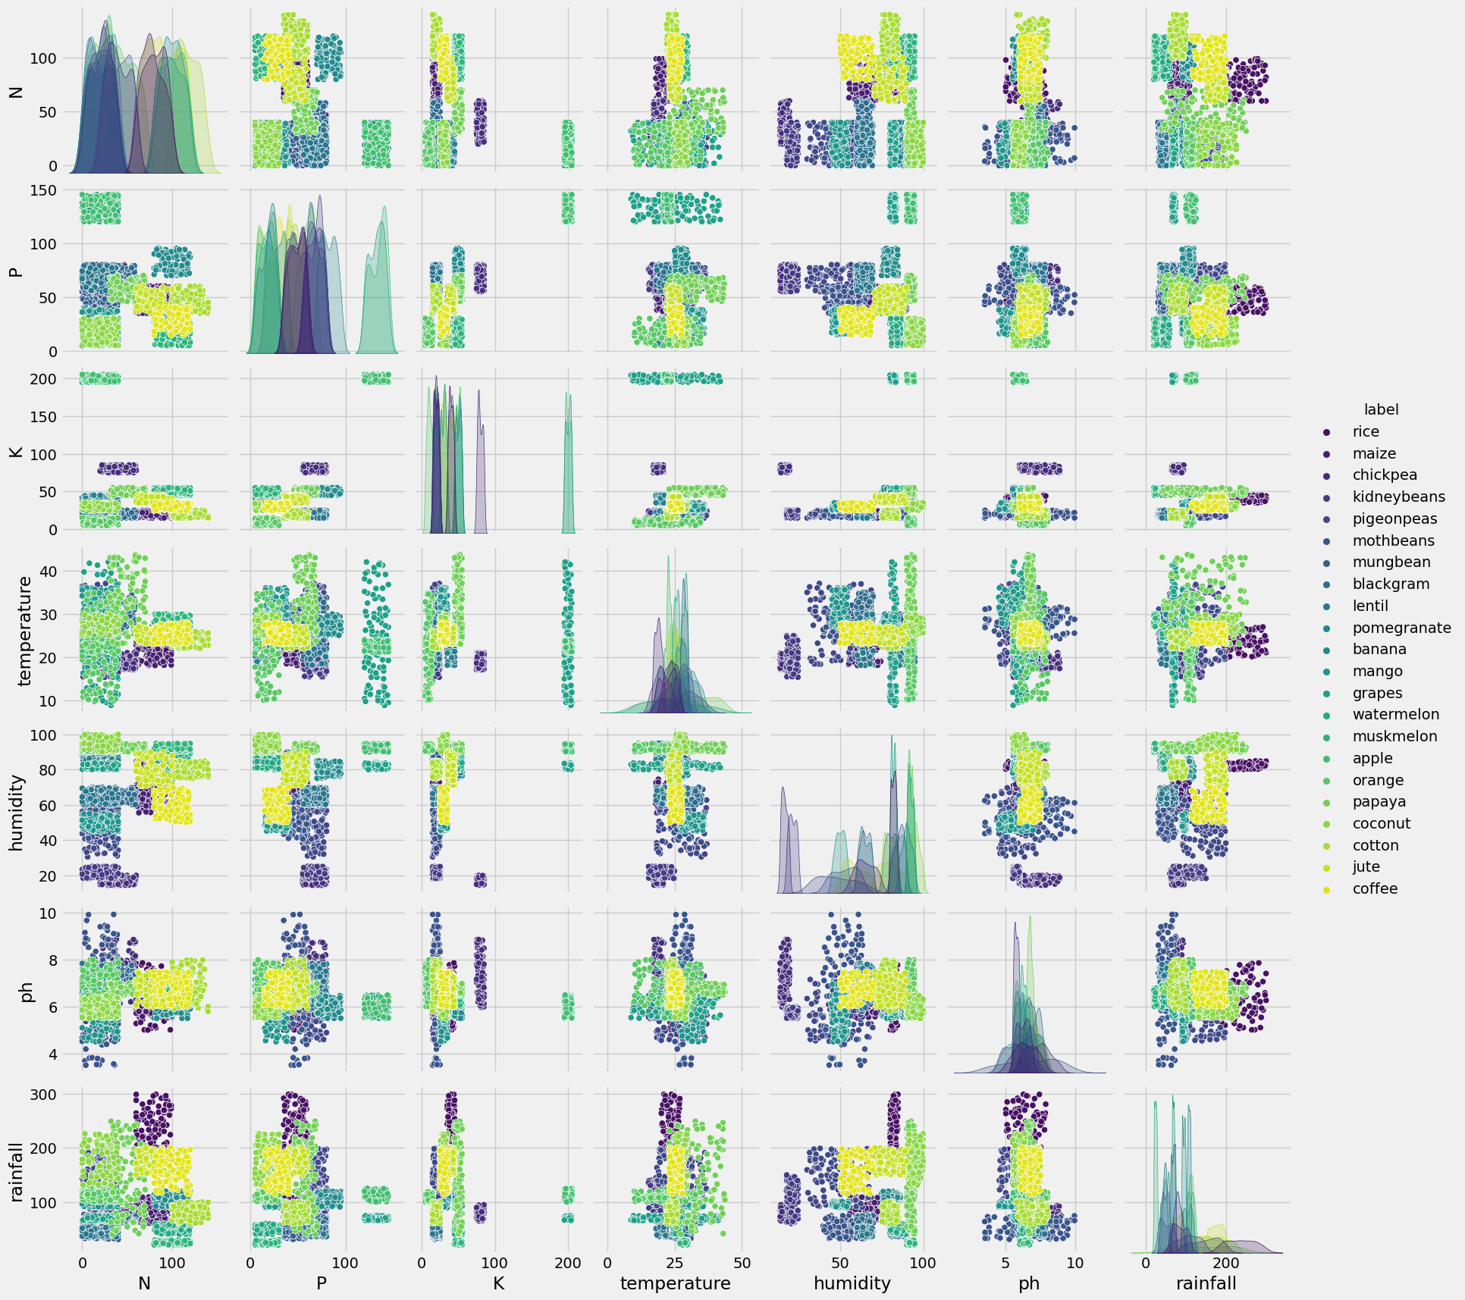
sns.heatmap(crop_recom.corr(), linecolor='white', linewidths=1,annot=True)
<ipython-input-220-260999dfce60>:1: FutureWarning: The default value of numeric_only in DataFrame.corr is deprecated. In a future version, it will default to False. Select only valid columns or specify the value of numeric_only to silence this warning.
sns.heatmap(crop_recom.corr(), linecolor='white', linewidths=1,annot=True)
<Axes: >
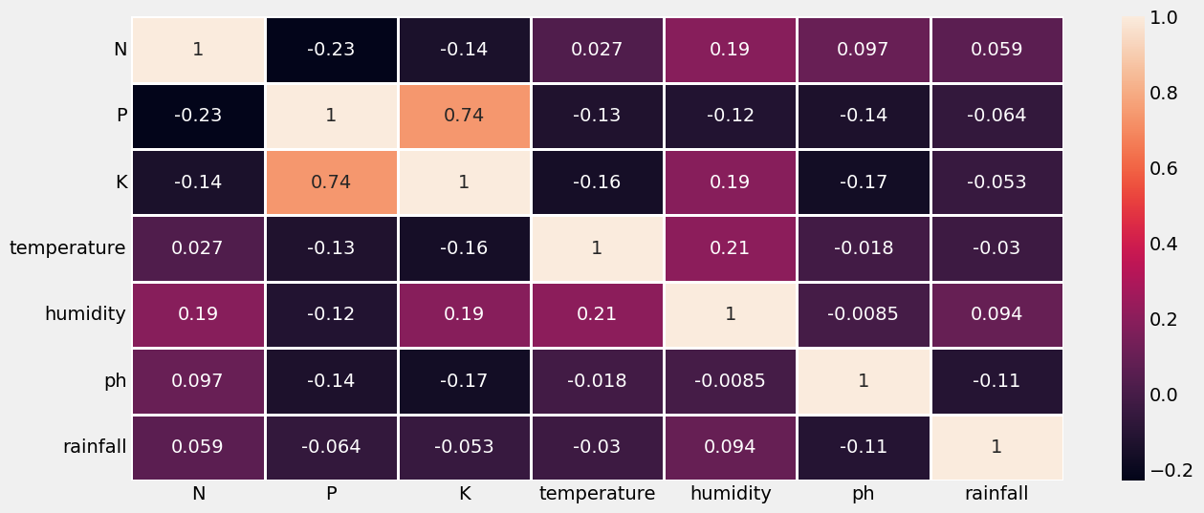

Logistic Regression
# Create a logistic regression classifier object
lm = LogisticRegression(random_state=0)
# Fit the model on the train set
lm.fit(X_train, y_train)
# Perform prediction on the test set
y_pred_lm = lm.predict(X_test)
# Calculate the accuracy of the model
score_test_lm= lm.score(X_test, y_test)
score_train_lm= lm.score(X_train, y_train)
print("Accuracy Train_lm:", score_train_lm)
print("Accuracy Test_lm:", score_test_lm)
print("Predictions_lm:", y_pred_lm)
Accuracy Train_lm: 0.9720779220779221
Accuracy Test_lm: 0.95
Predictions_lm: [21 21 7 3 2 8 13 9 15 1 13 5 10 14 12 0 5 10 5 12 4 2 9 8
6 5 10 16 13 9 19 20 11 15 4 6 12 12 21 13 11 2 18 21 18 14 9 9
6 14 13 2 0 15 18 1 17 12 10 6 16 14 21 20 15 0 7 5 0 16 4 19
9 11 7 13 3 11 8 12 20 13 21 21 15 6 11 10 2 17 2 8 14 7 14 11
5 8 10 3 16 8 14 1 1 20 21 5 18 15 15 12 5 7 16 19 14 10 11 8
19 10 16 3 3 2 19 16 3 17 13 2 15 14 6 14 4 19 16 2 10 7 0 5
3 0 8 12 21 17 16 4 13 1 19 3 21 11 0 8 10 18 8 9 9 15 20 15
1 16 18 0 13 4 6 14 9 19 17 16 20 17 13 18 9 1 4 18 20 17 11 8
13 20 11 5 18 4 3 12 4 19 6 13 18 16 15 11 18 1 3 2 18 16 13 14
12 17 15 19 8 20 2 17 2 5 11 5 16 20 13 14 16 9 19 4 12 14 6 20
3 14 0 18 13 20 21 2 19 16 11 7 3 18 8 13 19 5 12 13 8 21 19 20
7 4 8 10 3 5 5 17 19 11 20 3 18 16 19 18 4 9 19 15 13 12 10 1
2 12 9 12 6 14 17 7 7 18 17 8 20 3 15 5 21 8 8 13 7 15 2 13
13 3 2 12 1 12 19 8 16 15 3 10 6 17 7 9 10 0 8 15 0 17 2 8
3 13 10 7 20 9 15 17 7 17 20 5 15 13 1 17 16 9 21 18 0 21 21 18
9 2 9 8 4 11 9 16 6 18 19 6 6 0 6 0 16 11 7 1 0 13 20 9
1 8 10 3 19 1 3 15 19 0 10 15 16 2 15 13 12 3 19 12 3 4 15 1
18 17 8 2 6 20 1 4 20 2 11 16 21 20 0 7 18 7 3 12 8 19 11 12
7 1 14 18 1 6 2 0 0 8 8 21 3 1 19 1 9 7 11 5 6 8 7 5
14 2 8 16 18 18 15 2 21 14 21 17 14 14 14 19 16 13 0 5 4 11 4 7
7 3 3 12 9 17 16 14 17 18 2 17 15 2 1 20 5 6 7 8 3 15 1 7
21 15 9 8 18 6 21 19 5 4 11 20 14 9 21 14 0 0 21 1 18 14 0 14
6 20 17 6 17 3 0 19 13 20 2 12 16 8 1 13 5 6 12 5 4 19 6 7
2 3 8 3 17 16 6 1 2 15 17 0 16 19 11 18 17 12 19 17 7 20 6 8
13 10 13 9 1 13 0 18 21 4 3 10 9 13 7 7 16 20 2 1 6 6 13 20
20 4 13 6 5 17 5 14 10 16 19 3 10 6 12 16 5 20 17 17 4 20 6 13
4 20 7 0 1 4 1 11 12 17 17 20 8 15 6 10 9 2 5 20 16 4 1 2
0 11 12 3 4 15 5 19 16 7 17 3]
/usr/local/lib/python3.10/dist-packages/sklearn/linear_model/_logistic.py:458: ConvergenceWarning: lbfgs failed to converge (status=1):
STOP: TOTAL NO. of ITERATIONS REACHED LIMIT.
Increase the number of iterations (max_iter) or scale the data as shown in:
https://scikit-learn.org/stable/modules/preprocessing.html
Please also refer to the documentation for alternative solver options:
https://scikit-learn.org/stable/modules/linear_model.html#logistic-regression
n_iter_i = _check_optimize_result(
# Calculate the confusion matrix
cm_lm = confusion_matrix(y_test, y_pred_lm)
# Calculate the precision, recall, and accuracy
precision_lm = precision_score(y_test, y_pred_lm, average='macro')
recall_lm = recall_score(y_test, y_pred_lm, average='macro')
accuracy_lm = accuracy_score(y_test, y_pred_lm)
# Print the confusion matrix, precision, recall, and accuracy
print('Confusion Matrix_lm:\n', cm_lm)
print('Precision_lm:', precision_lm)
print('Recall_lm:', recall_lm)
print('Accuracy_lm:', accuracy_lm)
Confusion Matrix_lm:
[[28 0 0 0 0 0 0 0 0 0 0 0 0 0 0 0 0 0 0 0 0 0]
[ 0 30 0 0 0 0 0 0 0 0 0 0 0 0 0 0 0 0 0 0 0 0]
[ 0 0 27 0 0 0 0 0 0 0 1 1 0 2 0 0 0 0 0 0 0 0]
[ 0 0 0 34 0 0 0 0 0 0 0 0 0 0 0 0 0 0 0 0 0 0]
[ 0 0 0 0 26 0 0 0 0 0 0 0 0 0 0 0 0 0 0 0 0 0]
[ 0 0 0 0 0 29 0 0 0 0 0 0 0 0 0 0 0 0 0 0 0 0]
[ 0 0 0 0 0 0 27 0 0 0 0 1 0 0 0 0 0 0 0 0 0 0]
[ 0 0 0 0 0 0 0 30 0 0 0 0 0 0 0 0 0 0 0 0 0 0]
[ 0 0 0 0 0 0 0 0 29 0 0 0 0 0 0 0 0 0 0 0 2 0]
[ 0 0 0 0 0 0 0 0 0 26 0 0 0 0 0 0 0 0 0 0 0 0]
[ 0 0 1 0 0 0 0 0 0 0 20 0 0 1 0 0 0 0 0 0 0 0]
[ 0 0 0 0 0 0 5 0 0 0 0 22 0 0 0 0 0 0 0 0 0 0]
[ 0 0 0 0 0 0 0 0 0 0 0 0 28 0 0 0 0 0 0 0 0 0]
[ 0 0 4 0 0 0 0 0 0 0 0 0 0 29 0 0 0 0 3 0 0 0]
[ 0 0 0 0 0 0 0 0 0 0 1 0 0 0 28 0 0 0 0 0 0 0]
[ 0 0 0 0 0 0 0 0 0 0 0 0 0 0 0 30 0 0 0 0 0 0]
[ 0 0 0 0 0 0 0 0 0 0 0 0 0 0 0 0 34 0 0 0 0 0]
[ 0 0 0 0 0 0 0 0 1 0 0 0 0 4 0 0 0 34 0 0 0 0]
[ 0 0 0 0 0 0 0 0 0 1 0 0 0 0 0 0 0 0 27 0 0 0]
[ 0 0 0 0 0 0 0 0 0 0 0 0 0 0 0 0 0 0 0 32 0 0]
[ 0 0 0 0 0 0 0 0 5 0 0 0 0 0 0 0 0 0 0 0 32 0]
[ 0 0 0 0 0 0 0 0 0 0 0 0 0 0 0 0 0 0 0 0 0 25]]
Precision_lm: 0.9523419997016253
Recall_lm: 0.9530300590443175
Accuracy_lm: 0.95
# Visualize confusion matrix using seaborn
sns.heatmap(cm_lm, annot=True)
plt.xlabel("Predicted")
plt.ylabel("Actual")
plt.title("Confusion Matrix")
plt.show()
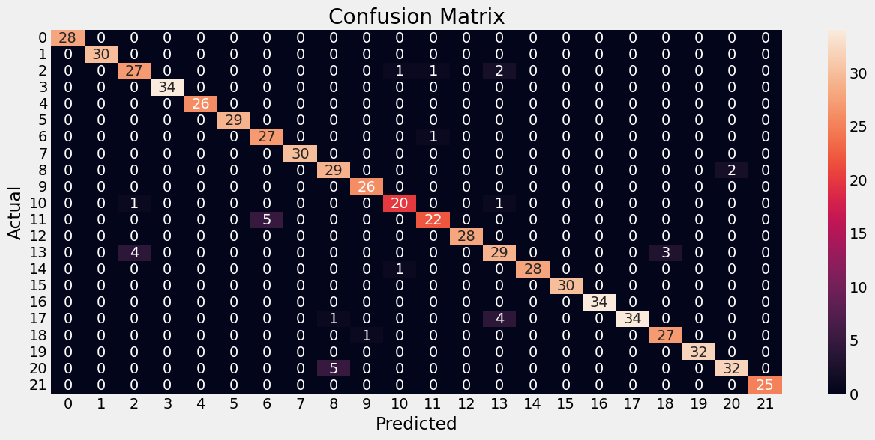
y_pred_lm_df = pd.DataFrame(y_pred_lm, columns=['LM_Pred'])
y_pred_lm_df
LM_Pred
0 21
1 21
2 7
3 3
4 2
.. ...
655 19
656 16
657 7
658 17
659 3
[660 rows x 1 columns]
y_test
array([21, 21, 7, 3, 2, 20, 13, 9, 15, 1, 13, 5, 10, 14, 12, 0, 5,
10, 5, 12, 4, 2, 9, 8, 6, 5, 10, 16, 13, 9, 19, 20, 11, 15,
4, 6, 12, 12, 21, 13, 11, 2, 18, 21, 18, 14, 9, 9, 6, 14, 13,
2, 0, 15, 18, 1, 17, 12, 10, 6, 16, 14, 21, 20, 15, 0, 7, 5,
0, 16, 4, 19, 9, 11, 7, 13, 3, 11, 8, 12, 20, 2, 21, 21, 15,
6, 11, 10, 13, 17, 2, 8, 14, 7, 14, 11, 5, 8, 10, 3, 16, 8,
14, 1, 1, 20, 21, 5, 18, 15, 15, 12, 5, 7, 16, 19, 14, 10, 11,
8, 19, 10, 16, 3, 3, 2, 19, 16, 3, 17, 13, 13, 15, 14, 11, 14,
4, 19, 16, 2, 2, 7, 0, 5, 3, 0, 8, 12, 21, 17, 16, 4, 13,
1, 19, 3, 21, 2, 0, 8, 10, 18, 8, 9, 9, 15, 20, 15, 1, 16,
18, 0, 13, 4, 6, 14, 9, 19, 17, 16, 20, 17, 17, 18, 9, 1, 4,
18, 20, 17, 11, 8, 13, 20, 11, 5, 18, 4, 3, 12, 4, 19, 11, 13,
13, 16, 15, 11, 18, 1, 3, 2, 18, 16, 13, 14, 12, 17, 15, 19, 20,
20, 2, 17, 2, 5, 11, 5, 16, 20, 13, 14, 16, 9, 19, 4, 12, 14,
6, 20, 3, 14, 0, 18, 2, 20, 21, 2, 19, 16, 11, 7, 3, 18, 8,
17, 19, 5, 12, 13, 8, 21, 19, 20, 7, 4, 8, 10, 3, 5, 5, 17,
19, 11, 20, 3, 18, 16, 19, 18, 4, 9, 19, 15, 13, 12, 10, 1, 2,
12, 9, 12, 6, 14, 17, 7, 7, 18, 17, 8, 20, 3, 15, 5, 21, 20,
8, 17, 7, 15, 2, 13, 13, 3, 2, 12, 1, 12, 19, 8, 16, 15, 3,
10, 6, 17, 7, 9, 10, 0, 20, 15, 0, 17, 2, 8, 3, 13, 10, 7,
8, 9, 15, 17, 7, 17, 20, 5, 15, 13, 1, 17, 16, 9, 21, 18, 0,
21, 21, 18, 9, 13, 9, 8, 4, 6, 9, 16, 6, 18, 19, 6, 6, 0,
6, 0, 16, 11, 7, 1, 0, 13, 20, 9, 1, 20, 10, 3, 19, 1, 3,
15, 19, 0, 10, 15, 16, 2, 15, 13, 12, 3, 19, 12, 3, 4, 15, 1,
18, 17, 8, 10, 6, 20, 1, 4, 20, 2, 11, 16, 21, 20, 0, 7, 18,
7, 3, 12, 8, 19, 11, 12, 7, 1, 14, 18, 1, 6, 2, 0, 0, 8,
8, 21, 3, 1, 19, 1, 9, 7, 11, 5, 11, 8, 7, 5, 14, 2, 8,
16, 18, 18, 15, 13, 21, 14, 21, 17, 14, 14, 14, 19, 16, 13, 0, 5,
4, 11, 4, 7, 7, 3, 3, 12, 9, 17, 16, 14, 17, 18, 2, 17, 15,
2, 1, 20, 5, 6, 7, 8, 3, 15, 1, 7, 21, 15, 18, 8, 18, 6,
21, 19, 5, 4, 11, 20, 14, 9, 21, 14, 0, 0, 21, 1, 13, 14, 0,
14, 6, 20, 17, 6, 17, 3, 0, 19, 13, 20, 2, 12, 16, 8, 1, 17,
5, 6, 12, 5, 4, 19, 6, 7, 2, 3, 8, 3, 17, 16, 6, 1, 2,
15, 17, 0, 16, 19, 11, 18, 17, 12, 19, 17, 7, 20, 6, 8, 13, 10,
13, 9, 1, 13, 0, 13, 21, 4, 3, 10, 9, 13, 7, 7, 16, 20, 2,
1, 6, 11, 10, 20, 20, 4, 13, 6, 5, 17, 5, 14, 14, 16, 19, 3,
10, 11, 12, 16, 5, 20, 17, 17, 4, 20, 6, 13, 4, 20, 7, 0, 1,
4, 1, 11, 12, 17, 17, 20, 17, 15, 6, 10, 9, 2, 5, 8, 16, 4,
1, 2, 0, 11, 12, 3, 4, 15, 5, 19, 16, 7, 17, 3])
y_test_df = pd.DataFrame(y_test,columns=['Orig'])
y_test_df
Orig
0 21
1 21
2 7
3 3
4 2
.. ...
655 19
656 16
657 7
658 17
659 3
[660 rows x 1 columns]
y_test_df['LM_Pred'] = y_pred_lm_df
y_test_df
Orig LM_Pred
0 21 21
1 21 21
2 7 7
3 3 3
4 2 2
.. ... ...
655 19 19
656 16 16
657 7 7
658 17 17
659 3 3
[660 rows x 2 columns]
# Get the odds ratio
import numpy as np
odds_ratio_lm = np.exp(lm.coef_)
print("Odds Ratio:", odds_ratio_lm) # but this one does not look nice
# Create a pandas dataframe with the variable names and the odds ratio
df_lm = pd.DataFrame({'Variable': ['N','P','K','temperature','humidity','ph','rainfall'], 'Odds Ratio': odds_ratio_lm[0]})
df_lm
Odds Ratio: [[0.5180479 1.37883429 3.23987368 0.75881 0.75985299 0.92392344
0.69915408]
[1.76676113 1.1864427 1.18019803 0.80905369 0.65844017 0.89480016
1.11440177]
[0.83453479 1.74303776 0.5655959 1.28515229 1.08194333 0.91691573
1.09684903]
[1.09249495 1.50951277 1.98261736 0.99757976 0.50803501 1.04935519
1.10895704]
[0.63394559 0.47697352 0.82775359 0.90301305 1.56246345 0.94113911
1.50838435]
[2.41052966 0.56036099 0.78701524 1.07855009 0.58415323 1.03235457
1.32780126]
[2.19470296 0.83625009 0.48422273 0.79415003 1.07682136 0.96821055
0.99575682]
[0.51488451 1.68163475 4.13222607 0.83830256 0.72792174 0.9619114
0.30520797]
[1.29301417 0.8127652 0.99880051 0.87828172 0.89905239 1.07462712
1.40675592]
[0.77021142 2.42551181 0.88830053 1.04537717 0.38783878 1.08037699
1.29180234]
[0.7802911 1.97097915 0.64775748 0.81956004 1.38245642 1.06983373
0.85665802]
[1.84177173 0.91807269 0.66418538 1.05954507 0.91558975 1.06277613
1.13918486]
[0.67279815 0.80951787 1.51238745 2.01375851 0.91107217 1.11574158
1.27530245]
[0.76721475 1.26968065 0.89239561 2.95705638 0.9374725 1.52309185
0.95682001]
[0.73386299 1.03421012 0.54890175 1.0153891 2.10085617 0.98416454
0.92478333]
[2.07288024 0.61984186 1.17471507 1.10126958 1.54085302 1.00107256
0.30982836]
[0.64857882 0.57748381 0.50488261 0.96683806 1.98387632 1.05534543
1.30973908]
[0.71903277 1.12202847 1.64038936 0.76752972 1.1418098 0.73359141
1.28406785]
[0.73237947 1.64657102 0.51195436 1.12974413 0.97960044 0.94238307
1.37364725]
[0.6383781 0.56337398 1.42295222 0.81055392 1.72659745 1.0224408
1.19598032]
[1.32114991 0.77819263 0.74391111 0.566907 0.94003185 0.84121107
1.56180722]
[2.1437 0.5622394 1.20002524 0.95813506 1.15649167 1.00176248
0.64790141]]
Variable Odds Ratio
0 N 0.518048
1 P 1.378834
2 K 3.239874
3 temperature 0.758810
4 humidity 0.759853
5 ph 0.923923
6 rainfall 0.699154
# Use numpy's unique function to get the unique class labels
class_labels = np.unique(y_train)
# Print the class labels
print(class_labels)
[ 0 1 2 3 4 5 6 7 8 9 10 11 12 13 14 15 16 17 18 19 20 21]
####################################
# ROC Curve Construction
####################################
# compute TPR = True Positive Rate and FPR=False Positive Rate for various thresholds
from sklearn.metrics import roc_curve, auc
from sklearn.preprocessing import label_binarize
# Binarize the output
y_test_bin_lm = label_binarize(y_test, classes=[0 ,1 ,2 ,3 ,4 ,5 ,6 ,7 ,8 ,9 ,10])
y_pred_bin_lm = label_binarize(y_pred_lm, classes=[0 ,1 ,2 ,3 ,4 ,5 ,6 ,7 ,8 ,9 ,10])
# compute ROC curve and AUC for each class
fpr = dict()
tpr = dict()
roc_auc = dict()
num_classes = y_test_bin_lm.shape[1] # Get the number of classes in your problem
for i in range(num_classes):
fpr[i], tpr[i], _ = roc_curve(y_test_bin_lm[:, i], y_pred_bin_lm[:, i])
roc_auc[i] = auc(fpr[i], tpr[i])
# plot ROC curves
plt.figure()
for i in range(num_classes):
plt.plot(fpr[i], tpr[i], label='Class %d (AUC = %0.2f)' % (i, roc_auc[i]))
plt.plot([0, 1], [0, 1], 'k--') # diagonal line for reference
plt.xlim([0.0, 1.0])
plt.ylim([0.0, 1.05])
plt.xlabel('False Positive Rate')
plt.ylabel('True Positive Rate')
plt.title('ROC Curves - Crop Recommendation')
plt.legend(loc="lower right")
plt.show()
# The ROC curve below shows a near perfect model since the ROC curve is almost touching the top left corner
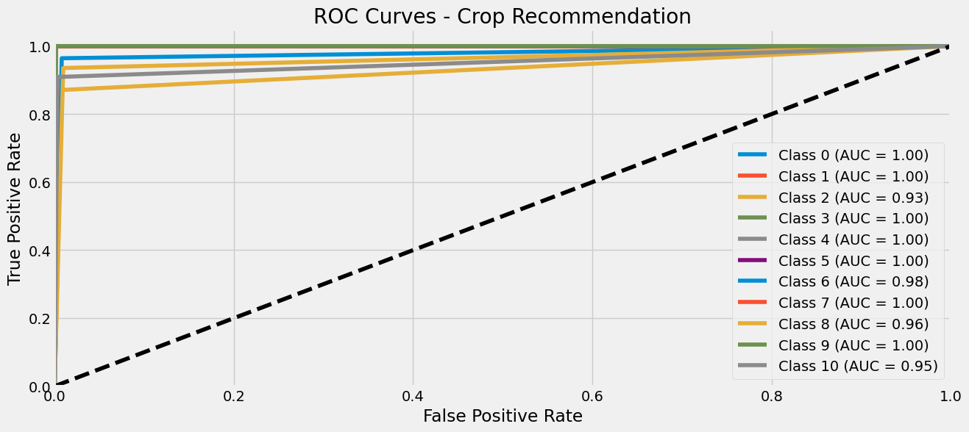
from sklearn.metrics import roc_auc_score
# Assuming y_pred_lm is the predicted labels from your model
# and y_test is the ground truth labels for the test set
# Binarize the output
y_test_bin = label_binarize(y_test, classes=[0 ,1 ,2 ,3 ,4 ,5 ,6 ,7 ,8 ,9 ,10 ])
y_pred_bin = label_binarize(y_pred_lm, classes=[0 ,1 ,2 ,3 ,4 ,5 ,6 ,7 ,8 ,9 ,10])
# Compute ROC AUC score for each class separately
roc_auc_scores = roc_auc_score(y_test_bin, y_pred_bin, average=None)
# Print the ROC AUC scores for each class
print("the ROC AUC scores for each class")
print(roc_auc_scores)
print("The classification report")
print(classification_report(y_test,y_pred_lm))
the ROC AUC scores for each class
[1. 1. 0.93150931 1. 1. 1.
0.97818716 1. 0.96297246 0.99921136 0.95297806]
The classification report
precision recall f1-score support
0 1.00 1.00 1.00 28
1 1.00 1.00 1.00 30
2 0.84 0.87 0.86 31
3 1.00 1.00 1.00 34
4 1.00 1.00 1.00 26
5 1.00 1.00 1.00 29
6 0.84 0.96 0.90 28
7 1.00 1.00 1.00 30
8 0.83 0.94 0.88 31
9 0.96 1.00 0.98 26
10 0.91 0.91 0.91 22
11 0.92 0.81 0.86 27
12 1.00 1.00 1.00 28
13 0.81 0.81 0.81 36
14 1.00 0.97 0.98 29
15 1.00 1.00 1.00 30
16 1.00 1.00 1.00 34
17 1.00 0.87 0.93 39
18 0.90 0.96 0.93 28
19 1.00 1.00 1.00 32
20 0.94 0.86 0.90 37
21 1.00 1.00 1.00 25
accuracy 0.95 660
macro avg 0.95 0.95 0.95 660
weighted avg 0.95 0.95 0.95 660

K-Nearest Neighbour
from sklearn.neighbors import KNeighborsClassifier
# Split the dataset into training and testing sets
X_train, X_test, y_train, y_test = train_test_split(X, y_encoded, test_size=0.3, random_state=0)
# Create a KNN classifier object : this is using a initial guess of k=3 neighbors, you can choose any small number
knn = KNeighborsClassifier(n_neighbors=3)
# Train the classifier on the training set
knn.fit(X_train, y_train)
# Predict the labels of the test set
y_pred = knn.predict(X_test)
# Print the accuracy of the classifier
print('Accuracy:', knn.score(X_test, y_test))
Accuracy: 0.9818181818181818
# Now it’s time to improve the model and find out the OPTIMAL k value.
error_rate = []
for i in range(1,40):
knn = KNeighborsClassifier(n_neighbors=i)
knn.fit(X_train,y_train)
pred_i = knn.predict(X_test)
error_rate.append(np.mean(pred_i != y_test))
plt.figure(figsize=(20,6))
plt.plot(range(1,40),error_rate,color='blue', linestyle='dashed', marker='o',markerfacecolor='red', markersize=10)
plt.title('Error Rate vs. K Value')
plt.xlabel('K')
plt.ylabel('Error Rate')
print("Minimum error:-",min(error_rate),"at K =",error_rate.index(min(error_rate))+1)
Minimum error:- 0.015151515151515152 at K = 1
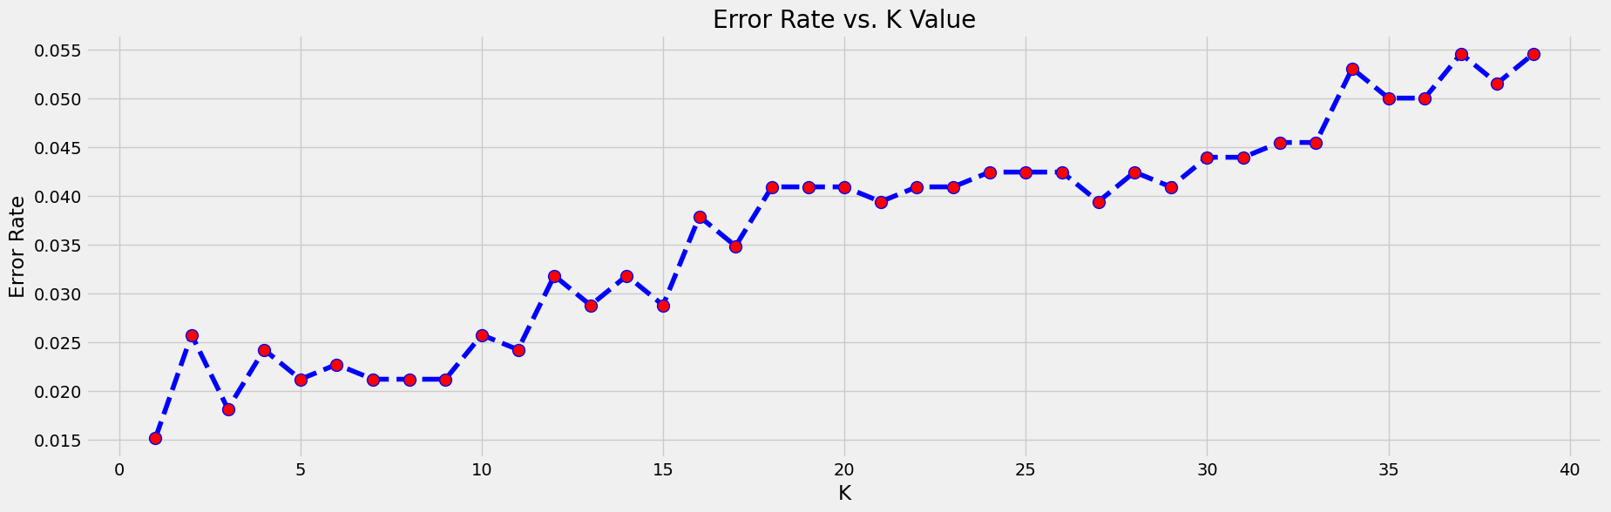
# see the error_rate visually
error_rate
[0.015151515151515152,
0.025757575757575757,
0.01818181818181818,
0.024242424242424242,
0.021212121212121213,
0.022727272727272728,
0.021212121212121213,
0.021212121212121213,
0.021212121212121213,
0.025757575757575757,
0.024242424242424242,
0.031818181818181815,
0.02878787878787879,
0.031818181818181815,
0.02878787878787879,
0.03787878787878788,
0.03484848484848485,
0.04090909090909091,
0.04090909090909091,
0.04090909090909091,
0.03939393939393939,
0.04090909090909091,
0.04090909090909091,
0.04242424242424243,
0.04242424242424243,
0.04242424242424243,
0.03939393939393939,
0.04242424242424243,
0.04090909090909091,
0.04393939393939394,
0.04393939393939394,
0.045454545454545456,
0.045454545454545456,
0.05303030303030303,
0.05,
0.05,
0.05454545454545454,
0.051515151515151514,
0.05454545454545454]
acc = []
# Will take some time
from sklearn import metrics
for i in range(1,40):
neigh = KNeighborsClassifier(n_neighbors = i).fit(X_train,y_train)
yhat = neigh.predict(X_test)
acc.append(metrics.accuracy_score(y_test, yhat))
plt.figure(figsize=(10,6))
plt.plot(range(1,40),acc,color = 'blue',linestyle='dashed', marker='o',markerfacecolor='red', markersize=10)
plt.title('accuracy vs. K Value')
plt.xlabel('K')
plt.ylabel('Accuracy')
print("Maximum accuracy:-",max(acc),"at K =",acc.index(max(acc))+1)
Maximum accuracy:- 0.9848484848484849 at K = 1
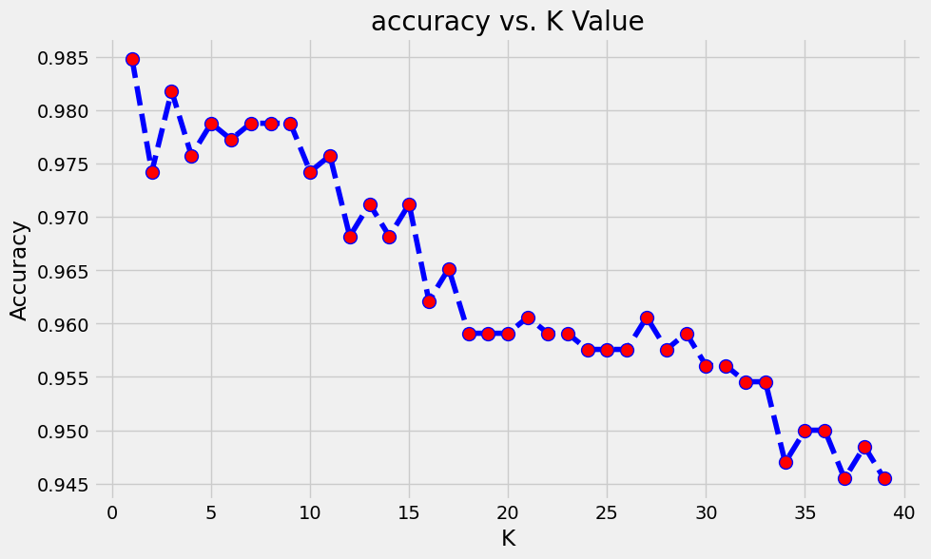
# See the accuracies visually
acc
[0.9848484848484849,
0.9742424242424242,
0.9818181818181818,
0.9757575757575757,
0.9787878787878788,
0.9772727272727273,
0.9787878787878788,
0.9787878787878788,
0.9787878787878788,
0.9742424242424242,
0.9757575757575757,
0.9681818181818181,
0.9712121212121212,
0.9681818181818181,
0.9712121212121212,
0.9621212121212122,
0.9651515151515152,
0.9590909090909091,
0.9590909090909091,
0.9590909090909091,
0.9606060606060606,
0.9590909090909091,
0.9590909090909091,
0.9575757575757575,
0.9575757575757575,
0.9575757575757575,
0.9606060606060606,
0.9575757575757575,
0.9590909090909091,
0.956060606060606,
0.956060606060606,
0.9545454545454546,
0.9545454545454546,
0.946969696969697,
0.95,
0.95,
0.9454545454545454,
0.9484848484848485,
0.9454545454545454]
## So we will retrain the model with k=1
knn = KNeighborsClassifier(n_neighbors=1)
# Train the classifier on the training set
knn.fit(X_train, y_train)
# Predict the labels of the test set
y_pred_knn = knn.predict(X_test)
# Print the accuracy of the classifier
print('Accuracy_knn:', knn.score(X_test, y_test))
# Calculate the accuracy of the model
score_test_knn = knn.score(X_test, y_test)
score_train_knn = knn.score(X_train, y_train)
print("Accuracy Train_knn:", score_train_knn) # here it is going to be 100% accurate, proving that the RF model over fitted the train dataset
print("Accuracy Test_knn:", score_test_knn) # here it will be 97% accurate
print("Predictions_knn:", y_pred_knn)
Accuracy_knn: 0.9848484848484849
Accuracy Train_knn: 1.0
Accuracy Test_knn: 0.9848484848484849
Predictions_knn: [21 21 7 3 2 20 13 9 15 1 13 5 10 14 12 0 5 10 5 12 4 2 9 8
6 5 10 16 13 9 19 20 11 15 4 6 12 12 21 13 11 2 18 21 18 14 9 9
6 14 13 2 0 15 18 1 17 12 10 6 16 14 21 20 15 0 7 5 0 16 4 19
9 11 7 13 3 11 8 12 20 2 21 21 15 6 11 10 13 17 2 8 14 7 14 11
5 8 10 3 16 8 14 1 1 20 21 5 18 15 15 12 5 7 16 19 14 10 11 8
19 10 16 3 3 2 19 16 3 17 13 13 15 14 11 14 4 19 16 2 2 7 0 5
3 0 8 12 21 17 16 4 13 1 19 3 21 2 0 8 10 18 8 9 9 15 20 15
1 16 18 0 13 4 6 14 9 19 17 16 20 17 17 18 9 1 4 9 20 17 11 8
13 20 11 5 18 4 3 12 4 19 11 13 13 16 15 11 18 1 3 2 18 16 13 14
12 17 15 19 8 20 2 17 2 5 11 5 16 20 13 14 16 9 19 4 12 14 6 20
3 14 0 18 2 20 21 2 19 16 11 7 3 18 8 17 19 5 12 13 8 21 19 20
7 4 8 10 3 5 5 17 19 11 20 3 18 16 19 18 4 9 19 15 13 12 10 1
2 12 9 12 6 14 17 7 7 18 17 20 20 3 15 5 21 8 8 17 7 15 2 13
13 3 2 12 1 12 19 8 16 15 3 10 6 17 7 9 10 0 20 15 0 17 2 8
3 13 10 7 20 9 15 17 7 17 20 5 15 13 1 17 16 9 21 18 0 21 21 18
9 10 9 8 4 6 9 16 6 18 19 6 6 0 6 0 16 11 7 1 0 13 20 9
1 20 10 3 19 1 3 15 19 0 10 15 16 2 15 13 12 3 19 12 3 4 15 1
18 17 8 10 6 20 1 4 20 2 11 16 21 20 0 7 18 7 3 12 8 19 11 12
7 1 14 18 1 6 2 0 0 8 8 21 3 1 19 1 9 7 11 5 11 5 7 5
14 2 8 16 18 18 15 13 21 14 21 17 14 14 14 19 16 13 0 5 4 11 4 7
7 3 3 12 9 17 16 14 17 18 2 8 15 2 1 20 5 6 7 8 3 15 1 7
21 15 18 20 18 6 21 19 5 4 11 20 14 9 21 14 0 0 21 1 13 14 0 14
6 20 17 6 17 3 0 19 13 20 2 12 16 8 1 17 5 6 12 5 4 19 6 7
2 3 8 3 17 16 6 1 2 15 17 0 16 19 11 18 17 12 19 17 7 20 6 8
13 10 13 9 1 13 0 13 21 4 3 10 9 13 7 7 16 20 2 1 6 6 10 20
20 4 13 6 5 17 5 14 14 16 19 3 10 11 12 16 5 20 17 17 4 20 6 13
4 20 7 0 1 4 1 11 12 17 17 20 17 15 6 10 9 2 5 8 16 4 1 2
0 11 12 3 4 15 5 19 16 7 17 3]
y_pred_knn
array([21, 21, 7, 3, 2, 20, 13, 9, 15, 1, 13, 5, 10, 14, 12, 0, 5,
10, 5, 12, 4, 2, 9, 8, 6, 5, 10, 16, 13, 9, 19, 20, 11, 15,
4, 6, 12, 12, 21, 13, 11, 2, 18, 21, 18, 14, 9, 9, 6, 14, 13,
2, 0, 15, 18, 1, 17, 12, 10, 6, 16, 14, 21, 20, 15, 0, 7, 5,
0, 16, 4, 19, 9, 11, 7, 13, 3, 11, 8, 12, 20, 2, 21, 21, 15,
6, 11, 10, 13, 17, 2, 8, 14, 7, 14, 11, 5, 8, 10, 3, 16, 8,
14, 1, 1, 20, 21, 5, 18, 15, 15, 12, 5, 7, 16, 19, 14, 10, 11,
8, 19, 10, 16, 3, 3, 2, 19, 16, 3, 17, 13, 13, 15, 14, 11, 14,
4, 19, 16, 2, 2, 7, 0, 5, 3, 0, 8, 12, 21, 17, 16, 4, 13,
1, 19, 3, 21, 2, 0, 8, 10, 18, 8, 9, 9, 15, 20, 15, 1, 16,
18, 0, 13, 4, 6, 14, 9, 19, 17, 16, 20, 17, 17, 18, 9, 1, 4,
9, 20, 17, 11, 8, 13, 20, 11, 5, 18, 4, 3, 12, 4, 19, 11, 13,
13, 16, 15, 11, 18, 1, 3, 2, 18, 16, 13, 14, 12, 17, 15, 19, 8,
20, 2, 17, 2, 5, 11, 5, 16, 20, 13, 14, 16, 9, 19, 4, 12, 14,
6, 20, 3, 14, 0, 18, 2, 20, 21, 2, 19, 16, 11, 7, 3, 18, 8,
17, 19, 5, 12, 13, 8, 21, 19, 20, 7, 4, 8, 10, 3, 5, 5, 17,
19, 11, 20, 3, 18, 16, 19, 18, 4, 9, 19, 15, 13, 12, 10, 1, 2,
12, 9, 12, 6, 14, 17, 7, 7, 18, 17, 20, 20, 3, 15, 5, 21, 8,
8, 17, 7, 15, 2, 13, 13, 3, 2, 12, 1, 12, 19, 8, 16, 15, 3,
10, 6, 17, 7, 9, 10, 0, 20, 15, 0, 17, 2, 8, 3, 13, 10, 7,
20, 9, 15, 17, 7, 17, 20, 5, 15, 13, 1, 17, 16, 9, 21, 18, 0,
21, 21, 18, 9, 10, 9, 8, 4, 6, 9, 16, 6, 18, 19, 6, 6, 0,
6, 0, 16, 11, 7, 1, 0, 13, 20, 9, 1, 20, 10, 3, 19, 1, 3,
15, 19, 0, 10, 15, 16, 2, 15, 13, 12, 3, 19, 12, 3, 4, 15, 1,
18, 17, 8, 10, 6, 20, 1, 4, 20, 2, 11, 16, 21, 20, 0, 7, 18,
7, 3, 12, 8, 19, 11, 12, 7, 1, 14, 18, 1, 6, 2, 0, 0, 8,
8, 21, 3, 1, 19, 1, 9, 7, 11, 5, 11, 5, 7, 5, 14, 2, 8,
16, 18, 18, 15, 13, 21, 14, 21, 17, 14, 14, 14, 19, 16, 13, 0, 5,
4, 11, 4, 7, 7, 3, 3, 12, 9, 17, 16, 14, 17, 18, 2, 8, 15,
2, 1, 20, 5, 6, 7, 8, 3, 15, 1, 7, 21, 15, 18, 20, 18, 6,
21, 19, 5, 4, 11, 20, 14, 9, 21, 14, 0, 0, 21, 1, 13, 14, 0,
14, 6, 20, 17, 6, 17, 3, 0, 19, 13, 20, 2, 12, 16, 8, 1, 17,
5, 6, 12, 5, 4, 19, 6, 7, 2, 3, 8, 3, 17, 16, 6, 1, 2,
15, 17, 0, 16, 19, 11, 18, 17, 12, 19, 17, 7, 20, 6, 8, 13, 10,
13, 9, 1, 13, 0, 13, 21, 4, 3, 10, 9, 13, 7, 7, 16, 20, 2,
1, 6, 6, 10, 20, 20, 4, 13, 6, 5, 17, 5, 14, 14, 16, 19, 3,
10, 11, 12, 16, 5, 20, 17, 17, 4, 20, 6, 13, 4, 20, 7, 0, 1,
4, 1, 11, 12, 17, 17, 20, 17, 15, 6, 10, 9, 2, 5, 8, 16, 4,
1, 2, 0, 11, 12, 3, 4, 15, 5, 19, 16, 7, 17, 3])
y_pred_knn_df = pd.DataFrame(y_pred_knn,columns=['KNN_Pred'])
y_pred_knn_df
KNN_Pred
0 21
1 21
2 7
3 3
4 2
.. ...
655 19
656 16
657 7
658 17
659 3
[660 rows x 1 columns]
y_test_df['KNN_Pred'] = y_pred_knn_df
y_test_df
Orig LM_Pred KNN_Pred
0 21 21 21
1 21 21 21
2 7 7 7
3 3 3 3
4 2 2 2
.. ... ... ...
655 19 19 19
656 16 16 16
657 7 7 7
658 17 17 17
659 3 3 3
[660 rows x 3 columns]
####################################
# ROC Curve Construction
####################################
# compute TPR = True Positive Rate and FPR=False Positive Rate for various thresholds
# Binarize the output
y_test_bin_knn = label_binarize(y_test, classes=[0 ,1 ,2 ,3 ,4 ,5 ,6 ,7 ,8 ,9 ,10 ,11 ,12 ,13 ,14 ,15 ,16 ,17 ,18 ,19 ,20 ,21])
y_pred_bin_knn= label_binarize(y_pred_knn_df, classes=[0 ,1 ,2 ,3 ,4 ,5 ,6 ,7 ,8 ,9 ,10 ,11 ,12 ,13 ,14 ,15 ,16 ,17 ,18 ,19 ,20 ,21])
# compute ROC curve and AUC for each class
fpr = dict()
tpr = dict()
roc_auc = dict()
num_classes = y_test_bin_knn.shape[1] # Get the number of classes in your problem
for i in range(num_classes):
fpr[i], tpr[i], _ = roc_curve(y_test_bin_knn[:, i], y_pred_bin_knn[:, i])
roc_auc[i] = auc(fpr[i], tpr[i])
# plot ROC curves
plt.figure()
for i in range(num_classes):
plt.plot(fpr[i], tpr[i], label='Class %d (AUC = %0.2f)' % (i, roc_auc[i]))
plt.plot([0, 1], [0, 1], 'k--') # diagonal line for reference
plt.xlim([0.0, 1.0])
plt.ylim([0.0, 1.05])
plt.xlabel('False Positive Rate')
plt.ylabel('True Positive Rate')
plt.title('ROC Curves - Crop Recommendation')
plt.legend(loc="lower right")
plt.show()
# The ROC curve below shows a near perfect model since the ROC curve is almost touching the top left corner
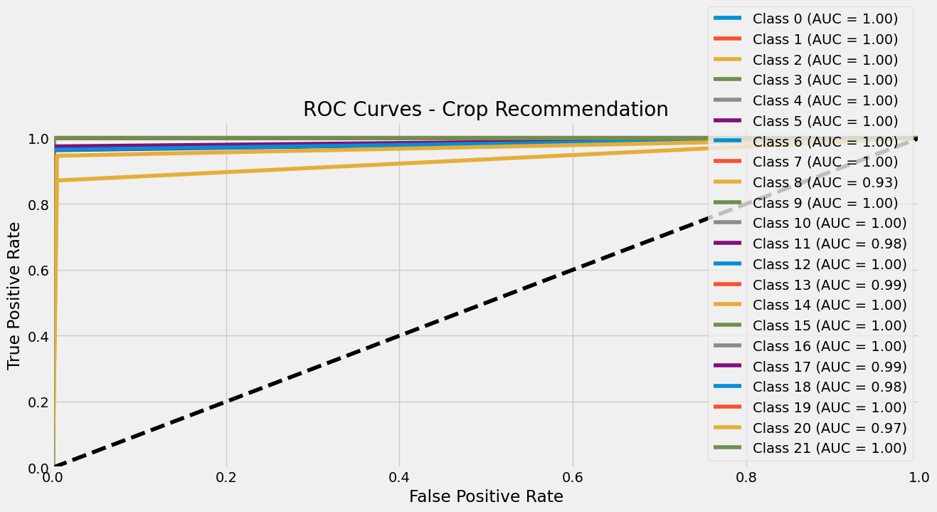
from sklearn.metrics import roc_auc_score
# Assuming y_pred_lm is the predicted labels from your model
# and y_test is the ground truth labels for the test set
# Binarize the output
#y_test_bin_knn = label_binarize(y_test, classes=[0 ,1 ,2 ,3 ,4 ,5 ,6 ,7 ,8 ,9 ,10 ,11 ,12 ,13 ,14 ,15 ,16 ,17 ,18 ,19 ,20 ,21])
#y_pred_bin_knn = label_binarize(y_pred_knn_df, classes=[0 ,1 ,2 ,3 ,4 ,5 ,6 ,7 ,8 ,9 ,10 ,11 ,12 ,13 ,14 ,15 ,16 ,17 ,18 ,19 ,20 ,21])
# Compute ROC AUC score for each class separately
roc_auc_scores = roc_auc_score(y_test_bin_knn, y_pred_bin_knn, average=None)
print("the ROC AUC scores for each class")
print(roc_auc_scores)
print("The classification report")
print(classification_report(y_test,y_pred_lm))
the ROC AUC scores for each class
[1. 1. 1. 1. 1. 0.99920761
0.99920886 1. 0.93309913 0.99921136 0.9992163 0.98148148
1. 0.98611111 1. 1. 1. 0.98717949
0.98214286 1. 0.97056527 1. ]
The classification report
precision recall f1-score support
0 1.00 1.00 1.00 28
1 1.00 1.00 1.00 30
2 0.84 0.87 0.86 31
3 1.00 1.00 1.00 34
4 1.00 1.00 1.00 26
5 1.00 1.00 1.00 29
6 0.84 0.96 0.90 28
7 1.00 1.00 1.00 30
8 0.83 0.94 0.88 31
9 0.96 1.00 0.98 26
10 0.91 0.91 0.91 22
11 0.92 0.81 0.86 27
12 1.00 1.00 1.00 28
13 0.81 0.81 0.81 36
14 1.00 0.97 0.98 29
15 1.00 1.00 1.00 30
16 1.00 1.00 1.00 34
17 1.00 0.87 0.93 39
18 0.90 0.96 0.93 28
19 1.00 1.00 1.00 32
20 0.94 0.86 0.90 37
21 1.00 1.00 1.00 25
accuracy 0.95 660
macro avg 0.95 0.95 0.95 660
weighted avg 0.95 0.95 0.95 660

Linear Discrimination Analysis
from sklearn.discriminant_analysis import LinearDiscriminantAnalysis
# Create a Linear Discriminant Analysis object
lda = LinearDiscriminantAnalysis()
# Train the classifier on the training set
lda.fit(X_train, y_train)
# Predict the labels of the test set
y_pred_lda = lda.predict(X_test)
# Calculate the accuracy of the model
score_test_lda = lda.score(X_test, y_test)
score_train_lda = lda.score(X_train, y_train)
print("Accuracy Train_lda:", score_train_lda)
print("Accuracy Test_lda:", score_test_lda)
print("Predictions_lda:", y_pred_lda)
Accuracy Train_lda: 0.9694805194805195
Accuracy Test_lda: 0.9636363636363636
Predictions_lda: [21 21 7 3 2 8 13 9 15 1 13 5 10 14 12 0 5 10 5 12 4 2 9 8
6 5 10 16 13 9 19 20 11 15 4 6 12 12 21 2 11 2 18 21 18 14 9 9
6 14 13 2 0 15 18 1 17 12 10 6 16 14 21 20 15 0 7 5 0 16 4 19
9 6 7 13 3 11 8 12 20 2 21 21 15 6 11 10 13 17 2 8 14 7 14 11
5 8 10 3 16 8 14 1 1 20 21 5 18 15 15 12 5 7 16 19 14 10 11 8
19 10 16 3 3 2 19 16 3 17 13 13 15 14 11 14 4 19 16 2 10 7 0 5
3 0 8 12 21 17 16 4 13 1 19 3 21 2 0 8 10 18 8 9 9 15 20 15
1 16 18 0 13 4 6 14 9 19 17 16 20 17 17 9 9 1 4 9 20 17 11 8
13 20 11 5 18 4 3 12 4 19 11 13 13 16 15 11 18 1 3 10 18 16 13 14
12 17 15 19 8 20 2 17 2 5 11 5 16 8 13 14 16 9 19 4 12 14 6 20
3 14 0 18 2 20 21 2 19 16 11 7 3 18 8 17 19 5 12 12 8 21 19 20
7 4 8 10 3 5 5 17 19 11 20 3 18 16 19 18 4 9 19 15 13 12 10 1
2 12 9 12 6 14 17 7 7 2 17 8 20 3 15 5 21 8 8 17 7 15 2 13
13 3 2 12 1 12 19 8 16 15 3 10 6 1 7 9 10 0 20 15 0 17 2 8
3 13 10 7 20 9 15 17 7 17 8 5 15 13 1 17 16 9 21 18 0 21 21 18
9 10 9 8 4 6 9 16 6 18 19 6 6 0 6 0 16 11 7 1 0 13 20 9
1 8 2 3 19 1 3 15 19 0 10 15 16 2 15 13 12 3 19 12 3 4 15 1
2 17 8 10 6 20 1 4 20 2 11 16 21 20 0 7 18 7 3 12 8 19 11 12
7 1 14 18 1 6 2 0 0 8 8 21 3 1 19 1 9 7 11 5 11 8 7 5
14 2 8 16 18 18 15 13 21 14 21 17 14 14 14 19 16 13 0 5 4 11 4 7
7 3 3 12 9 17 16 14 17 18 2 17 15 2 1 20 5 6 7 8 3 15 1 7
21 15 18 8 18 6 21 19 5 4 11 20 14 9 21 14 0 0 21 1 13 14 0 14
6 20 17 6 17 3 0 19 13 20 2 12 16 8 1 17 5 6 12 5 4 19 6 7
2 3 8 3 17 16 6 1 2 15 17 0 16 19 11 18 17 12 19 17 7 20 6 8
13 10 13 9 1 12 0 10 21 4 3 10 9 13 7 7 16 20 10 1 6 6 10 20
8 4 13 6 5 17 5 14 14 16 19 3 10 11 12 16 5 20 17 17 4 20 6 13
4 20 7 0 1 4 1 11 12 17 17 20 17 15 6 10 9 2 5 8 16 4 1 2
0 11 12 3 4 15 5 19 16 7 17 3]
y_pred_lda_df = pd.DataFrame(y_pred_lda,columns=['LDA_Pred'])
y_test_df['LDA_Pred'] = y_pred_lda_df
y_test_df
Orig LM_Pred KNN_Pred LDA_Pred
0 21 21 21 21
1 21 21 21 21
2 7 7 7 7
3 3 3 3 3
4 2 2 2 2
.. ... ... ... ...
655 19 19 19 19
656 16 16 16 16
657 7 7 7 7
658 17 17 17 17
659 3 3 3 3
[660 rows x 4 columns]
####################################
# ROC Curve Construction
####################################
# compute TPR = True Positive Rate and FPR=False Positive Rate for various thresholds
# Binarize the output
y_test_bin_lda = label_binarize(y_test, classes=[0 ,1 ,2 ,3 ,4 ,5 ,6 ,7 ,8 ,9 ,10 ,11 ,12 ,13 ,14 ,15 ,16 ,17 ,18 ,19 ,20 ,21])
y_pred_bin_lda= label_binarize(y_pred_lda_df, classes=[0 ,1 ,2 ,3 ,4 ,5 ,6 ,7 ,8 ,9 ,10 ,11 ,12 ,13 ,14 ,15 ,16 ,17 ,18 ,19 ,20 ,21])
# compute ROC curve and AUC for each class
fpr = dict()
tpr = dict()
roc_auc = dict()
num_classes = y_test_bin_lda.shape[1] # Get the number of classes in your problem
for i in range(num_classes):
fpr[i], tpr[i], _ = roc_curve(y_test_bin_lda[:, i], y_pred_bin_lda[:, i])
roc_auc[i] = auc(fpr[i], tpr[i])
# plot ROC curves
plt.figure()
for i in range(num_classes):
plt.plot(fpr[i], tpr[i], label='Class %d (AUC = %0.2f)' % (i, roc_auc[i]))
plt.plot([0, 1], [0, 1], 'k--') # diagonal line for reference
plt.xlim([0.0, 1.0])
plt.ylim([0.0, 1.05])
plt.xlabel('False Positive Rate')
plt.ylabel('True Positive Rate')
plt.title('ROC Curves - Crop Recommendation')
plt.legend(loc="lower right")
plt.show()
# The ROC curve below shows a near perfect model since the ROC curve is almost touching the top left corner
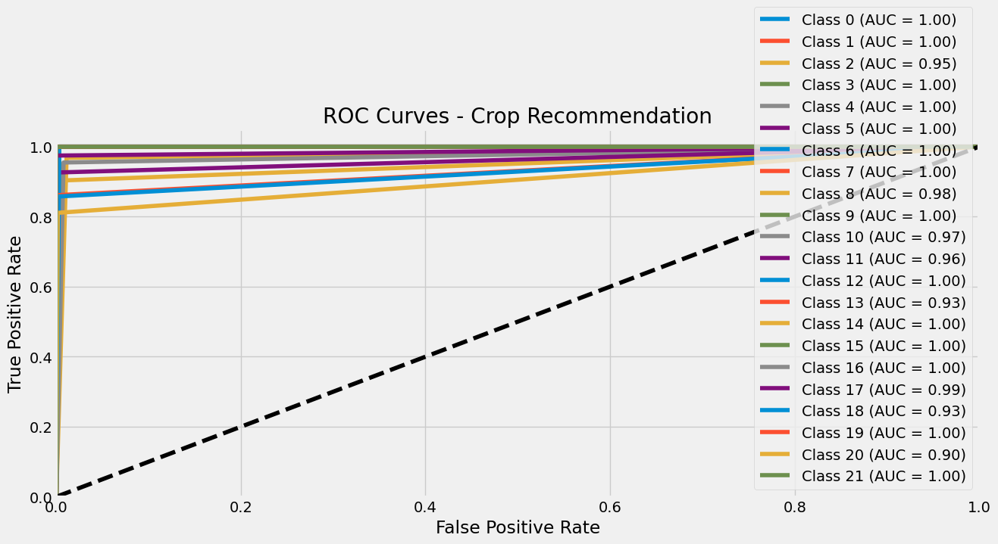
# Compute ROC AUC score for each class separately
roc_auc_scores = roc_auc_score(y_test_bin_lda, y_pred_bin_lda, average=None)
# Print the ROC AUC scores for each class
print("the ROC AUC scores for each class")
print(roc_auc_scores)
print("The classification report")
print(classification_report(y_test,y_pred_lm))
the ROC AUC scores for each class
[1. 0.99920635 0.94843325 1. 1. 1.
0.99841772 1. 0.97830658 0.99842271 0.97335423 0.96296296
0.99841772 0.93055556 1. 1. 1. 0.98717949
0.92857143 1. 0.90460284 1. ]
The classification report
precision recall f1-score support
0 1.00 1.00 1.00 28
1 1.00 1.00 1.00 30
2 0.84 0.87 0.86 31
3 1.00 1.00 1.00 34
4 1.00 1.00 1.00 26
5 1.00 1.00 1.00 29
6 0.84 0.96 0.90 28
7 1.00 1.00 1.00 30
8 0.83 0.94 0.88 31
9 0.96 1.00 0.98 26
10 0.91 0.91 0.91 22
11 0.92 0.81 0.86 27
12 1.00 1.00 1.00 28
13 0.81 0.81 0.81 36
14 1.00 0.97 0.98 29
15 1.00 1.00 1.00 30
16 1.00 1.00 1.00 34
17 1.00 0.87 0.93 39
18 0.90 0.96 0.93 28
19 1.00 1.00 1.00 32
20 0.94 0.86 0.90 37
21 1.00 1.00 1.00 25
accuracy 0.95 660
macro avg 0.95 0.95 0.95 660
weighted avg 0.95 0.95 0.95 660

Random Forest
from sklearn.ensemble import RandomForestClassifier
# Build the random forest model
rfc = RandomForestClassifier(n_estimators=100, random_state=42)
rfc.fit(X_train, y_train)
RandomForestClassifier(random_state=42)

# Evaluate the model
print('Accuracy_rfc:', rfc.score(X_test, y_test))
# Predict the labels of the test set
y_pred_rfc = rfc.predict(X_test)
# Calculate the accuracy of the model
score_test_rfc = rfc.score(X_test, y_test)
score_train_rfc = rfc.score(X_train, y_train)
print("Accuracy Train_rfc:", score_train_rfc) # here it is going to be 100% accurate, proving that the RF model over fitted the train dataset
print("Accuracy Test_rfc:", score_test_rfc) # here it will be 99% accurate
print("Predictions_rfc:", y_pred_rfc)
Accuracy_rfc: 0.9939393939393939
Accuracy Train_rfc: 1.0
Accuracy Test_rfc: 0.9939393939393939
Predictions_rfc: [21 21 7 3 2 20 13 9 15 1 13 5 10 14 12 0 5 10 5 12 4 2 9 8
6 5 10 16 13 9 19 20 11 15 4 6 12 12 21 2 11 2 18 21 18 14 9 9
6 14 13 2 0 15 18 1 17 12 10 6 16 14 21 20 15 0 7 5 0 16 4 19
9 11 7 13 3 11 8 12 20 2 21 21 15 6 11 10 13 17 2 8 14 7 14 11
5 8 10 3 16 8 14 1 1 20 21 5 18 15 15 12 5 7 16 19 14 10 11 8
19 10 16 3 3 2 19 16 3 17 13 13 15 14 11 14 4 19 16 2 2 7 0 5
3 0 8 12 21 17 16 4 13 1 19 3 21 2 0 8 10 18 8 9 9 15 20 15
1 16 18 0 13 4 6 14 9 19 17 16 20 17 17 18 9 1 4 18 20 17 11 8
13 20 11 5 18 4 3 12 4 19 11 13 13 16 15 11 18 1 3 2 18 16 13 14
12 17 15 19 8 20 2 17 2 5 11 5 16 20 13 14 16 9 19 4 12 14 6 20
3 14 0 18 2 20 21 2 19 16 11 7 3 18 8 17 19 5 12 13 8 21 19 20
7 4 8 10 3 5 5 17 19 11 20 3 18 16 19 18 4 9 19 15 13 12 10 1
2 12 9 12 6 14 17 7 7 18 17 8 20 3 15 5 21 20 8 17 7 15 2 13
13 3 2 12 1 12 19 8 16 15 3 10 6 17 7 9 10 0 20 15 0 17 2 8
3 13 10 7 8 9 15 17 7 17 20 5 15 13 1 17 16 9 21 18 0 21 21 18
9 13 9 8 4 6 9 16 6 18 19 6 6 0 6 0 16 11 7 1 0 13 20 9
1 20 10 3 19 1 3 15 19 0 10 15 16 2 15 13 12 3 19 12 3 4 15 1
18 17 8 10 6 20 1 4 20 2 11 16 21 20 0 7 18 7 3 12 8 19 11 12
7 1 14 18 1 6 2 0 0 8 8 21 3 1 19 1 9 7 11 5 11 8 7 5
14 2 8 16 18 18 15 13 21 14 21 17 14 14 14 19 16 13 0 5 4 11 4 7
7 3 3 12 9 17 16 14 17 18 2 17 15 2 1 20 5 6 7 8 3 15 1 7
21 15 18 8 18 6 21 19 5 4 11 20 14 9 21 14 0 0 21 1 13 14 0 14
6 20 17 6 17 3 0 19 13 20 2 12 16 8 1 17 5 6 12 5 4 19 6 7
2 3 8 3 17 16 6 1 11 15 17 0 16 19 11 18 17 12 19 17 7 20 6 8
13 10 13 9 1 13 0 13 21 4 3 10 9 13 7 7 16 20 2 1 6 11 10 20
20 4 13 6 5 17 5 14 14 16 19 3 10 11 12 16 5 20 17 17 4 20 6 13
4 20 7 0 1 4 1 11 12 17 17 20 17 15 6 10 9 2 5 20 16 4 1 2
0 11 12 3 4 15 5 19 16 7 17 3]
y_pred_rfc_df = pd.DataFrame(y_pred_rfc,columns=['RF_Pred'])
y_test_df['RF_Pred']= y_pred_rfc_df
y_test_df
Orig LM_Pred KNN_Pred LDA_Pred RF_Pred
0 21 21 21 21 21
1 21 21 21 21 21
2 7 7 7 7 7
3 3 3 3 3 3
4 2 2 2 2 2
.. ... ... ... ... ...
655 19 19 19 19 19
656 16 16 16 16 16
657 7 7 7 7 7
658 17 17 17 17 17
659 3 3 3 3 3
[660 rows x 5 columns]

XGBoost
from xgboost import XGBClassifier
# Split the dataset into training and testing sets
X_train, X_test, y_train, y_test = train_test_split(X, y_encoded, test_size=0.3, random_state=0)
# Build the XGBoost model
xgb_model = XGBClassifier(objective='binary:logistic', random_state=42)
xgb_model.fit(X_train, y_train)
# Evaluate the model
print('Accuracy_xgb:', xgb_model.score(X_test, y_test))
# Predict the labels of the test set
y_pred_xgb = xgb_model.predict(X_test)
# Calculate the accuracy of the model
score_test_xgb = xgb_model.score(X_test, y_test)
score_train_xgb = xgb_model.score(X_train, y_train)
print("Accuracy Train_xgb:", score_train_xgb) # here it is going to be 100% accurate, proving that the RF model over fitted the train dataset
print("Accuracy Test_xgb:", score_test_xgb) # here it will be 97% accurate
print("Predictions_xgb:", y_pred_xgb)
Accuracy_xgb: 0.990909090909091
Accuracy Train_xgb: 1.0
Accuracy Test_xgb: 0.990909090909091
Predictions_xgb: [21 21 7 3 2 20 13 9 15 1 13 5 10 14 12 0 5 10 5 12 4 2 9 20
6 5 10 16 13 9 19 20 11 15 4 6 12 12 21 13 11 2 18 21 18 14 9 9
6 14 13 2 0 15 18 1 17 12 10 6 16 14 21 20 15 0 7 5 0 16 4 19
9 11 7 13 3 11 8 12 20 2 21 21 15 6 11 10 13 17 2 8 14 7 14 11
5 5 10 3 16 8 14 1 1 20 21 5 18 15 15 12 5 7 16 19 14 10 11 8
19 10 16 3 3 2 19 16 3 17 13 13 15 14 11 14 4 19 16 2 2 7 0 5
3 0 8 12 21 17 16 4 13 1 19 3 21 2 0 8 10 18 8 9 9 15 20 15
1 16 18 0 13 4 6 14 9 19 17 16 20 17 17 18 9 1 4 18 20 17 11 8
13 20 11 5 18 4 3 12 4 19 11 13 13 16 15 11 18 1 3 2 18 16 13 14
12 17 15 19 20 20 2 17 2 5 11 5 16 20 13 14 16 9 19 4 12 14 6 20
3 14 0 18 2 20 21 2 19 16 11 7 3 18 8 17 19 5 12 13 8 21 19 20
7 4 8 10 3 5 5 17 19 11 20 3 18 16 19 18 4 9 19 15 13 12 10 1
2 12 9 12 6 14 17 7 7 18 17 8 20 3 15 5 21 20 8 17 7 15 2 13
13 3 2 12 1 12 19 8 16 15 3 10 6 17 7 9 10 0 20 15 0 17 2 8
3 13 10 7 8 9 15 17 7 17 20 5 15 13 1 17 16 9 21 18 0 21 21 18
9 13 9 8 4 6 9 16 6 18 19 6 6 0 6 0 16 11 7 1 0 13 20 9
1 20 10 3 19 1 3 15 19 0 10 15 16 2 15 13 12 3 19 12 3 4 15 1
18 17 8 13 6 20 1 4 20 2 11 16 21 20 0 7 18 7 3 12 8 19 11 12
7 1 14 18 1 6 2 0 0 8 8 21 3 1 19 1 9 7 11 5 6 8 7 5
14 2 8 16 18 18 15 13 21 14 21 17 14 14 14 19 16 13 0 5 4 11 4 7
7 3 3 12 9 17 16 14 17 18 2 17 15 2 1 20 5 6 7 8 3 15 1 7
21 15 18 8 18 6 21 19 5 4 11 20 14 9 21 14 0 0 21 1 13 14 0 14
6 20 17 6 17 3 0 19 13 20 2 12 16 8 1 17 5 6 12 5 4 19 6 7
2 3 8 3 17 16 6 1 2 15 17 0 16 19 11 18 17 12 19 17 7 20 6 8
13 10 13 9 1 13 0 2 21 4 3 10 9 13 7 7 16 20 2 1 6 11 10 20
20 4 13 6 5 17 5 14 14 16 19 3 10 11 12 16 5 20 17 17 4 20 6 13
4 20 7 0 1 4 1 11 12 17 17 20 17 15 6 10 9 2 5 20 16 4 1 2
0 11 12 3 4 15 5 19 16 7 17 3]

Principal Component Analysis
# Load Data
crop_recom=pd.read_csv("Crop_recommendation.csv")
crop_recom.info()
# Loading the dataset as X and Y
X=crop_recom[['N','P','K','temperature','humidity','ph','rainfall']]
y=crop_recom['label']
#Let's convert the labels(type of crop) to binary
le = LabelEncoder()
y_encoded = le.fit_transform(crop_recom['label'].values)
print(y_encoded)
print(np.unique(y_encoded)) #Checking unique labels
# Split the dataset into training and testing sets
X_train, X_test, y_train, y_test = train_test_split(X, y_encoded, test_size=0.3, random_state=0)
<class 'pandas.core.frame.DataFrame'>
RangeIndex: 2200 entries, 0 to 2199
Data columns (total 8 columns):
# Column Non-Null Count Dtype
--- ------ -------------- -----
0 N 2200 non-null int64
1 P 2200 non-null int64
2 K 2200 non-null int64
3 temperature 2200 non-null float64
4 humidity 2200 non-null float64
5 ph 2200 non-null float64
6 rainfall 2200 non-null float64
7 label 2200 non-null object
dtypes: float64(4), int64(3), object(1)
memory usage: 137.6+ KB
[20 20 20 ... 5 5 5]
[ 0 1 2 3 4 5 6 7 8 9 10 11 12 13 14 15 16 17 18 19 20 21]
# For PCA, we need to Normalize our X column data (i.e., (X - u)/St.Dev) to make them neutral to their individual scales/magnitude
# NOTE: The transformation below will permanently change the X_train, X_test dataframes
# If you want to run prior codes discussed above, you need to re-do the test-train split at the top for running earlier codes
from sklearn.preprocessing import StandardScaler
sc = StandardScaler()
X_train = sc.fit_transform(X_train)
X_test =sc.transform(X_test)
from sklearn.decomposition import PCA
pca = PCA(n_components = 3)
# here we are asking specifically to just give us top 3 PCs
X_train = pca.fit_transform(X_train)
X_test = pca.transform(X_test)
explained_variance = pca.explained_variance_ratio_
explained_variance
array([0.27730092, 0.1834501 , 0.15592683])
# Let's Fit a Logistic Regression To the training set
from sklearn.linear_model import LogisticRegression
pcalog = LogisticRegression(random_state = 23)
pcalog.fit(X_train, y_train)
# Predicting the test set result using
# predict function under LogisticRegression
y_pred_pcalog = pcalog.predict(X_test)
# Evaluate the model
print('Accuracy_pcalog:', pcalog.score(X_test, y_test))
# Predict the labels of the test set
y_pred_pcalog = pcalog.predict(X_test)
# Calculate the accuracy of the model
score_test_pcalog = pcalog.score(X_test, y_test)
score_train_pcalog = pcalog.score(X_train, y_train)
print("Accuracy Train_pcalog:", score_train_pcalog)
print("Accuracy Test_pcalog:", score_test_pcalog)
print("Predictions_pcalog:", y_pred_pcalog)
Accuracy_pcalog: 0.6712121212121213
Accuracy Train_pcalog: 0.7337662337662337
Accuracy Test_pcalog: 0.6712121212121213
Predictions_pcalog: [21 21 7 3 14 8 9 9 15 1 13 5 10 14 12 0 5 10 5 12 4 2 9 8
6 5 10 5 13 9 16 20 11 15 4 21 12 12 6 2 19 14 18 6 18 14 9 9
6 14 11 10 0 15 18 1 17 12 10 6 5 14 6 4 15 0 7 5 0 5 4 11
9 6 7 18 3 11 8 12 8 2 15 21 15 14 2 10 18 17 14 14 14 7 10 19
5 8 10 3 16 8 2 1 1 8 21 5 18 15 15 12 5 7 5 19 14 2 11 8
19 10 16 3 3 14 19 16 3 17 18 13 15 14 11 2 4 19 6 2 10 7 0 5
3 0 8 16 6 1 5 4 18 1 11 3 6 6 0 21 10 18 8 9 9 15 4 15
1 12 18 0 13 8 6 14 9 19 15 13 4 1 15 9 9 1 4 18 8 17 10 8
18 4 19 4 12 4 3 16 20 6 11 13 13 12 15 19 12 1 3 10 12 19 13 14
12 1 15 18 8 20 14 17 14 5 11 5 6 4 13 14 5 9 11 4 12 14 6 20
3 14 0 18 14 4 21 2 19 8 13 0 3 18 8 17 19 5 12 18 8 6 19 20
7 20 8 10 3 5 5 1 11 19 4 3 12 16 19 18 4 9 8 15 13 12 10 1
2 12 9 12 21 14 17 0 7 19 17 8 4 3 15 5 21 20 8 15 7 15 2 18
13 3 14 18 1 12 19 8 5 15 3 10 6 14 7 9 10 0 20 15 0 17 2 20
3 13 10 7 8 9 15 17 0 1 4 5 15 13 1 1 16 9 15 18 0 21 21 12
9 18 9 8 4 6 9 5 6 18 8 21 21 0 6 0 16 19 7 1 0 13 20 9
1 20 10 3 11 1 3 15 19 0 10 15 12 14 15 18 16 3 8 12 3 4 15 1
19 17 8 11 6 20 1 4 4 2 11 5 21 8 0 7 11 7 3 12 8 11 11 12
7 1 14 18 1 6 2 0 0 8 17 21 3 1 16 1 9 0 16 16 19 6 7 4
6 2 4 5 18 13 15 13 6 14 21 17 14 2 2 19 16 6 0 6 4 11 4 7
7 3 3 18 9 17 8 6 1 18 2 1 15 2 1 20 5 21 0 8 3 15 1 7
21 15 13 8 18 8 21 11 12 4 19 20 14 9 15 2 0 0 21 1 13 14 0 14
15 20 17 6 17 3 0 19 18 4 14 12 5 8 17 15 5 6 12 5 4 19 21 1
2 3 8 3 1 11 6 1 14 15 17 7 5 8 2 18 1 12 8 17 0 4 21 8
13 10 18 9 1 18 7 18 15 4 3 10 9 13 7 0 5 20 10 1 6 14 10 4
8 4 6 6 5 14 5 14 14 5 8 3 10 16 12 16 5 4 17 17 20 4 21 12
4 20 0 7 1 4 1 11 16 1 1 20 17 15 6 10 9 11 5 20 5 4 1 14
0 2 12 3 20 15 5 11 5 7 17 3]
y_pred_pcalog_df = pd.DataFrame(y_pred_pcalog,columns=['PCALog_Pred'])
y_test_df['PCALog_Pred']= y_pred_pcalog_df
y_test_df
Orig LM_Pred KNN_Pred LDA_Pred RF_Pred PCALog_Pred
0 21 21 21 21 21 21
1 21 21 21 21 21 21
2 7 7 7 7 7 7
3 3 3 3 3 3 3
4 2 2 2 2 2 14
.. ... ... ... ... ... ...
655 19 19 19 19 19 11
656 16 16 16 16 16 5
657 7 7 7 7 7 7
658 17 17 17 17 17 17
659 3 3 3 3 3 3
[660 rows x 6 columns]

Decision Tree

# Build the Decision Tree model
decision_tree = DecisionTreeClassifier( random_state=42)
decision_tree.fit(X_train, y_train)
# Evaluate the model
print('Accuracy_decision_tree:', decision_tree.score(X_test, y_test))
# Predict the labels of the test set
y_pred_decision_tree = decision_tree.predict(X_test)
# Calculate the accuracy of the model
score_test_decision_tree = decision_tree.score(X_test, y_test)
score_train_decision_tree = decision_tree.score(X_train, y_train)
print("Accuracy Train_decision_tree:", score_train_decision_tree) # here it is going to be 100% accurate, proving that the RF model over fitted the train dataset
print("Accuracy Test_decision_tree:", score_test_decision_tree) # here it will be 97% accurate
print("Predictions_decision_tree:", y_pred_decision_tree)
Accuracy_decision_tree: 0.6515151515151515
Accuracy Train_decision_tree: 1.0
Accuracy Test_decision_tree: 0.6515151515151515
Predictions_decision_tree: [15 21 7 3 14 8 13 9 15 1 13 5 10 14 12 0 16 10 5 12 4 2 13 20
6 16 10 5 13 9 5 20 19 15 4 6 18 12 21 13 19 2 13 21 13 11 9 9
16 14 11 10 0 15 18 1 17 12 10 6 16 14 6 4 15 0 7 5 0 6 4 11
9 21 7 18 3 19 8 18 20 14 15 21 15 11 2 10 18 17 14 19 14 7 10 19
16 8 10 3 16 8 2 1 1 4 21 5 18 15 15 12 16 7 5 19 14 14 11 8
19 10 11 3 3 2 19 19 3 17 13 13 15 11 2 2 20 19 16 2 2 7 0 5
3 0 8 12 21 17 5 20 18 1 11 3 6 6 0 6 10 13 8 9 9 15 20 15
1 16 18 0 11 8 6 14 9 20 15 16 4 1 17 3 9 1 4 12 4 17 10 8
18 20 11 20 16 4 3 12 4 21 11 13 18 12 21 19 16 1 3 10 12 19 13 14
12 17 15 13 16 20 14 17 14 16 11 5 16 5 13 14 5 9 14 20 18 2 6 20
3 14 0 18 2 20 15 10 19 16 13 0 3 18 20 17 14 16 11 18 16 6 19 20
7 4 8 2 3 5 16 1 2 18 20 3 18 16 11 12 4 9 8 15 13 12 2 1
2 12 9 12 6 14 17 0 7 18 17 8 4 3 21 5 21 17 8 15 7 15 2 13
13 3 2 12 17 12 19 16 16 15 3 10 6 17 7 9 10 0 20 15 0 17 2 8
3 13 10 7 17 9 15 17 0 17 4 16 15 13 1 17 5 9 15 18 0 21 21 12
9 18 9 8 4 6 9 16 11 18 8 6 21 0 6 0 5 11 7 1 0 10 17 9
1 20 10 3 19 1 3 15 11 0 10 15 12 14 15 18 12 3 19 12 3 4 15 1
19 17 20 18 6 17 1 4 8 2 13 5 6 8 7 7 19 7 3 18 20 11 19 18
7 17 14 18 1 21 2 0 0 8 20 21 3 1 19 1 9 7 11 16 19 6 7 5
6 2 4 5 18 13 15 13 6 14 6 17 2 2 2 11 16 13 0 5 4 19 20 7
7 3 3 18 9 17 20 6 19 18 2 8 17 2 1 17 5 6 7 8 3 15 1 7
21 15 18 20 18 20 21 11 19 4 19 20 14 9 15 2 0 0 15 1 13 14 0 14
15 20 17 6 17 3 0 19 18 4 14 12 5 8 17 17 5 6 12 5 20 19 21 7
2 3 8 3 17 11 6 1 14 15 8 7 5 20 10 12 17 12 20 17 7 4 21 8
13 10 18 9 1 18 7 13 21 20 3 10 9 13 7 7 16 20 2 1 6 14 10 20
8 20 13 21 5 17 11 14 14 5 8 3 10 6 12 12 5 20 17 17 8 17 21 12
20 20 0 7 1 4 1 11 12 17 17 4 17 15 21 10 9 14 5 20 16 4 1 2
0 2 5 3 20 6 5 11 16 7 17 3]
# Visualize the Decision Tree
plt.figure(figsize=(15, 10))
plot_tree(decision_tree, feature_names=X_train.columns, class_names=True, filled=True, rounded=True)
plt.show()
---------------------------------------------------------------------------
AttributeError Traceback (most recent call last)
<ipython-input-260-9ea2f41f2b3f> in <cell line: 3>()
1 # Visualize the Decision Tree
2 plt.figure(figsize=(15, 10))
----> 3 plot_tree(decision_tree, feature_names=X_train.columns, class_names=True, filled=True, rounded=True)
4 plt.show()
AttributeError: 'numpy.ndarray' object has no attribute 'columns'
<Figure size 1500x1000 with 0 Axes>
from sklearn.tree import DecisionTreeClassifier, export_graphviz
import graphviz
# Export the Decision Tree to DOT format
dot_data = export_graphviz(decision_tree, out_file=None,
feature_names=X_train.columns,
class_names=True, filled=True, rounded=True, special_characters=True)
# Visualize the Decision Tree using Graphviz
graph = graphviz.Source(dot_data)
graph = graphviz.Source(dot_data, format="png")
graph
#graph.render("decision_tree") # Save the visualization to a file (optional)
#graph.view() # Show the visualization in your default image viewer

Finding the correct model based on Accuracy for Training and Testing dataset
print("*******************************************")
print("********* Accuracy during Training ********")
print("*******************************************")
print(" ")
print("Accuracy Train_lm. :", score_train_lm)
print("Accuracy Train_lda. :", score_train_lda)
print("Accuracy Train_knn. :", score_train_knn)
print("Accuracy Train_rfc. :", score_train_rfc)
print("Accuracy Train_xgb. :", score_train_xgb)
print("Accuracy Train_pcalog:", score_train_pcalog)
print("Accuracy Accuracy Train_decision_tre:", score_train_decision_tree)
print(" ")
print("*******************************************")
print("********* Accuracy during Testing ********")
print("*******************************************")
print(" ")
print("Accuracy Test_lm :", score_test_lm)
print("Accuracy Test_lda. :", score_test_lda)
print("Accuracy Test_knn. :", score_test_knn)
print("Accuracy Test_rfc. :", score_test_rfc)
print("Accuracy Test_xgb. :", score_test_xgb)
print("Accuracy Test_pcalog:", score_test_pcalog)
print("Accuracy Test_Accuracy Train_decision_tre:", score_test_decision_tree)
# Here you discuss which model performed best during Testing, that is basically your best model
# Talk about the models that outperformed during Training significantly relative to Testing, those are models that sufferred from overfitting (e.g., RFC, XGBoost)
*******************************************
********* Accuracy during Training ********
*******************************************
Accuracy Train_lm. : 0.9720779220779221
Accuracy Train_lda. : 0.9694805194805195
Accuracy Train_knn. : 1.0
Accuracy Train_rfc. : 1.0
Accuracy Train_xgb. : 1.0
Accuracy Train_pcalog: 0.7337662337662337
Accuracy Accuracy Train_decision_tre: 1.0
*******************************************
********* Accuracy during Testing ********
*******************************************
Accuracy Test_lm : 0.95
Accuracy Test_lda. : 0.9636363636363636
Accuracy Test_knn. : 0.9848484848484849
Accuracy Test_rfc. : 0.9939393939393939
Accuracy Test_xgb. : 0.990909090909091
Accuracy Test_pcalog: 0.6712121212121213
Accuracy Test_Accuracy Train_decision_tre: 0.6515151515151515
y_test_df['Avg_Pred'] = y_test_df.mean(axis=1)
y_test_df
Orig LM_Pred KNN_Pred LDA_Pred RF_Pred PCALog_Pred Avg_Pred
0 21 21 21 21 21 21 21.000000
1 21 21 21 21 21 21 21.000000
2 7 7 7 7 7 7 7.000000
3 3 3 3 3 3 3 3.000000
4 2 2 2 2 2 14 4.000000
.. ... ... ... ... ... ... ...
655 19 19 19 19 19 11 17.666667
656 16 16 16 16 16 5 14.166667
657 7 7 7 7 7 7 7.000000
658 17 17 17 17 17 17 17.000000
659 3 3 3 3 3 3 3.000000
[660 rows x 7 columns]
# Convert the Avg. Pred to Binary
y_test_df['Avg_Pred_Binary'] = np.where(y_test_df['Avg_Pred'] >= 0.5, 1, 0)
y_test_df
Orig LM_Pred KNN_Pred LDA_Pred RF_Pred PCALog_Pred Avg_Pred \
0 21 21 21 21 21 21 21.000000
1 21 21 21 21 21 21 21.000000
2 7 7 7 7 7 7 7.000000
3 3 3 3 3 3 3 3.000000
4 2 2 2 2 2 14 4.000000
.. ... ... ... ... ... ... ...
655 19 19 19 19 19 11 17.666667
656 16 16 16 16 16 5 14.166667
657 7 7 7 7 7 7 7.000000
658 17 17 17 17 17 17 17.000000
659 3 3 3 3 3 3 3.000000
Avg_Pred_Binary
0 1
1 1
2 1
3 1
4 1
.. ...
655 1
656 1
657 1
658 1
659 1
[660 rows x 8 columns]

