**Report on**

**Design of Electric Aircraft with 1 Hour endurance**

**Abstract:**

This project aims to design an electric aircraft which is capable of flying nearby the sea level and with an endurance of h1ours. In this project preliminary design of the aircraft is being carried out. The aircraft is designed to fly efficiently for long duration without compromising the manoeuvrability or speed of the aircraft. This is achieved by choosing proper aerodynamic design of wing, stabilizers and fuselage to optimize aerodynamic characteristics of aircraft, keeping in mind the stability and manoeuvrability of the aircraft.

**Contents**

Abstract ---------------------------------------------------------------------------------------------------

Introduction-----------------------------------------------------------------------------------------------

Requirements and Constraints-----------------------------------------------------------------------

Literature Review---------------------------------------------------------------------------------------

Design Process-------------------------------------------------------------------------------------------

Given Constraints-----------------------------------------------------------------------------------

Assumptions-----------------------------------------------------------------------------------------

Wing sizing-----------------------------------------------------------------------------------------

Aileron sizing-----------------------------------------------------------------------------------------

Airfoil Selection--------------------------------------------------------------------------------------

Weight Estimation -----------------------------------------------------------------------------------------

Estimation of the Weight of the Battery ------------------------------------------------------------

Battery Selection -----------------------------------------------------------------------------------------

Empennage sizing and Aircraft Stability -----------------------------------------------------------

The tail assembly (horizontal and vertical stabilizer) --------------------------------------------

Drag Estimation-----------------------------------------------------------------------------------------

Drag Calculation-----------------------------------------------------------------------------------------

Propeller Design and Selection-----------------------------------------------------------------------

Performance study----------------------------------------------------------------------------------------

**Introduction:-**

An unmanned aerial vehicle (UAV) is an aircraft without a human pilot on board. UAVs are a component of an unmanned aircraft system (UAS); which include a UAV, a ground-based controller, and a system of communications between the two. The UAV’s can be controlled either by ground station or they can fly autonomously with autopilot. Here we have designed a fixed wing UAV. A fixed-wing aircraft is a flying machine, which is capable of flight by using its wings that will generate lift by creating a pressure difference over it due to its shape. Fixed-wing aircraft are distinct from rotary-wing aircraft (in which the wings form a rotor mounted on a spinning shaft or "mast") like quadcopters, and ornithopters (in which the wings flap in a manner similar to that of a bird). UAVs have various applications in military as well as in civilian life. In military, UAVs are used for surveillance operations, payload drop operations, etc. In civilian, UAVs can be used for drone delivery project, data collection, photography etc.

**Requirements and Constraints**

The main requirements of our aircraft are,

i) Endurance = 1 hours.

ii) Available Total Battery Energy <= 100Wh.

iii) Wingspan <= 1.4m.

iv) Chord = 100mm.

v) Fuselage length = 960mm.

vi) Payload weight = 20% of Takeoff weight.

**Literature Review:-**

A study on aircrafts with similar characteristics is done first. Here we have gathered the data of various aircrafts with similar features and compared the performances of these aircrafts. Calculation of various parameters for these aircrafts are carried out, to determine the way the performance varies with these parameters. Thus this study gives us a vague idea on the size, shape, characteristics, performance, etc. of the aircraft we are going to design. It is seen that these information help us taking many crucial decisions while designing our aircraft.

The different data’s of aircrafts obtained from various sources are listed below

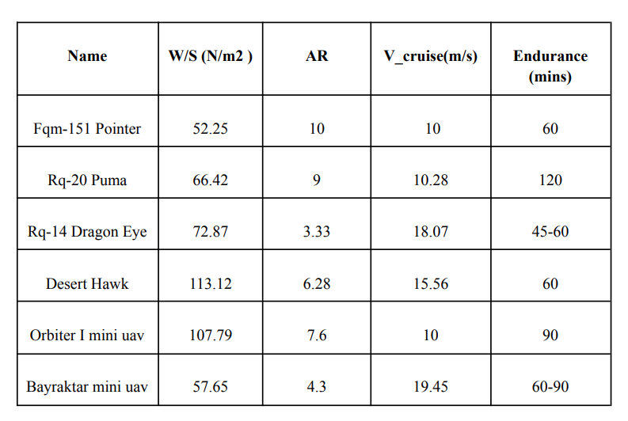

**Design Process**

The design process begins with a specific set of requirements established by the given constraints. An initial layout is analysed to estimate the aerodynamics and weight fractions in comparison with previous designs. The results incorporate the approximate wing and tail geometries, fuselage shape, and major components positioning.

**1. Given Constraints**

The wingspan and chord length are taken as 1.4m and 100mm respectively, the maximum

allowed value.

The other parameters considered in the design process are,

Endurance = 1 hours.

Available Total Battery Energy <= 100Wh.

Payload weight = 20% of Take-off weight.

**2. Assumptions**

For the design process, certain parameters are assumed taking reference from the historical data and general trend of the parameters and we have done all the calculation considering the operating altitude of UAV will be sea level. Corresponding density = 1.225 kg/m^3 and dynamic viscosity = 1.789*10^-5 N.s/m2is taken.

* W/S = 50 N/m^2(considered from the great flight diagram)
* Vcruise = 20 m/s
* L/D = 15 (at Vcruise)
* AR = 9

**3. Wing Sizing: -**First step of preliminary aircraft designing is to find out the wing size and shape of our aircraft. This is carried out in this section. We have already assumed value of AR and W/S. The wing planform is selected to be trapezoidal as it has better efficiency than a rectangular wing while is less complex to manufacture than an elliptical wing.

Now as, 𝐴𝑅𝑤 = 𝑏2/ 𝑆 we get 𝑆 = 𝑏 2/ 𝐴𝑅𝑤 = 1.96/9 = 0.218 m^2

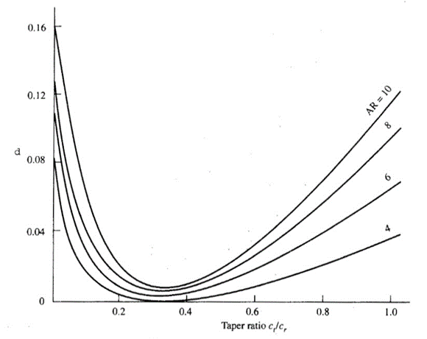

The next parameter essential for the design of the wing is the taper ratio λ. From the given plot we can see that a taper ratio of 0.5 gives almost the best performance as it has low value of induced drag factor and at the same time does not duffers from “Tip first stall” problem.

The Root and tip chord of the wing are then evaluated.

From 𝑆 = 𝑏/2 * (𝐶r + 𝐶t )

We get Cr = 0.207619 and consequently, Ct = 0.103809 for λ=0.5.

In the next step the mean aerodynamic chord of the wing is calculated which plays an important role in determining the Reynolds number of the airplane.

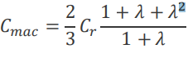

Hence 𝐶mac = 0.161481 m

Now, we have all the necessary data for calculating the Reynolds number.

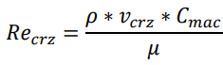

= 2.21145* 105

For our aerofoil selection feasibility, we are considering Re = 2*105

With assumed Vcrz now we proceed to calculate the value of CLcrz where,



The obtained value of 𝐶𝑙crz= 0.20408

**4. Aileron Sizing:**

The size of the aileron is estimated in this section. Theory predicts that the size of aileron depends mainly on the chord distribution of the wing and aileron to wing area ratio. Thus it can be done in this section since we have already fixed our chord distribution.

The aileron is designed using strip theory and the main parameter guiding our design process is the ratio 𝑃𝑏 /2𝑉 which is kept above 0.07 for most UAV.

The value of 𝑃𝑏/ 2𝑉 as predicted from strip theory is given as :-

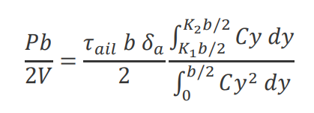

The parameter 𝜏𝑎𝑖𝑙 is the aileron effectiveness parameter and it depends on the aileron to wing area ratio.

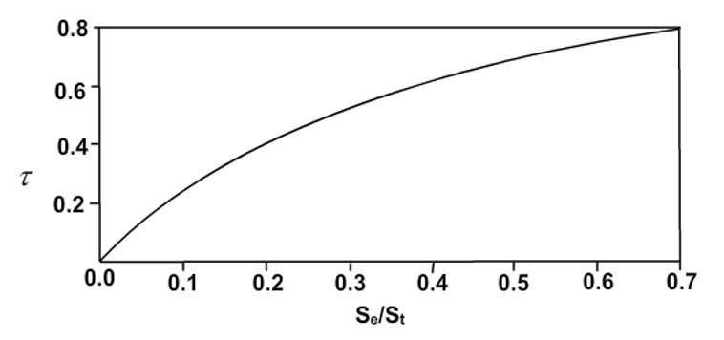

𝛿𝑎 denotes the maximum aileron deflection possible. We assumed 𝛿𝑎 max to be 20 degrees. Now the values of 𝐾1 𝑎𝑛𝑑 𝐾2are obtained from literature to be 0.6 and 0.95 respectively. Hence the only unknown that remains is the aileron surface area.

Solving the problem, we got the aileron surface area to be 1/ 20 𝑚2

while 𝑃𝑏/ 2𝑉 came to be 0.0721. Thus, it satisfies the requirement and hence we obtain the required dimensions of the aileron.

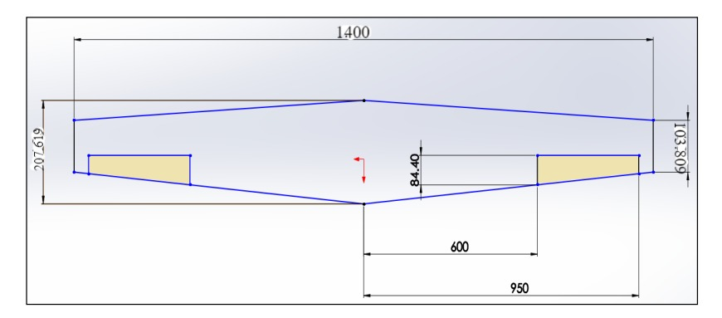

**Aerofoil Selection: -**

Selection of airfoil is an important step which is very crucial and has a huge impact on the overall performance of the aircraft. For our problem we need to find an airfoil that gives the best performance at a Reynolds number of 0.2 million. The important features that we will need to look for are low zero lift drag (𝐶𝑑0), high lift curve slope (𝐶𝑙𝛼), high aerodynamic efficiency(𝐶𝑙⁄𝐶𝑑), high max Lift coefficient(𝐶𝑙𝑚𝑎𝑥) and angle of stall (𝛼𝑠𝑡𝑎𝑙𝑙). Apart from these parameters certain other features like drag bucket, low zero lift moment coefficient (𝐶𝑚0) can also be desired although their absence will not drastically affect the performance of the aircraft.

Based on the given selection criteria a set of airfoils are listed and compared among one another to find the best candidate. The airfoil that we have selected for our design is NACA-63212.

0

10

20

30

40

50

0

20

40

60

80

100

**AIRFOIL NACA -**

**-**

**63212**

The characteristics of the airfoil are given below.

|  |  |  |  |  |  |  |  |
| --- | --- | --- | --- | --- | --- | --- | --- |
| Airfoil | 𝐶𝑙0 | 𝐶𝑙𝛼 𝑝𝑒𝑟 ° | 𝛼𝑠𝑡𝑎𝑙𝑙 | 𝐶𝑙𝑚𝑎𝑥 | 𝐶𝑚𝑎𝑐 | 𝐶𝑑0 | 𝛼0𝑙𝑤 |
| NACA-63212 | 0.2 | 0.1125 | 14 | 1.147 | -0.0375 | 0.005 | −20 |

The airfoil is found to satisfy all the requirements. Being a NACA 6 series airfoil it also forms drag bucket hence provide a large operating range with minimal drag.

In the next step we compute the above-mentioned parameters for the entire wing.

To estimate the Lift characteristics of the entire wing and to find the required angle of attack at cruise Lifting Line Theory is used.

Based on Lifting Line theory the lift curve slope of the airfoil turns out to be 𝐶𝑙aw =0.0838 /𝑑𝑒𝑔𝑟𝑒𝑒. Hence the required angle of attack at cruise is given by 𝛼crz =4.4737

The Airfoil gives a maximum lift coefficient of 1.1469. Considering the fact that Clmax aircraft is less than Clmax wing we take Clmax aircraft=0.9*Clmax wing.

Thus the stall velocity of the aircraft is found to be 𝑉𝑠𝑡𝑎𝑙𝑙

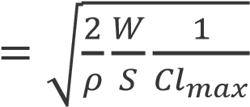

= 8.8926 m/s

**Weight Estimation :-**

The preliminary weight of the aircraft is calculated from the assumed values of W/S and S.

W = (W/S)*S = 10.9N

Thus, the aircraft is estimated to weigh about 10.9N or 1.1021 Kg.

So, Wpayload = 0.2*W = 2.18N or 0.220424 kg.

**Estimation of the Weight of the Battery: -**

We do not know the efficiency of the propeller or the electrical system. Thus, we have assumed efficiency of both propeller and motor together to be = 0.64.

Since the power required by the aircraft times the endurance gives the maximum energy required we can equate it to the maximum energy supplied by the battery to get the estimate of the weight of the battery

𝐸𝑛𝑑𝑢𝑟𝑎𝑛𝑐𝑒 ∗ 𝑃𝑟𝑒𝑞 = (𝑊ℎ/𝐾𝑔) ∗ 3600 ∗ (𝑀𝑏𝑎𝑡𝑡𝑒𝑟𝑦) ∗ 𝜂_(𝑝𝑟𝑜𝑝𝑒𝑙𝑙𝑒𝑟+𝑚𝑜𝑡𝑜𝑟+𝑒𝑠𝑐)

We can calculate the mass of the battery, as we are already provided with the energy density. We only need to calculate the Preq.

we know at cruise,

𝑃𝑟𝑒𝑞 = 𝑇 ∗ 𝑉𝑐𝑟𝑢𝑖𝑠𝑒 = 𝑊/ (𝐶𝑙/ 𝐶𝑑)∗ 𝑉𝑐𝑟𝑢𝑖𝑠𝑒= (10.9/15)*20 =14.534 W

Using the value of the Preq , from the above equation, we get

𝑀𝑏𝑎𝑡𝑡𝑒𝑟𝑦 = 0.227 kg = 227 grams

**Battery Selection**

To find the number of batteries required we did a survey of different batteries and found “**HV Shorty 3S LiPo Battery**” to be the best candidate for our design.” From the table the mass of one battery is given to be 225 grams, hence we need to use 1 battery in our aircraft. ‘

|  |  |
| --- | --- |
| **Battery Model** | **HV Shorty 3S LiPo** |
| **Application** | Crawlers, Drag, Boats & Aircraft |
| **Type** | Silicon Graphene |
| **Voltage** | 11.4V nominal |
| **Capacity @11.1V** | 4300mAh |
| **Capacity @11.4V** | 4800mAh |
| **Weight** | 225g |
| **Connector Type** | T-Style |
| **Balance Connector** | 4 Pin XH |
| **Number of Cells** | 3 Cell |
| **Configuration** | 3S1P |
| **Dimensions (WxLxH)** | 43x93x25.7mm |
| **Maximum Charge Rate** | 10C (45A) |
| **Burst Current** | 130C |
| **Watt Hour @11.4V** | 54.7Wh |

**Empennage Sizing and Aircraft Stability**

The empennage is the whole tail unit at the extreme rear of the fuselage and it provides the stability and directional control of the aircraft (Fig. 3.8). Structurally, the empennage consists of the entire tail assembly, including the vertical stabilisers, horizontal stabilisers, rudder, elevators, and the rear section of the fuselage to which they are attached. The stabilisers are fixed wing sections which provide stability for the aircraft to keep it flying straight.

* The airfoil that will be integrated for the empennage section is the NACA 0012

**Horizontal Tail:-**

We need horizontal stabilizers to make our plane statically stable along longitudinal direction. Generally, the static stability is dependent in tail volume ratios. Thus, we need to find horizontal tail volume ratio to find the dimension of our tail.

From stick-fixed longitudinal static stability, moment coefficient is given as

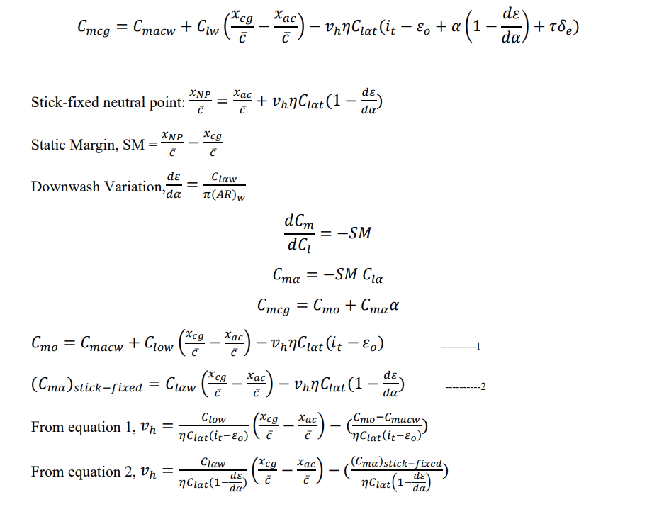

From historical data,we take SM=0.15 and cruise angle, α=4°

𝐶𝑚𝛼 = −𝑆𝑀 𝐶𝑙𝛼=-0.15*(0.0825*57.9)= -0.70909 /rad

Solving for values in Matlab, we get the following values: -

Tail volume ratio, 𝑣ℎ𝑡= 1.184446…

𝑙ℎ𝑡 = 1.2

Horizontal tail surface area, 𝑆ℎ = 0.101094 𝑚2

Span, 𝑏ℎ𝑡 = 0.635907𝑚

Root chord, 𝑐𝑟=0.211969 m

Tip chord, 𝑐𝑡 =0.105984 m

Mean aerodynamic chord, 𝑐𝑚𝑎𝑐 =0.1648649 m

𝑦𝑚𝑎𝑐 =0.141312 m

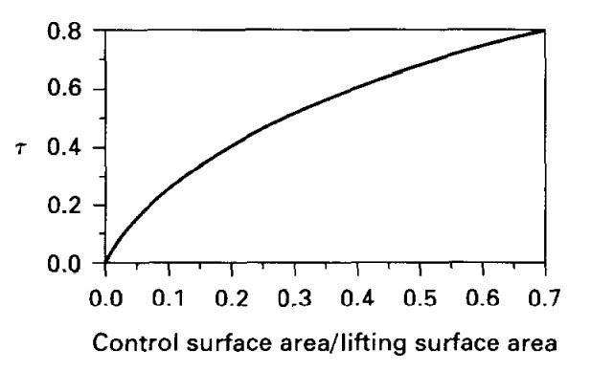

Elevator Design

Considering the elevator effectiveness parameter𝜏 = 0.45 Using the plot the elevator area is found to be 𝑆𝑒 = 0.028 𝑚2

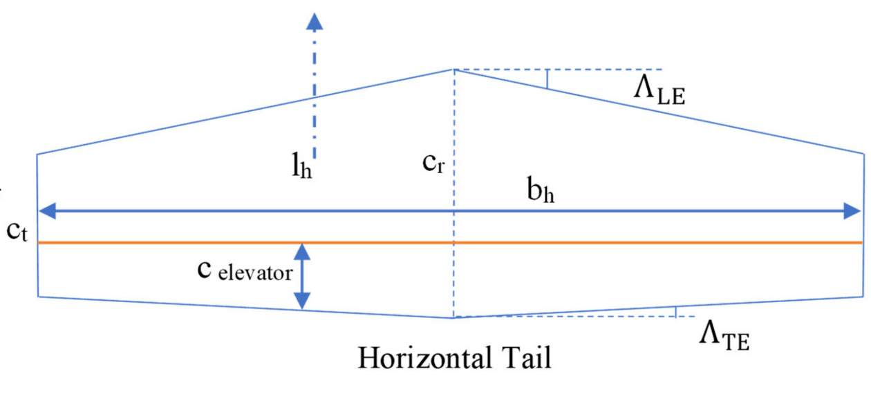

### ii) For Vertical Tail: -

𝑊 

𝐶𝑛𝛽 𝑑𝑒𝑠𝑖𝑟𝑒𝑑 = 0.005 (𝑏2)

Factors affecting 𝐶𝑛𝛽are –

* Wing Sweep
* Wing fuselage interaction
* Vertical tail size

𝐶𝑛𝛽 = 𝐶𝑛𝛽 𝑤𝑖𝑛𝑔 + 𝐶𝑛𝛽𝑤𝑓 + 𝐶𝑛𝛽𝑣𝑡

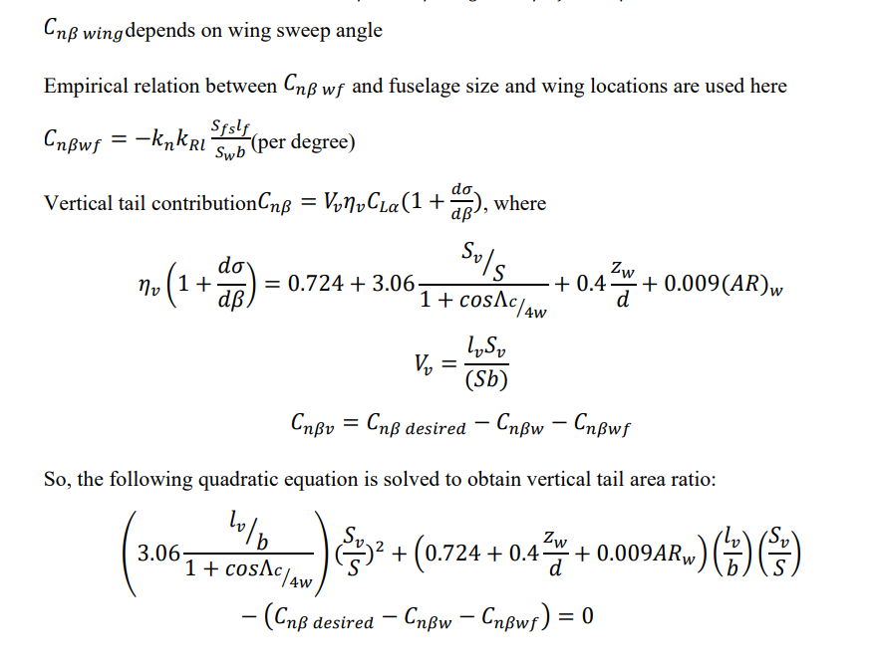

Dimensions of the vertical tail are obtained after solving the equation considering

𝑙𝑣 = 1.12 𝑚, Λ𝑐⁄4𝑤 = 0 and 𝑧𝑤 𝑑 = 0

Vertical tail surface area, 𝑆𝑣 = 0.0748 m2

Span, 𝑏𝑣𝑡 = 0.3869m

Root chord, 𝑐𝑟 = 0.2579m

Tip chord, 𝑐𝑡 = 0.1290m

Mean aerodynamic chord, 𝑐𝑚𝑎𝑐 = 0.2006 m

𝑦𝑚𝑎𝑐 = 0.086 m

**Rudder Design**

The rudder effectiveness parameter is taken as 𝜏 = 0.6

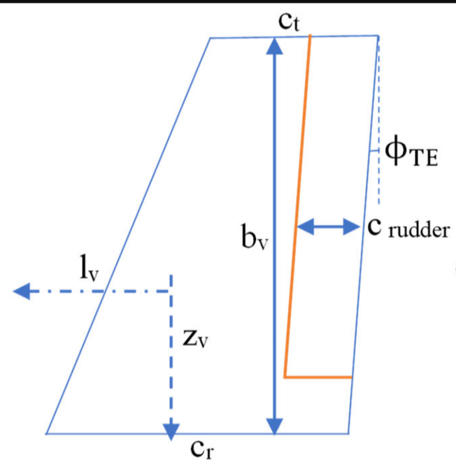 And using the plot of control surface effectiveness parameter, the rudder area is calculated.

𝑆𝑟𝑢𝑑 = 0.025 𝑚2

**Fuselage Design:-**

To design the fuselage some existing UAV s are studied and an appropriate design is selected. Based on existing airframe design and 3d modelling that we have done in solidworks the dimensions of the fuselage is evaluated.

The fuselage is designed to have sufficient volume to carry the payloads and other necessary equipment while having a minimum wetted area to minimize drag. The fuselage is made of two main sections, the first one being the front part dedicated to carry payloads and the second being the thin cylindrical second part that basically connects the main fuselage with the empennage.

The front part is made using two elliptical sections connected together by a cylindrical section. The front ellipse holds the motor and esc, the middle part houses the batteries and payload and the third section houses the electronics. The trailing ellipse is made keeping in mind that initial slope is not more than 150 as it might lead to unwanted flow separation and increase in drag.

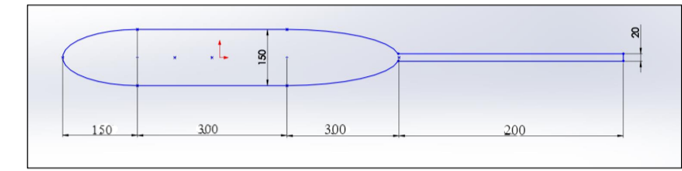

**Estimation of Drag** :

Now, based on the dimensions of the fuselage we are now capable of estimating the drag polar of the aircraft. We divide the drag polar into two parts, zero lift drag and drag due to lift.

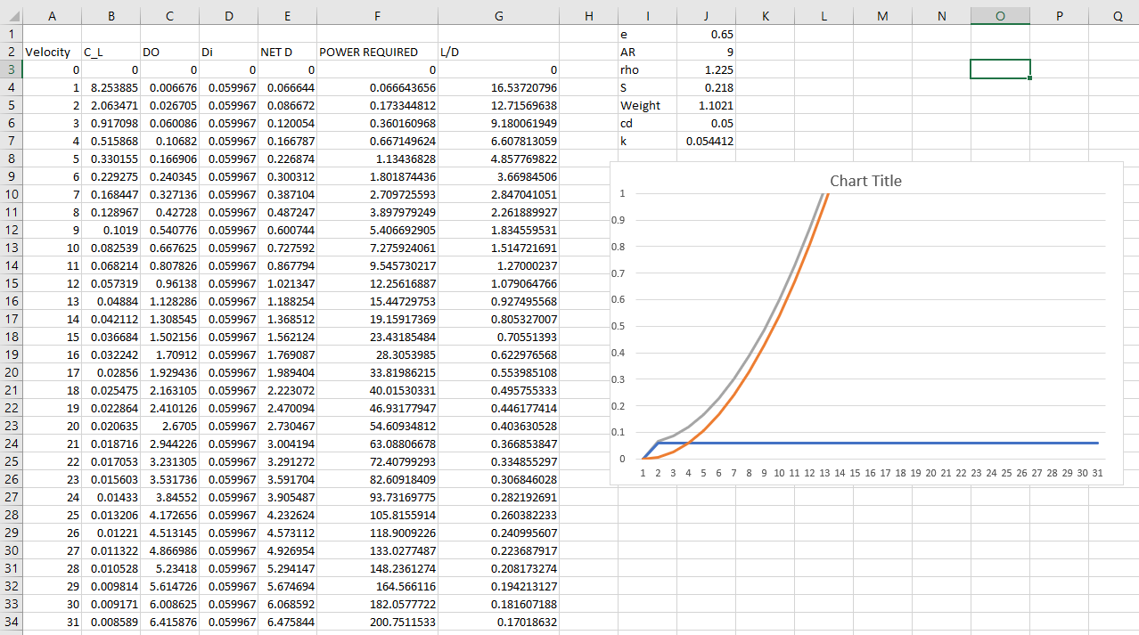

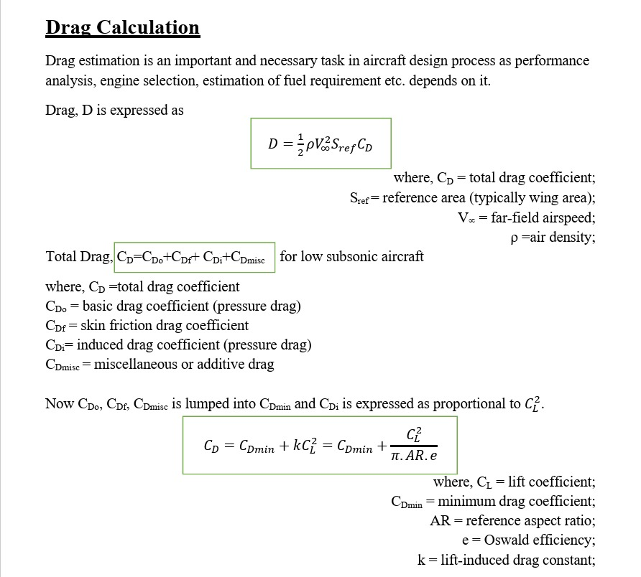

We are calculating only CDmin.

Given parameters:

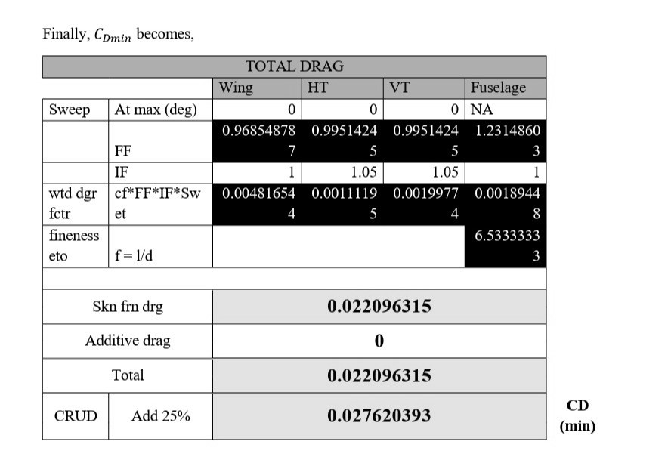

# **Propeller design and selection**

Propeller theory indicates that, other factors remaining constant, an increase in the total blade area, or solidity, of a propeller will generally result in a loss of efficiency. Despite this fact the trend for a number of years has been toward a greater solidity as a result of increases in the power of engines and tip-speed or other limitations on the diameter.

The design of the propeller is done based on certain features of the aircraft that are pre-determined by drag estimation study, weight estimation study or others. The final outcome of the propeller design gives the propeller diameter, the pitch angle or the blade angle (for constant pitch propellers) and the propeller efficiency at the design speed.

Input parameter:

CL  = 1.4

CD = 0.0276

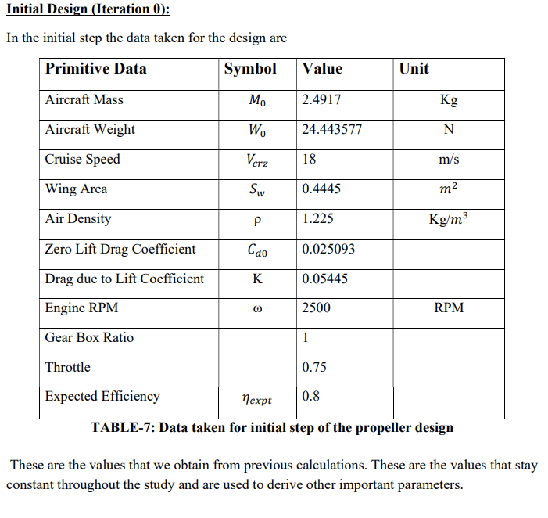

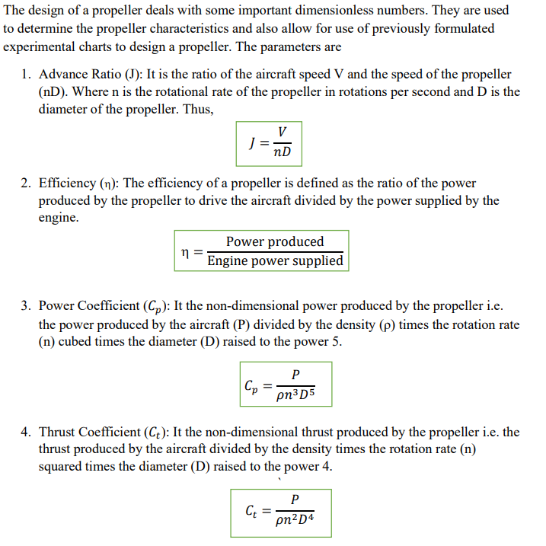

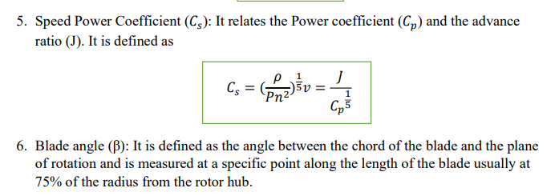

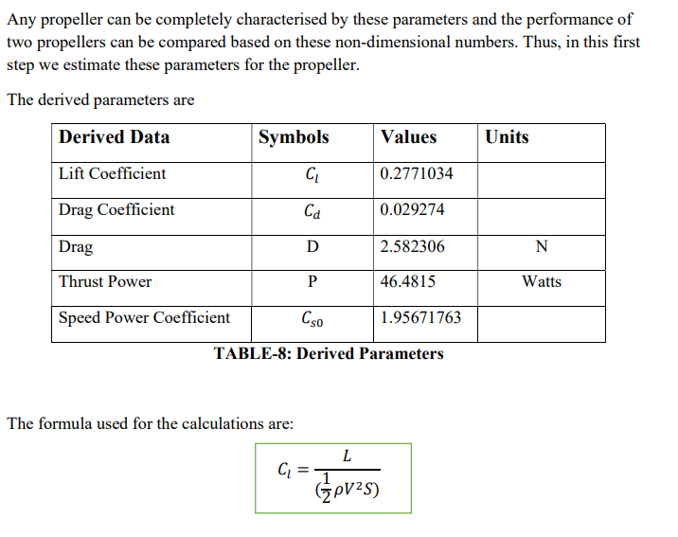

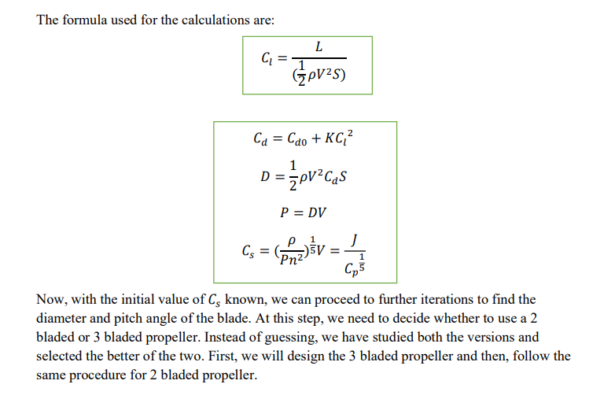

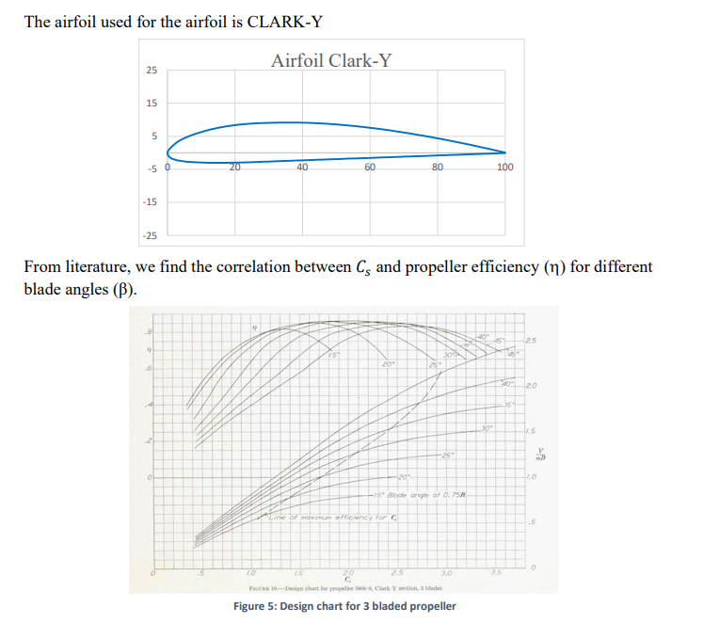

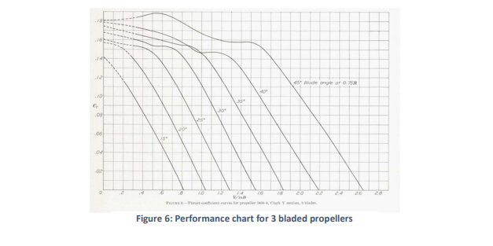

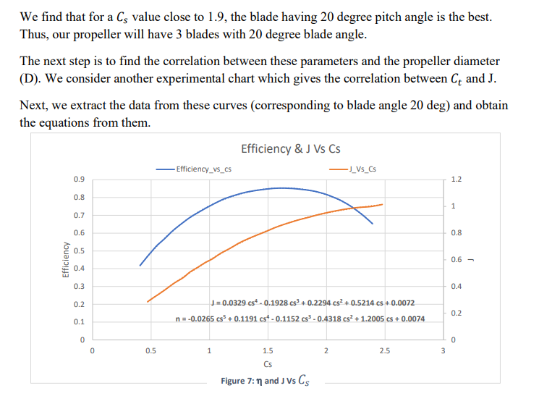

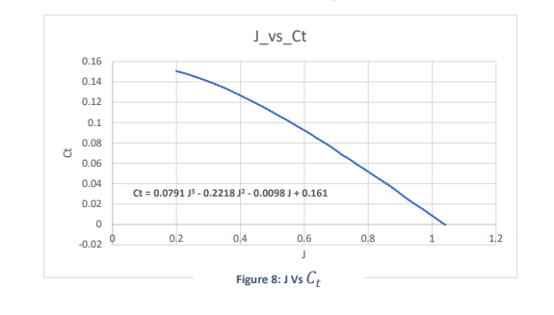

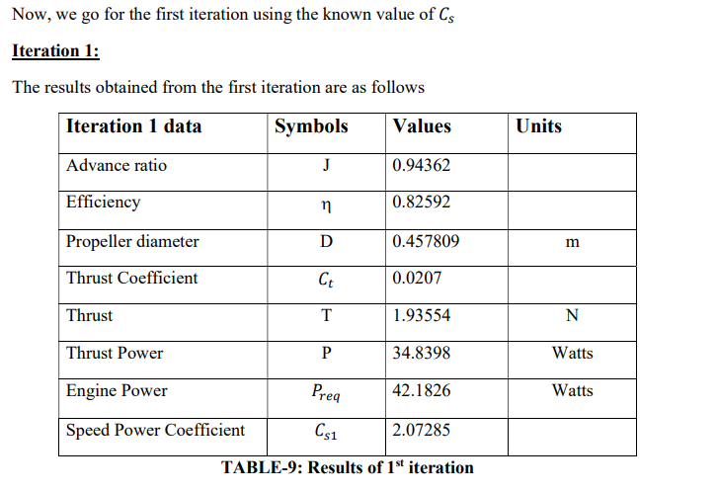

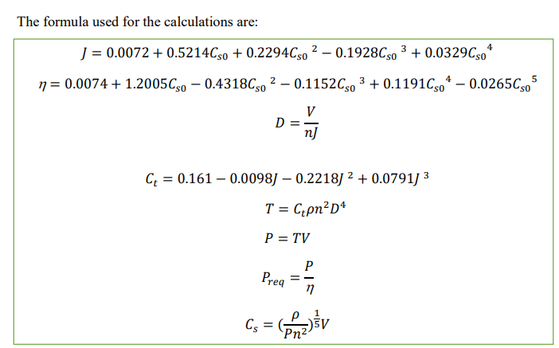

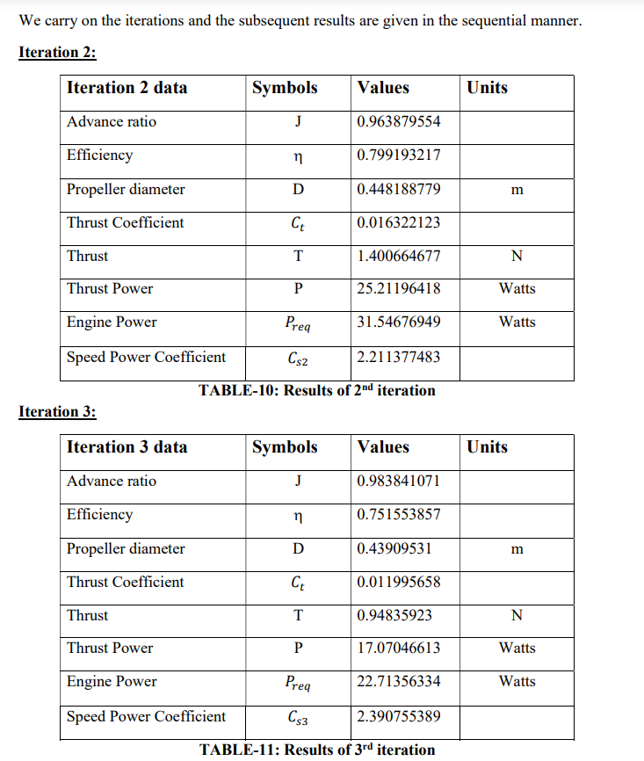

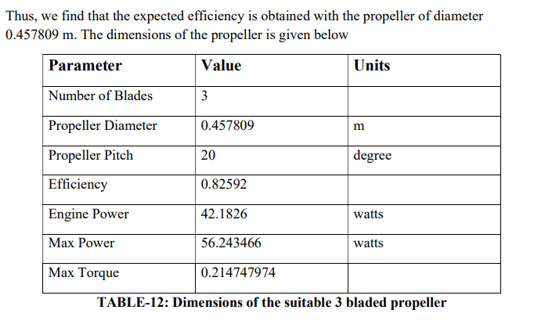

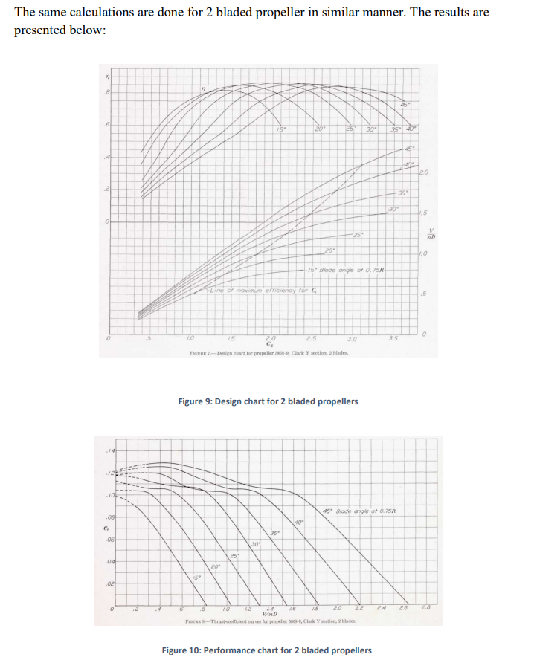

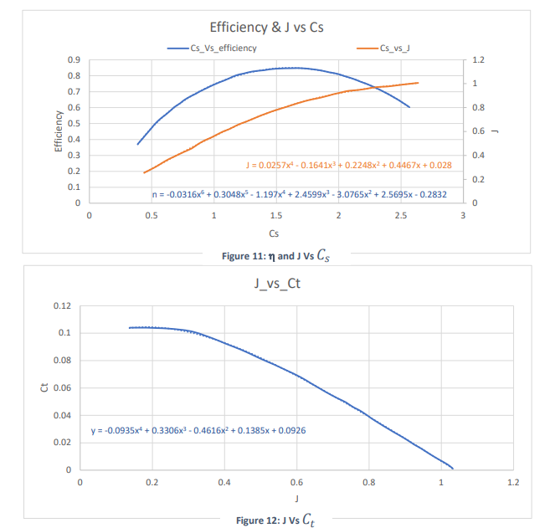

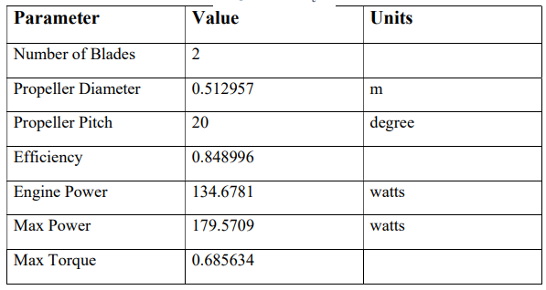

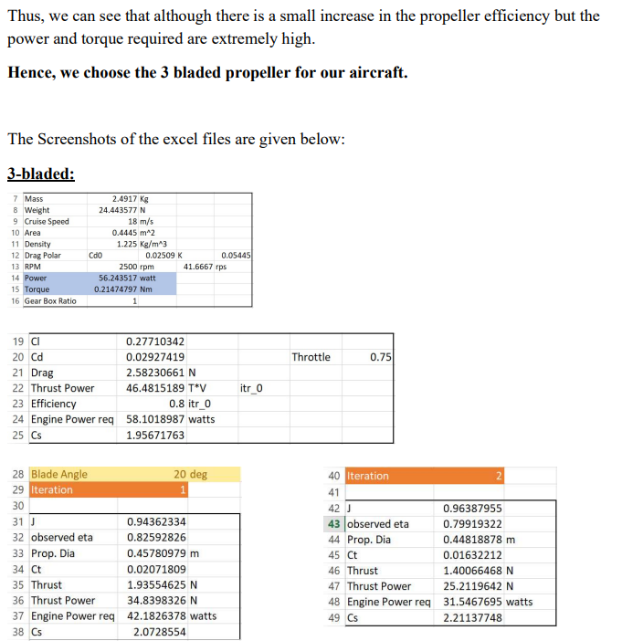

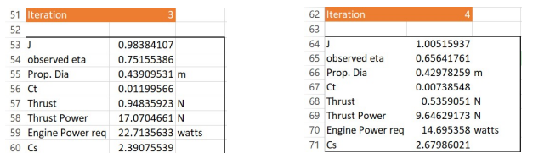

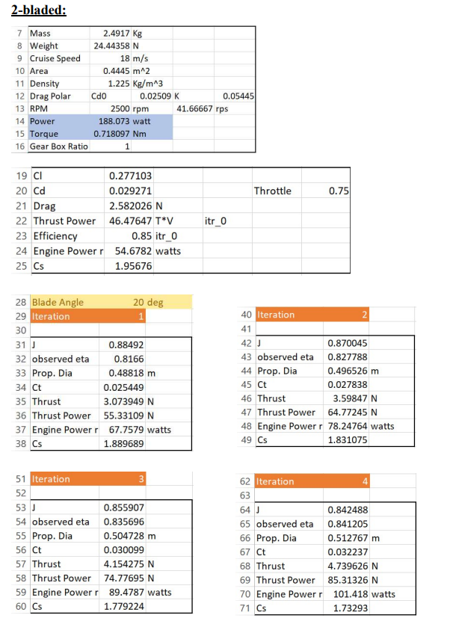

**Landing Gear**

We have chosen the tricycle landing gear for our aircraft

**Performance Study:-**

The performance parameters of the airplane are then evaluated to verify whether the airplane meets the required specifications or not.

i) Endurance:- To calculate the endurance of the airplane we equate the maximum energy consumed by the airplane during its 4 hrs journey and the maximum energy that can be stored in 3 Lipo’s.

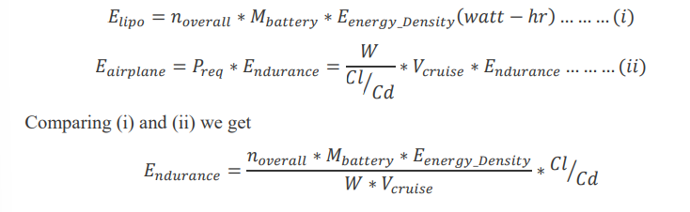

This gives Endurance= 1.0078 hrs. Thus the airplane achieves the desired Endurance of 1 hour.

ii) Maximum Velocity:-

Maximum velocity of an airplane is an important parameter that needs to be considered to find the flight envelope of the airplane. When an aircraft flies at its maximum velocity the power required and power available curves cut each other on the high velocity side, representing both the power required and power available. Thus to find the maximum velocity we need to find the Power required and Power available for the aircraft. We have calculated the maximum velocity of the aircraft at 4 different altitudes.

Power available for the aircraft is given by

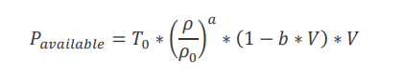

The thrust required by the aircraft is given by

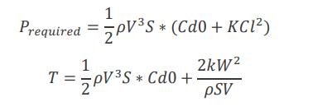

Maximum velocity is obtained by equating the two Power equations and solving for the velocity. The solution will give two velocities, one the maximum velocity and the other the minimum velocity governed by power available, however the minimum velocity is generally governed by stall.

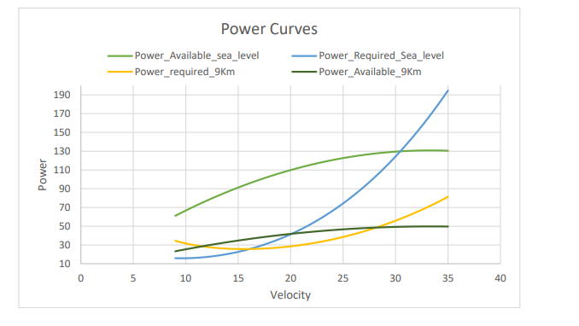

Solving the Thrust equation we get

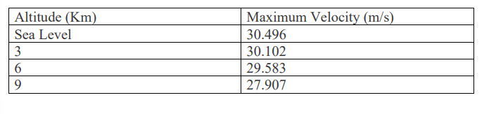

iii) Rate of Climb:-

The rate of climb of an airplane is an important parameter for any airplane as it gives an indication of how fast the airplane can reach its design altitude. Also it gives an indication of the maximum altitude at which the aircraft can fly.

The rate of climb of the airplane is estimated at four different altitudes which gives us a clear indication of the performance of the aircraft. During a steady climb ( acc=0) the Thrust of the aircraft balances the drag and a part of the weight (𝑊𝑠𝑖𝑛(𝜃)) , while the lift balances 𝑊𝑐𝑜𝑠(𝜃). Thus the equation of motion is given by

𝑇 = 𝐷 + 𝑊𝑠𝑖𝑛(𝜃)

𝐿 = 𝑊𝑐𝑜𝑠(𝜃)

Now Rate of climb RC is given by

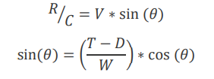 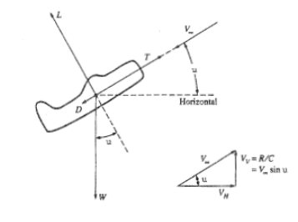

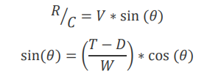

At a given altitude the rate of climb is estimated for different flight speeds ranging from𝑉𝑠𝑡𝑎𝑙𝑙 𝑡𝑜 𝑉𝑚𝑎𝑥. The value of 𝜃 is calculated using iterative methods to satisfy the above equation.

IV) Longitudinal Static Stability Analysis:-

The longitudinal Static stability of an airplane is an important parameter that helps in determining the response of the aircraft towards any disturbance. It also helps in determining the dynamic stability of the airplane.

determine the longitudinal static stability of the airplane we need to consider the contribution of the different parts individually and them add together to get the desired results.

In stability analysis the contribution of the wing, the fuselage, the tail and the power plant is generally considered as they are the main parts of any airplane.

1. Contribution of Fuselage:-

The contribution of fuselage is obtained from slender body theory. According to the theory we divide our airplane into several segments and estimate the required variables based on empirical results.

We divide the fuselage into 10 segments, 5 in front of the wing and 5 behind the wing. The empirical values of 𝐶𝑚0 𝑎𝑛𝑑 𝐶_𝑚𝛼 are calculated on the basis of some empirical relations which are plotted below.

Based on these empirical model constants the values of 𝐶𝑀0 can be calculated as

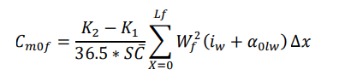

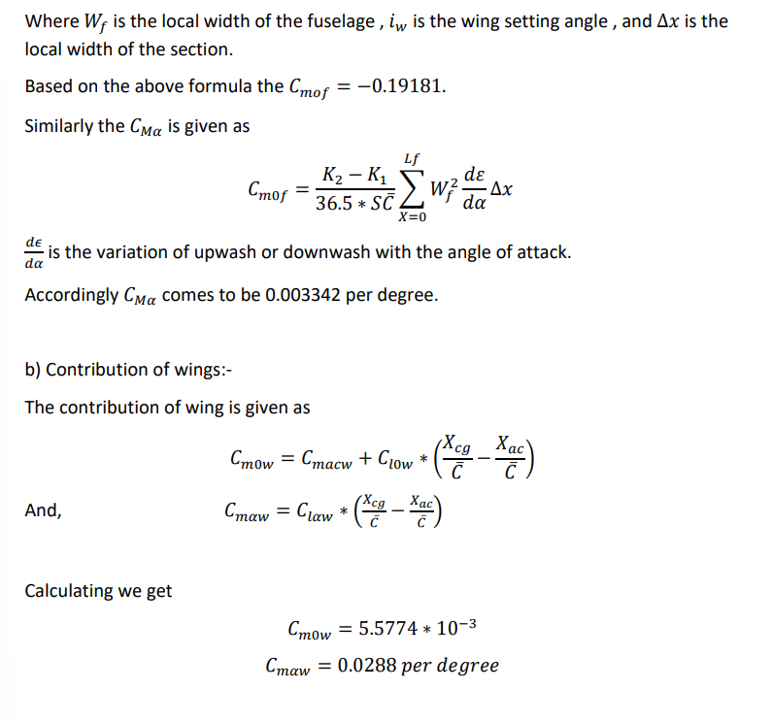

1. Contribution of Horizontal tail:-

The contribution of Horizontal tail is given as

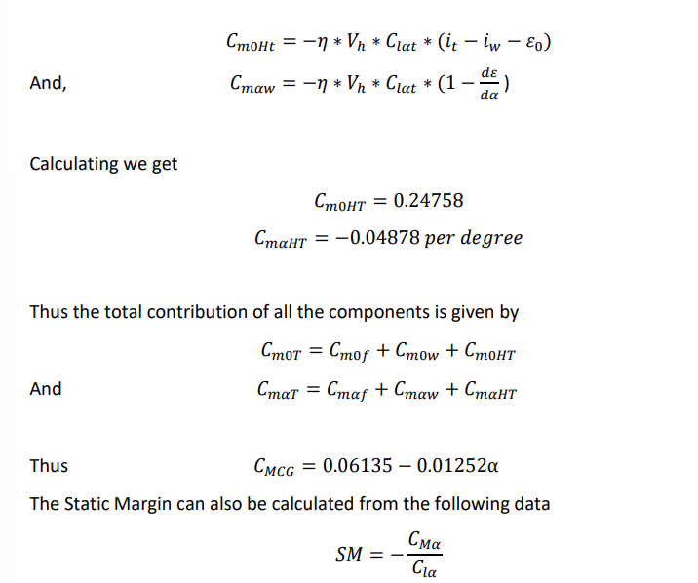

Cmalpha =-0.70909

Clalpha= 0.0825*57.3

Which gives Sm as 14.91 which matches closely with the assumed value of 15%

Also from the graph we find that the value of alpha required for trim is 4.64 degree is slightly higher than our estimated alpha value of 4.6 degree.

