

NATIONAL CENTRE FOR EXCELLENCE
BENGALURU
A PROJECT REPORT ON
“ ANIMAL SHELTER MANAGEMENT ”
For the session
2024-25
Guided By: Prepared By:
Mrs. Krithika T M Gaurilakshmi Yadhunath

PGT Computer Science Reg no:

Prepared as partial fulfilment of requirement in the subject as per the guidelines issued by Central Board of Secondary Education, New Delhi


CERTIFICATE

This is to certify that the project entitled “Animal Shelter Management” has been carried out by Ankita Paramanik and Gaurilakshmi Yadhunath under my guidance and supervision. To the best of my knowledge, the report:
- Embodies the work of the candidate himself.
- Has duly been completed.
- Fulfills the requirement of the ordinance of CBSE.
- Is up to the standard for the purpose for which it is submitted.

______________ ______________
Mrs. Krithika T M Mrs. Deepa R
(PGT Computer Science) (Principal)

______________
(External Examiner)

TABLE OF CONTENTS

S. NO. | CONTENT | PAGE NO.
1 | Acknowledgement | 4
2 | Preface | 5
3 | System Requirements | 6
4 | Source Code | 7
5 | Screenshots of the Outputs | 32
6 | Bibliography | 40

ACKNOWLEDGEMENT
I would like to extend my sincere thanks to our Principal, Mrs. Deepa R for letting me choose my desired field of interest, for working on the project and also for inspiring me through the course of the project work. Her words of encouragement helped me throughout.

I would also hereby like to earnestly thank my guide, Mrs. Krithika T M, for her sincere and genuine guidance throughout the project. Without her dedication, it would not have been possible for me to carry out this project report.

Last but not the least, I would love to thank my teammate, Ankita Paramanik as if not for their relentless hard work, this group project could have never been possible.
Gaurilakshmi Yadhunath

PREFACE

This project aims to develop an efficient and user-friendly software solution for managing the operations of an animal shelter.
The primary objective is to simplify various tasks that are often handled in animal shelters such as animal registration, adoption tracking, awareness and ensuring that shelter activities are organised and easy to monitor.
The inspiration for this project stems from the growing need for shelters to handle an increasing number of animals efficiently while maintaining high standards of care.
There is also a database attached to the program which helps in monitoring the shelter activities efficiently. Python concepts used are tkinter, numpy, matplotlib.pyplot and mysql.connector.

SYSTEM REQUIREMENTS

- Microsoft Windows/XP/Vista/Windows 7:
- Processor: 800 MHz Intel Pentium III or equivalent.
- Memory: 128 MB or more.
- Disk Space: 512 KB of free disk space.
- Ubuntu 9.10:
- Processor: 800 MHz Intel Pentium III or equivalent.
- Memory: 128 MB or more.
- Disk Space: 512 KB of free disk space.
- Macintosh OS X 10.5 Intel:
- Processor: Dual Core Intel (32 or 64-bit).
- Memory: 128 MB or more.
- Disk Space: 512 KB of free disk space.

SOURCE CODE
import mysql.connector as ms
import tkinter as tk
from tkinter import ttk, messagebox
import matplotlib.pyplot as plt
import numpy as np
from datetime import datetime

# Connect to MySQL database
def connect_database():
try:
mycon = ms.connect(
host='localhost',
database='Animal_Shelter',
user='root',
password='sql4gauri'
)
return mycon
except ms.Error as err:
messagebox.showerror("Database Connection Error", str(err))
return None

# Function for the home page
def homepage(notebook):
frame = tk.Frame(notebook)
notebook.add(frame, text="Home Page")

frame.configure(bg='light blue')
try:
hp = tk.PhotoImage(file='Homepage.png') # Ensure the image path is correct
hp_disp = tk.Label(frame, image=hp)
hp_disp.image = hp # Keep a reference to avoid garbage collection
hp_disp.pack(fill=tk.Y, expand=True)
except Exception as e:
messagebox.showerror("Image Error", f"Error loading image: {e}")

# Function for displaying shelter data
def shelter_data(notebook):
frame = tk.Frame(notebook)
notebook.add(frame, text="Shelter Data")

columns = ('ID', 'Metric', 'Value')
tree = ttk.Treeview(frame, columns=columns, show='headings')

for col in columns:
tree.heading(col, text=col)
tree.column(col, anchor="center")

scrollbar = ttk.Scrollbar(frame, orient="vertical", command=tree.yview)
tree.configure(yscroll=scrollbar.set)
scrollbar.pack(side='right', fill='y')

tree.pack(padx=10, pady=10, fill=tk.BOTH, expand=True)

t_animals = tk.Button(frame, text="Animals", command=lambda: Animals_disp(tree))
t_adoptions = tk.Button(frame, text="Adoptions", command=lambda: Adoptions_disp(tree))
finance = tk.Button(frame, text="Finance", command=lambda: Finance_disp(tree))

t_animals.pack(pady=5)
t_adoptions.pack(pady=5)
finance.pack(pady=5)

def Animals_disp(tree):
try:
mycon = connect_database()
if mycon is None:
return
cursor = mycon.cursor()
cursor.execute("SELECT * FROM Operations")
results = cursor.fetchall()
tree.delete(*tree.get_children()) # Clear the treeview
for row in results:
tree.insert("", tk.END, values=row)
except ms.Error as err:
messagebox.showerror("Database Error", str(err))
finally:
if mycon:
cursor.close()
mycon.close()

def Adoptions_disp(tree):
try:
mycon = connect_database()
if mycon is None:
return
cursor = mycon.cursor()
cursor.execute("SELECT * FROM Adoption")
results = cursor.fetchall()
tree.delete(*tree.get_children())
for row in results:
tree.insert("", tk.END, values=row)
except ms.Error as err:
messagebox.showerror("Database Error", str(err))
finally:
if mycon:
cursor.close()
mycon.close()

def Finance_disp(tree):
try:
mycon = connect_database()
if mycon is None:
return
cursor = mycon.cursor()
cursor.execute("SELECT * FROM Finance")
results = cursor.fetchall()
tree.delete(*tree.get_children())
for row in results:
tree.insert("", tk.END, values=row)
except ms.Error as err:
messagebox.showerror("Database Error", str(err))
finally:
if mycon:
cursor.close()
mycon.close()

# Registration and login functions
def register_user(username, password, notebook):
try:
mycon = connect_database()
if mycon is None:
return
cursor = mycon.cursor()
cursor.execute("SELECT * FROM Users WHERE Username = %s", (username,))
result = cursor.fetchone()
if result:
messagebox.showwarning("Warning", "Username already exists!")
else:
cursor.execute("INSERT INTO Users (Username, Password) VALUES (%s, %s)", (username, password))
mycon.commit()
messagebox.showinfo("Success", "Registration successful!")
add_animal(notebook, username)
load_adoption_page(notebook, username, None)
except ms.Error as err:
messagebox.showerror("Database Error", f"Error during registration: {str(err)}")
finally:
if mycon:
cursor.close()
mycon.close()

def login_user(username, password, notebook):
try:
mycon = connect_database()
if mycon is None:
return
cursor = mycon.cursor()
cursor.execute("SELECT UserID FROM Users WHERE Username = %s AND Password = %s", (username, password))
result = cursor.fetchone()
if result:
user_id = result[0]
messagebox.showinfo("Success", "Login successful!")
add_animal(notebook, username)
load_adoption_page(notebook, username, user_id)
else:
messagebox.showwarning("Warning", "Invalid username or password!")
except ms.Error as err:
messagebox.showerror("Database Error", f"Error during login: {str(err)}")
finally:
if mycon:
cursor.close()
mycon.close()

# Function to add animal to shelter
def add_animal(notebook, username):
add_animal_frame = tk.Frame(notebook)
notebook.add(add_animal_frame, text="Add Animal")

# Current Date
current_date = datetime.now().strftime("%Y-%m-%d")

# Title Label
tk.Label(add_animal_frame, text="Add Animal to Shelter", font=("Helvetica", 16)).pack(pady=10)

# Animal Name
tk.Label(add_animal_frame, text="Name:").pack(pady=5)
name_entry = tk.Entry(add_animal_frame)
name_entry.pack(pady=5)

# Species
tk.Label(add_animal_frame, text="Species:").pack(pady=5)
species_entry = tk.Entry(add_animal_frame)
species_entry.pack(pady=5)

# Age
tk.Label(add_animal_frame, text="Age:").pack(pady=5)
age_entry = tk.Entry(add_animal_frame)
age_entry.pack(pady=5)

# Display Current Date
tk.Label(add_animal_frame, text=f"Date: {current_date}").pack(pady=10)

# Success Message Frame
message_frame = tk.Frame(add_animal_frame)
message_frame.pack(pady=10)
success_message = tk.Label(message_frame, text="", fg="green")
success_message.pack()

# Submit Animal Button
def submit_animal():
name = name_entry.get()
species = species_entry.get()
age = age_entry.get()
if name and species and age:
try:
mycon = connect_database()
if mycon is None:
return
cursor = mycon.cursor()
cursor.execute("INSERT INTO animals(animal_name, animal_species, age) VALUES (%s, %s, %s)",
(name, species, age))
mycon.commit()
success_message.config(
text=f"Success! {name} has been added to the shelter by {username} on {current_date}."
)
except ms.Error as err:
messagebox.showerror("Database Error", f"Error adding animal: {str(err)}")
finally:
if mycon:
cursor.close()
mycon.close()
else:
messagebox.showwarning("Input Error", "Please fill out all fields.")

submit_button = tk.Button(add_animal_frame, text="Add Animal", command=submit_animal)
submit_button.pack(pady=10)

# Adoption process page
def load_adoption_page(notebook, adopter_name, user_id):
adoption_frame = tk.Frame(notebook)
notebook.add(adoption_frame, text="Adoption Process")

# Display the name of the logged-in user
tk.Label(adoption_frame, text=f"Adopter Name: {adopter_name}").pack(pady=10)

# Create a frame for available animals
animals_frame = ttk.LabelFrame(adoption_frame, text="Available Animals for Adoption")
animals_frame.pack(fill="both", expand="yes", padx=10, pady=10)

# Add treeview to display animals
animals_tree = ttk.Treeview(animals_frame, columns=("ID", "Name", "Species", "Age"), show="headings")
animals_tree.heading("ID", text="ID")
animals_tree.heading("Name", text="Name")
animals_tree.heading("Species", text="Species")
animals_tree.heading("Age", text="Age")
animals_tree.pack(fill="both", expand=True)

# Fetch Animals
try:
mycon = connect_database()
if mycon is None:
return
cursor = mycon.cursor()
cursor.execute("SELECT * FROM Animals")
animals_results = cursor.fetchall()
for animal in animals_results:
animals_tree.insert('', 'end', values=animal)
except ms.Error as err:
messagebox.showerror("Database Error", f"Error fetching animals: {str(err)}")
finally:
if mycon:
cursor.close()
mycon.close()

# Adoption Entry Frame
adoption_entry_frame = tk.Frame(adoption_frame)
adoption_entry_frame.pack(pady=10)

# Automatically set the adoption date to today
tk.Label(adoption_entry_frame, text="Adoption Date (YYYY-MM-DD):").pack()
adoption_date = datetime.now().strftime("%Y-%m-%d")
tk.Label(adoption_entry_frame, text=adoption_date).pack()

# Create "Record Adoption" button
add_adoption_button = tk.Button(
adoption_entry_frame, text="Record Adoption",
command=lambda: add_adoption(animals_tree, adopter_name, adoption_date, user_id)
)
add_adoption_button.pack(pady=5)

# Create a frame for the adoptions table
adoptions_frame = ttk.LabelFrame(adoption_frame, text="Previous Adoptions")
adoptions_frame.pack(fill="both", expand="yes", padx=10, pady=10)

# Treeview to display adoptions
adoptions_tree = ttk.Treeview(adoptions_frame, columns=("Adopter Name", "Animal Name", "Adoption Date"), show="headings")
adoptions_tree.heading("Adopter Name", text="Adopter Name")
adoptions_tree.heading("Animal Name", text="Animal Name")
adoptions_tree.heading("Adoption Date", text="Adoption Date")
adoptions_tree.pack(fill="both", expand=True)

# Load previous adoptions from the database
load_previous_adoptions(adoptions_tree)

# Function to record an adoption
def add_adoption(animals_tree, adopter_name, adoption_date, user_id):
selected_item = animals_tree.selection() # Get selected animal
if selected_item:
animal_data = animals_tree.item(selected_item, 'values')
animal_name = animal_data[1] # Get the selected animal name
animal_id = animal_data[0]

try:
mycon = connect_database()
if mycon is None:
return
cursor = mycon.cursor()
cursor.execute("DELETE FROM Animals WHERE id = %s", (animal_id,))
cursor.execute(
"INSERT INTO Adopters (UserID, AdopterName, AnimalName, AdoptionDate) VALUES (%s, %s, %s, %s)",
(user_id, adopter_name, animal_name, adoption_date)
)
mycon.commit()
animals_tree.delete(selected_item)
adoptions_tree.insert("", "end", values=(adopter_name, animal_name, adoption_date))
messagebox.showinfo("Adoption Recorded", f"{animal_name} adopted by {adopter_name} on {adoption_date}!")
except ms.Error as err:
messagebox.showerror("Database Error", f"Error during adoption: {str(err)}")
finally:
if mycon:
cursor.close()
mycon.close()
else:
messagebox.showwarning("Input Error", "Please select an animal.")

def load_previous_adoptions(tree):
try:
mycon = connect_database()
if mycon is None:
return
cursor = mycon.cursor()
cursor.execute('''SELECT AdopterName, AnimalName, AdoptionDate FROM Adopters''')
previous_adoptions = cursor.fetchall()

tree.delete(*tree.get_children()) # Clear the treeview
for adoption in previous_adoptions:
tree.insert("", "end", values=adoption)
except ms.Error as err:
messagebox.showerror("Database Error", str(err))
finally:
if mycon:
cursor.close()
mycon.close()

# Function for displaying global data and graphs
def global_data(notebook):
frame = tk.Frame(notebook)
notebook.add(frame, text="Global Data")

# First Treeview for Global Data
columns1 = ('ID', 'Metric', 'Value')
tree1 = ttk.Treeview(frame, columns=columns1, show='headings')

for col in columns1:
tree1.heading(col, text=col)
tree1.column(col, anchor="center")

scrollbar1 = ttk.Scrollbar(frame, orient="vertical", command=tree1.yview)
tree1.configure(yscroll=scrollbar1.set)
scrollbar1.pack(side='right', fill='y')

tree1.pack(padx=10, pady=10, fill=tk.BOTH, expand=True)

fetch_global_data(tree1)

# Second Treeview for Additional Data
columns2 = ('ID', 'Term', 'Definition')
tree2 = ttk.Treeview(frame, columns=columns2, show='headings')

for col in columns2:
tree2.heading(col, text=col)
tree2.column(col, anchor="center")

scrollbar2 = ttk.Scrollbar(frame, orient="vertical", command=tree2.yview)
tree2.configure(yscroll=scrollbar2.set)
scrollbar2.pack(side='right', fill='y')

tree2.pack(padx=10, pady=10, fill=tk.BOTH, expand=True)

fetch_additional_data(tree2)

# Graph buttons
btn_vulnerable = tk.Button(frame, text="Vulnerable Animals Graph", command=show_vulnerable_graph)
btn_adoptions = tk.Button(frame, text="Adoptions Graph", command=show_adoptions_graph)
btn_species = tk.Button(frame, text="Species Graph", command=show_scatter_graph)

btn_vulnerable.pack(pady=5)
btn_adoptions.pack(pady=5)
btn_species.pack(pady=5)

def fetch_global_data(tree):
try:
mycon = connect_database()
if mycon is None:
return
cursor = mycon.cursor()
cursor.execute("SELECT * FROM Global_data")
results = cursor.fetchall()
tree.delete(*tree.get_children())
for row in results:
tree.insert("", tk.END, values=row)
except ms.Error as err:
messagebox.showerror("Database Error", str(err))
finally:
if mycon:
cursor.close()
mycon.close()

def fetch_additional_data(tree):
try:
mycon = connect_database()
if mycon is None:
return
cursor = mycon.cursor()
cursor.execute("SELECT * FROM Terms")
results = cursor.fetchall()
tree.delete(*tree.get_children())
for row in results:
tree.insert("", tk.END, values=row)
except ms.Error as err:
messagebox.showerror("Database Error", str(err))
finally:
if mycon:
cursor.close()
mycon.close()

def show_vulnerable_graph():
months = ['Jan', 'Feb', 'Mar', 'Apr', 'May', 'Jun', 'Jul', 'Aug', 'Sep', 'Oct', 'Nov', 'Dec']
vulnerable_animals = [15, 20, 25, 30, 28, 35, 40, 42, 40, 44, 37, 40]

plt.figure(figsize=(10, 5))
plt.plot(months, vulnerable_animals, marker='', linestyle='--', color='r')
plt.title('Vulnerable Animals Over Time')
plt.xlabel('Months')
plt.ylabel('Number of Vulnerable Animals')
plt.grid()
plt.show()

def show_adoptions_graph():
months = np.array(['Jan', 'Feb', 'Mar', 'Apr', 'May', 'Jun', 'Jul', 'Aug', 'Sep', 'Oct', 'Nov', 'Dec'])
dogs_adopted = np.array([5, 6, 7, 8, 10, 12, 11, 13, 15, 14, 16, 18])
cats_adopted = np.array([3, 4, 5, 6, 7, 8, 9, 10, 11, 12, 14, 15])

plt.figure(figsize=(10, 6))
plt.plot(months, dogs_adopted, label='Dogs Adopted', marker='o', color='blue')
plt.plot(months, cats_adopted, label='Cats Adopted', marker='o', color='green')

plt.title('Monthly Animal Adoptions at the Shelter')
plt.xlabel('Months')
plt.ylabel('Number of Animals Adopted')
plt.legend()
plt.grid(True)
plt.show()

def show_scatter_graph():
species = [
'Dogs', 'Cats', 'Rabbits', 'Birds (Parrots)',
'Turtles', 'Hamsters', 'Ferrets',
'Guinea Pigs', 'Lizards', 'Macaw',
'Tortoise', 'Red-Footed Tortoise', 'Cockatoo',
'Green Iguana', 'Beagle'
]
lifespan = [12, 15, 8, 50, 100, 2, 6, 5, 5, 60, 80, 70, 50, 70, 15]
offspring = [6, 4, 5, 3, 2, 7, 6, 3, 2, 2, 2, 4, 2, 3, 5]

plt.figure(figsize=(12, 8))
colors = ['salmon', 'red', 'orange', 'purple',
'turquoise', 'brown', 'orchid', 'cyan', 'magenta',
'darkgreen', 'olive', 'chocolate', 'darkgrey', 'navy', 'lightgreen']
sizes = [100, 80, 50, 200, 20, 40, 60, 30, 25, 100, 20, 40, 100, 60, 20]

plt.scatter(lifespan, offspring, color=colors, s=sizes, alpha=0.7)

# Add annotations for each point
for i, s in enumerate(species):
plt.annotate(s, (lifespan[i], offspring[i]), textcoords="offset points", xytext=(0, 5), ha='center')

plt.title('Animal Species: Lifespan vs Offspring')
plt.xlabel('Average Lifespan (years)')
plt.ylabel('Average Offspring per Litter')
plt.grid(False)
plt.show()

# Main Application
def main():
root = tk.Tk()
root.title("Happy Paws Shelter")

# Create a notebook (tabs)
notebook = ttk.Notebook(root)
notebook.pack(fill='both', expand=True)

# Create tabs
homepage(notebook)
shelter_data(notebook)
global_data(notebook)

# Create registration/login frame
login_frame = tk.Frame(notebook)
notebook.add(login_frame, text="Login / Register")

# Username and password entry
tk.Label(login_frame, text="Username:").pack()
username_entry = tk.Entry(login_frame)
username_entry.pack()

tk.Label(login_frame, text="Password:").pack()
password_entry = tk.Entry(login_frame, show='*')
password_entry.pack()

register_button = tk.Button(
login_frame, text="Register",
command=lambda: register_user(username_entry.get(), password_entry.get(), notebook)
)
login_button = tk.Button(
login_frame, text="Login",
command=lambda: login_user(username_entry.get(), password_entry.get(), notebook)
)

register_button.pack(pady=5)
login_button.pack(pady=5)

root.mainloop()

main()

SCREENSHOTS OF THE OUTPUTS
Screenshot 1: Home Page
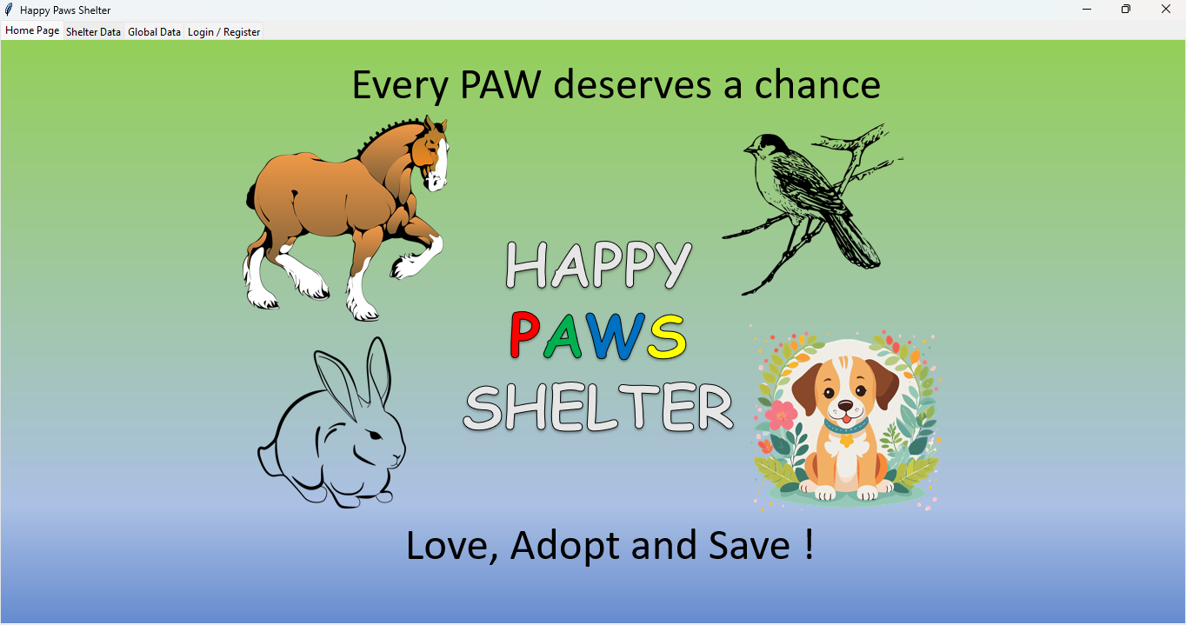

Screenshot 2: Shelter Data
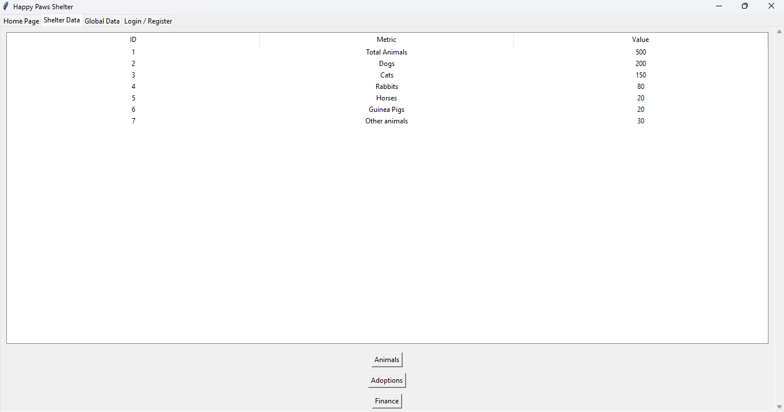
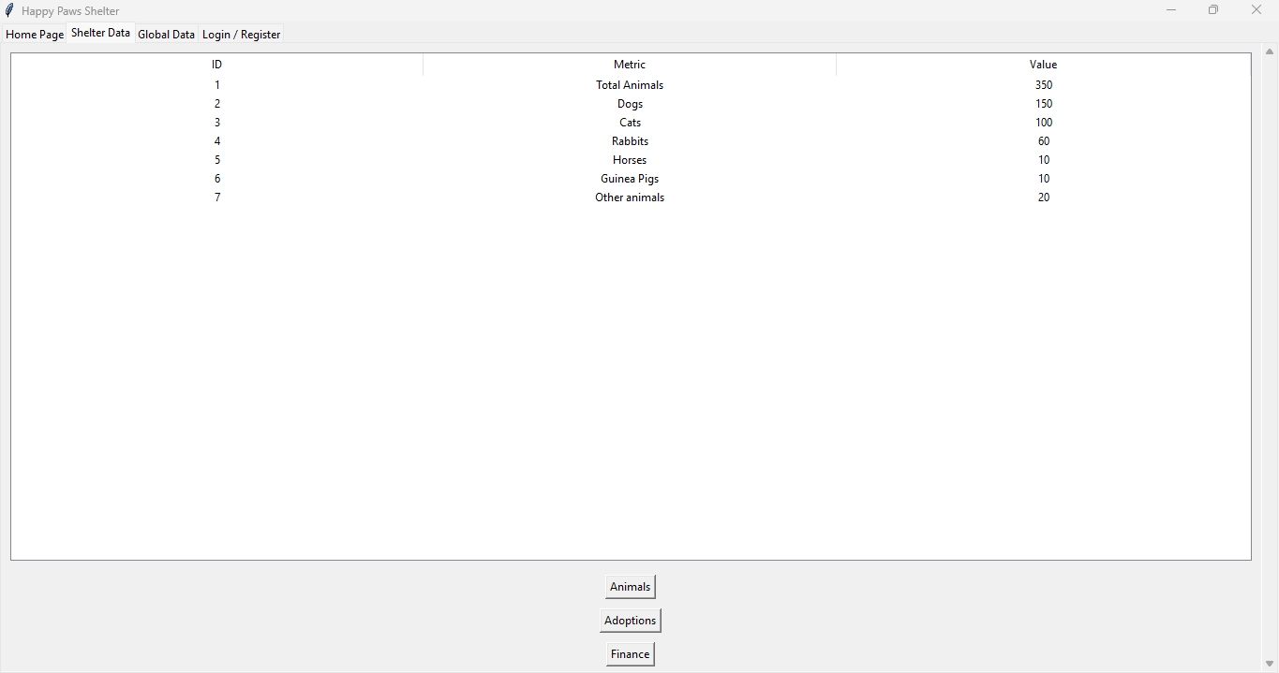
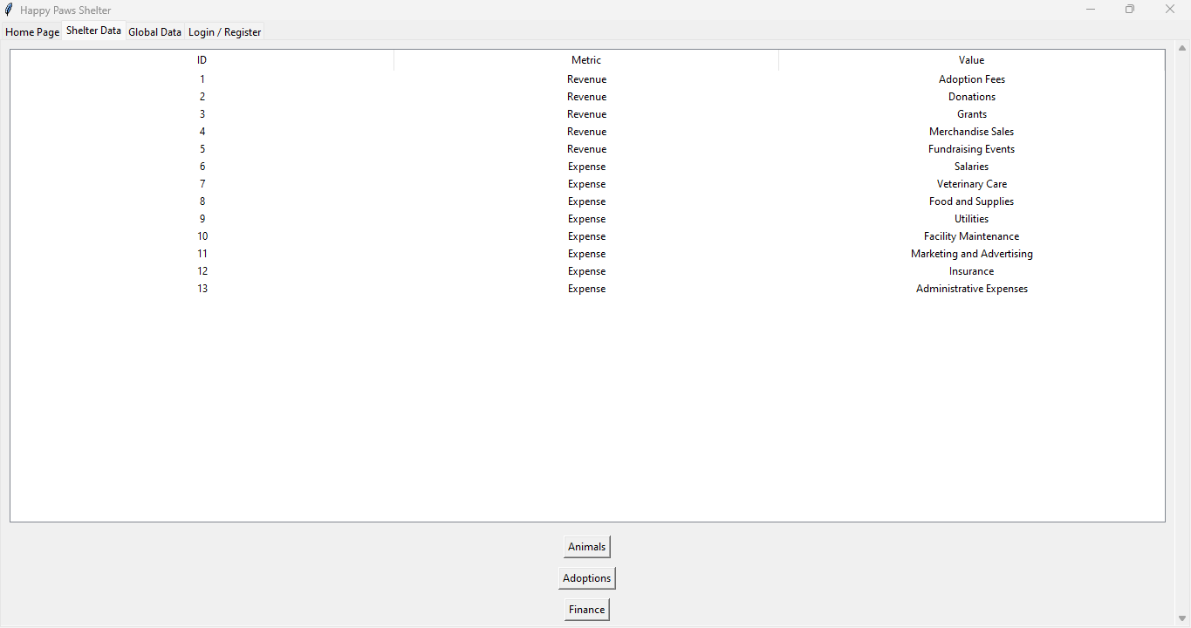

Screenshot 3: Global Data
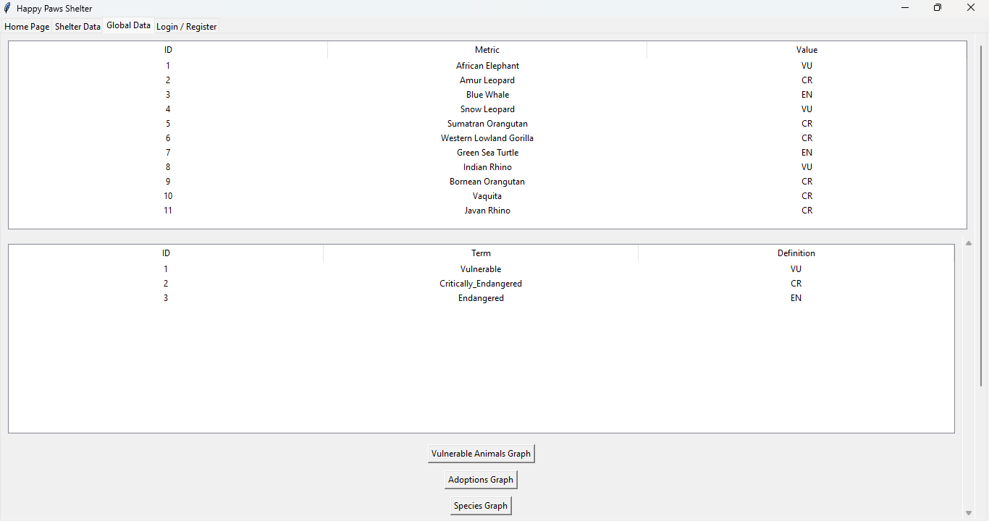

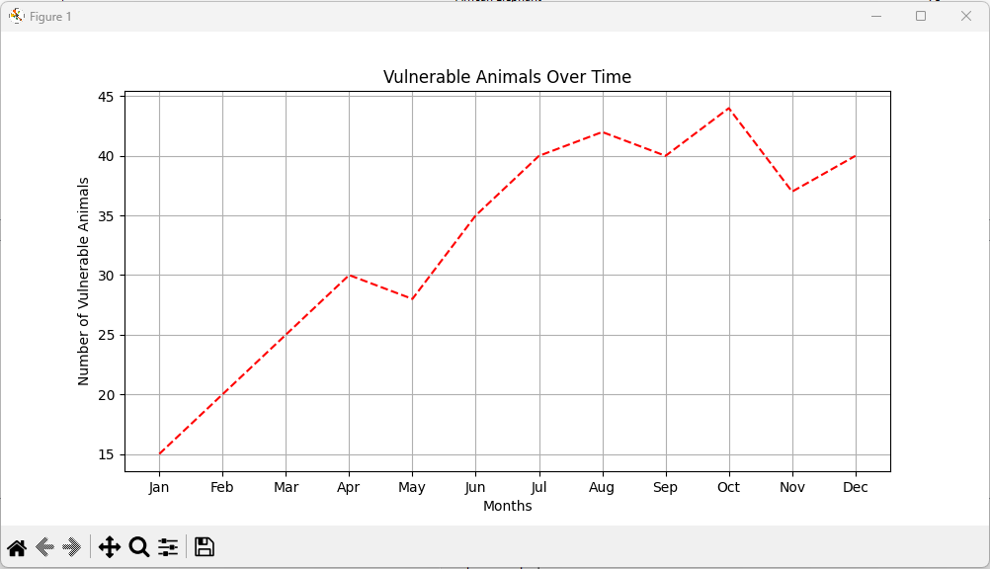

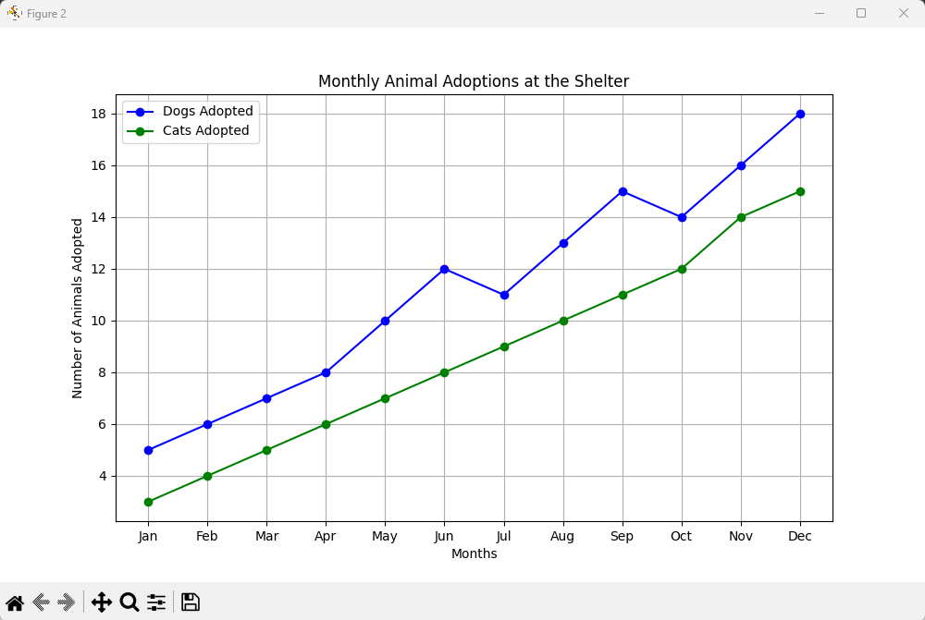

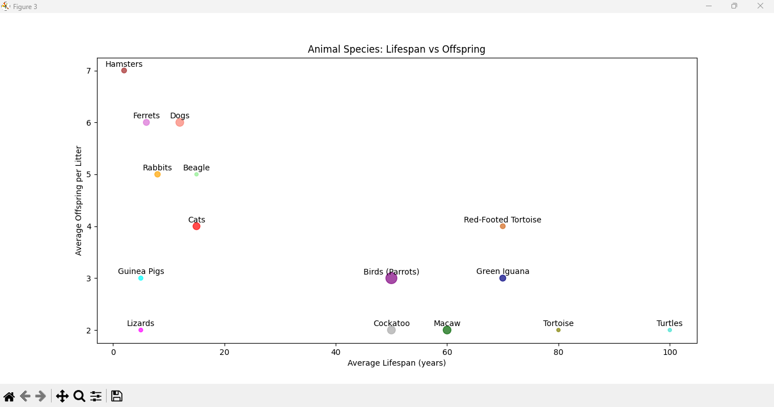

Screenshot 4: Login/Registration
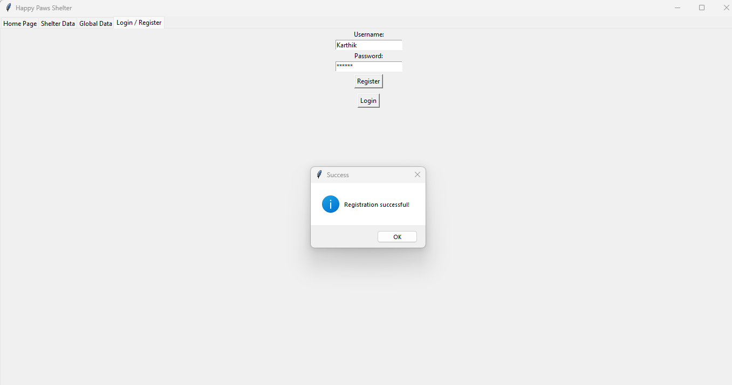
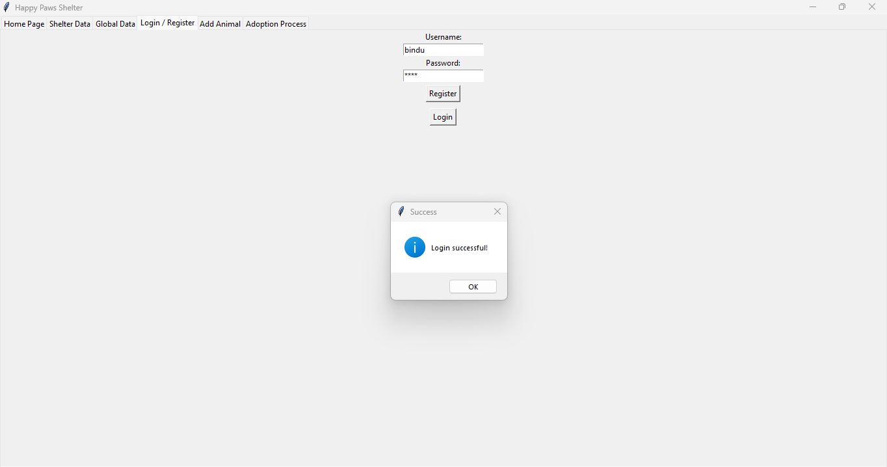

Screenshot 5: Admission of Animal
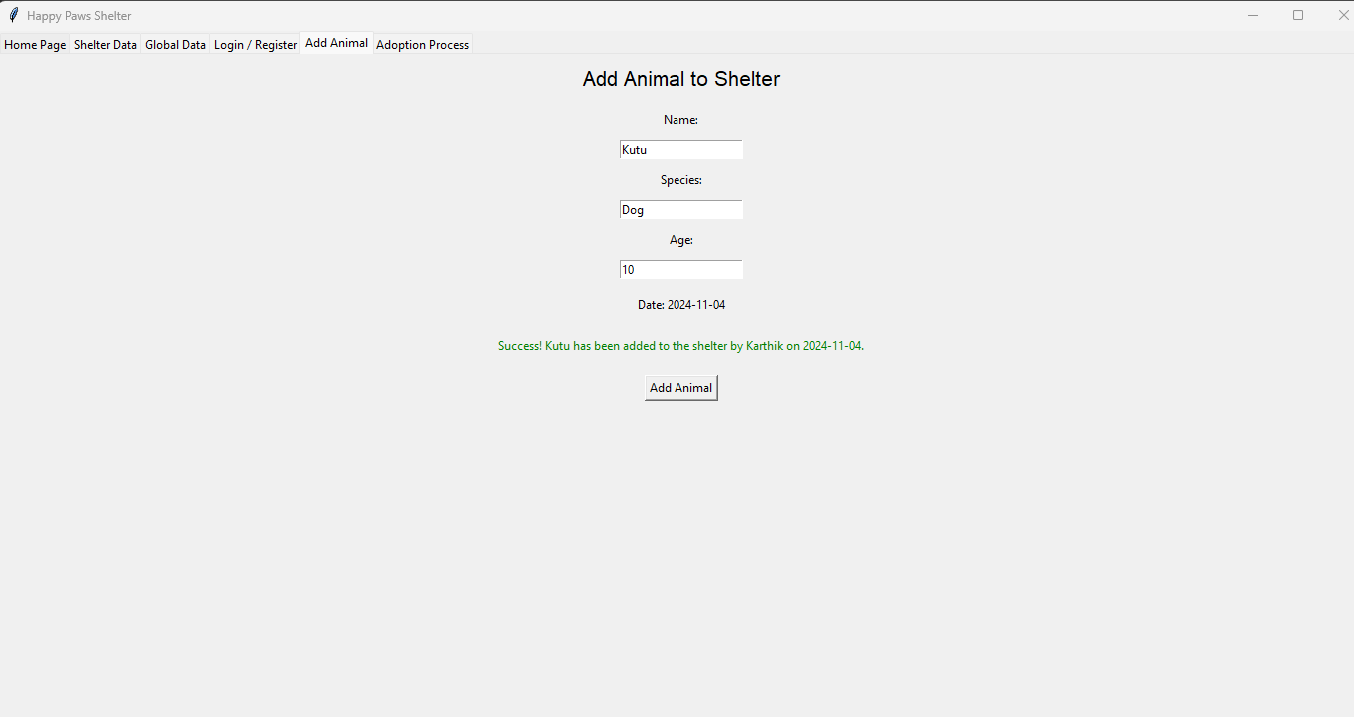

Screenshot 6: Adoption of Animal
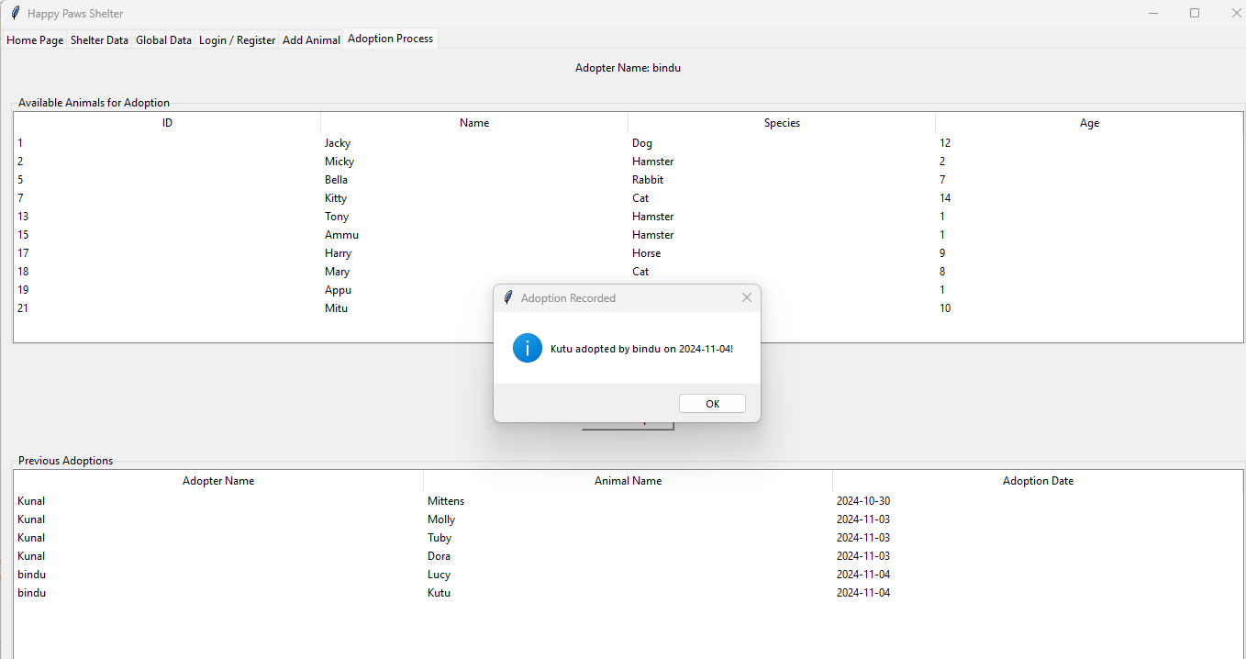

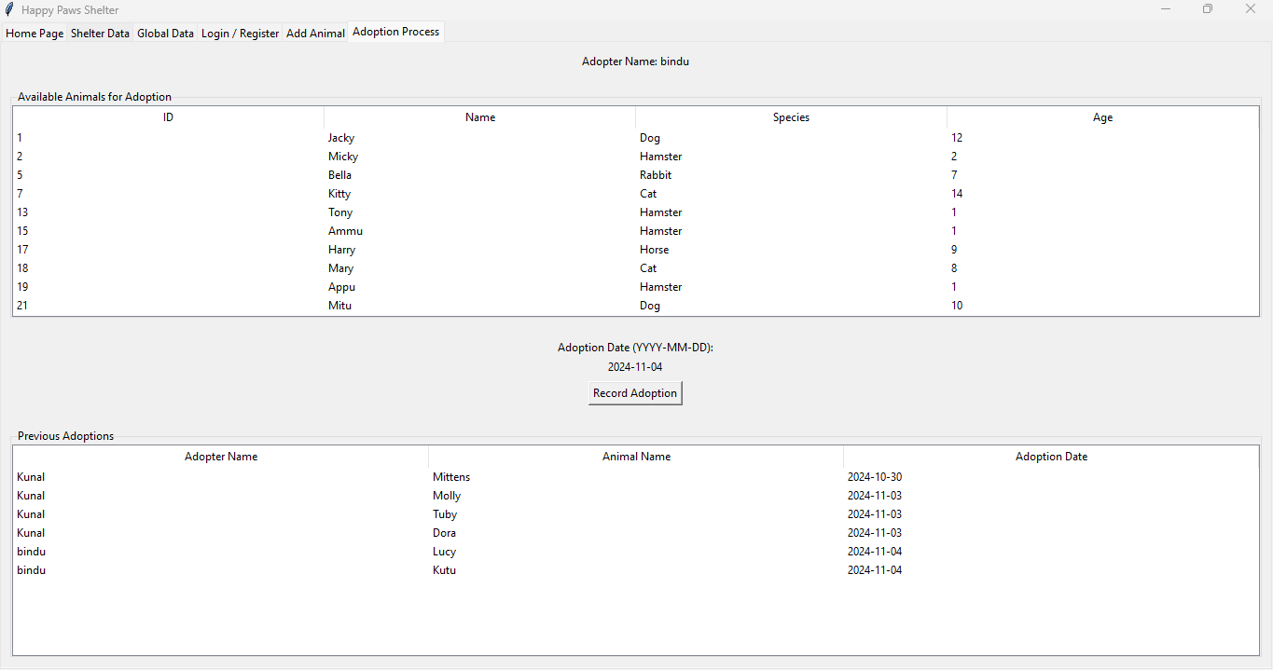

BIBLIOGRAPHY

Internet Resources:
- https://www.dropbox.com/scl/fi/r4nosytel5v8epy6y57tx/Winter-CodeX-2018---The-Python-Wing-%F0%9F%90%8D.paper?dl=0&rlkey=3bxesvz1fg07rafsk3wnz1aye
- https://realpython.com/python-mysql/
- https://realpython.com/python-sql-libraries/
- https://dev.mysql.com/doc/connector-python/en/connector-python-example-connecting.html
- https://www.javatpoint.com/python-mysql-database-connection

Textbooks:
- Computer Science with Python By Sumita Arora
- How to Think like a Computer Scientist - Learning with Python By Allen Downey, Jeffrey Elkner, Chris Meyers

