1. **RFQ System (customer account creation)**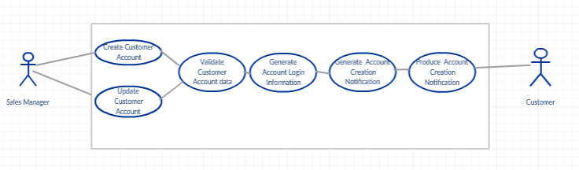
2. **RFQ System (search parts)**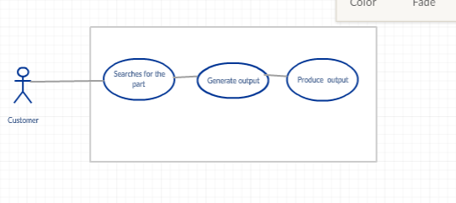
3. **RFQ System(create RFQ)**  
     
   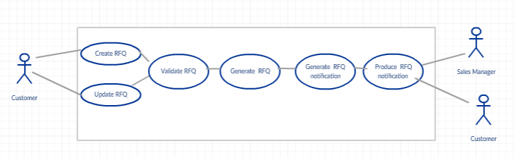
4. **RFQ System(Sales Quote creation)**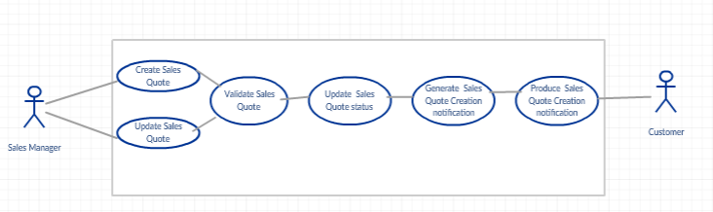
5. **RFQ System (submitted sales quote to customer)**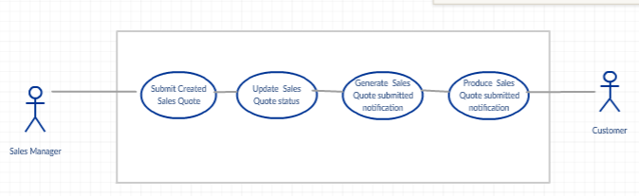
6. **RFQ system (sales order creation and notification generation)**  
   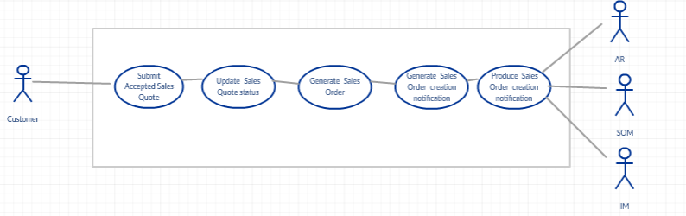
7. **RFQ System(sales quote rejection)**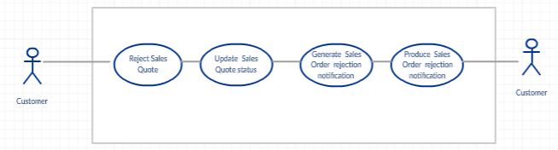
8. **RFQ System (generate detailed RFQ)**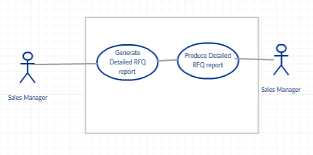
9. **RFQ System (generate summary RFQ)**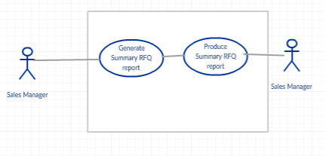
10. **RFQ system (Generate detailed Sales Order Report)**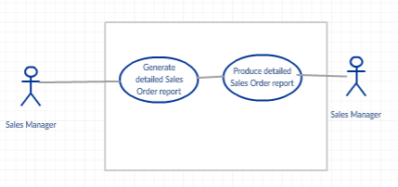
11. **RFQ system (Generate summary Sales Order Report)**  
      
      
    