**Part 1:  
Create a new item**   
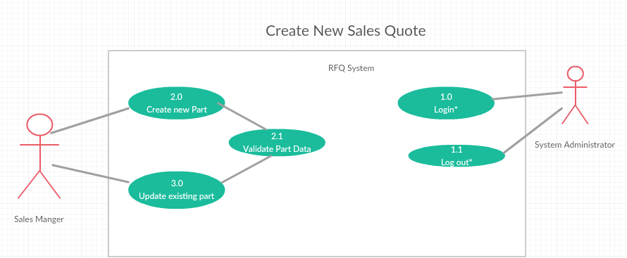

**Create a new Sales Quote**

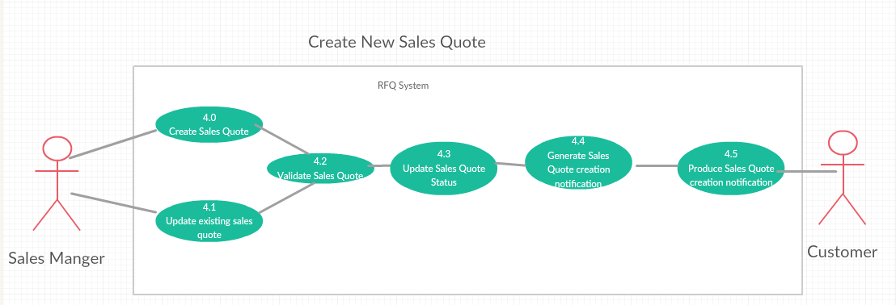

**Part 2:  
Create a new part**

|  |  |
| --- | --- |
| Use case Name: | Create New Part |
| ID: | 2.0 |
| Summary: | The RFQ System must allow an authorized sales manager to create a new airplane inventory part. Each inventory part contains a unique part number, part name, barcode, part description, quantity, listing/selling price (may be blank), manufacturer name, image(s) and comments. (New) |
| Primary Actor(s): | Authorized Sales Manager |
| Secondary Actor(s): | None |
| Precondition(s): | The Sales Manager successfully logged into the RFQ System (1.0). |
| Main flow: | 1. This use case starts when the Primary actor selects the “Create new part”. 2. The System displays the Create Part Page. 3. The system auto generates and auto-fill part Number. 4. The primary actor enters  part name barcode  part description quantity listing/selling price (optional) manufacturer name images comments(optional) in the respective fields of Create Part Page. 5. The primary actor chooses “Create part” button. 6. The system validates the part data to make sure required field is not empty and meets all requirements (2.1) 7. The system then displays a message “Part Created” |
| Post Condition(s): | 1. The User clicks the confirmation message after creation of part 2. The primary actor recieves the part creation notification 3. The system creates the part object and stores in the database. |
| Alternative Flows/Exceptions: | Cancel |

**Create a new sales quote**

|  |  |
| --- | --- |
| Use case Name: | Create New Sales Quote |
| ID: | 4.0 |
| Summary: | The RFQ system must allow an authorized sales manager to create a sales quote for a selected customer with an RFQ with the “Created” status. The sales manager must be able to select an RFQ associated with the selected customer. For each part on the RFQ, the sales manager must be able to indicate the date GPS can provide the part and the price for that part. After the manager confirms to create the sales quote, the system generates the sales quote, which contains a unique sales quote number, the date the quote was created, the part number, part description, part image(s), the quantity, the date that GPS can provide the part, the price and the date the quote expires (30 days from the sales quote date.) The system also sets the sales quote status to “Created.” |
| Primary Actor(s): | Authorized Sales Manager |
| Secondary Actor(s): | Authorized Customer |
| Precondition(s): | 1. The Sales Manager successfully logged into the RFQ System. 2. The customer should exist in the system. 3. The customer account type should be “Manual”. 4. The requested part should exist in the system. 5. The RFQ should exist in system. |
| Main flow: | 1. This use case starts when the Primary actor selects a created RFQ. 2. The System displays the RFQ details Unique RFQ number Quantity RFQ status Require Date Part Number 3. For each part found on the selected RFQ 3.1 The primary actor indicates the date GPS can provide the part 3.2 The primary actor indicates the price for the part 4. The primary actor chooses “Create Sales quote” button. 5. The system validates the sales quote data to make sure it is not empty and meet its requirements (4.2) 6. The system generates sales quote containing unique sales quote number date the quote was created part number part description part image(s) quantity date that GPS can provide the part price date the quote expires 7. The System updates the Sales Quote status to “Created” (4.3). 8. The system generates Sales Quote creation notification (4.4). 9. The System produces the Sales Quote creation notification (4.5) 10. The System display a message “Sales Order created” |
| Post Condition(s): | 1. The primary actor clicks the confirmation message after creation of sales quote 2. The primary actor recieves the sales quote creation notification 3. The system creates the part object and stores in the database. |
| Alternative Flows/Exceptions: | Cancel |