CarWise: Used Car Price Prediction & Market Analysis
Mini Project Report
Submitted in fulfillment of the requirements
for the degree of
Bachelor of Technology
in
Information Technology
TE B.TECH INFT SEM V
by
Shanbhag Ankita (24101C0017)
Gupta Shweta (24101C0018)

Project Guide
Prof. Shruti Agarwal


Department of Information Technology
Vidyalankar Institute of Technology
Wadala (E), Mumbai – 400037
(Affiliated to University of Mumbai)
2026-2027
Certificate
This is to certify that the project entitled
“CarWise: Used Car Price Prediction & Market Analysis”
is a bonafide work done by
Shanbhag Ankita (24101C0017)
Gupta Shweta (24101C0018)
and is submitted in fulfillment of the requirement for
TE B.TECH INFT SEM V
to the
Vidyalankar Institute of Technology, Wadala, Mumbai.

Project Guide
Head of the Department |  | Principal

Report Approval for T.Y. B.Tech.
This is to certify that the dissertation entitled “CarWise: Used Car Price Prediction & Market Analysis” is a Bonafide work done by Ankita Shanbhag, Shweta Gupta under the supervision of Prof. Shruti Agarwal. This report has been approved for the T.Y. B.Tech. in Information Technology, Vidyalankar Institute of Technology, Wadala, Mumbai.

Examiners:
1.
2.

Date:
Place:
Declaration
I declare that this written submission represents my ideas in my own words and where others’ ideas or words have been included, I have adequately cited and referenced the original sources. I also declare that I have adhered to all principles of academic honesty and integrity and have not misrepresented or fabricated or falsified any idea/data/fact/source in my submission. I understand that any violation of the above will be cause for disciplinary action by the Institute and can also evoke penal action from the sources which have thus not been properly cited or from whom proper permission has not been taken when needed.

1. Shanbhag Ankita (24101C0017)
2. Gupta Shweta (24101C0018)

Date:
Place:
Acknowledgement
We would like to express our sincere gratitude to our project guide, Dr. / Prof. Shruti Agarwal, for the guidance, encouragement and constructive feedback that we received throughout this mini project. We are thankful to the Head of the Department of Information Technology and the Principal of Vidyalankar Institute of Technology for providing the academic environment and resources needed to explore this Data Warehousing and Mining problem. We also thank the faculty members and laboratory staff of the department for their support, and our families and friends for their constant encouragement.

Shanbhag Ankita (24101C0017)
Gupta Shweta (24101C0018)

Abstract
Pricing a used car fairly is difficult because depreciation depends on age, usage, brand, transmission, fuel type and ownership history. This project, CarWise, applies data warehousing and mining techniques to the CarDekho used-car dataset to analyse the market and estimate selling prices. The raw data of 4,340 records was cleaned by removing 763 duplicate rows, deriving a car-age feature from the model year and extracting the brand from the car name, which left 3,577 records with seven predictive features. Exploratory analysis showed a right-skewed price distribution and a steady fall in price with vehicle age. K-Means clustering on scaled attributes, with K = 3 chosen by the elbow method, divided the market into Budget Daily Drivers (45.0%), Optimal Commuters (52.4%) and Premium Low-Mileage cars (2.6%). Linear Regression, Decision Tree and Random Forest regressors were trained on an 80/20 split of the data. Random Forest performed best on unseen data, with a test MAE of ₹1,57,686, an RMSE of ₹3,63,871 and an R² of 0.589, while both tree-based models fitted the training data far more closely than the test data. The selected model is deployed in an interactive Streamlit application that offers price prediction, market analysis, segmentation and model insights.
Keywords: Used car price prediction, Data mining, K-Means clustering, Random Forest, Streamlit
Contents
Abstract vi
List of Figures viii
List of Tables ix
Abbreviations x
Chapter 1 Introduction 1
1.1 Background 1
1.2 Motivation 1
1.3 Problem Statement 2
1.4 Objectives 2
1.5 Scope of the Work 2
1.6 Organization of the Report 3
Chapter 2 Literature Survey 4
2.1 Review of Existing Work 4
2.2 Summary of Literature 4
2.3 Research Gaps 5
Chapter 3 Proposed Methodology 7
3.1 System Architecture 7
3.2 Dataset Description 7
3.3 Algorithm / Model Description 9
3.3.1 Performance Metrics 10
3.4 System Design and Implementation 11
3.5 Tools and Technologies Used 11
Chapter 4 Results and Discussion 12
4.1 Experimental Setup 12
4.2 Results 12
4.2.1 Exploratory Data Analysis 12
4.2.2 Car Segmentation with K-Means 14
4.2.3 Feature Importance 14
4.2.4 Testing of the Application 15
4.3 Comparison with Existing Methods 16
4.4 Link of GitHub Repository 17
Chapter 5 Conclusion and Future Scope 18
5.1 Conclusion 18
5.2 Future Scope 18
Chapter 6 List of Publications 19
6.1 List of Published Papers 19
6.2 Details of Participation in Project Competitions 19
References 19
Appendix A: Viva Preparation Q&A 20

List of Figures
Figure 3.1: Block diagram of the proposed system 7
Figure 4.1: Distribution of selling price 13
Figure 4.2: Selling price by vehicle age group 13
Figure 4.3: Random Forest feature importance 15
Figure 4.4: Train vs test R² of the three regression models 17

List of Tables
Table 2.1: Summary of literature survey 5
Table 3.1: Dataset description 8
Table 3.2: Attributes of the raw dataset 8
Table 3.3: Data cleaning and transformation steps 9
Table 4.1: Customer segments found by K-Means (K = 3) 14
Table 4.2: Application test cases and results 16
Table 4.3: Performance comparison of the regression models 16

Abbreviations
CSV – Comma-Separated Values
DT – Decision Tree
DWM – Data Warehousing and Mining
EDA – Exploratory Data Analysis
INR – Indian Rupee
LR – Linear Regression
MAE – Mean Absolute Error
ML – Machine Learning
R² – Coefficient of Determination
RF – Random Forest
RMSE – Root Mean Squared Error
UI – User Interface
WCSS – Within-Cluster Sum of Squares

Introduction
Buying or selling a used car involves one difficult question: what is a fair price? Unlike a new car, a used car has no fixed list price. Its value falls over time in a non-linear way and depends on how old it is, how far it has been driven, who made it, how many owners it has had and how it is sold. Buyers risk overpaying and sellers risk underpricing because these factors are hard to weigh by intuition. This project presents CarWise, a data mining and machine learning application that studies the used-car market using the CarDekho dataset and turns the patterns it finds into a price estimation tool. The work covers the full Data Warehousing and Mining (DWM) workflow: data cleaning and transformation, exploratory analysis, clustering, predictive modelling and deployment in an interactive web application.

Background
Used-car prices are influenced by many attributes, including model, age, mileage, brand and fuel type [5]. Online listing platforms such as CarDekho collect these attributes for thousands of vehicles, which makes it possible to learn pricing patterns from data instead of relying on guesswork. Machine learning has therefore been applied to used-car price prediction with several regression methods, and Random Forest is often reported as one of the strongest [3], [5].
Data mining adds value beyond a single price estimate. Clustering can reveal natural groups in the market, such as low-priced older cars and expensive low-mileage cars, and exploratory analysis can show how price changes with age. CarWise combines these ideas: it describes the market through exploratory analysis and K-Means segmentation, and it estimates the price of a given car through a trained regression model.

Motivation
Pricing a used car accurately is a constant challenge for buyers and sellers because vehicles depreciate in a non-linear way that depends on usage, manufacturer reliability and ownership history. The motivation of this project is to apply Data Warehousing and Mining techniques to quantify these factors and to produce an objective, data-driven appraisal tool that anyone can use through a simple interface.

Problem Statement
Used-car prices vary significantly with vehicle age, usage, fuel type, transmission, ownership history and seller type. There is no simple rule that combines these factors into a price, and a buyer or seller usually has no way to see how a particular car compares with the rest of the market. This project aims to discover pricing patterns in historical CarDekho listings and to encapsulate them in an interactive application that segments the market and estimates the selling price of a used car.

Objectives
The objectives of this project are:
- To apply robust preprocessing to the CarDekho dataset, including duplicate removal and feature engineering.
- To identify patterns and dependencies between car attributes and selling price through exploratory data analysis.
- To partition the used-car market using K-Means clustering and discover meaningful groupings.
- To train, evaluate and compare Linear Regression, Decision Tree and Random Forest regressors, and to examine how well each generalises to unseen data.
- To implement and test a Streamlit prototype that connects the data workflow, the trained model and the analysis results.

Scope of the Work
Covered. The project covers data preprocessing, exploratory analysis, K-Means clustering, baseline regression models, model evaluation and the design, implementation and testing of a Streamlit application with pages for price prediction, market analysis, car segmentation and model insights.
Not covered, and limitations.
- The system does not use geographic location, so regional price differences are not modelled.
- Accident history, vehicle condition and service records are not part of the dataset and are not considered.
- The system does not update itself with real-time market prices. The dataset reflects past listings, and car age is measured against the dataset’s reference year of 2020.
- Only baseline model settings are used. Extensive hyperparameter tuning and cross-validation are outside the scope of this mini project.

Organization of the Report
The rest of the report is organized as follows. Chapter 2 reviews related work on used-car price prediction. Chapter 3 describes the proposed methodology, including the system architecture, the dataset, the algorithms and metrics, the Streamlit implementation and the tools used. Chapter 4 presents the experimental setup, the results of the analysis and models, the testing of the application and a comparison of the models. Chapter 5 concludes the report and outlines future scope. Chapter 6 lists publications and competitions arising from this work. An appendix with viva preparation questions follows the references.

Literature Survey

Review of Existing Work
Used-car price prediction has been studied with many regression techniques. Venkatasubbu and Ganesh [1] compared multiple regression, lasso regression and regression trees on a small set of 804 cars drawn from the Kelley Blue Book. Monburinon et al. [2] compared Random Forest, gradient boosted regression trees and multiple linear regression on a large German e-commerce listing dataset of 304,133 records after preparation, and found that gradient boosted trees gave the lowest error, followed by Random Forest and then multiple linear regression. Pal et al. [3] used Random Forest with 500 trees on a Kaggle used-car database of more than 370,000 listings and reported higher accuracy than linear regression, with about 95.8% accuracy on the training data and 83.6% on the test data.
Gajera et al. [4] tested K-nearest neighbours, linear regression, Random Forest, Decision Tree and XGBoost on more than 92,000 records and reported that Random Forest gave the lowest RMSE and an R² of 0.93. Gollapalli et al. [5] compared Linear Regression, Random Forest and XGBoost on a Saudi Arabian used-car dataset of 8,248 records collected from the Syarah platform. Random Forest was again the best model, with an R² of 0.82 against 0.74 for Linear Regression and 0.67 for XGBoost, and the authors note that their model applies only to the Saudi market. Most of this work used data from foreign markets, which limits how directly its prices apply to Indian listings.
Two general techniques underpin the methods in this project. Random Forest [6] averages many decorrelated decision trees to reduce the variance of a single tree, and K-Means [7] groups records by minimising the distance between each record and its cluster centre. Both are available in scikit-learn [8], and the overall preprocessing, clustering and modelling workflow follows standard data mining practice [9].

Summary of Literature
Table 2.1 summarizes the literature reviewed.
Table 2.1: Summary of literature survey
Sr. No. | Author(s) & Year | Method / Technique | Dataset | Result | Limitation
1 | Venkatasubbu & Ganesh, 2019 [1] | Multiple regression, lasso regression, regression trees | Kelley Blue Book data, 804 cars | Error rates of the three methods were close, at about 3.5% | Small dataset; no deployed tool described
2 | Monburinon et al., 2018 [2] | Random Forest, gradient boosted trees, multiple linear regression | German e-commerce listings, 304,133 records, 11 features | Gradient boosted trees had the lowest error, then Random Forest, then linear regression | Model parameters not fine-tuned
3 | Pal et al., 2019 [3] | Linear regression and Random Forest (500 trees) | Kaggle used-car database, more than 370,000 listings | Random Forest beat linear regression: 95.82% training and 83.62% test accuracy | Large gap between training and test accuracy
4 | Gajera et al., 2021 [4] | KNN, linear regression, Random Forest, Decision Tree, XGBoost | More than 92,000 records (euro prices) | Random Forest was best: R² of 0.93 | European market data, not Indian listings
5 | Gollapalli et al., 2023 [5] | Linear Regression, Random Forest, XGBoost | Saudi Arabia Used Cars, 8,248 records, 13 features | Random Forest was best: R² of 0.82 (LR 0.74, XGBoost 0.67) | Limited dataset size; valid only for the Saudi market

The studies in rows 1, 2, 3 and 4 are described as reported in the review by Gollapalli et al. [5].

Research Gaps
The reviewed work shows that Random Forest is a strong model for used-car prices, but several gaps remain. Based on Table 2.1 and the discussion in Section 2.1, the following gaps are identified.
1. Foreign-market data. The reviewed studies used data from other markets, such as Saudi Arabia, Germany and Europe. Gollapalli et al. [5] point out that a model trained on one market gives inaccurate prices for another. An open question is how these methods behave on Indian listings such as the CarDekho dataset.
2. Little attention to generalisation. Studies usually report a single accuracy figure. Pal et al. [3] show a large difference between training accuracy (95.82%) and test accuracy (83.62%), which means the training score alone can be misleading. Reporting both training and test results shows how much a model overfits.
3. Prediction without market description. The reviewed work focuses on regression. It does not describe clustering or segmentation to show how the market itself is structured, which would help a user interpret a predicted price.
4. Models stop short of an application. Gollapalli et al. [5] and Monburinon et al. [2] both name a web or real-world application as future work, so a usable tool that connects the data analysis and the model is still missing.
How this project addresses the gaps. CarWise uses an Indian dataset (CarDekho), reports both training and test metrics for three regressors so that overfitting is visible, adds K-Means segmentation and exploratory analysis to describe the market, and delivers everything in a tested Streamlit application.

Proposed Methodology
This chapter describes how CarWise is built, from the raw dataset to the deployed application.

System Architecture
The block diagram of the proposed system is shown in Figure 3.1. The raw CarDekho data is cleaned and transformed into a dataset of 3,577 records with seven features. This dataset feeds three activities: exploratory analysis, K-Means segmentation and regression modelling. The best regression pipeline is saved with joblib, and the Streamlit application loads it together with the saved evaluation results.
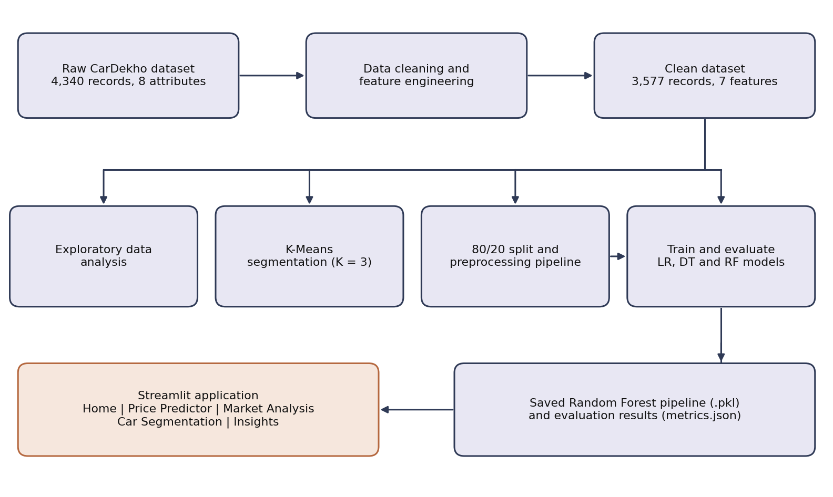
Figure 3.1: Block diagram of the proposed system

Dataset Description
The project uses the publicly available CarDekho used-car dataset [10]. The details of the dataset are given in Table 3.1.
Table 3.1: Dataset description
Parameter | Details
Name of dataset | CarDekho used-car listings (CAR DETAILS FROM CAR DEKHO.csv)
Source | Public dataset [10]
Raw records / attributes | 4,340 records, 8 attributes
Duplicate records removed | 763 identical rows
Records after cleaning | 3,577
Input features / target | 7 features (car_age, km_driven, fuel, seller_type, transmission, owner, brand); target: selling_price
Problem type | Regression (number of classes: not applicable)
Train / Test split | 80% / 20% (2,861 training and 716 test records, random_state = 42)

The raw table has eight attributes, listed in Table 3.2. Of these, name and year are not used directly: brand is extracted from name and car_age is derived from year.
Table 3.2: Attributes of the raw dataset
Attribute | Type | Role
name | String | Identifier (parsed to get brand)
year | Integer | Feature (converted to car_age)
selling_price | Integer | Target variable
km_driven | Integer | Feature
fuel | Categorical | Feature
seller_type | Categorical | Feature
transmission | Categorical | Feature
owner | Categorical | Feature

An initial inspection showed that selling_price is strongly right-skewed and that 763 records were exact duplicates. High-volume public datasets often contain such repeated rows, and leaving them in would let the same record appear in both the training and test sets, which inflates test scores. Table 3.3 lists the cleaning and transformation steps.
Table 3.3: Data cleaning and transformation steps
Issue | Evidence | Action | Reason
Duplicate records | 763 identical rows | Removed completely | Prevents the same record appearing in both training and test sets
Static year | Model year only gives an absolute date | Created car_age = 2020 − year | Expresses age directly instead of an absolute timestamp
High cardinality | More than 1,000 distinct car names | Extracted brand (first word of name) | Avoids a very large, sparse set of one-hot columns
Inconsistent brand names | "Land" and "OpelCorsa" appear as brands | Replaced with "Land Rover" and "Opel" | Merges split or malformed brand labels
Skewed target | selling_price has a long right tail | Kept as is; outliers retained | Premium listings are genuine market data and are not removed

These steps reduce the data from 4,340 to 3,577 records. We chose to keep high-priced listings instead of dropping them as outliers, because they reflect the uneven nature of the real market. The effect of this choice on the error metrics is discussed in Section 4.3.

Algorithm / Model Description
The workflow followed in this project is given step by step below.
- Data loading and cleaning: the CarDekho CSV (4,340 records, 8 attributes) is loaded and the 763 exact duplicate rows are removed, leaving 3,577 records.
- Feature engineering: brand is extracted from the first word of the car name and corrected for "Land" and "OpelCorsa", and car_age is computed as 2020 − year.
- Feature selection: seven input features are used (car_age, km_driven, fuel, seller_type, transmission, owner, brand) and selling_price is the target.
- Exploratory analysis: the price distribution and the relationship between price and vehicle age are examined (Section 4.2.1).
- Segmentation: numerical attributes are scaled with MinMaxScaler and K-Means is run. The Within-Cluster Sum of Squares (WCSS) elbow method gives K = 3.
- Train/test split: the data is split 80/20 with random_state = 42, giving 2,861 training and 716 test records.
- Preprocessing pipeline: car_age and km_driven are standardised with StandardScaler, and fuel, seller_type, transmission, owner and brand are encoded with OneHotEncoder (unknown categories ignored). This produces 43 input columns for the models.
- Model training: Linear Regression (default settings), Decision Tree (random_state = 42) and Random Forest (200 trees, random_state = 42) are trained inside the same pipeline structure.
- Evaluation and selection: MAE, RMSE and R² are computed on the test set, and MAE and R² are also computed on the training set. The model with the lowest test error and highest test R² is selected, which is Random Forest.
- Deployment: the selected pipeline is saved with joblib and loaded by the Streamlit application, which applies the same preprocessing to user input.
Scaling and clustering use the following definitions. StandardScaler transforms a value x using the feature mean μ and standard deviation σ (Equation 3.1), and MinMaxScaler maps a value into the range 0 to 1 (Equation 3.2). MinMax scaling is applied before K-Means because distance-based algorithms would otherwise be dominated by attributes with a larger numeric range, such as km_driven compared with car_age. K-Means chooses cluster centres μ_k that minimise the WCSS in Equation 3.3, where C_k is the set of records in cluster k.
$z=\frac{x-μ}{σ}$ (3.1)
$x'=\frac{x-x_{min}}{x_{max}-x_{min}}$ (3.2)
$WCSS=\sum_{k=1}^{K}{\sum_{x∈C_{k}}{{\left\|x-μ_{k}\right\|}^{2}}}$ (3.3)

Performance Metrics
The regression models are compared using three metrics, defined in Equations 3.4 to 3.6, where yᵢ is the actual price, ŷᵢ is the predicted price, ȳ is the mean actual price and n is the number of records.
$MAE=\frac{1}{n}\sum_{i=1}^{n}{\left|y_{i}-{\hat{y}}_{i}\right|}$ (3.4)
$RMSE=\sqrt{\frac{1}{n}\sum_{i=1}^{n}{{\left(y_{i}-{\hat{y}}_{i}\right)}^{2}}}$ (3.5)
$R^{2}=1-\frac{\sum_{i=1}^{n}{{\left(y_{i}-{\hat{y}}_{i}\right)}^{2}}}{\sum_{i=1}^{n}{{\left(y_{i}-\overline{y}\right)}^{2}}}$ (3.6)
MAE is the average size of the prediction error in rupees. RMSE squares the errors before averaging, so it is more sensitive to a few large mistakes. R² is the fraction of the variation in price that the model explains, with 1 as a perfect fit. Computing these on both the training and test sets shows whether a model has memorised the training data.

System Design and Implementation
The development notebooks cover data understanding, preprocessing and exploratory analysis, clustering and price prediction. Their finalized logic is moved into reusable Python modules, and the Streamlit application (app.py) is organised into five pages: Home, Price Predictor, Market Analysis, Car Segmentation and Insights. Prices are formatted in Indian Rupees (INR) with Indian digit grouping.
The trained Random Forest pipeline is saved as a single joblib file that contains the preprocessing steps and the model. When a user enters a car’s details in the Price Predictor, the application builds a one-row table with the same seven features, and the pipeline applies exactly the same scaling and one-hot encoding that was used in training before predicting. Because the pipeline predicts the price directly, no inverse transformation of the output is needed. The Insights page shows the model comparison metrics and feature importances taken from the evaluation results saved by the price prediction notebook (metrics.json), so the application and this report present the same numbers.

Tools and Technologies Used
- Programming language: Python 3
- Libraries / frameworks: pandas and NumPy for data handling; scikit-learn (pipelines, preprocessing, K-Means and the three regressors); Matplotlib, Seaborn and Plotly for visualisation; joblib for saving the model; Streamlit for the web interface
- Environment: Jupyter notebooks run on Google Colab for analysis and model training
- Hardware: standard personal computer; no GPU was required

Results and Discussion
This chapter presents the experimental setup, the results of the analysis, segmentation and application testing, and a comparison of the three regression models.

Experimental Setup
All experiments use the cleaned dataset of 3,577 records and the same train/test split, so that the models are compared fairly. The settings are:
- Data split: 80% training (2,861 records) and 20% test (716 records), random_state = 42.
- Preprocessing: StandardScaler on car_age and km_driven; OneHotEncoder with unknown categories ignored on the five categorical features, giving 43 model input columns.
- Models: LinearRegression with default settings; DecisionTreeRegressor with random_state = 42; RandomForestRegressor with 200 trees, random_state = 42 and n_jobs = -1.
- Clustering: MinMaxScaler followed by K-Means with K = 3, chosen from the WCSS elbow curve.
- Metrics: MAE, RMSE and R² on the test set, and MAE and R² on the training set.
- Software: Python with scikit-learn 1.6.1 (the version used to save the final model) on Google Colab.

Results

Exploratory Data Analysis
Visual analysis of the 3,577 cleaned records shows how individual features relate to price. Figure 4.1 shows the distribution of selling prices. It is strongly right-skewed: most listings sit below about ₹10 lakh, and a small number of premium vehicles form a long tail.
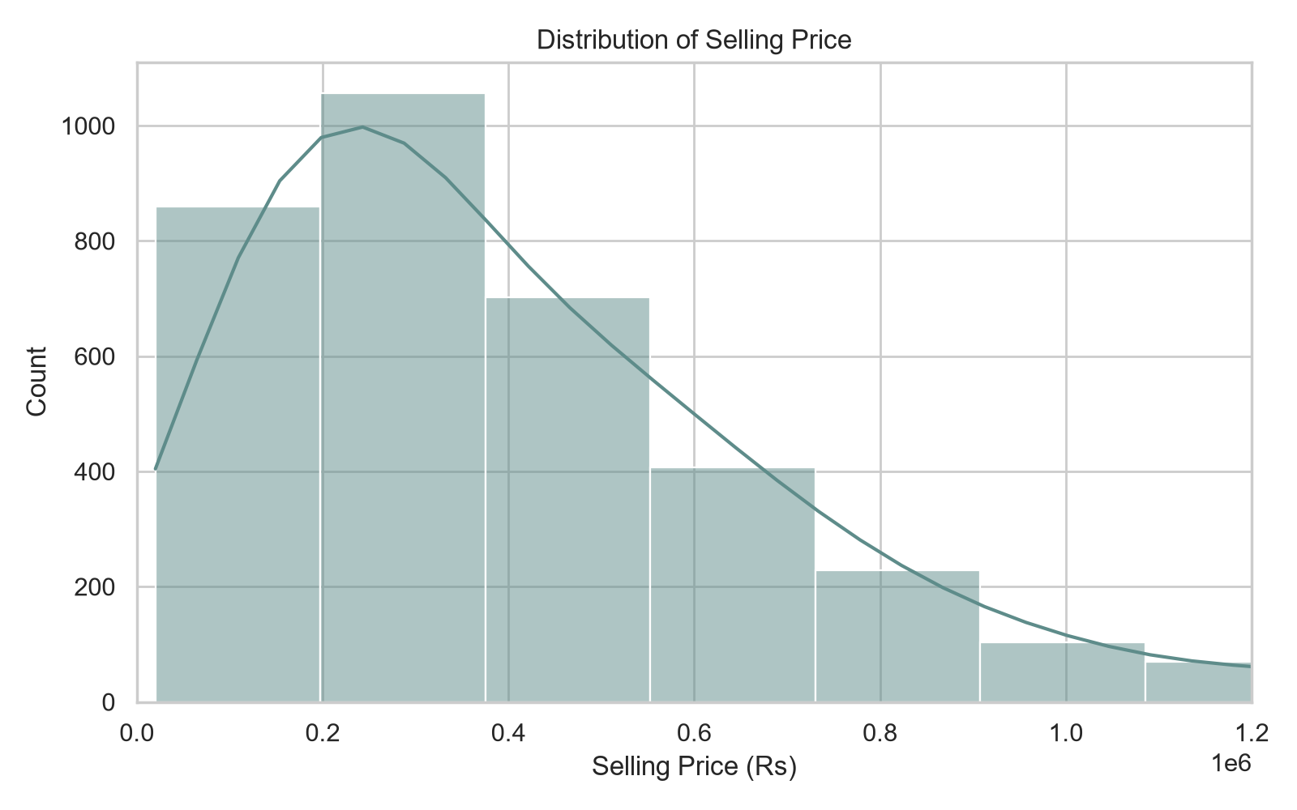
Figure 4.1: Distribution of selling price
Figure 4.2 groups the cars by age. The median price falls at every step, from roughly ₹6.5 lakh for cars up to 3 years old to under ₹1 lakh for cars older than 15 years, and the spread of prices narrows with age. Older groups also contain many high-priced outliers, which are listings priced well above their age group.
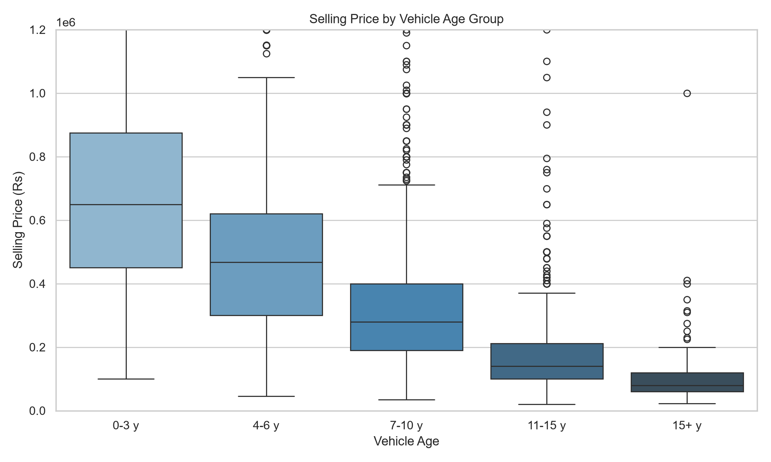
Figure 4.2: Selling price by vehicle age group
What this tells us: the market consists of a large budget majority and a narrow premium segment, and age is a clear driver of price. The skew also means a few expensive cars can dominate squared-error metrics, which is discussed in Section 4.3.

Car Segmentation with K-Means
To see how the vehicle market divides naturally, K-Means clustering was applied after MinMax scaling. The WCSS elbow method gave K = 3. The segments are summarised in Table 4.1.
Table 4.1: Customer segments found by K-Means (K = 3)
Segment | Share of records | Avg. price | Avg. age (years) | Avg. km driven
Budget Daily Drivers | 45.0% | ₹2,50,929 | 10.6 | 99,531
Optimal Commuters | 52.4% | ₹5,53,302 | 4.2 | 44,193
Premium Low-Mileage | 2.6% | ₹27,34,397 | 3.8 | 49,944

What this tells us: the market splits into three groups. Older, high-mileage cars at low prices form a large budget segment, and newer, lower-mileage cars at mid prices form the biggest segment, the Optimal Commuters. A very small premium segment is clearly separated from both.

Feature Importance
Figure 4.3 shows the importance of each original feature in the final Random Forest model, with the importance of one-hot columns added back to their parent feature. Transmission (24.8%), brand (24.0%) and car age (22.2%) are close to each other and together account for about 71% of the total. Kilometres driven (13.4%) and fuel type (11.6%) follow, while seller type (2.3%) and owner history (1.8%) contribute little. The values are rounded and sum to about 100%.
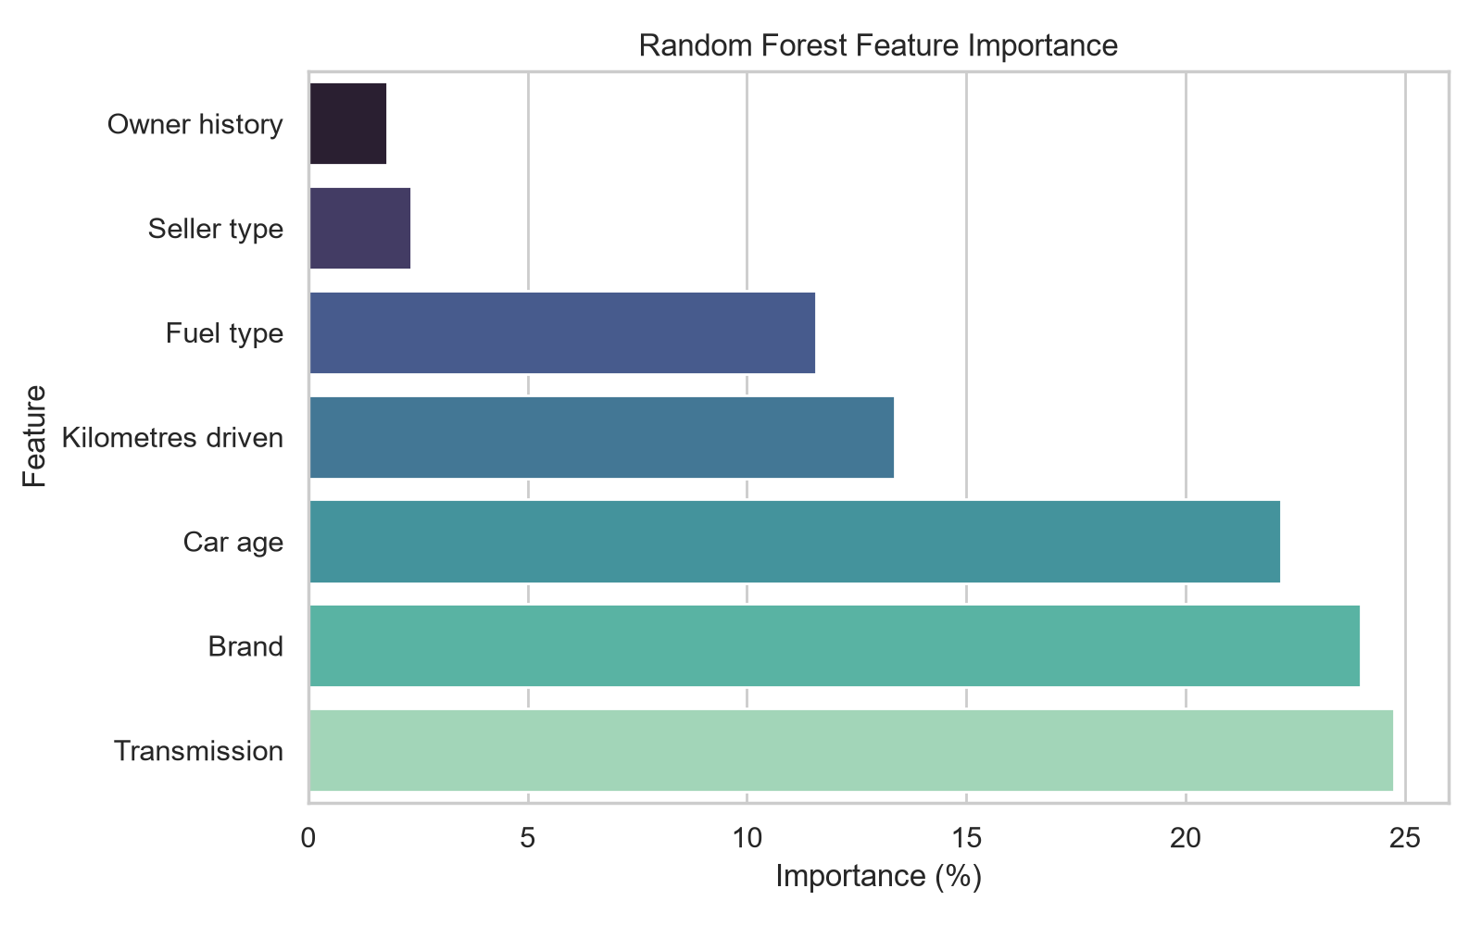
Figure 4.3: Random Forest feature importance
Impurity-based importance should be read with care. Car age and kilometres driven are correlated, so their effects overlap, and brand is split over 27 one-hot columns before being added back together. The ranking shows what the forest used most, not a strict measure of how much each factor causes price changes.

Testing of the Application
The application was tested against normal, invalid and boundary inputs, and the saved model was checked for reproducibility. The results are in Table 4.2.
Table 4.2: Application test cases and results
Test case | Input / condition | Result / status
Standard input | Audi, 2016, 47,000 km, Manual, fuel entered as Electric | Prediction displayed without errors. Electric is not a fuel type in the training data (CNG, Diesel, LPG, Petrol); the encoder ignores unknown categories, so this input has no fuel effect
Negative kilometres | −1,000 km | Blocked by the input widget’s minimum value
Missing field | Prediction requested with an empty field | Caught; the interface shows an error message instead of failing
Application run | streamlit.testing.v1.AppTest execution | Passed; no exceptions raised during the workflow
Saved model reload | Maruti, 5 years old, 50,000 km, Petrol, Individual, Manual, First Owner | The reloaded joblib pipeline predicts ₹2,60,721, identical to the notebook output

The first test also shows a weakness: a fuel type outside the training categories is accepted silently. Restricting the input choices to the trained categories is listed as future work.

Comparison with Existing Methods
Linear Regression and Decision Tree serve as baseline methods against which the Random Forest model is compared. Table 4.3 gives the results on the same split. The Random Forest model has the lowest test MAE and RMSE and the highest test R².
Table 4.3: Performance comparison of the regression models
Method | Train MAE (₹) | Test MAE (₹) | Test RMSE (₹) | Train R² | Test R²
Linear Regression | 1,62,856 | 1,79,643 | 3,84,722 | 0.661 | 0.541
Decision Tree | 17,137 | 1,95,085 | 4,71,391 | 0.989 | 0.310
Random Forest (proposed) | 61,687 | 1,57,686 | 3,63,871 | 0.943 | 0.589

Compared with Linear Regression, Random Forest lowers the test MAE by about ₹22,000 (12%) and the test RMSE by about ₹21,000 (5%), and raises R² from 0.541 to 0.589. The Decision Tree is the weakest on unseen data. Its test R² is only 0.310 against a training R² of 0.989, and its test MAE is about eleven times its training MAE, which is a clear case of overfitting.
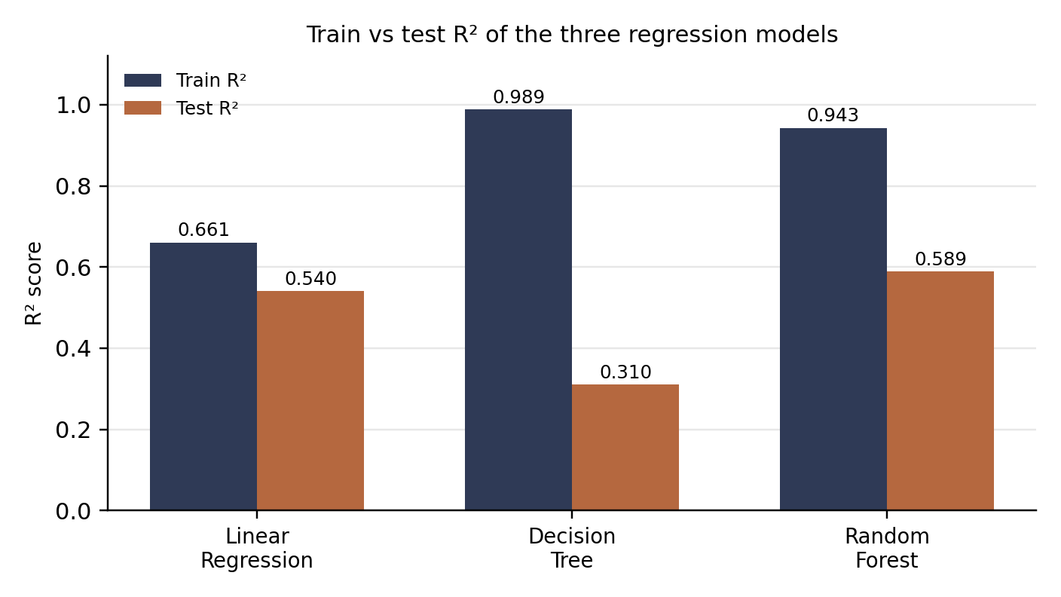
Figure 4.4: Train vs test R² of the three regression models
Random Forest also overfits: its training R² of 0.943 is far above its test R² of 0.589, and its training MAE (₹61,687) is about 2.6 times its test MAE. It is still the best choice because its test performance is the best of the three, but the gap shows that its training score should not be quoted as its accuracy. Linear Regression shows the smallest gap (0.661 against 0.541), but it cannot capture the non-linear relationships in the data and so has the largest error among the models other than the Decision Tree.
The test RMSE of the Random Forest (about ₹3.6 lakh) is more than twice its test MAE (about ₹1.6 lakh). This difference indicates that a few large errors, mostly on expensive vehicles, have a strong effect on squared-error metrics. Predictions for premium cars are therefore less reliable than for mainstream cars.
Limitations. An R² of 0.589 means that about 41% of the variation in price is not explained by the model. The dataset has no location, condition or accident information, so the model implicitly assumes average condition. The models use baseline settings, a single train/test split and no cross-validation, and the data reflects 2020-era prices.

Link of GitHub Repository

https://github.com/ankita01209/dwm-project

Conclusion and Future Scope

Conclusion
CarWise applies the Data Warehousing and Mining workflow to the CarDekho used-car dataset. The data was cleaned from 4,340 to 3,577 records, exploratory analysis showed a right-skewed price distribution and a steady fall of price with age, and K-Means divided the market into three segments: Budget Daily Drivers, Optimal Commuters and Premium Low-Mileage cars. Three regression models were compared on the same split. Random Forest gave the best test performance, with an MAE of ₹1,57,686, an RMSE of ₹3,63,871 and an R² of 0.589, and it was deployed in a tested Streamlit application. All five objectives of the project were met.
The results also show the limits of the approach. Both tree-based models fit the training data much better than the test data, and about 41% of price variation is unexplained, so the application gives an estimate to guide a decision and not an exact valuation.

Future Scope
- Test a log transformation of the selling price as the modelling target, since the price distribution is strongly skewed, and compare it with the current setup. The scikit-learn TransformedTargetRegressor [12] supports this.
- Reduce overfitting by tuning hyperparameters such as tree depth and minimum samples per leaf with cross-validation, and try gradient boosting models.
- Add model explanations, such as SHAP values or permutation importance, so users can see why a price was predicted.
- Include location, vehicle condition and accident history, and refresh the data with recent listings.
- Restrict the input choices in the application to the categories seen in training, and deploy the application online.

List of Publications

List of Published Papers
None at the time of submission

Details of Participation in Project Competitions
None at the time of submission.

References
- P. Venkatasubbu and M. Ganesh, “Used cars price prediction using supervised learning techniques,” Int. J. Eng. Adv. Technol., vol. 9, no. 1S3, pp. 216–223, 2019, doi: 10.35940/IJEAT.A1042.1291S319.
- N. Monburinon, P. Chertchom, T. Kaewkiriya, S. Rungpheung, S. Buya, and P. Boonpou, “Prediction of prices for used car by using regression models,” in Proc. 5th Int. Conf. Business and Industrial Research (ICBIR), 2018, pp. 115–119, doi: 10.1109/ICBIR.2018.8391177.
- N. Pal, P. Arora, P. Kohli, D. Sundararaman, and S. S. Palakurthy, “How much is my car worth? A methodology for predicting used cars’ prices using random forest,” in Advances in Information and Communication Networks (FICC 2018), Adv. Intell. Syst. Comput., vol. 886. Cham, Switzerland: Springer, 2019, doi: 10.1007/978-3-030-03402-3_28.
- P. Gajera, A. Gondaliya, and J. Kavathiya, “Old car price prediction with machine learning,” Int. Res. J. Mod. Eng. Technol. Sci., vol. 3, pp. 284–290, 2021.
- M. Gollapalli et al., “Intelligent modelling techniques for predicting used cars prices in Saudi Arabia,” Math. Model. Eng. Probl., vol. 10, no. 1, pp. 139–148, 2023, doi: 10.18280/mmep.100115.
- L. Breiman, “Random forests,” Mach. Learn., vol. 45, no. 1, pp. 5–32, 2001.
- J. MacQueen, “Some methods for classification and analysis of multivariate observations,” in Proc. 5th Berkeley Symp. Math. Statist. Probab., vol. 1, 1967, pp. 281–297.
- F. Pedregosa et al., “Scikit-learn: Machine learning in Python,” J. Mach. Learn. Res., vol. 12, pp. 2825–2830, 2011.
- J. Han, M. Kamber, and J. Pei, Data Mining: Concepts and Techniques, 3rd ed. Waltham, MA, USA: Morgan Kaufmann, 2012.
- CarDekho used-car listings dataset (“CAR DETAILS FROM CAR DEKHO.csv”), publicly available dataset.
- Streamlit Inc., “Streamlit documentation.” [Online]. Available: https://docs.streamlit.io
- scikit-learn developers, “Transforming target in regression,” scikit-learn user guide. [Online]. Available: https://scikit-learn.org/stable/modules/compose.html#transforming-target-in-regression

