Module – 4.3 : Employee View Salary History:

Ask the employee to login and then display the salary, the history of salary disbursements, also allow them to download the salary slip of a particular month.

1. Conceptual design:

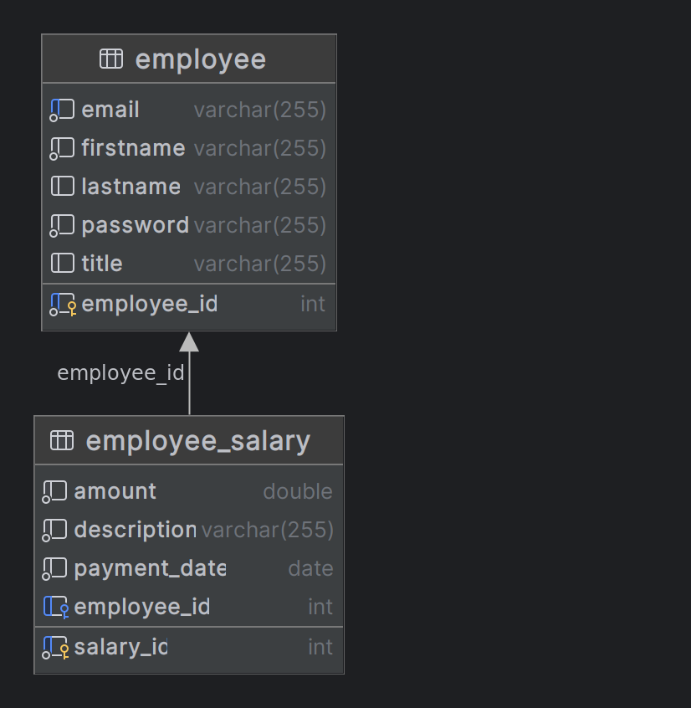

2. Logical design:

Table Name – employee

Name of Column | Data Type | Contraints
employee_id | int | PK, AUTO_INCREMENT
tiltle | varchar(255) | NULL
firstname | varchar(255) | NOT NULL
lastname | varchar(255) | NULL
email | varchar(255) | NOT NULL, UNIQUE
password | varchar(255) | NOT NULL

Table Name – employee_salary

Name of Column | Data Type | Contraints
salary_id | int | PK, AUTO_INCREMENT
amount | double | NOT NULL
description | varchar(255) | NOT NULL
payment_date | date | NOT NULL
employee_id | int | FK REFRENCES employee.employee_id,  NULL

3. Implementation design:

create table academicERP.employee
(
employee_id int auto_increment
primary key,
email varchar(255) not null,
firstname varchar(255) not null,
lastname varchar(255) null,
password varchar(255) not null,
title varchar(255) null,
constraint UK_fopic1oh5oln2khj8eat6ino0
unique (email)
);

create table academicERP.employee_salary
(
salary_id int auto_increment
primary key,
amount double not null,
description varchar(255) not null,
payment_date date not null,
employee_id int null,
constraint FKo7mki93c83b1kx9olp1vmcwcq
foreign key (employee_id) references academicERP.employee (employee_id)
);

INSERT INTO academicERP.employee (employee_id, email, firstname, lastname, password, title) VALUES (1, 'abc@gmail.com', 'abc', 'abc', 'abc', 'Mr');

INSERT INTO academicERP.employee (employee_id, email, firstname, lastname, password, title) VALUES (2, 'def@gmail.com', 'def', 'def', 'def', 'Mr');

INSERT INTO academicERP.employee (employee_id, email, firstname, lastname, password, title) VALUES (3, 'ghi@gmail.com', 'ghi', 'ghi', 'ghi', 'Mr');

INSERT INTO academicERP.employee (employee_id, email, firstname, lastname, password, title) VALUES (4, 'jkl@gmail.com', 'jkl', 'jkl', 'jkl', 'Mr');

INSERT INTO academicERP.employee_salary (salary_id, amount, description, payment_date, employee_id) VALUES (1, 100000, 'Salary of Nov', '2022-11-01', 1);

INSERT INTO academicERP.employee_salary (salary_id, amount, description, payment_date, employee_id) VALUES (2, 110000, 'Salary of Dec', '2022-12-02', 1);

INSERT INTO academicERP.employee_salary (salary_id, amount, description, payment_date, employee_id) VALUES (3, 120000, 'Salary of Jan', '2023-01-01', 1);

INSERT INTO academicERP.employee_salary (salary_id, amount, description, payment_date, employee_id) VALUES (4, 130000, 'Salary of Feb', '2023-02-01', 1);

INSERT INTO academicERP.employee_salary (salary_id, amount, description, payment_date, employee_id) VALUES (5, 140000, 'salary of March', '2023-03-02', 1);

INSERT INTO academicERP.employee_salary (salary_id, amount, description, payment_date, employee_id) VALUES (6, 100000, 'Salary of Nov', '2022-11-01', 2);

INSERT INTO academicERP.employee_salary (salary_id, amount, description, payment_date, employee_id) VALUES (7, 110000, 'Salary of Dec', '2022-12-02', 2);

INSERT INTO academicERP.employee_salary (salary_id, amount, description, payment_date, employee_id) VALUES (8, 120000, 'Salary of Jan', '2023-01-01', 2);

INSERT INTO academicERP.employee_salary (salary_id, amount, description, payment_date, employee_id) VALUES (9, 130000, 'Salary of Feb', '2023-02-01', 2);

INSERT INTO academicERP.employee_salary (salary_id, amount, description, payment_date, employee_id) VALUES (10, 140000, 'salary of March', '2023-03-02', 2);

INSERT INTO academicERP.employee_salary (salary_id, amount, description, payment_date, employee_id) VALUES (11, 100000, 'Salary of Nov', '2022-11-01', 3);

INSERT INTO academicERP.employee_salary (salary_id, amount, description, payment_date, employee_id) VALUES (12, 110000, 'Salary of Dec', '2022-12-02', 3);

INSERT INTO academicERP.employee_salary (salary_id, amount, description, payment_date, employee_id) VALUES (13, 120000, 'Salary of Jan', '2023-01-01', 3);

INSERT INTO academicERP.employee_salary (salary_id, amount, description, payment_date, employee_id) VALUES (14, 130000, 'Salary of Feb', '2023-02-01', 3);

INSERT INTO academicERP.employee_salary (salary_id, amount, description, payment_date, employee_id) VALUES (15, 140000, 'salary of March', '2023-03-02', 3);

INSERT INTO academicERP.employee_salary (salary_id, amount, description, payment_date, employee_id) VALUES (16, 100000, 'Salary of Nov', '2022-11-01', 4);

INSERT INTO academicERP.employee_salary (salary_id, amount, description, payment_date, employee_id) VALUES (17, 110000, 'Salary of Dec', '2022-12-02', 4);
INSERT INTO academicERP.employee_salary (salary_id, amount, description, payment_date, employee_id) VALUES (18, 120000, 'Salary of Jan', '2023-01-01', 4);

INSERT INTO academicERP.employee_salary (salary_id, amount, description, payment_date, employee_id) VALUES (19, 130000, 'Salary of Feb', '2023-02-01', 4);

INSERT INTO academicERP.employee_salary (salary_id, amount, description, payment_date, employee_id) VALUES (20, 140000, 'salary of March', '2023-03-02', 4);

