WEEK 3 TASK REPORT
Unsupervised Learning and Clustering Analysis
Dataset: Iris | Algorithm: K-Means Clustering

1. Objective
Apply an unsupervised learning technique to a public dataset, discover meaningful groups, and interpret their characteristics. K-Means is used to group flower observations using measurements only.

2. Dataset Selection
The Iris dataset contains 150 observations, four numerical measurements (sepal length, sepal width, petal length, petal width), and three known species. Species labels are excluded from model training and used only after clustering to help interpret the result.

3. Tools and Libraries
Python, Pandas, Matplotlib, and Scikit-learn were used. Scikit-learn provides scaling, K-Means, PCA, and evaluation metrics.

4. Methodology
The dataset was loaded and inspected, features were standardized, candidate K values were compared with the Elbow Method and Silhouette Score, and K-Means was fitted with K=3. Cluster sizes and average measurements were summarized. PCA was used to visualize clusters in two dimensions.

5. Preprocessing
StandardScaler was applied to the four numerical features. K-Means relies on distances, so standardizing prevents variables with larger numeric scales from dominating the calculation. The standard Iris dataset has no missing values, so imputation was not required.

6. Rationale for K-Means
K-Means is a common distance-based clustering algorithm. It assigns each observation to the nearest centroid and updates centroids iteratively. It is appropriate for this introductory task because the features are numeric and cluster profiles can be summarized with means.

7. Selecting K
The Elbow Method examines how inertia decreases as K increases; a bend in the curve can indicate diminishing gains. Silhouette Score measures how close observations are to their own cluster compared with neighboring clusters. Both were examined for K=2 through K=7. K=3 was chosen for an interpretable three-group analysis; the known labels were not used to fit the model.
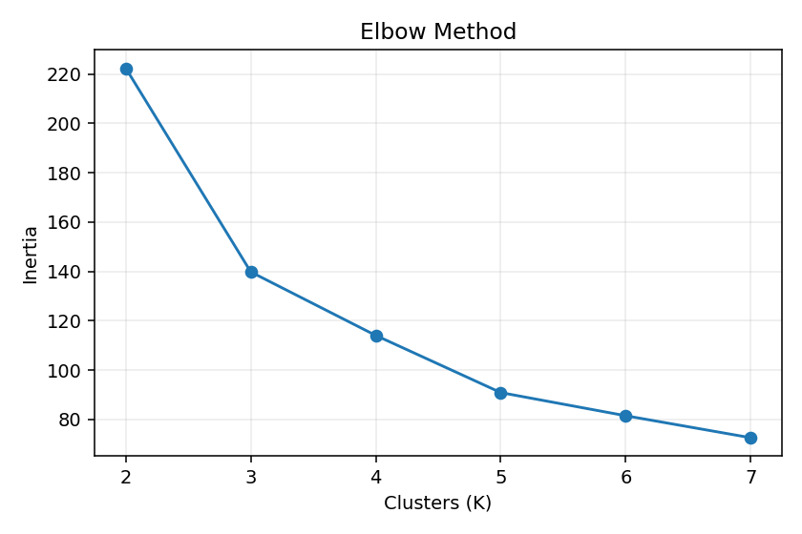
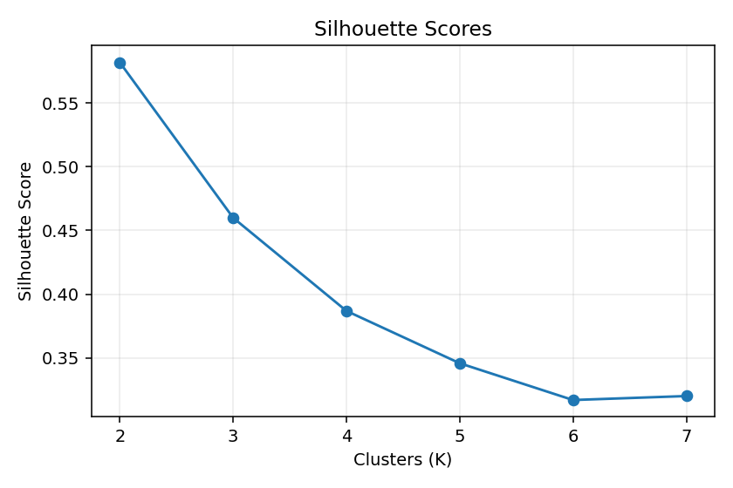

8. Model and Evaluation
The final model used n_clusters=3, random_state=42, and n_init=10. The fixed random state supports reproducibility and multiple initializations reduce dependence on one starting position. The final Silhouette Score was 0.460; scores closer to 1 generally indicate stronger separation. The Adjusted Rand Index (ARI) was 0.620, calculated only as a post-training comparison with known species—not as training input.

9. Cluster Visualization
PCA projects the standardized data into two dimensions for display. K-Means itself was trained on all four standardized features, not on the two PCA components.
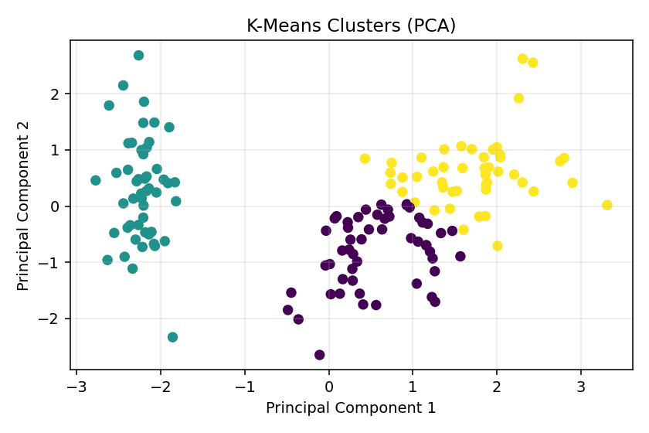
The projection shows visible group structure, with some overlap between clusters. This is expected because real measurements do not always form perfectly separated groups.

10. Cluster Sizes and Profiles
K-Means does not force groups to be equal in size. The bar chart and table below summarize the number of observations and average measurements in each cluster.
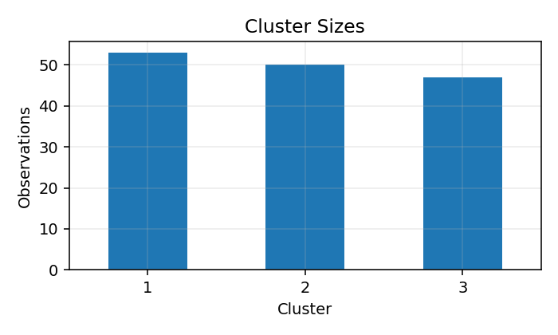
Cluster | Sepal length | Sepal width | Petal length | Petal width | Count
1 | 5.80 | 2.67 | 4.37 | 1.41 | 53
2 | 5.01 | 3.43 | 1.46 | 0.25 | 50
3 | 6.78 | 3.10 | 5.51 | 1.97 | 47
The mean values show that petal length and petal width are important for separating groups. One cluster has substantially smaller petals, while the other two contain flowers with larger and more similar petal measurements.
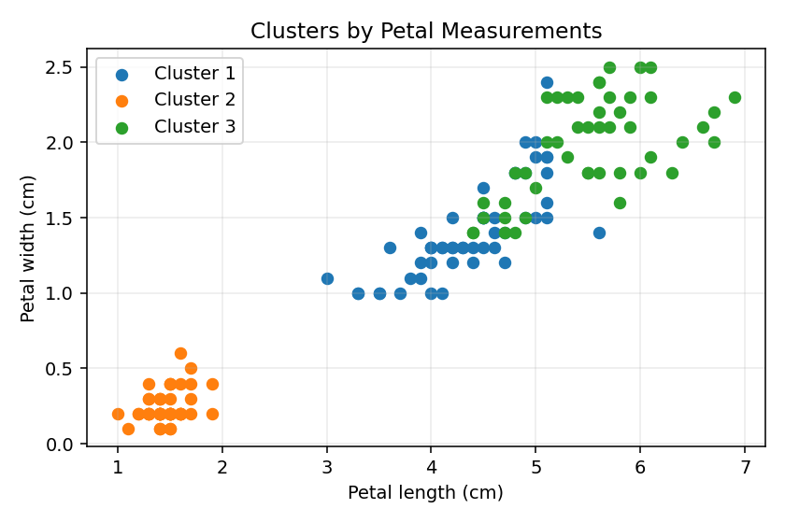

11. Comparison with Known Species
Species labels were not provided to the model. They were compared with cluster assignments only after training to understand the grouping.
species setosa versicolor virginica
cluster
1 0 39 14
2 50 0 0
3 0 11 36
Cluster numbers are arbitrary identifiers and do not inherently correspond to species. The comparison indicates how strongly the data-driven groups align with the known categories, while any mixed cells reflect overlap in measurements.

12. Cluster Interpretation
Cluster profiles can be described by their average sepal and petal measurements. The cluster with the smallest petal averages represents small-petal observations; the remaining clusters represent larger-petal patterns that can overlap. These descriptions come from measured features, not from assigning biological meaning to cluster IDs.

13. Applications
Similar clustering workflows can support customer segmentation, grouping products by measurable attributes, identifying usage patterns, or exploring biological samples when labels are unavailable. Cluster outputs should be validated with domain knowledge before being used for decisions.

14. Challenges and Solutions
Choosing K was addressed by examining inertia and silhouette scores. Feature-scale differences were addressed with standardization. Four-dimensional data was displayed using PCA. Cluster IDs were interpreted through feature averages rather than assuming that cluster numbers have fixed meanings.

15. Limitations
K-Means is sensitive to feature scaling, initialization, outliers, and the chosen K. PCA is a projection and may hide some variation. Iris is a small, clean dataset, so results may not generalize to complex real-world data. Other algorithms, such as hierarchical clustering or DBSCAN, could be explored for comparison.

16. Conclusion
This project applied K-Means to the Iris dataset without using species labels during training. Standardization, Elbow and Silhouette analysis, cluster summaries, and PCA visualization were used to examine the results. The groups show meaningful differences, particularly in petal measurements, though some overlap remains. The exercise demonstrates how unsupervised learning can reveal structure in unlabeled data.

17. References
Scikit-learn documentation for the Iris dataset, K-Means, StandardScaler, PCA, Silhouette Score, and Adjusted Rand Index. Fisher, R. A. (1936), The use of multiple measurements in taxonomic problems, Annals of Eugenics.

18. Complete Python Code
import pandas as pd
import matplotlib.pyplot as plt
from sklearn.datasets import load_iris
from sklearn.preprocessing import StandardScaler
from sklearn.cluster import KMeans
from sklearn.metrics import silhouette_score, adjusted_rand_score
from sklearn.decomposition import PCA

iris = load_iris()
X = pd.DataFrame(iris.data, columns=iris.feature_names)
y = iris.target # Used only after clustering for comparison
Z = StandardScaler().fit_transform(X) # Scale features for distance calculation

inertia, scores = [], []
for k in range(2, 8):
model = KMeans(n_clusters=k, random_state=42, n_init=10)
labels = model.fit_predict(Z)
inertia.append(model.inertia_)
scores.append(silhouette_score(Z, labels))

plt.plot(range(2, 8), inertia, marker="o")
plt.title("Elbow Method"); plt.xlabel("K"); plt.ylabel("Inertia"); plt.show()
plt.plot(range(2, 8), scores, marker="o")
plt.title("Silhouette Scores"); plt.xlabel("K"); plt.ylabel("Score"); plt.show()

model = KMeans(n_clusters=3, random_state=42, n_init=10)
clusters = model.fit_predict(Z)
print("Silhouette Score:", silhouette_score(Z, clusters))
print("Adjusted Rand Index:", adjusted_rand_score(y, clusters))

# PCA is only for plotting; model used all four features
points = PCA(n_components=2).fit_transform(Z)
plt.scatter(points[:, 0], points[:, 1], c=clusters, s=35)
plt.title("K-Means Clusters (PCA)"); plt.xlabel("PC1"); plt.ylabel("PC2"); plt.show()

result = X.copy()
result["cluster"] = clusters + 1
print(result.groupby("cluster").mean())
print(result["cluster"].value_counts().sort_index())

