**ASSESSMENT**

1. For the given Dimensional Modeling, please identify the following:

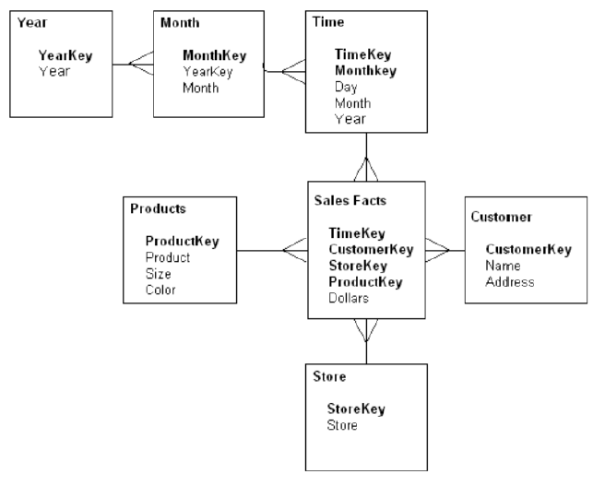

1. How many dimensions and Facts are present?

Above given schema is called snowflakes schema. We have **sales Facts** as a fact table in this schema and **six dimension tables** where two tables (year and Month) are normalized dimension tables.

1. Please identify the cardinality between each table?

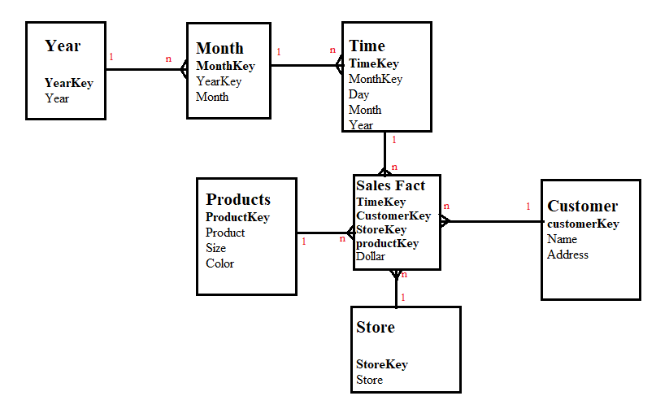

1. How to create a Sales_Aggr fact using the following structure (SQL Statement):

CREATE TABLE Sales_Aggr (SELECT Y.YearKey as YearID, C.CustomerKey as Customer_Key, S.Storekey as Store_key, P.ProductKey as Product_key

FROM Store S, Customer C, Products P, Year y INNER JOIN Month m

ON y.YearKey= m.YearKey

INNER JOIN Time t

ON t.MonthKey = m.MonthKey);

1. Can you Please Modify the above snowflake schema to Star schema and draw the dimension model, showing all the cardinality?
2. For the following dimension Model can you please give an example of Circular Join and how to avoid it:

The following query will create circular join

Select date from date d, sales s where d.date=s.orderDate and d.date=s.salesDate;

We can avoid this by giving two alias name to date attribute as

SELECT S.order_date, S.shipping_date

FROM Date order_date,

Date shipping_date,

Sales S

WHERE

order_date.date=S.order_date;

shipping_date.date= S.shipping_date;

3. For the given Dimension Model, can you please generate a sql to get the total divergence between Quantity sold and Quantity Forecast for the current month for all the stores:

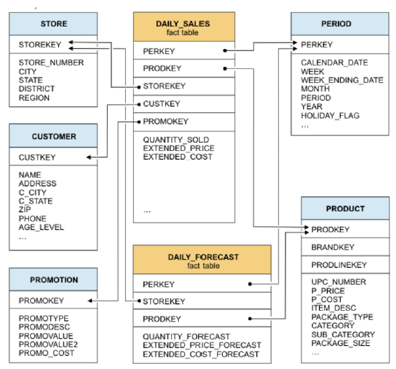

1. For the above-mentioned dimension model, please identify the conformed and non-conformed dimensions. Additionally, identify the measure types?

We have three confirmed dimensions as product dimensions, period dimension and store dimensions.

Non-confirm dimensions are promotion dimension table and Customer dimension table

They have semi-additive type of measures.

5. Make a list of differences between DW and OLTP based on Size, Usage, Processing and Data Models.

|  |  |  |
| --- | --- | --- |
|  | **DATAWAREHOUSE** | **OLTP** |
| ***Size:*** | Large amount of data is stored here | Comparatively less amount of data store |
| ***Usage:*** | Help in business analysis, and runs fundamental business task | Helps in fast transaction, maintains data integrity in multiple environment. |
| ***Processing:*** | Depends on complex queries and as data get refreshed every interval so complex query may take little time. | Typically very fast |
| ***Data Models:*** | De-normalized with few tables creating star and/or snowflakes schema. | Normalized with many tables |