**Project Name:**Pharma Care System

**Group No**:76

**Group Members:**

1]Sunita Patil -1210

2]Ankita Shirke-1195

**---------------------------------------------------------------------------------------**

**Software Requirement Specification(SRS)**

**For Pharma Care System(PCS)**

1. **Introduction:**

**1 .1 Purpose:**

This document is meant to delineate the features of Pharma Care System, so as to serve as a guide to the developers on one hand and a software validation document for the prospective client on the other. system is a complete web based application for managing a pharma cares entire operation. No need to own any computer for this specific ordering of medicine, it just require user to register with the system. It provides easy to use and user friendly interface for the users. The system provides freedom to the users. The user can view the diseases ,enquire about medicine availability and the administrator can login into the system ,admin can add the medicine, view the medicines and update the medicine information,delete the medicine if it is expired or out of date .

**1 .2 Scope:**

This system allows the patients to enquire about medicine & order the medicine .

**1 .3 Definitions:**

PCS- Pharma Care System

SRS- Software Requirement Specification

GUI- Graphical User Interface

Stackholder- The person who will participate in system

Ex. , Administrator, Patients etc.

**1.4 References:**

<https://docs.oracle.com/javaee/7/api/toc.htm>

<https://docs.oracle.com/javase/7/docs/api/>

<https://getbootstrap.com/docs/3.3/>

<https://www.javatpoint.com/jsp-tutorial>

<https://www.researchgate.net/publication/305426561_Online_Pharmaceutical_Management_System>.

**1.5 Overview:**

This system provides an easy solution for patients to buy

the medicine without going to the shop .

This proposed system can be used by any users and it

does not require any educational level,experience or

technical expertise in computer field but it will be of good use

if user has the good knowledge of how to operate a

computer.

**2.Overall Description:**

The main aim of developing this application is to supply the medicines and to reduce the time consumption. Pharma care system is a web-based application. The patient(user) can enquire for medicine. User can purchase medicine online. As per the prescription, the user can search medicine . The user can view the medicine from the medicine table which they require and the administrator can view the medicine,update medicine information,delete particular medicine and can update status of medicine i.e wheather that particular medicine is availale or not. The patient goes to the shop and purchases the medicine as per required. So a lot of time is wasted and the person gets tired.

**2.1 User Perspective:**

This product aimed toward a user who don’t want to visit the shop as he might don’t get time for that or might not interested in visiting there and dealing with lot of formalities.

**2.2 Functions:**

The Pharma Care System support this use case:

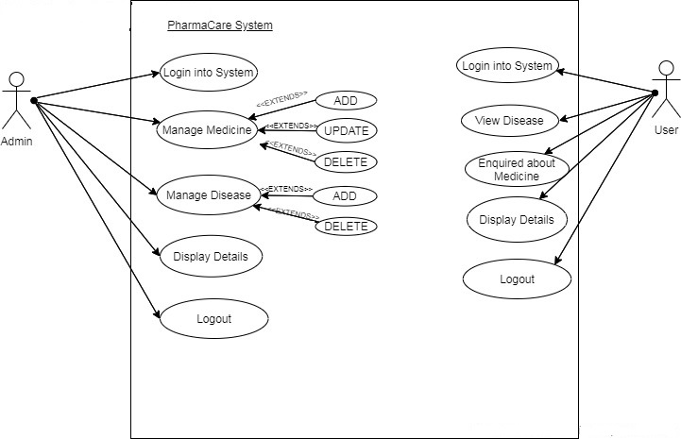

**2.3 User Characeristics:**

User should be familiar with the terms like

register,order medicine etc.

**2.4 Principle Actors:**

Two Principle Actors are User and

Administrator.

**2.5 General Constraints:**

A full internet connection is required for PCS.

**2.6 Assumptions and Dependencies** :

Working of PCS need Internet Connection.

**3. Specific Requirements**:

**3.1 Functional Requirements:**

This section provides requirement overview of the

system.

Various functional modules that can be implemented by

the system will be –

**3.1 Description:**

**3.1.1 Registration**

If Patient wants to enquire the Medicine then he/she

be registered or unregistered simply fill the details an Order the medicine.

**3.1.2 Login**

Aministrator logins to the system by entering

valid user id and password for the

System.

**3.1.3 Add Medicine:**

The Admin after

login can make changes of the Medicine list.If he wants to add then add it.

**3.1.4 update Medicine:**

The Admin after

login can make changes of the Medicine list.If he/she wants to edit medicine details then upate it e.g. status i.e. Available or not.

**3.1.5 Delete Medicine:**

The Admin after

login can make changes of the Medicine list.If he/she wants to delete medicine details then delete it in case of unavailabitity or after the expiry of the medicine.

**3.1. 6 Logout:**

Logout from the system .

**3.1.7 Report Generation**

After ordering for the Medicine,the system

will display all the details .

**3.2 Non-Functional Requirements:**

Following Non-Functional Requirements will be there in the

insurance to the internet:

**(i)** Secure access to consumer’s confidential data.

**(ii)** 24X7 availability**.**

**(iii)** Better component design to get better performance at peak

time.

**(iv)** Flexible service based architecture will be highly desirable for

future extension.Non-Functional Requirements define system

properties and constraints.

Various other Non-Functional Requirements are:

➢ **Security**

➢ **Reliability**

➢ **Maintainability**

➢ **Portability**

➢ **Extensibility**

➢ **Reusability**

➢ **Compatibility**

➢ **Resource Utilization**

**3.3 Performance Requirements:**

In order to maintain an acceptable speed at maximum number of

uploads allowed from a particular customer as any number of patients

can access to the system at any time.

**3.4 Technical Issues:**

This system will work on client-server

architecture. It will require an internet

server and which will be able to run Spring

application. The system should support

some commonly used browser such as IE,

mozzila firefox,chrome etc.

**4 . Interface Requirement:**

Various interfaces for the system could be-

1) Login Page

2) Registration(enquiry) Form

3)There will be a screen displaying information

about diseases .

4) There will be a screen displaying information

about medicine .

5)If admin can select medicine button then he/she can add medicine also update the medicine info and delete particular medicine which is unavailable or expired.

6)If admin can select disease button then he/she can add medicine.

7)Logout Page

**Software Interface:**

1.Operating System:Windows7 and above.

2.JAVA development toolkit.

**Hardware Interface:**

Hardware requirements for insurance on internet

will be same for both parties which are as follows:

Processor:Dual Core

RAM:2 GB

Hard Disk:320 GB

NIC:For each party

**Communication Interfaces:**

The two parties should be connected by LAN or

WAN for the communication purpose.

SENDER Communication channel.

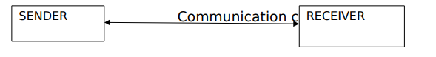

**E-R DIAGRAM:**

**1.Role:**

Id

username

password

role

**2.Disease:**

disease_id

disease_name

**3.Medicine:**

medicine_id

medicine_name

medicine_price

medicine_quantity

added_date

modified_date

status

**4.User:**

user_id

first_name

last_name

email_id

contact_number

medicine_id

disease_id

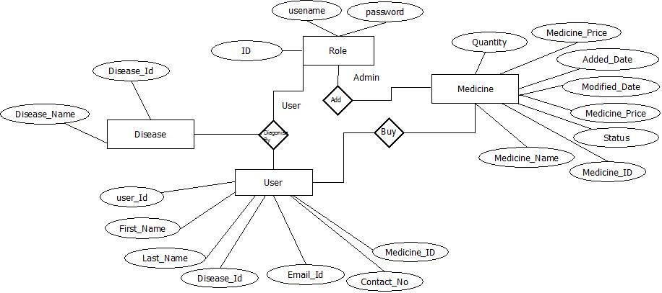

**Class Diagram:**

