**Exposys Data Labs**

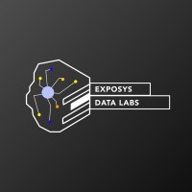

**Topic: Login Credentials using UI/UX**

**Submitted by**

**Ankita Aravind Dongrekar**

**Abstract:**

Login credentials are an integral part of User Interface (UI) and User Experience (UX) design, serving as the gateway for users to access personaLogin credentials are an integral part of User Interface (UI) and User Experience (UX) design, serving as the gateway for users to access personalized accounts and secure areas within applications or websites. Lized accounts and secure areas within applications or websites. Effective UI/UX design considers the accessibility and visibility of login forms, ensuring users can locate and understand the required fields easily. Clear error handling mechanisms guide users in case of mistakes, fostering a smooth login process. Emphasizing password security encourages users to create robust passwords, while password strength indicators provide valuable feedback. This is simple Login and Signup authentication app using MERN-Stack. And also it is integrated with Google and Github auth buttons for easy to login & sign-up, whenever user need to know its forget password the reset link will be send to on his/her registered email address which is already stored in database.

**Introduction:**

The MERN stack is a popular and powerful combination of technologies used for building modern web applications. It stands for MongoDB (database), Express.js (backend framework), React.js (frontend library), and Node.js (runtime environment). In this introduction, we'll explore the concept of a simple Login and Signup Authentication App built using the MERN stack.

The Login and Signup Authentication App is designed to allow users to create an account, log in with their credentials, and access personalized content or features securely. The app demonstrates the fundamental principles of user authentication and data management using the MERN stack.

The MERN stack enables a smooth flow of data and actions between the frontend and backend, ensuring a fast and efficient user experience. The combination of these technologies allows developers to create a robust, scalable, and maintainable application with excellent performance. Simple Login and Signup Authentication App using the MERN stack showcases the power of this technology stack in building modern web applications with secure user authentication. It serves as a foundation for more complex projects and can be extended to include additional features like password recovery, user profile management, and user roles, depending on specific requirements.

**Methodologies:**

Creating login credentials involves implementing various methodologies to ensure the security and usability of user authentication systems. Here are some essential methodologies to consider when building login credentials:

* User Registration: Provide a user registration process where new users can sign up by providing a unique username, email address, and password. Implement validation checks to ensure that usernames and emails are not already taken and that passwords meet security requirements.
* Password Security: Enforce password security by requiring users to create strong passwords. Encourage a combination of uppercase and lowercase letters, numbers, and special characters. Avoid storing passwords in plaintext; instead, use secure hashing algorithms like bcrypt to store hashed versions of passwords in the database.
* Password Recovery: Implement a password recovery mechanism that allows users to reset their passwords if they forget them. This can be achieved through email verification, security questions, or temporary login tokens.

**Key Features of the App:**

* User Signup: Users can register by providing a unique username, email, and password. The app ensures that the username and email are not already taken.
* User Login: Registered users can log in using their username/email and password. The app authenticates the user's credentials and grants access to authorized content.
* Session Management: The app maintains user sessions to keep users logged in across different pages or after browser refreshes until they choose to log out.
* Protected Routes: Certain parts of the app are accessible only to authenticated users. Unauthorized users are redirected to the login page.
* Error Handling: The app handles errors gracefully, providing informative messages to users in case of incorrect login attempts or registration errors.
* Database Interaction: User data is stored securely in a MongoDB database. The app utilizes Mongoose (an ODM - Object Data Modeling library for MongoDB) to interact with the database.
* Password Hashing: User passwords are securely hashed using bcrypt before storing them in the database to ensure data privacy.
* Frontend Interactivity: The frontend, built using React.js, provides an interactive and intuitive user interface for seamless user experiences during login, signup, and navigation.
* Backend Security: The backend, powered by Node.js and Express.js, implements middleware and security measures to protect against common web vulnerabilities.

**Result:**

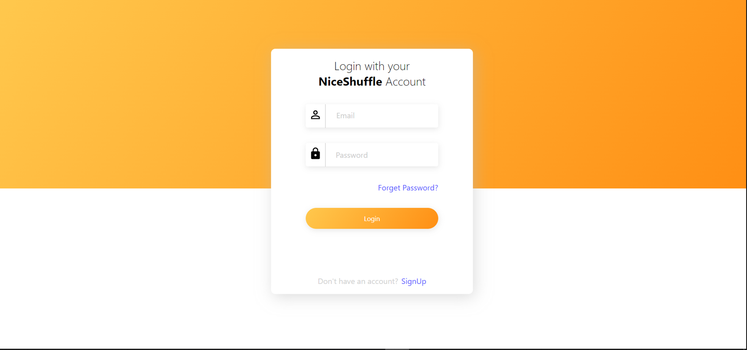

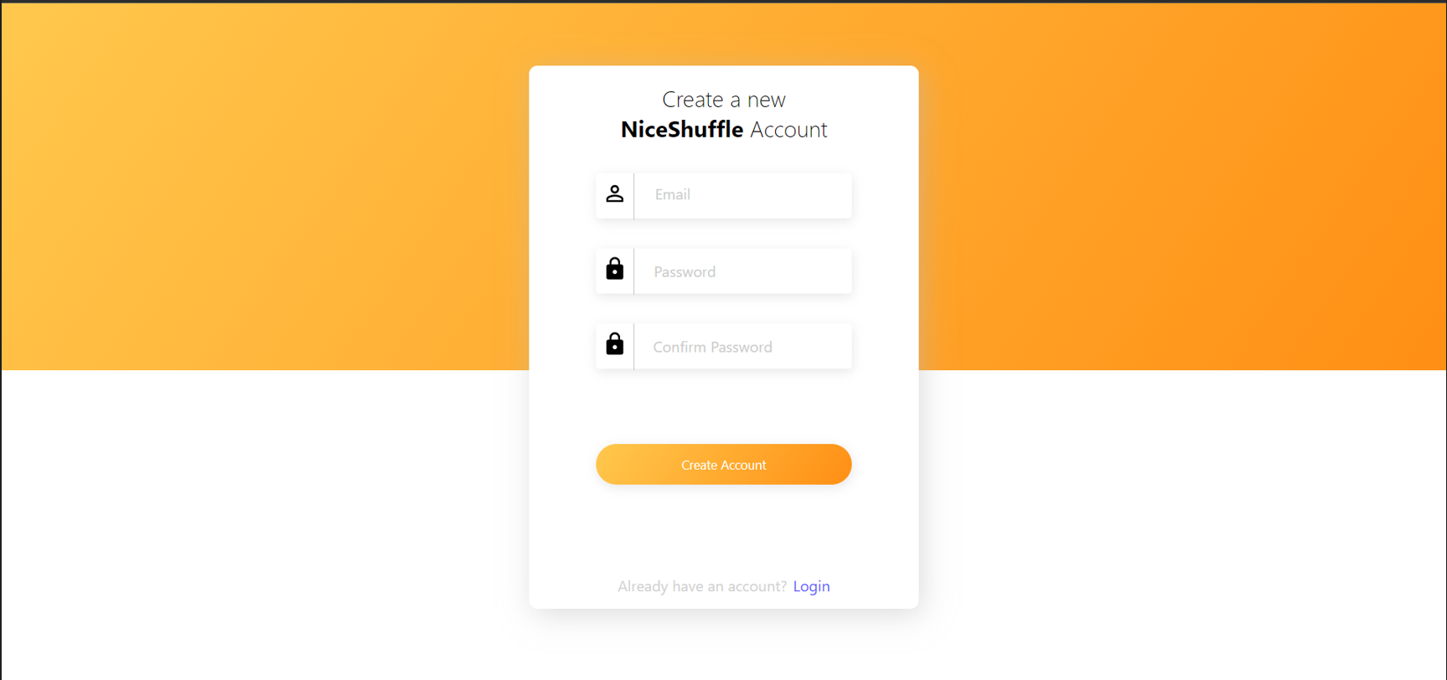

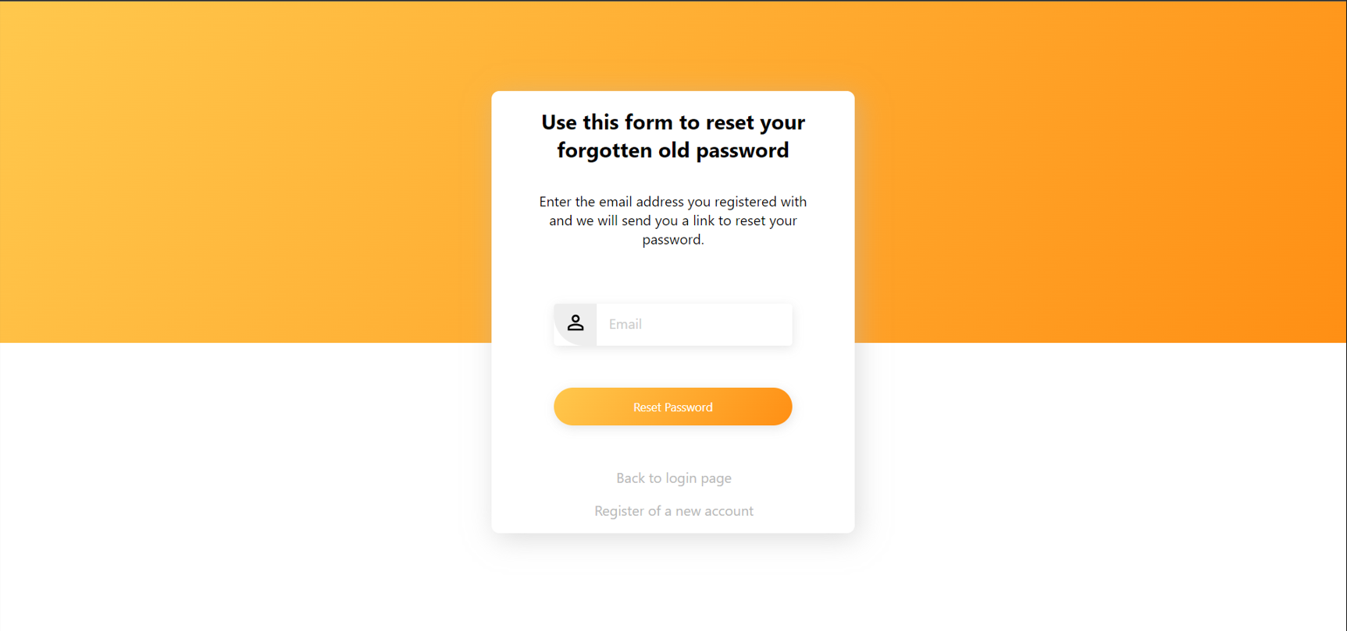

**Conclusion:**

login credentials play a pivotal role in the world of digital interactions, providing a secure and personalized experience for users across various applications and websites. Whether it's a simple username-password combination or advanced multi-factor authentication, login credentials serve as the front gate to access private information, accounts, and features.The importance of well-designed login credentials cannot be overstated. A user-friendly login system contributes to enhanced user experience, fostering trust and satisfaction among users. By following best practices in UI/UX design, such as clear visibility, error handling, and password security indicators, designers can ensure a smooth login process and minimize user frustration.