📊 MODULE 3
Monitoring & APM Labs
Lab 3.1 — Uptime Kuma — Build Your Own Site24x7
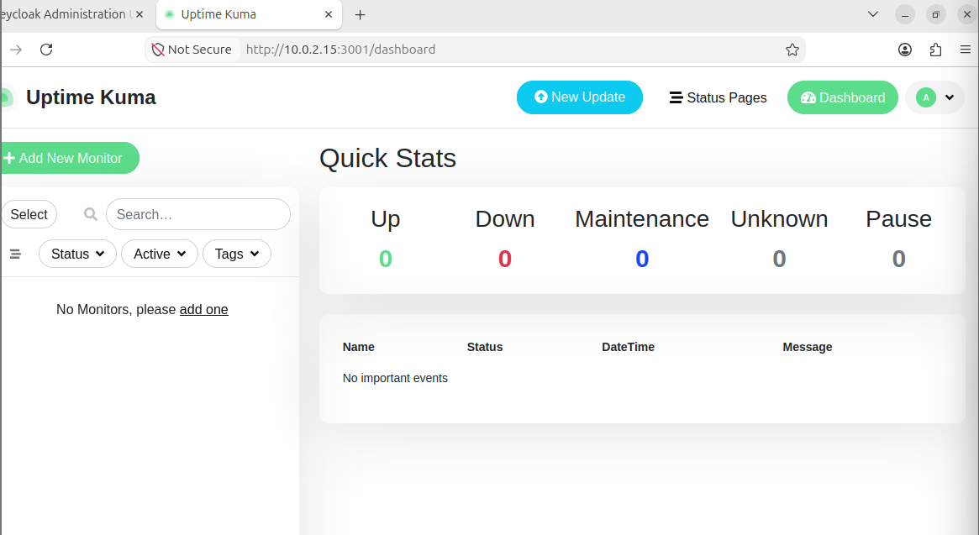
Lab 3.2 — Prometheus + Grafana — Build Your Own APM Dashboard
Prometheus Queries
1 > Open Prometheus: http://<VM-IP>:9090
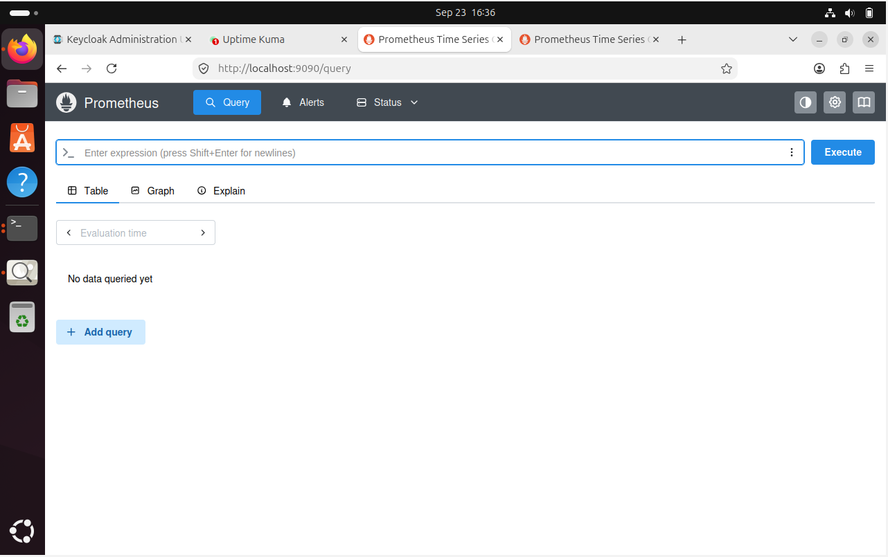
2> CPU usage (like Site24x7 CPU alert):
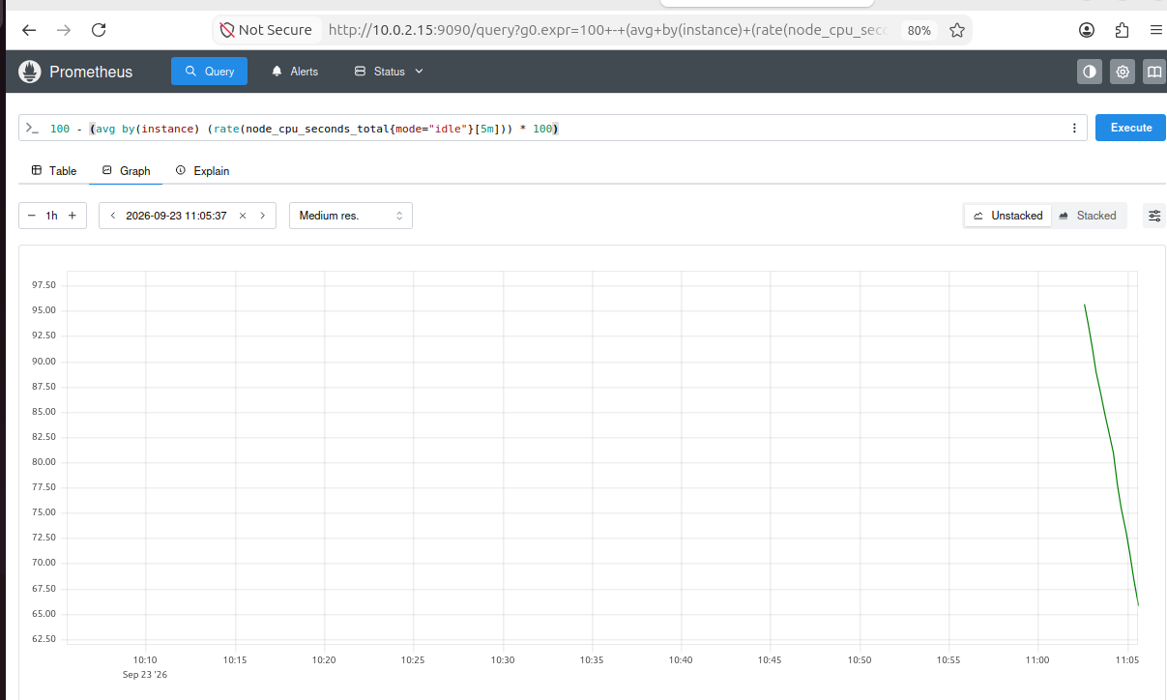

3 >Memory usage:
(1 - node_memory_MemAvailable_bytes / node_memory_MemTotal_bytes) * 100
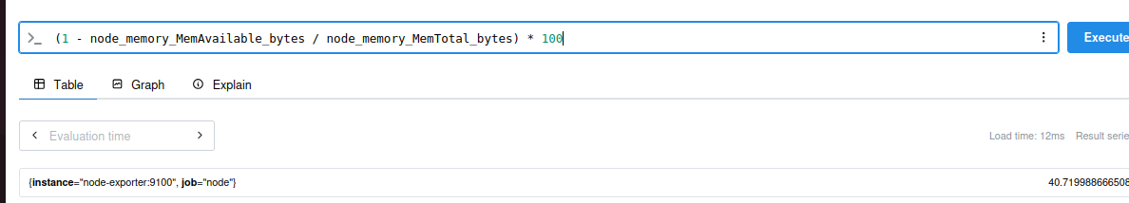

4> Disk usage:
(1 - node_filesystem_avail_bytes{mountpoint='/'} / node_filesystem_size_bytes{mountpoint='/'}) * 100
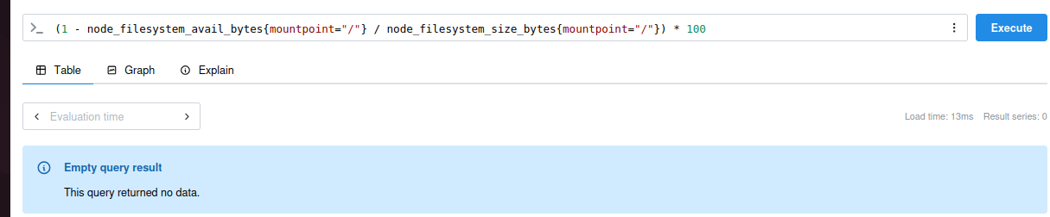
5> Network bytes in (like bandwidth monitoring):
rate(node_network_receive_bytes_total{device='eth0'}[5m])
Step 3 — Build a Grafana Dashboard
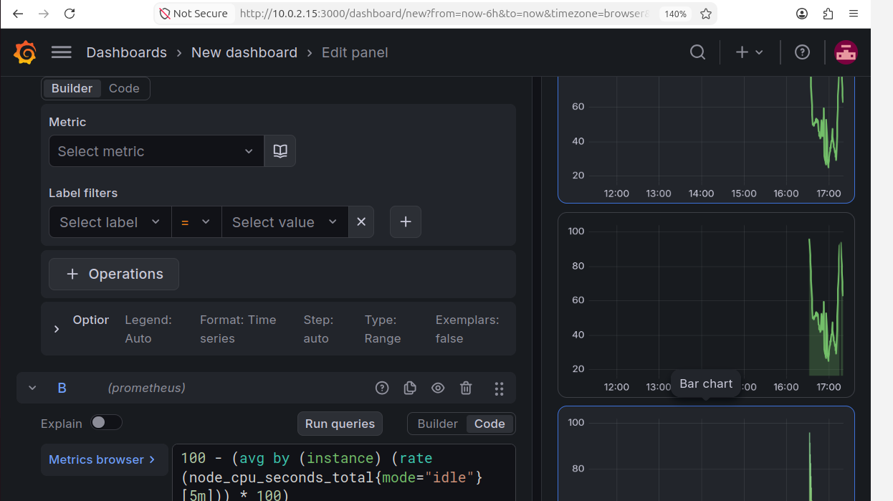
CPU Usage (%) — use the CPU query from Step 2
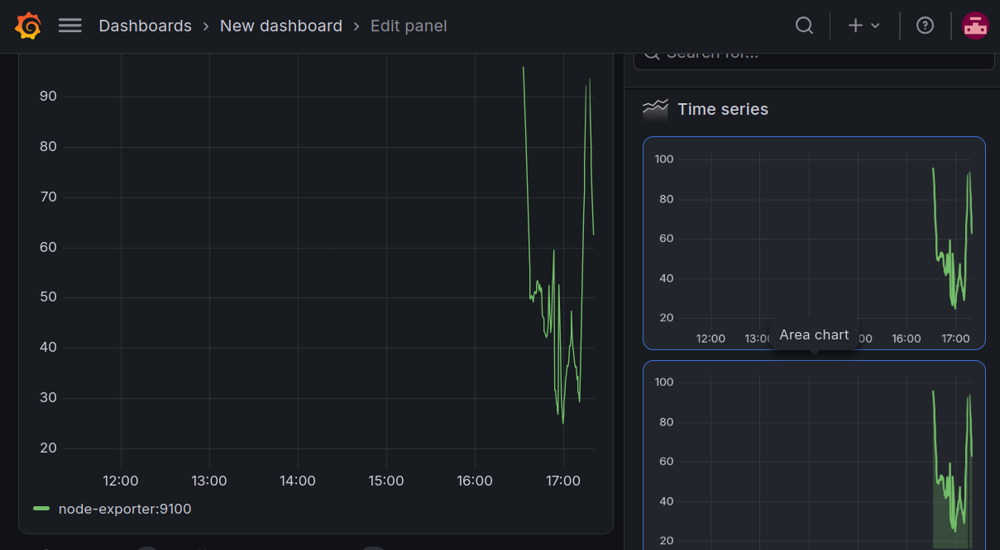
Panel 2: Memory Usage (%) — use memory query
