Generate a TOTP Secret and QR Code
1>pip3 install pyotp qrcode pillow
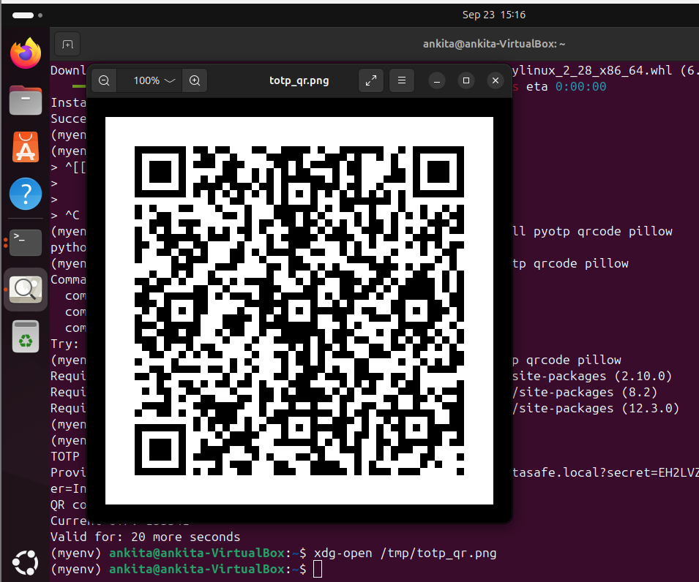
*Verify TOTP (Simulating the Server Side)
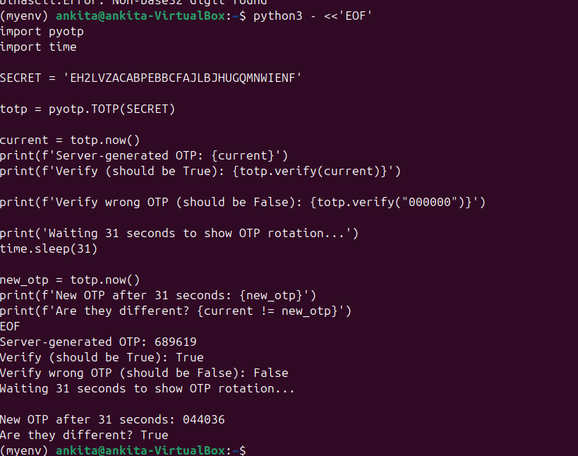
Step 3 — Scan the QR Code with Google Authenticator

