***Assignment – 11***

**Subqueries.**

1. Write a query that uses a subquery to obtain all orders for the customer named Cisneros. Assume you do not know his customer number (cnum).

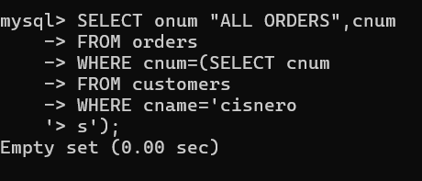

1. Write a query that produces the names and ratings of all customers who have above-average orders.

mysql> select cname,rating

-> FROM customers

-> WHERE cnum IN

-> (SELECT cnum

-> FROM orders

-> WHERE amt >

-> (SELECT avg(amt)

-> FROM orders));

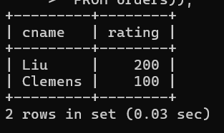

3) Write a query that selects the total amount in orders for each salesperson for whom this total is greater than the amount of the largest order in the table.

mysql> SELECT sum(amt)

-> FROM orders

-> GROUP BY snum

-> HAVING sum(amt)>

-> (SELECT max(amt)

-> FROM orders);

