***Assignment – 12***

**Using the operators IN, ANY, and ALL.**

1. Write a query that selects all customers whose ratings are equal to or greater than ANY of Serres’.
2. **SELECT** *
3. **FROM** customers
4. **WHERE** rating >=**ANY**
5. ( **SELECT** rating
6. **FROM** customers
7. **WHERE** snum **IN**
8. ( **SELECT** snum
9. **FROM** salespeople
10. **WHERE** sname='serres' ) );

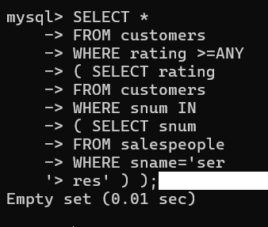

2) Write a query using ANY or ALL that will find all salespeople who have no customers located in their city.

mysql> select snum

-> FROM salespeople

-> WHERE (snum,

-> city) NOT IN

-> (SELECT snum,

-> city

-> FROM customers);

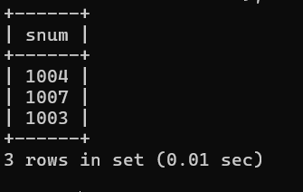

3) Write a query that selects all orders for amounts greater than any for the customers in London.

mysql> SELECT *

-> FROM orders

-> WHERE amt> ANY

-> ( SELECT amt

-> FROM orders

-> WHERE cnum IN

-> ( SELECT cnum

-> FROM customers

-> WHERE city='lond

'> on' ) );

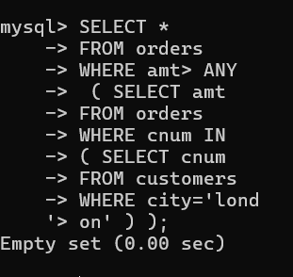

4) Write the above query using MIN or MAX.

mysql> SELECT *

-> FROM orders

-> WHERE amt>

-> (SELECT min(amt)

-> FROM customers

-> NATURAL JOIN orders

-> WHERE city='london');

