***Assignment – 14***

**Entering, Deleting, and Changing Field Values.**

1) Write a command that puts the following values, in their given order, into the salespeople table: city – San Jose, name – Blanco, comm – NULL, cnum – 1100.

mysql> INSERT INTO salespeople (city,sname,comm,snum)

-> VALUES('San Jose','Blanco',

-> NULL, 1100);

Query OK, 1 row affected (0.16 sec)

2) Write a command that removes all orders from customer Clemens from the Orders table.

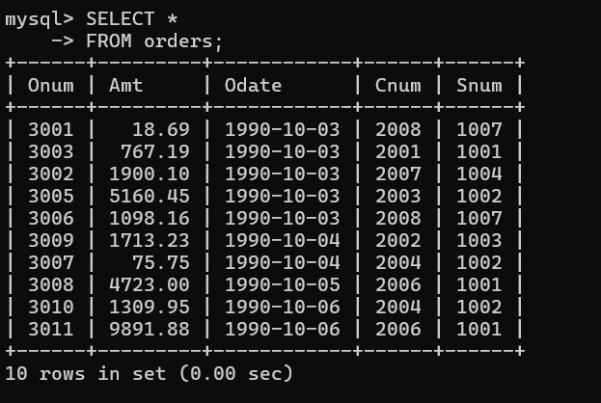

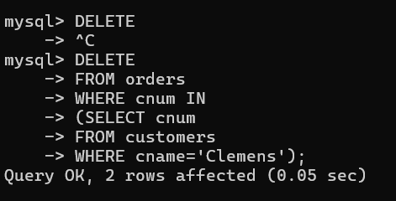

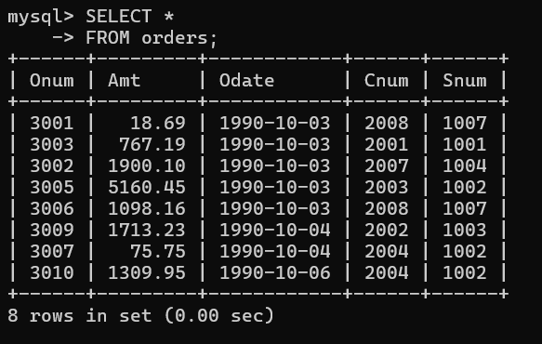

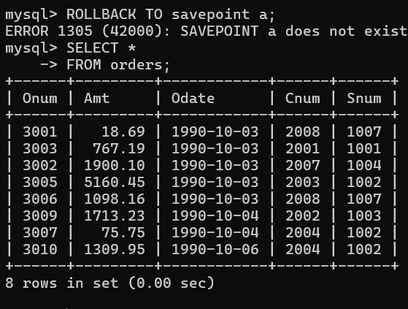

3) Write a command that increases the rating of all customers in Rome by 100.

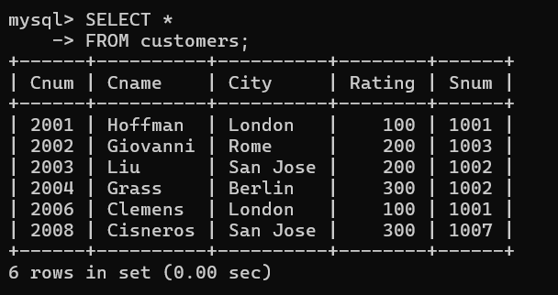

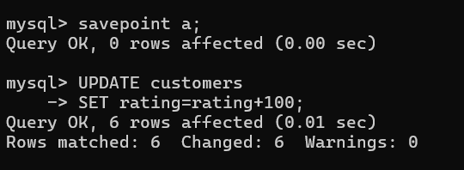

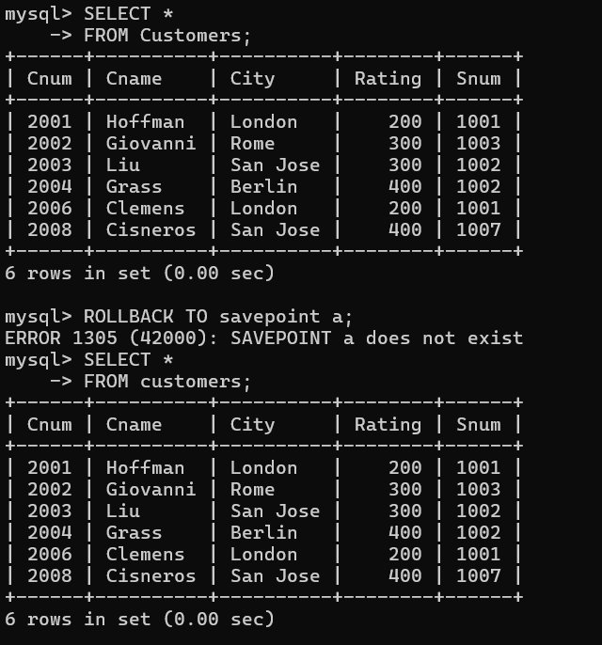

4) Salesperson Serres has left the company. Assign her customers to Motika.

