***Assignment – 15***

**Using Subqueries with DML Commands.**

1) Assume there is a table called Multicust, with all of the same column definitions as Salespeople. Write a command that inserts all salespeople with more than one customer into this table.

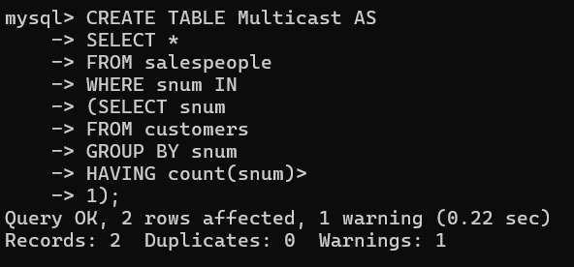

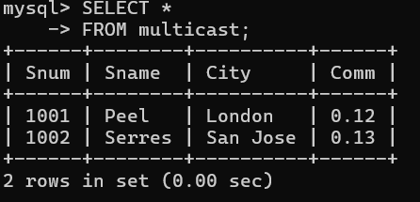

2) Write a command that deletes all customers with no current orders.

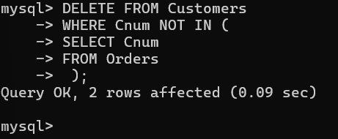

3) Write a command that increases by twenty percent the commissions of all salespeople with total orders above Rs. 3,000.

Ans: UPDATE Salespeople -> SET Comm = Comm * 1.20 -> WHERE Snum IN ( -> SELECT Snum -> FROM Orders -> GROUP BY Snum -> HAVING SUM(Amt) > 3000 -> );

