***Assignment – 20***

**Changing Values through Views.**

1) Which of these views are updateable (will allow DML operations)?

|  |  |
| --- | --- |
| #1 | Create View Dailyorders |
| as Select Distinct cnum, snum, onum, odate from Orders; | |

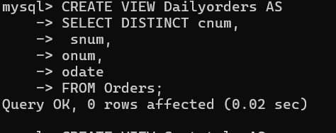

ans: yes

|  |  |
| --- | --- |
| #2 | Create View Custotals |
| as Select cname, Sum (amt) Sum_Amt from Orders, Customers  where Orders.cnum=Customers.cnum Group by cname; | |

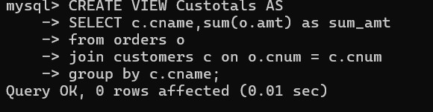

Ans:  
  
 Views are note updatable which consists of join.

|  |  |
| --- | --- |
| #3 | Create view Thirdorders |
| as Select * from Dailyorders where odate=’1990-10-03’; | |

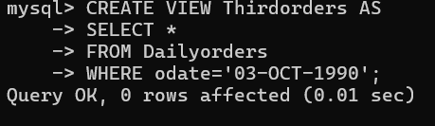

Ans:  
  
 not updatable due to distinct keyword in dailyorders;

|  |  |
| --- | --- |
| #4 | Create view Nullcities |
| as Select snum, sname, city  from Salespeople where city is NULL  OR sname BETWEEN ‘A’ and ‘MZ’; | |

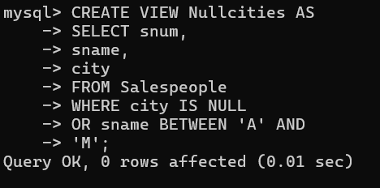

ans: yes

2) Create a view of the Salespeople table called Commissions. This view will include only the snum and comm fields. Through this view, someone could enter or change commissions, but only to values between .10 and .20.

Ans:

mysql> CREATE VIEW commission AS

-> SELECT snum,

-> comm

-> FROM salespeople

-> WHERE comm BETWEEN .10 AND

-> .20;

Query OK, 0 rows affected (0.01 sec)

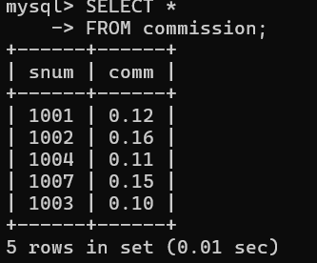

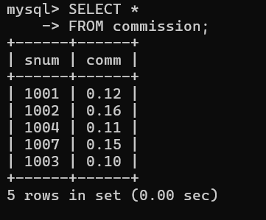

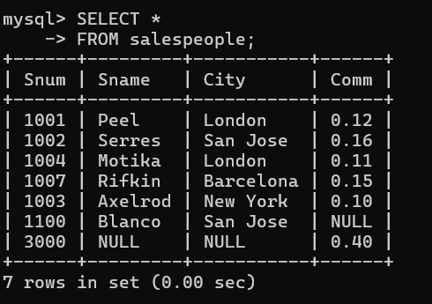

3) Some SQL implementations have a built-in constant representing the current date, sometimes called “CURDATE” or “SYSDATE”. The word SYSDATE can therefore be used in a SQL statement, and be replaced by the current date when the value is accessed by commands such as Select or Insert. We will use a view of the Orders table called Entryorders to insert rows into the Orders table. Create the Orders table, so that SYSDATE is automatically inserted for odate if no value is given. Then create the Entryorders view so that no values can be given.

Ans:

Suppose if you have a view named view1 on table t  
And if you apply another view on this view named view2  
And now if you make update on view 2 then it will be made on the table t;  
  
But remember if you have used distinct keyword in base view then the identifier in view2  
will be virtual view and they will not allow to update.