***Assignment – 9* Querying Multiple Tables at Once.**

1. Write a query that lists each order number followed by the name of the customer who made the order.

**Ans : SELECT o.Onum, c.Cname**

**-> FROM orders o**

**-> JOIN customers c ON o.Cnum = c.Cnum;**

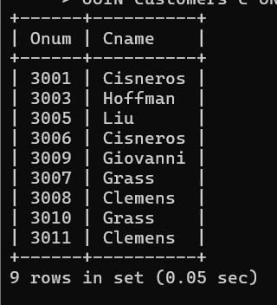

1. Write a query that gives the names of both the salesperson and the customer for each order along with the order number.

**Ans : mysql> SELECT o.Onum, c.Cname AS Customer_Name, s.Sname AS Salesperson_Name**

**-> FROM orders o**

**-> JOIN customers c ON o.Cnum = c.Cnum**

**-> JOIN salespeople s ON o.Snum = s.Snum;**

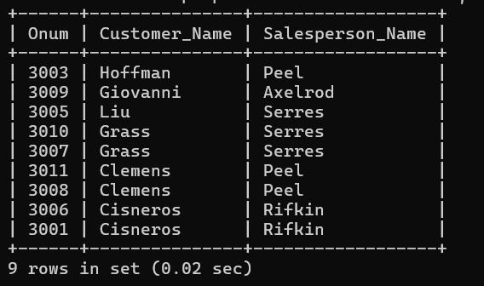

1. Write a query that produces all customers serviced by salespeople with a commission above 12%. Output the customer’s name, the salesperson’s name, and the salesperson’s rate of commission.

**Ans : mysql> SELECT c.Cname AS Customer_Name, s.Sname AS Salesperson_Name, s.Comm AS Commission_Rate**

**-> FROM customers c**

**-> JOIN salespeople s ON c.Snum = s.Snum**

**-> WHERE s.Comm > 0.12;**

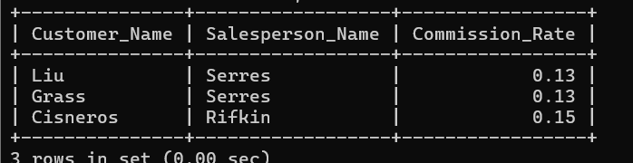

1. Write a query that calculates the amount of the salesperson’s commission on each order by a customer with a rating above 100.
2. 