MySQL

Exercise 7

Create the following 3 tables and insert sample data as shown:-

|  |  |  |  |
| --- | --- | --- | --- |
| **Ord_mst** |  |  |  |
| **Ord_no** | **Cust_cd** | **Status** |  |
| 1  **Ord_dtl** | C1 | P |  |
| **Ord_no** | **Prod_cd** | **Qty** |  |
| 1 | P1 | 100 |  |
| 1  **Prod_mst** | P2 | 200 |  |
| **Prod_cd** | **Prod_name Qty_in_stock** | | **Booked_qty** |
| P1 | Floppies 10000 | | 1000 |
| P2 | Printers 5000 | | 600 |
| P3 | Modems 3000 | | 200 |

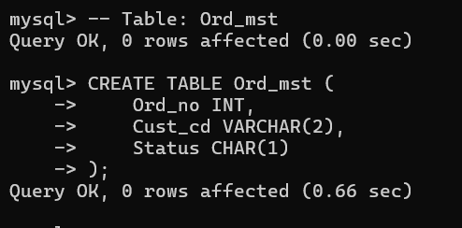

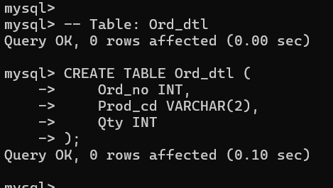

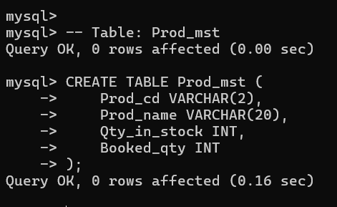

1. Write a Before Insert trigger on Ord_dtl. Anytime a row is inserted in Ord_dtl, the Booked_qty in Prod_mst should be increased accordingly.

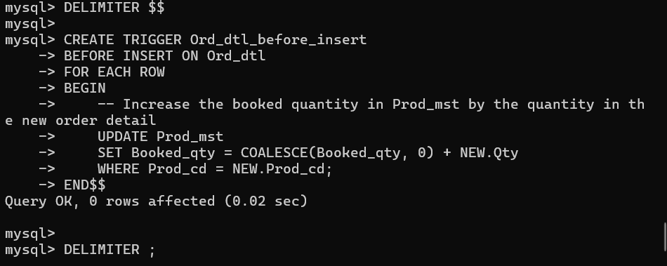

1. Write a Before Delete trigger on Ord_dtl. Anytime a row is deleted from Ord_dtl, the Booked_qty in Prod_mst should be decreased accordingly.

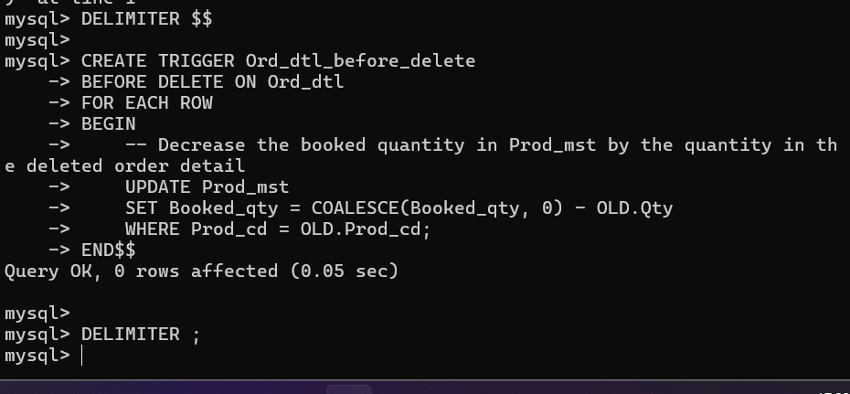

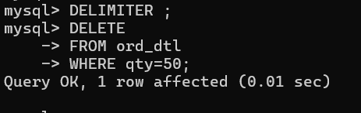

1. Write a Before Update of Prod_cd, Qty trigger on Ord_dtl. Anytime the Prod_cd or Qty is updated, the Booked_qty in Prod_mst should be increased/decreased accordingly.

Ans:

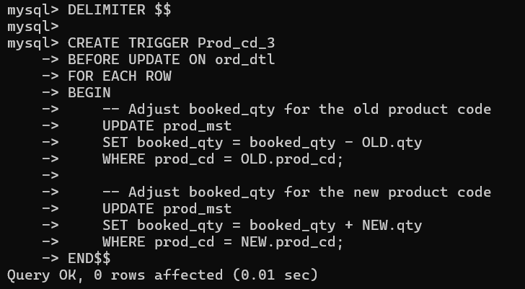

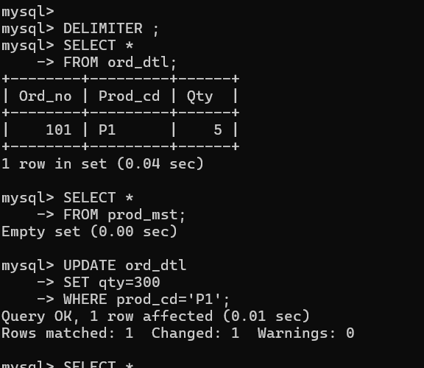

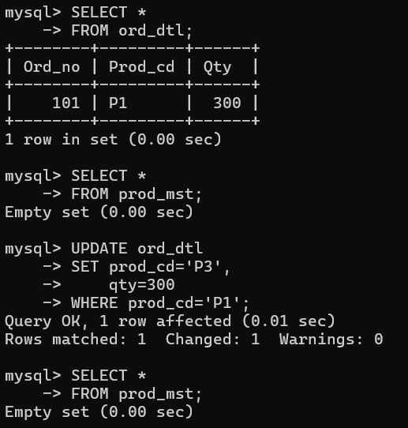

1. Write a Before Update of Status trigger on Ord_mst. If the Status is updated from P (Pending) to D (Delivered), the Booked_qty and Qty_in_stock from Prod_mst should be decreased accordingly. If the Status is updated from P (Pending) to C (Cancelled), the details of the order should be deleted from Ord_dtl and corresponding Booked_qty from Prod_mst should be decreased accordingly. (The Before delete trigger on Ord_dtl would automatically decrease the Booked_qty from Prod_mst).

Ans:

