**Assignment –6**

**Using Special Operators in Conditions.**

1) Write two different queries that would produce all orders taken on October 3rd or

**4th, 1990.**

**Ans:** select * from Orders where Odate='04-10-1990'or '03-10-1990';

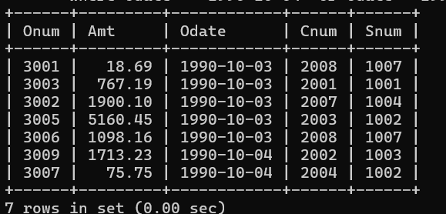

select * from Orders where Odate in ('03-10-1990', '04-10-1990');



**2) Write a query that selects all of the customers serviced by Peel or Motika.**

**(Hint: the snum field relates the two tables to one another).**

**Ans: select * from customers where Snum = 1001 or Snum =1004;**

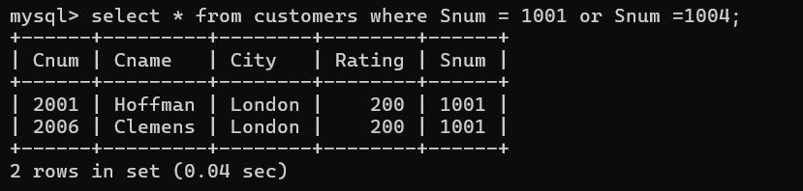

**3) Write a query that will produce all the customers whose names begin with a letter**

**from ‘A’ to ‘G’.**

**Ans: select * from customers where left(Cname,1)between 'A' and 'G';**

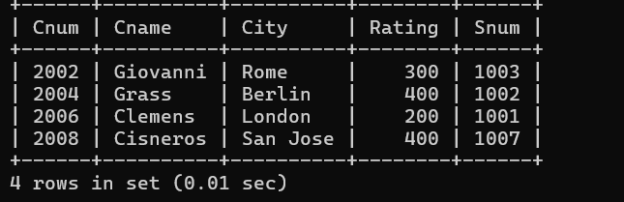

**4) Write a query that selects all customers whose names begin with the letter ‘C’.**

**Ans: select * from customers where Cname like 'C%';**

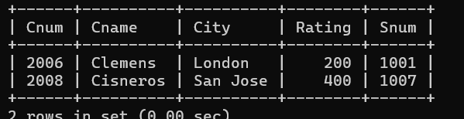

**5) Write a query that selects all orders except those with zeroes or NULLs in the amt**

**field.**

**Ans: select * from orders where amt <> 0 and amt is not null;**

