**I made this outline based on this article:** [**https://rhiveness.files.wordpress.com/2015/08/ford-imc-final.pdf**](https://rhiveness.files.wordpress.com/2015/08/ford-imc-final.pdf)

**I randomly picked Mustang EcoBoost Fastback model, we can change it and also change the highlighted parts accordingly.**

**Outline**

**Company Introduction**

* an American automaker that is based out of Detroit.
* It was founded by Henry Ford on June 16th, 1903.
* The company sells automobiles and commercial vehicles under the Ford brand and most of its luxury cars are sold under the Lincoln brand.
* Ford is the second largest automaker in the United States and the fifth largest automaker in the world.

**SWOT analysis**

**Strengths**

* Strong brand image
* Global supply chain
* Effective innovation process

**Weaknesses**

* Limited global production network
* Higher costs compared to competitors
* Slow innovation processes

**Opportunities**

* Global expansion through market penetration
* Product development
* Cost reduction through strategic supply chain management

**Threats**

* Competitive rivalry
* High tech firms
* Fluctuating oil prices

**BCG Matrix**

**4Ps of Marketing**

**Place**

* **Dealerships**
* **Ford Motor Credit Company\***
* **11,428 Ford/Lincoln dealerships around the world**
* **About 3,000 in the United States**
* **Auto Parts Stores**
* **Ford's Website**

**Product**

* **Automobiles**
* **Trucks**
* **Buses**
* **Tractors**
* **Parts/Components**
* **Financial Services / Vehicle Leasing**

**Promotion**

* **Advertising**
* **Mostly television and online advertisements**
* **Personal Selling**
* **Direct Selling**
* **Sales Promotions**
* **Public Relations**

**Price**

* **Market Oriented Pricing Strategy**
* **Premium Pricing Strategy**

**Porter’s 5 forces**

**Threat of new entry - Low**

* High capital costs
* High cost of brand development
* Difficult entering into established industry

**Competitive rivalry – High**

* Compete against top companies that aggressively innovate their products
* High exist barriers
* Numerous competitors

**Buyer power - Relatively high**

* High level of customer preferences
* Low switching costs
* Customers make long term purchase

**Supplier power – Relatively low**

* Large number of suppliers
* Input are standardized
* Easily switch between suppliers

**Threat of substitution – Low**

* Considerable substitutes are not available in certain area, like public transportation
* Customers loyalty
* Customers can’t easily switch due to car loans

**Specific Category: Mustang**

Shall we include what is the unmet need of that person, can the company deliver that unmet need, eg: apple watch can offer but watch maker can’t offer, apple watch can do more instead of tells time, what is the strength of a brand can bring to the table (Porter’s 5 Forces might provide answers)?

* + **Our Point of View**
  + **Product**
    - **Price**
    - **Quality**
    - **Warranty**
  + **Competitor Analysis (Who are our competitors?)**
    - **Number**
    - **Type**
    - **Strengths**
    - **Weaknesses**
    - **Market Shares**

**Objectives**

**Business Objectives**

* Reach 9,000 sales of the Mustang EcoBoost Fastback model in 2020 in the US, starting at $26,670. [According to Ford’s 2018 US sales report(<https://s22.q4cdn.com/857684434/files/doc_news/2018/12/November-2018-Sales.Final.pdf> ), Ford sold 71,450 Mustang in 2018, there are 11 models available on its website, 71,45/11=6,500/model. We except sales of the Mustang EcoBoost Fastback model will increase to 9,000. Price from Ford website]

Reason:

* US auto market continues to growth

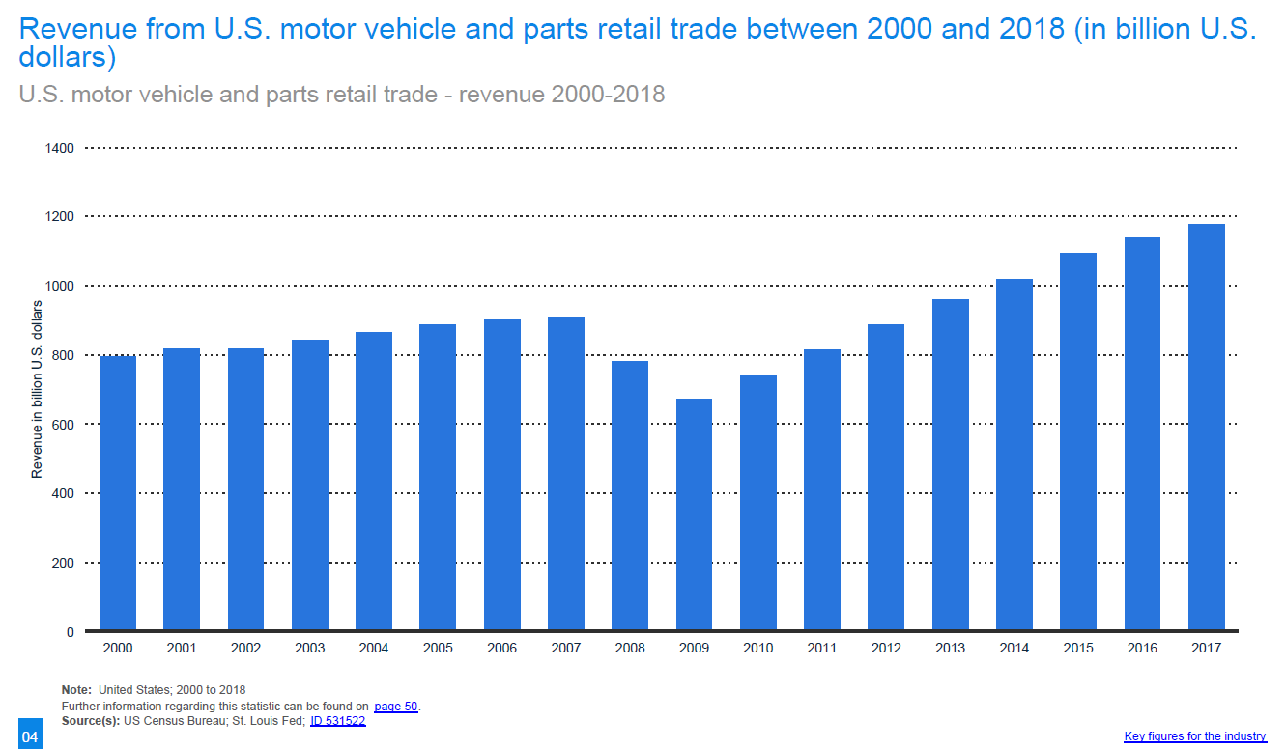

* Limited new car models available in the market

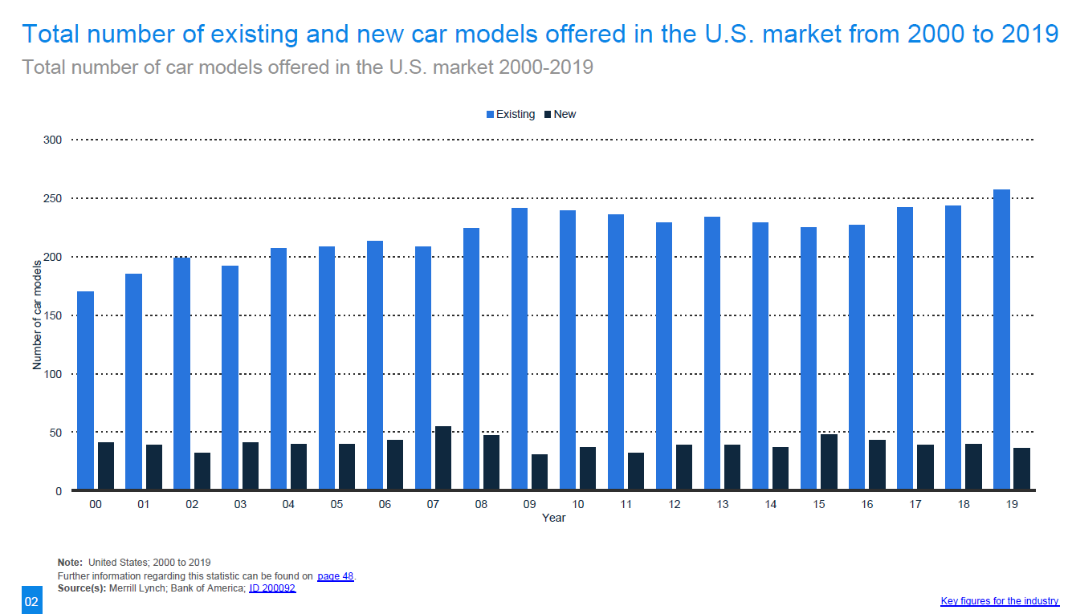

* ranked as the 2nd best sports car by U.S. News

(<https://cars.usnews.com/cars-trucks/rankings/sports-cars> )

* growth in sales

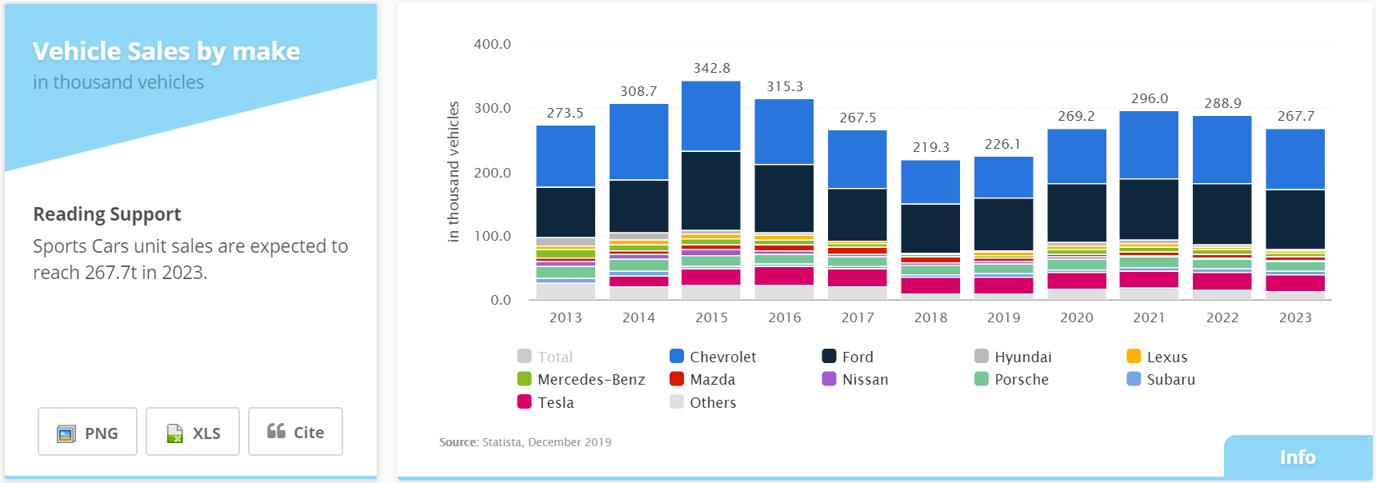

* stable demand for new cars

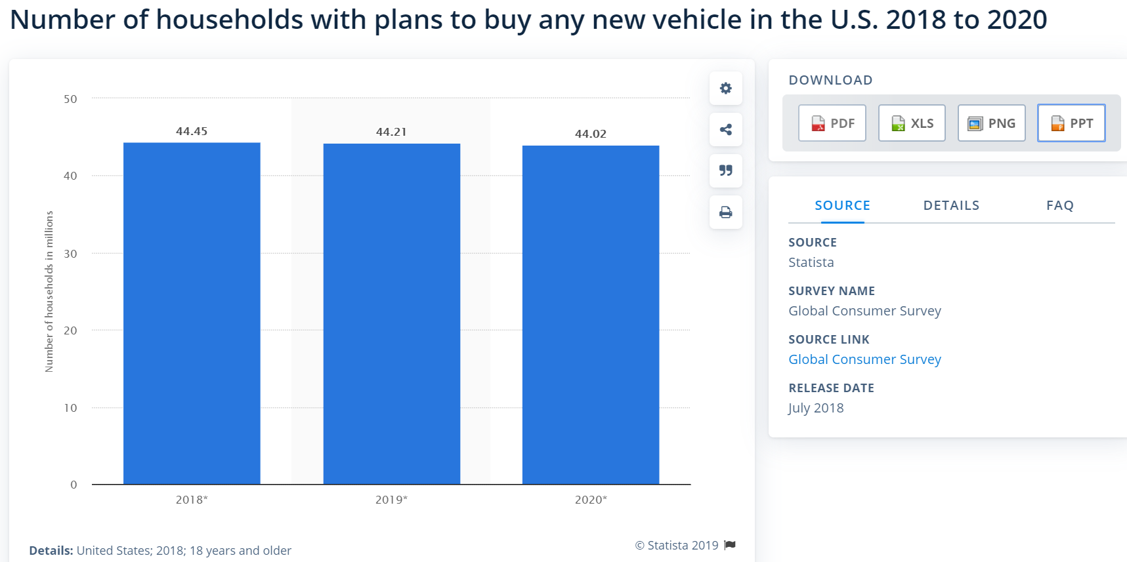

**Marketing Objectives**

* Enhance brand awareness of 2020 Mustang (<https://blog.alexa.com/marketing-objectives/>)
* Increase sales of the 2020 Mustang in 2020 (<https://blog.alexa.com/marketing-objectives/>)
* Aim to reach at least 70% of our primary target customers in 2020, (<https://blog.alexa.com/marketing-objectives/>)
* Talk to 25,000 people

**Budget**

Total budget around 5% of sales revenue. [According to Ford’s 2018 financial report(<https://s22.q4cdn.com/857684434/files/doc_financials/2018/annual/2018-Annual-Report.pdf> ), advertising expense was $4 billion, total revenue was $160.34 billion, 4/160.34 = 2%. We except to increase advertising in order to reach our business and marketing objectives, so expenses around 5% of Mustang EcoBoost Fastback model’s sales revenue]

**Target Audience**

Primary Target

Males

Age: 25-40 years old

(<https://www.federalreserve.gov/econresdata/notes/feds-notes/2016/the-young-and-the-carless-the-demographics-of-new-vehicle-purchases-20160624.html> )

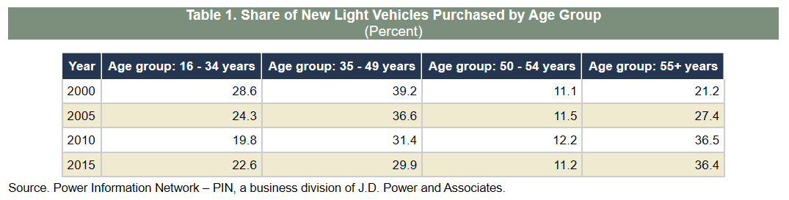

Mostly single or not with a family yet

Income: >800,000

Location: metropolitan areas to reach a wide range of dealerships, and reflects the wide uses of and attitudes towards the Mustang brand.

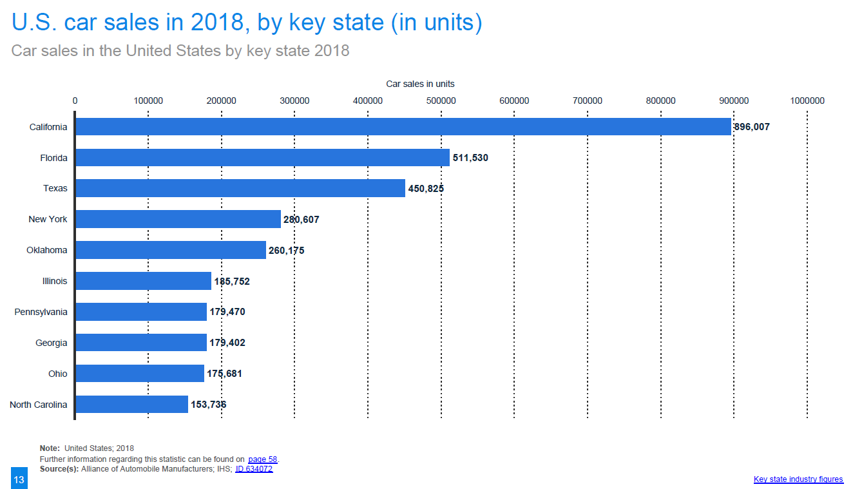

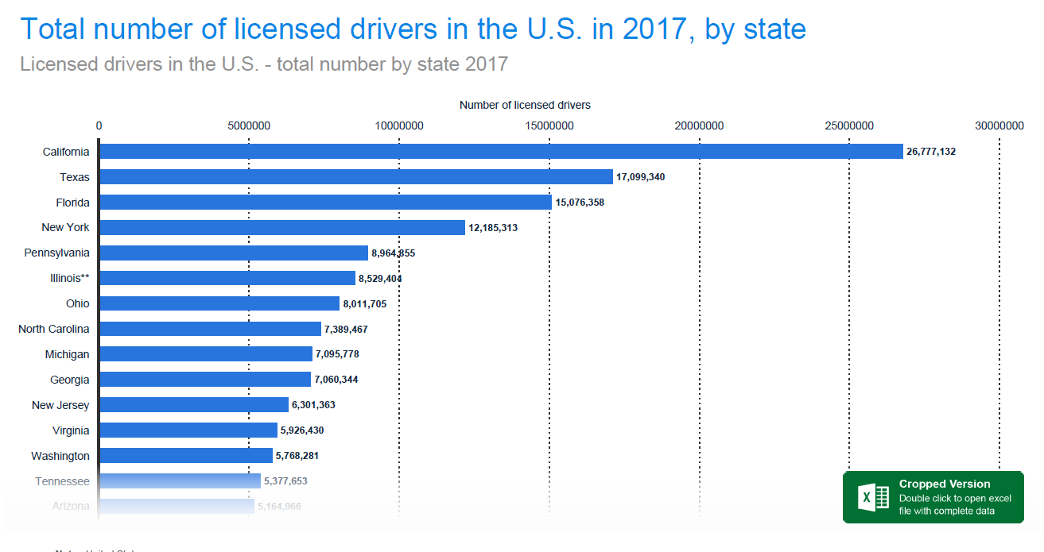

looking to impress friends and make new friends with a stylish and sporty car.

**Secondary Target Audience**

Males, 41-50 years old.

Income: >150,000

Life status: married with kids.

Location: in the same broad regions as the first target market.

Looking for an alternately a car with an iconic history that can satisfy their cravings for power on weekend getaways.

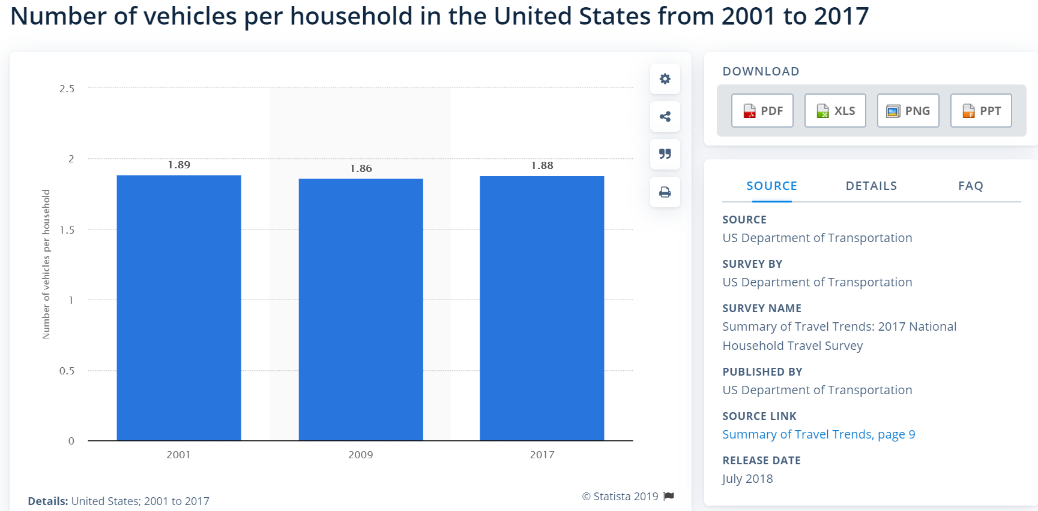

**Messages**

There are a number of messages that need to be conveyed to the target consumers during the promotion of the 2020 Ford Mustang. The overarching message encourages and prompts the target consumers to purchase the 2020 Mustang. Men, as in the basis for the target consumer, are generally low effort decision makers and simpler, more straight forward the messages will make it easier for the consumer to make the decision to purchase. (<https://rhiveness.files.wordpress.com/2015/08/ford-imc-final.pdf> )

The following messages will be included in the advertising and promotional activities set out in this plan:

(<https://www.thethings.com/15-reasons-why-you-should-ditch-your-car-and-buy-the-2020-mustang/> )

* The 2020 Mustang meets the needs of a modern driver in terms of handling, technology, Fuel-efficient turbo, stylish and high-quality interior.
* The entry-level Mustang EcoBoost will set you back less than $26,670. It's possible to add the $4,995 High-Performance package later on, which brings the total price to a reasonable $31,665.

**When the communication will hit the market**

Mustang 2020 already released on April 15th 2019 and our marketing plan is selling an existing product. Start with digital channels, such as social media and email on December 10th 2019. Follow by display advertising and search engine optimization on 17th December 2019. Then television and radio, direct mail and cinema before new year. Print and event sales after new year.

**Digital Marketing Channels**

**Social media (**[**https://digitalmarketingphilippines.com/how-to-choose-the-best-digital-marketing-channel-for-your-business/**](https://digitalmarketingphilippines.com/how-to-choose-the-best-digital-marketing-channel-for-your-business/) **)**

Social media is definitely one of the most phenomenal thing to happen in the digital arena that business owners and digital marketers can leverage on to create brand awareness for their products and services. Through Social Media Marketing (SMM), digital marketers can reach out to highly targeted potential customers through direct and person-to-person engagement. Digital marketers however should select the most appropriate social network to promote their kind of business to a particular kind of targeted audience.

Through Facebook, twitter, Instagram, Google+, Pinterest to tell everything customer want and need to know about Mustang. Create hashtags on facebook, twitter and Instagram for sharing pictures, videos and texts with Mustang.

**Display advertising (**[**https://digitalmarketingphilippines.com/how-to-choose-the-best-digital-marketing-channel-for-your-business/**](https://digitalmarketingphilippines.com/how-to-choose-the-best-digital-marketing-channel-for-your-business/) **)**

Many people visit blogs, forums, and other websites that are interesting or useful to them. Reach out to these potential customers by placing relevant Mustang display ads on these third party sites. These include banners, boxes, interactive ads, video ads, interstitial ads, overlays and other similar ads that are linked to a landing page or website. Display advertising creates greater brand awareness as well as generate highly targeted traffic that may convert into leads or sales.

**Email marketing (**[**https://digitalmarketingphilippines.com/how-to-choose-the-best-digital-marketing-channel-for-your-business/**](https://digitalmarketingphilippines.com/how-to-choose-the-best-digital-marketing-channel-for-your-business/)**)**

Email marketing helps to connect with primary target audience to promote 2020 Mustang and increase sales. Other things can do with emails, like sell products, share some news, or tell a story about new Mustang.

**Search engine optimization marketing (**[**https://masterful-marketing.com/on-page-seo/**](https://masterful-marketing.com/on-page-seo/) **)**

Optimize Mustang page of Ford website in order to rank higher in the search engine results pages. To ensure that the website shows up in the search results, it needs to support screens of all mobile phone types and sizes and make the content is equivalent across mobile and desktop. Create a mix of both external links to quality content and internal links to other content on the website.

Linking internally makes it easy for search engines to navigate. Internal links also helps the primary target customer to find more content to investigate, keeping them on your website longer. Linking externally to reputable websites and supporting content provides the readers with additional information.

**Traditional Marketing Channels**

**Television and radio commercials (**[**https://smallbusiness.chron.com/examples-traditional-marketing-20423.html**](https://smallbusiness.chron.com/examples-traditional-marketing-20423.html) **)**

Television and radio marketing reaches a large audience within a limited period of time. Television advertisements also bring authenticity and realism to a product as people can see how the product works.

For example, Mustang ads will appear on abc, fox, nbc and cbs channels.

**Cinema (**[**https://rhiveness.files.wordpress.com/2015/08/ford-imc-final.pdf**](https://rhiveness.files.wordpress.com/2015/08/ford-imc-final.pdf) **)**

Cinema provides a captive audience and an extended medium to allow targeted customers extra time to develop an emotional connection with the brand. Cinema advertising offers a number of benefits including higher recall of advertising message, less clutter and often lower cost per exposure.

For example, ads before movie.

**Print Media – Magazines and Newspapers (**[**https://smallbusiness.chron.com/examples-traditional-marketing-20423.html**](https://smallbusiness.chron.com/examples-traditional-marketing-20423.html) **)**

Print marketing is both a mass-marketing and niche-marketing strategy. As a mass-marketing strategy, printed advertisements reach different classes of people, who might or might not have an interest in the product. In magazines, print marketing reaches out to the niche market that reads the magazine, such young men, fathers or car lovers.

The Mustang will appear in auto section of newspapers. The Mustang will also appear in Car and Driver magazine, Popular Mechanics Magazine, and Road Track Magazine.

**Events and sales promotion (**[**https://rhiveness.files.wordpress.com/2015/08/ford-imc-final.pdf**](https://rhiveness.files.wordpress.com/2015/08/ford-imc-final.pdf) **)**

Person to person marketing such as events and sales promotion are a proven and effective method for communicating brand and product messages. Launch events will be scheduled to promote the introduction for each car.

For example, New York International Auto Show at Javits Center.

**Direct Mail (**[**https://smallbusiness.chron.com/examples-traditional-marketing-20423.html**](https://smallbusiness.chron.com/examples-traditional-marketing-20423.html) **)**

Direct-mail marketing creates awareness of a product through postcards, brochures, letters and fliers sent through mail. Direct mail is called a targeted type of marketing strategy because information is sent to a specific target market. However, direct-mail marketing can be expensive as a business incurs design and printing costs as well as postage expenses to reach its target

**Evaluation**

**(**[**https://www.cyberclick.es/numericalblogen/what-is-a-kpi-in-your-marketing-strategy**](https://www.cyberclick.es/numericalblogen/what-is-a-kpi-in-your-marketing-strategy) **)**

Select following KPIs to track the performance of our market plan:

Return on investment

Which are the most sources of traffic that give more visitors

Measure the success rate of sales

Average visits to the page

Followers in social media

Attendance numbers and consumer feedback at the events