**HTML5 Assignments**

**Day1 Assignments:**

After solving the assignments participants will be equipped on below objectives

**Objective:**

* Semantic Elements
* HTML5 Form Designing and validation

**Assignment1 –**

**Design the HTML5 Layout for a “joe Pizza restaurant “using the semantic elements introduced in HTML5 and design the page given below**

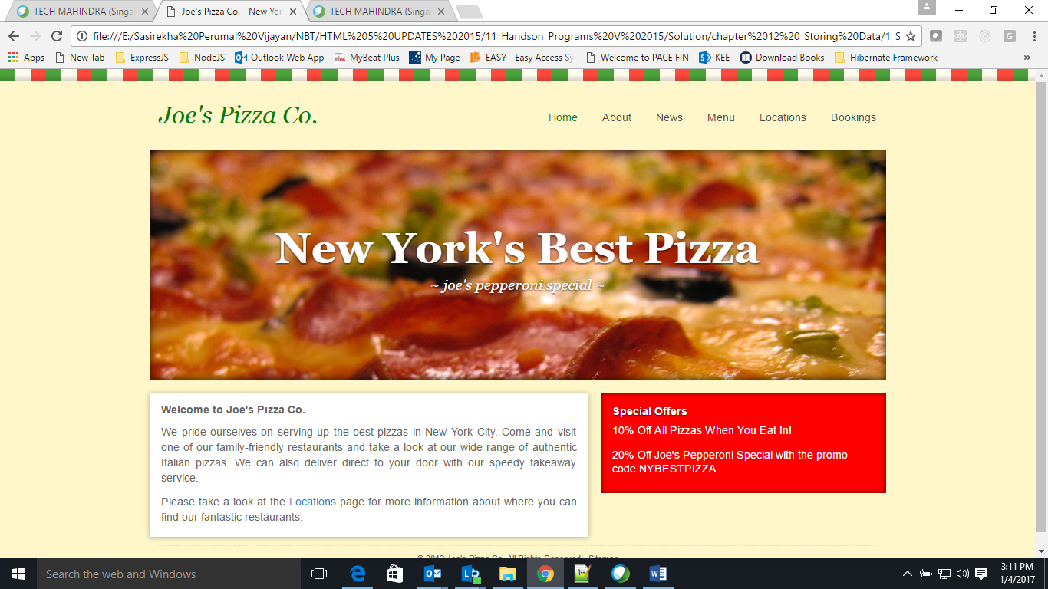

**Assignment2 –**

This case study is about the design of an online application form for a University, which has all its affiliations spread across various states of India.

User will get a form to register for once, as he log on to the University Portal for Registration.

Registration Form will have the following details to be filled by the User:

First Name

Last Name

Address

Email id

City

State

University Branch Name

Phone number

Enrolled Course

Date of Test

Written Test Marks

Form has a submit button to submit the details.

1.First Name or Last Name:

It should contain only letters, special symbols and numbers are not allowed. When user enters any special symbol or a number, user should immediately get an alert message "special chars and numbers are not allowed". The maximum length of the name in each of these fields should not exceed 25 chars.

2. Address: Maximum number of chars allowed should be 50 chars.

3. Email id: It should be of the format something@something.something

4. City and State: State and cities are two dropdown list boxes, when user selects the state the city drop down should get updated as respect to state.

5. Phone number: Should contain only numbers and the maximum length is 10.

Enrolled course: Should be 5 digit alpha numeric course code, there should be a hyperlink, "click here to select the course" which when clicked will open a window that contains the course name and the corresponding course code. When the user clicks on any course name, the corresponding course code should get set in this field.

7. Marks obtained: This will accept only a number which is not less than 50 and not more than 100. Highest acceptable num is 100. If the user enters any other number and clicks the submit button, there should be a red colored text message displayed exactly after this field with the following message.

"Enter a valid score between 50 & 100, if your score does not fall in this range, you are not eligible for enrollment".

8. Finally provide a submit button on the page.