**Name: Ankita Badak**

**Email ID:** [**ankita.badak91@gmail.com**](mailto:ankita.badak91@gmail.com)

**Version: 1.0**

**Date: 11th March 2022**

|  |  |  |  |  |  |
| --- | --- | --- | --- | --- | --- |
| **Programming Language** | **MVC Framework** | **Database** | **Rest API Authorization** | **Architecture** | **Project Setup** |
| PHP | Codeigniter 3.X | Mysql | JWT Token | 3-Tier | Local Virtual Host |

**Database:** db/aertripassignment.sql

**Git Hub URL:** https://github.com/ankitabadak21/aertripassignment

**Git Hub Repository Name**: aertripassignment

**Branch name:** development

**Project Configuration:**

Virtual Host Setup

**STEP 1-**

**Open and Edit below file:**

* Folder Path: <directory name>/xampp/apache/conf/extra/httpd-vhosts.conf
* Copy below code and paste it in above file.

<VirtualHost *:80>

ServerAdmin aertrip.local.com

ServerAlias aertrip.local.com

DocumentRoot "D:/xampp/htdocs/aertripassignment/portal/"

ServerName aertrip.local.com

Alias /application/logs/ D:/xampp/htdocs/aertripassignment/portal/application/logs

<Directory /application/logs/>

Order allow,deny

Allow from all

</Directory>

</VirtualHost>

<VirtualHost *:80>

ServerAdmin aertripapi.local.com

ServerAlias aertripapi.local.com

DocumentRoot "D:/xampp/htdocs/aertripassignment/portalapi/"

ServerName aertripapi.local.com

Alias /application/logs/ D:/xampp/htdocs/aertripassignment/portalapi/application/logs

<Directory /application/logs/>

Order allow,deny

Allow from all

</Directory>

</VirtualHost>

**STEP 2-**

**Open and Edit below file:**

* **Open file and run as administrator:** <directory>/Windows/System32/drivers/etc/hosts
* Copy below code and paste it in above file.

127.0.0.1 aertrip.local.com

127.0.0.1 aertripapi.local.com

**How to run:**

Open browser paste below URL:

<http://aertrip.local.com>

**Admin Credentials:**

Username – admin

Password - 123456

**API Details:**

1. **Admin Login:**

**URL**: <http://aertripapi.local.com/API/userLogin>

**Header:** <UTOKEN>

**Payload:**

username: admin

password: 123456

**Response:**

{"success":true,"msg":" Authenticated Successfully"}

{"success":false,"msg":"Username or Password incorrect"}

1. **Add Employee:**

**URL:** <http://aertripapi.local.com/API/addEditEmployee>

**Header:** <UTOKEN>

**Payload:**

department_id: 1

employee_name: John Smith

phone_no[]: 6333333333

phone_no[]: 7888888888

address[]: test address

address[]: addresss

emp_id:

**Response:**

{"success": true,"msg":"Record created\/updated successfully."}

1. **Edit/Update Employee:**

**URL:** <http://aertripapi.local.com/API/addEditEmployee>

**Header:** <UTOKEN>

**Payload:**

department_id: 1

employee_name: John Smith

phone_no[]: 6333333333

phone_no[]: 7888888888

address[]: test address

address[]: addresss

emp_id:1

**Response:**

{"success": true,"msg":"Record created\/updated successfully."}

1. **Delete Employee:**

**URL:** http://aertripapi.local.com/API/delEmployee

**Header:** <UTOKEN>

**Payload:**

id: 1

**Response:**

{"success": true,"msg":"Record deleted successfully."}

1. **List/Search Employee:**

**URL:** http://aertripapi.local.com/API/EmployeeListing

**Header:** <UTOKEN>

**Payload:**

act: fetch

sEcho: 1

iColumns: 4

sColumns: ,,,

iDisplayStart: 0

iDisplayLength: 10

mDataProp_0: 0

sSearch_0:

bRegex_0: false

bSearchable_0: true

bSortable_0: true

mDataProp_1: 1

sSearch_1:

bRegex_1: false

bSearchable_1: true

bSortable_1: true

mDataProp_2: 2

sSearch_2:

bRegex_2: false

bSearchable_2: true

bSortable_2: true

mDataProp_3: 3

sSearch_3:

bRegex_3: false

bSearchable_3: true

bSortable_3: false

sSearch:

bRegex: false

iSortingCols: 0

Searchkey_0:

_: 1646978350654

**Response:**

{"sEcho":"1","iTotalRecords":1,"iTotalDisplayRecords":1,"aaData":[["IT","John Smith","2022-03-10 20:37:38","<a href=\"employee\/addEdit?text=aWQ9OQ\" title=\"Edit\">Edit<\/a>&nbsp;&nbsp;|&nbsp;&nbsp;<a href=\"javascript:void(0);\" onclick=\"deleteData('9');\" title=\"Delete\">Delete<\/a>"]]}

**SCREEN SHOTS:**

* **Login Page**

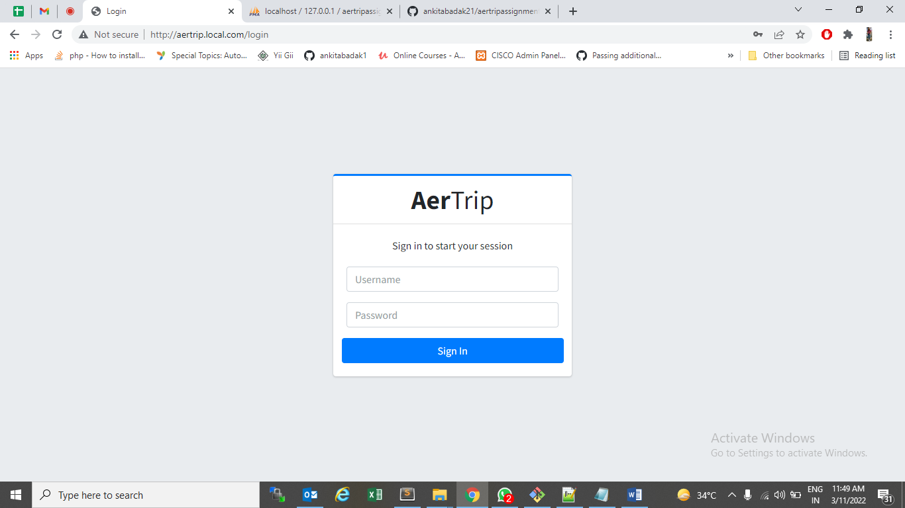

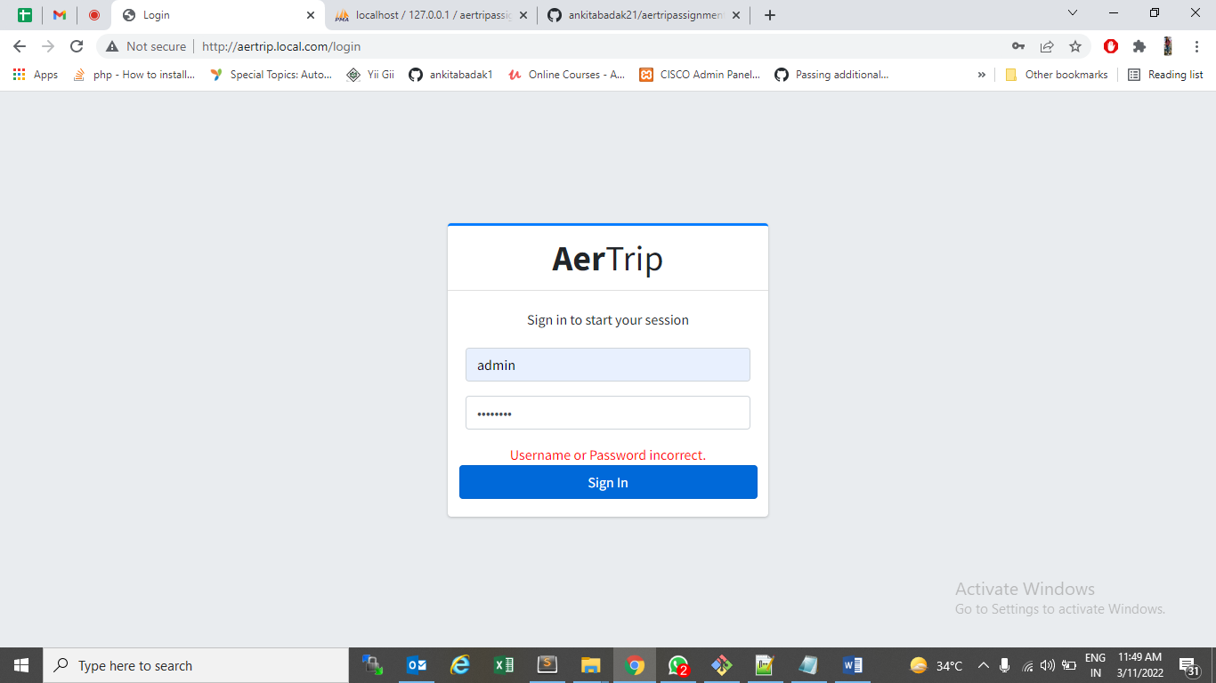

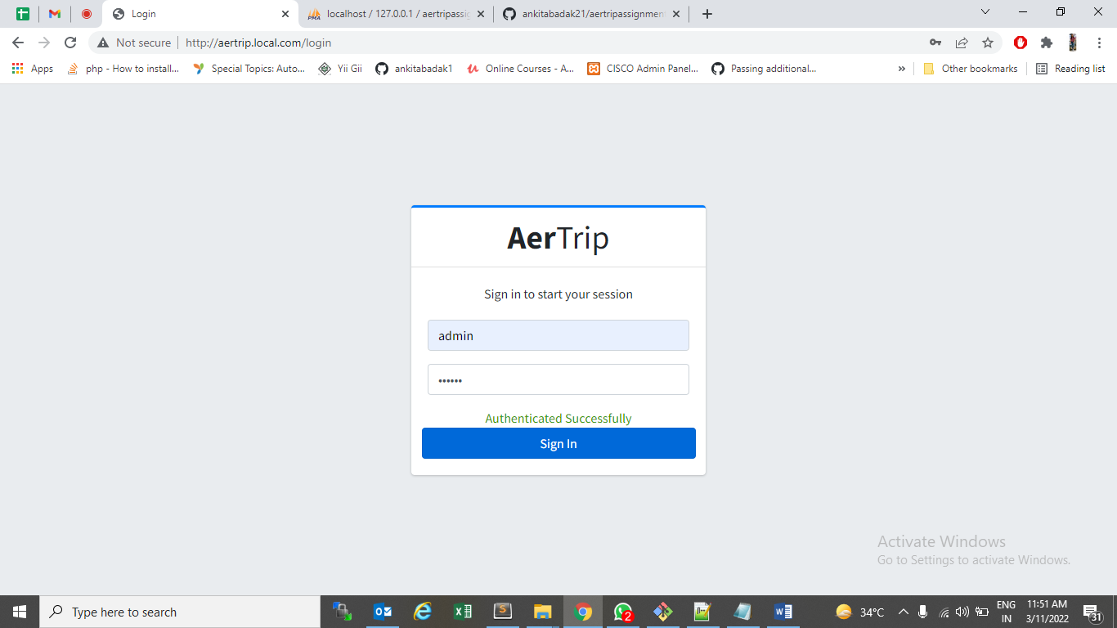

* **Dashboard Page**

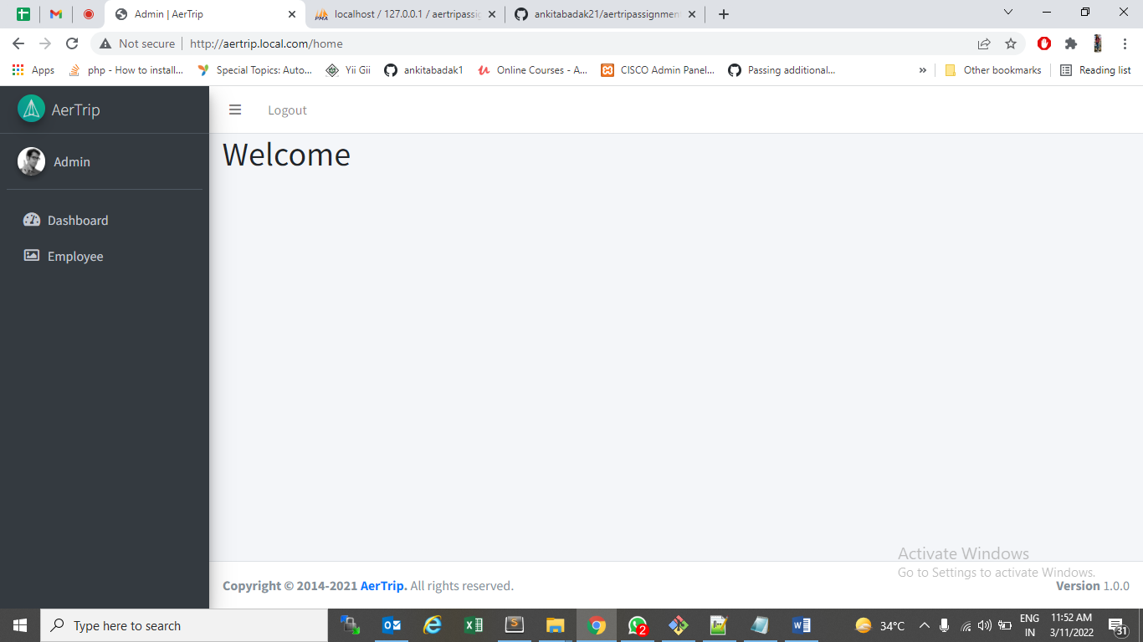

* **Employee Listing :**

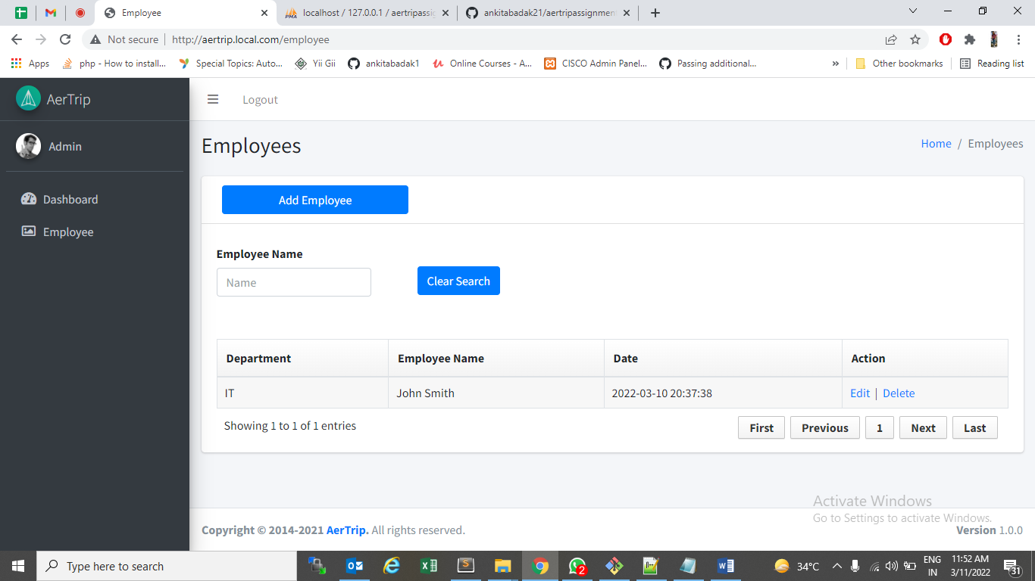

* **Add Employee**

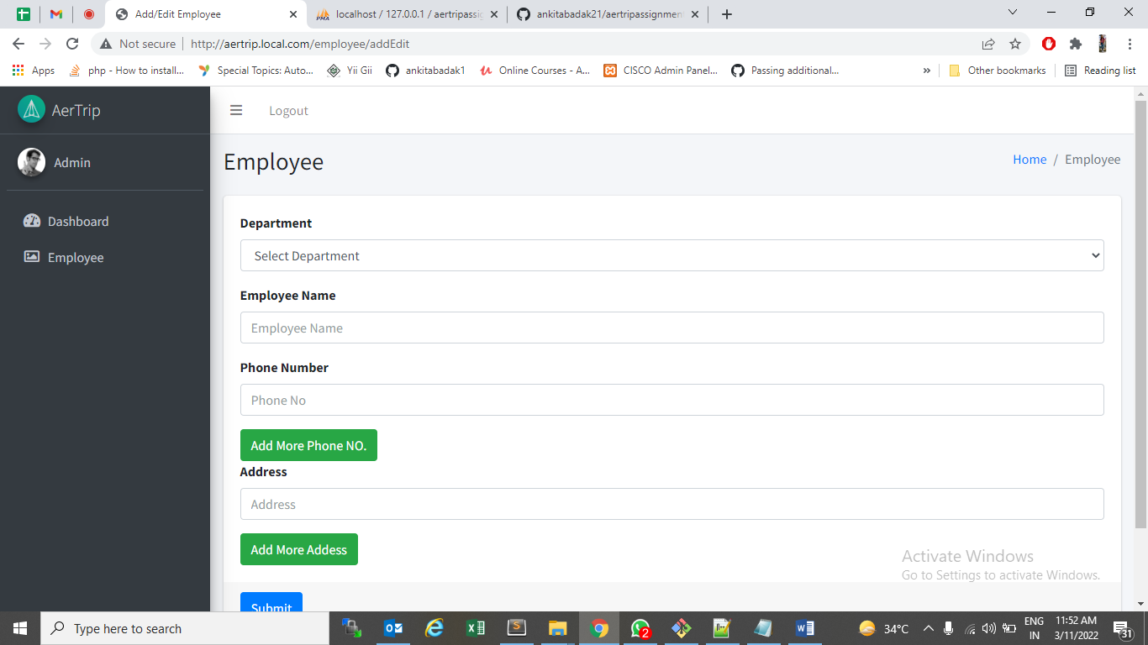

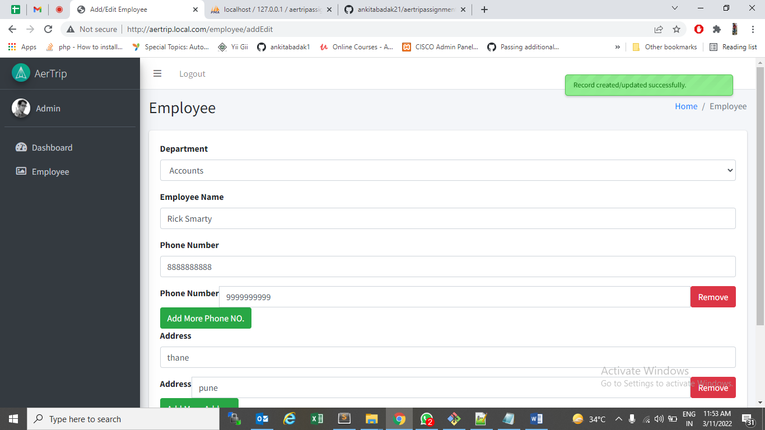

* **Edit Page:**

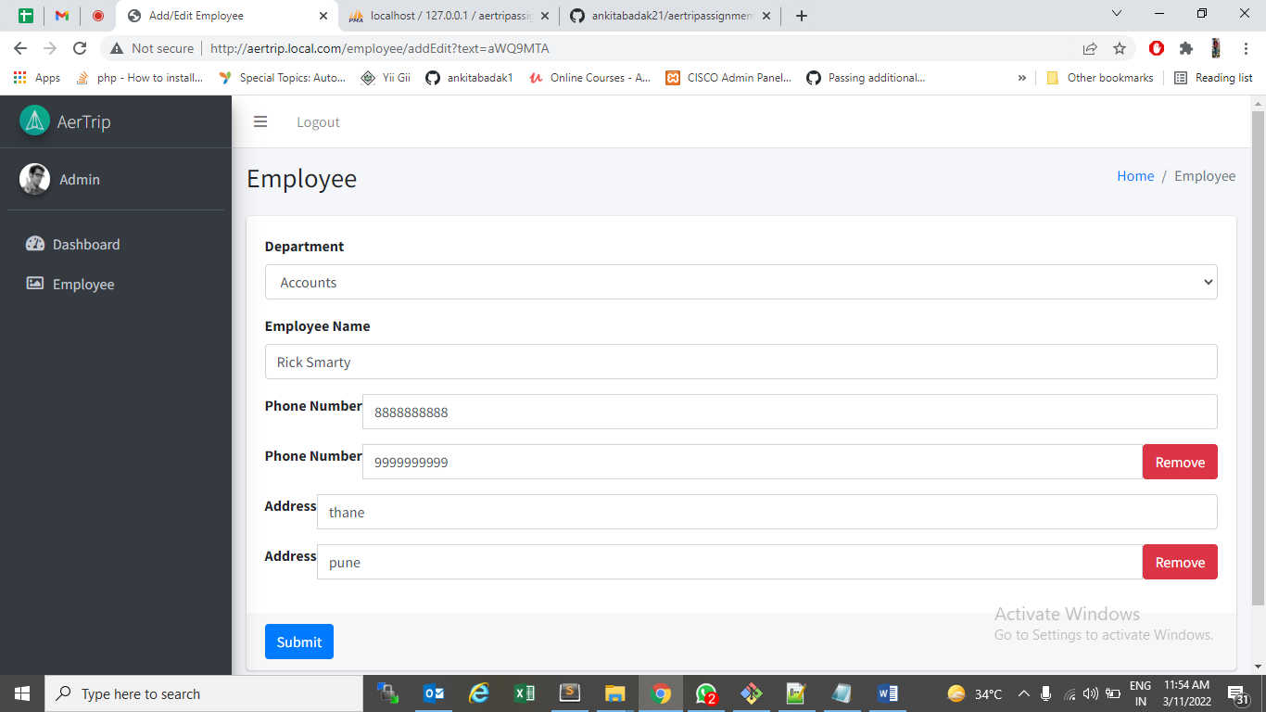

* **Delete Employee:**

