**Aim: Capturing and analysing network packets using Wireshark.**

**1)Identifying the live networks.**

TCP

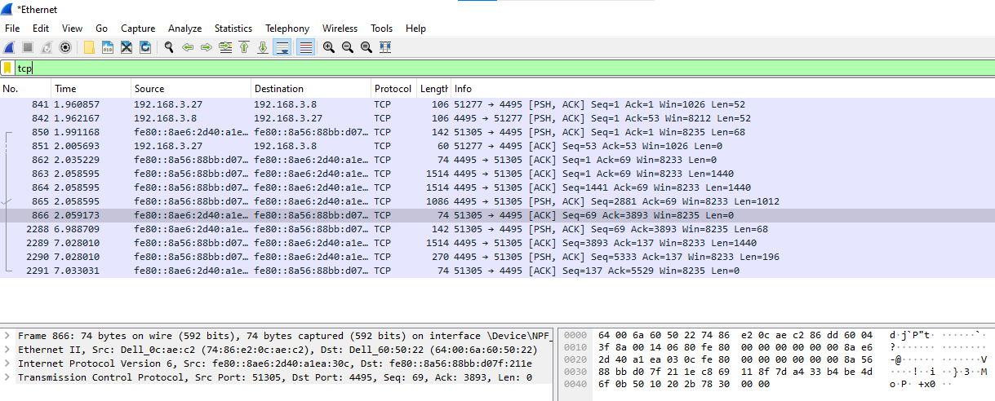

SSDP

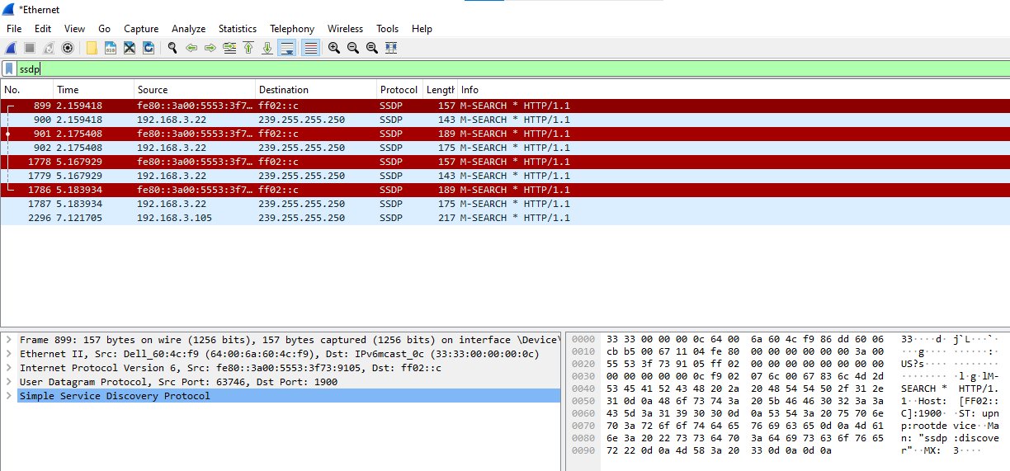

ARP

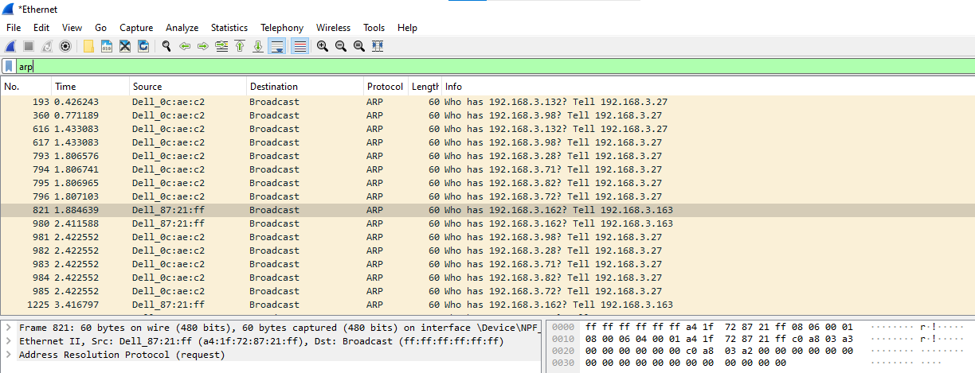

MDNS

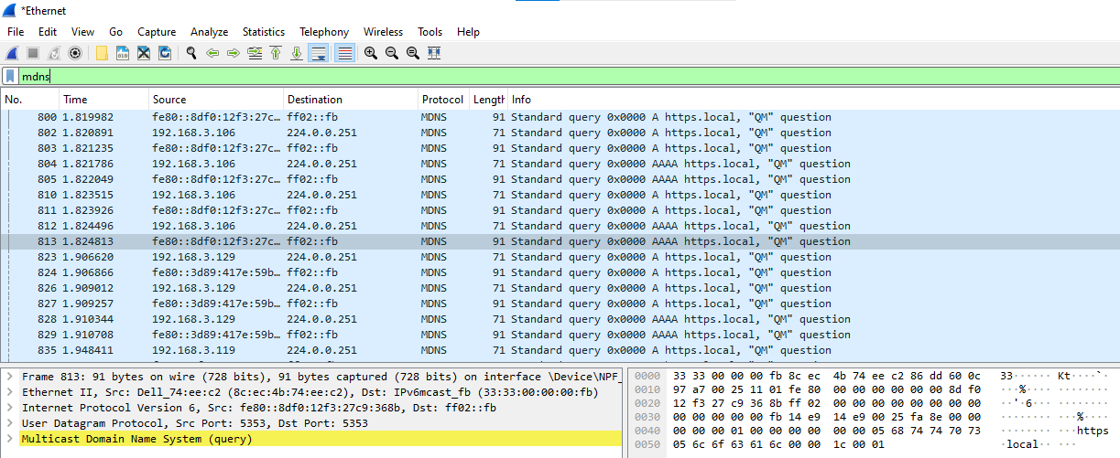

NBNS

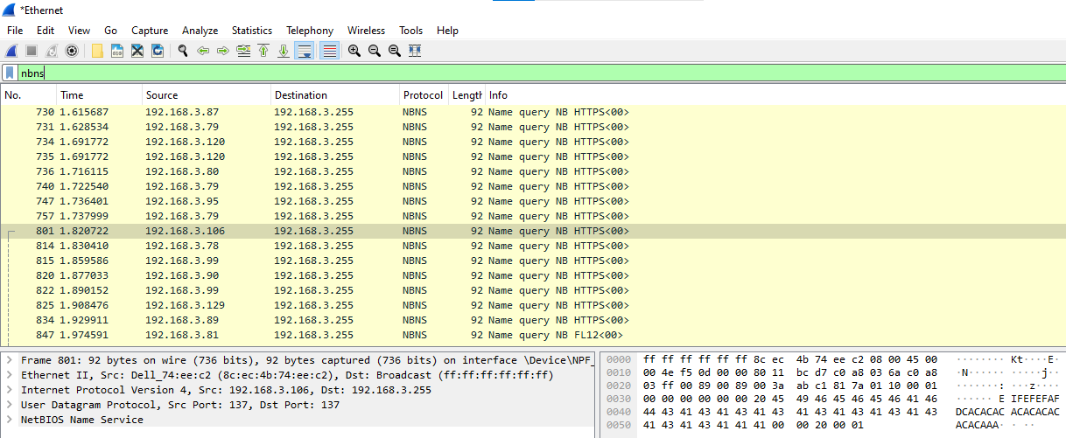

**2)Capture packets.**

**3)Analyse the captured packets.**

Step 1: Open Wireshark tool and click on the start button.

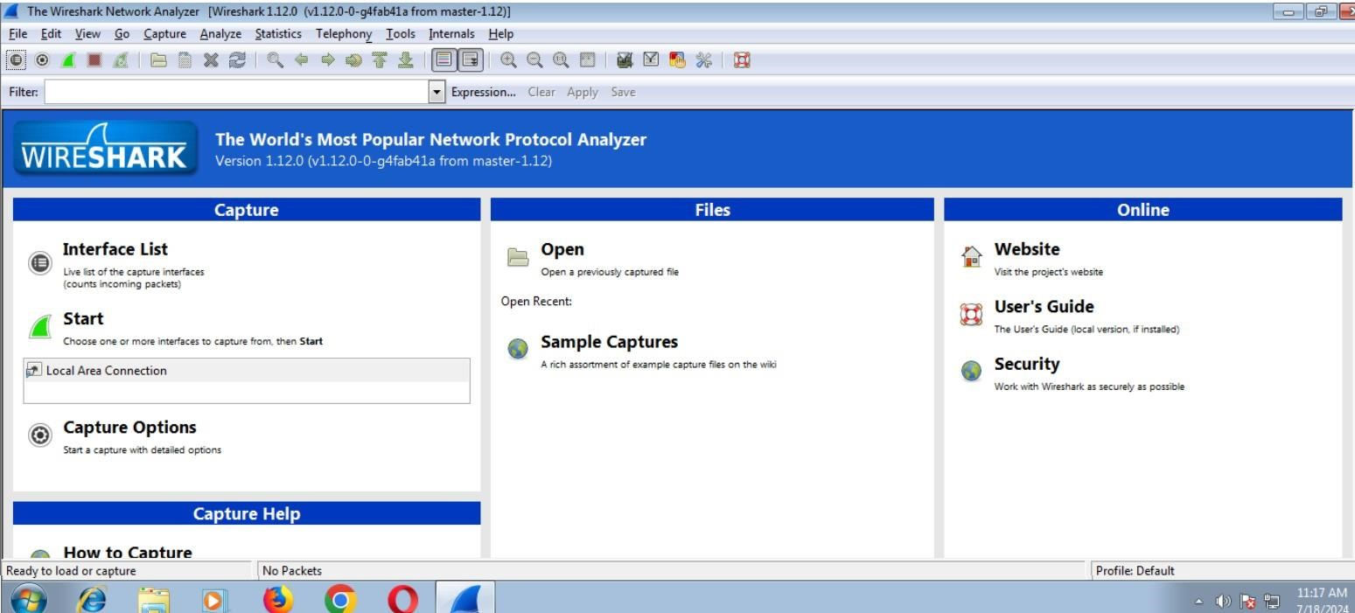

Step 2: It will show the list of packets going through the network.

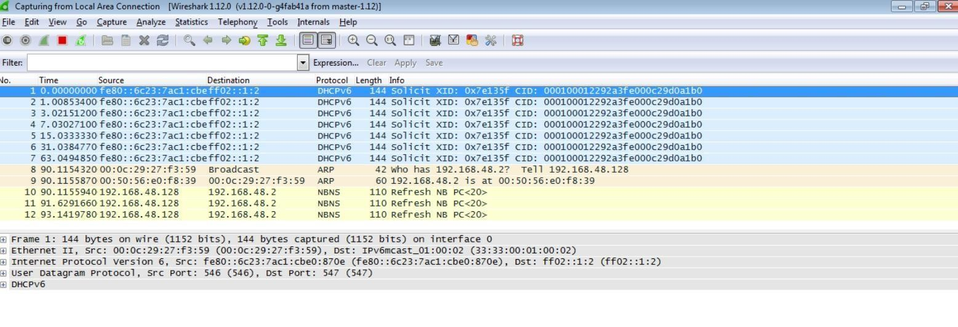

Step 3: Open Google > search techpanda.org and get logged in to the website.

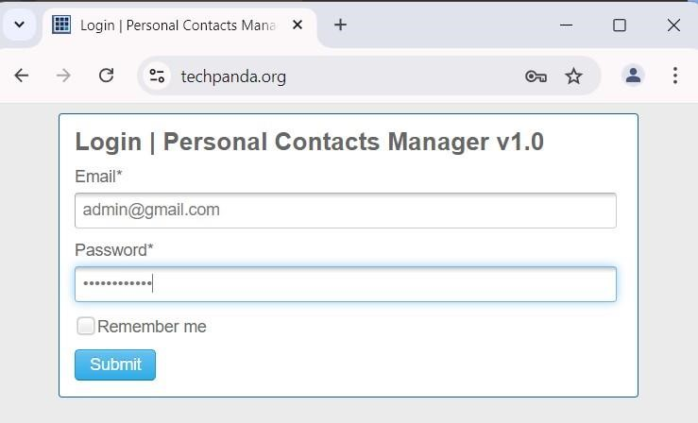

Step 4: Now go back to the Wireshark application and in filter option search http.

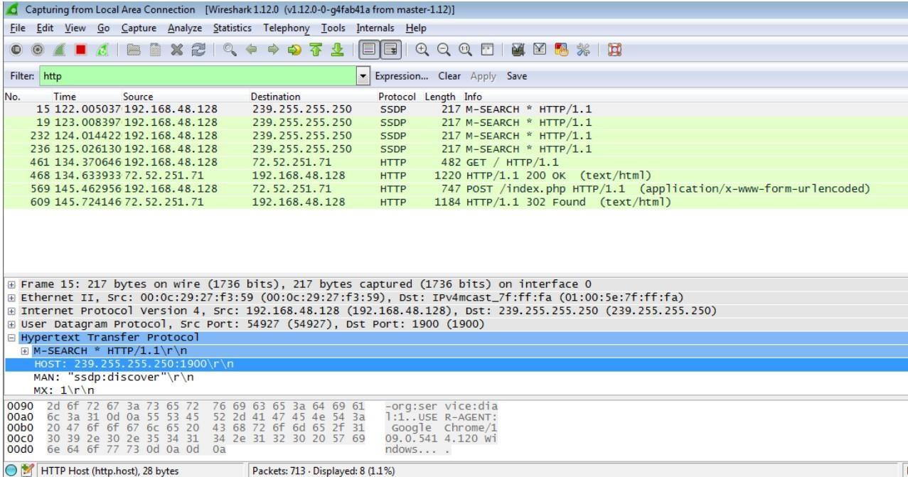

Step 5: Now click on index.php and then click on Hypertext Transfer Protocol

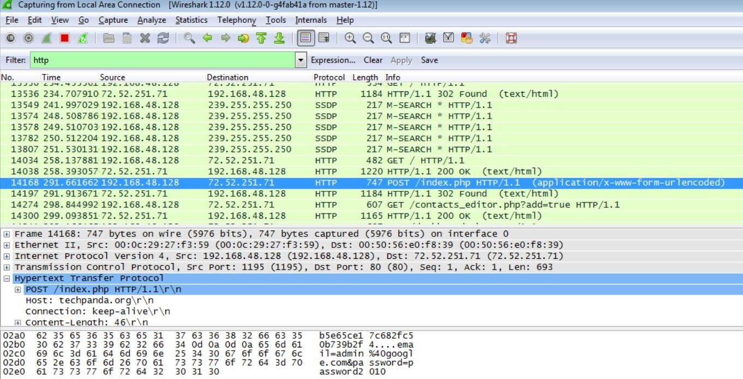

Step 6: As now you can see that the username and the password, we used for logged in is now showing below.

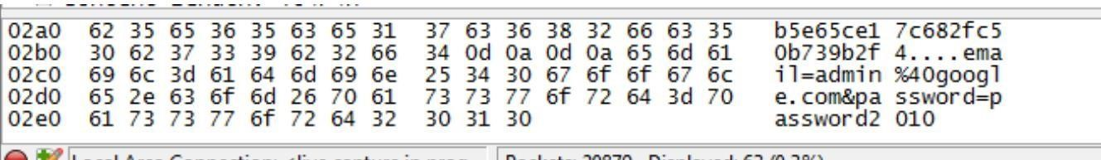

**Aim: Creating a Forensic Image using FTK Image/Encase Imager.**

1)Creating Forensic Image

2)Check Integrity of Data

3)Analyze Forensic Image

**1)Creating Forensic Image**

**Step 1: File create disk image**

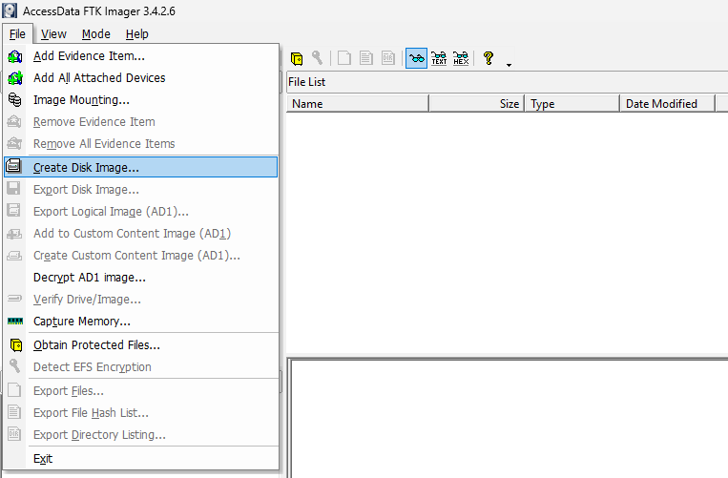

**Step 2:   Select source, contents of a folder**

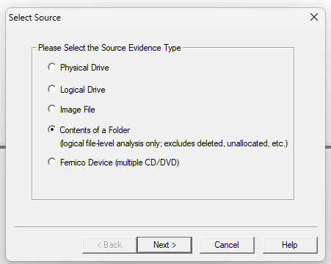

**Step 3:  select the folder directory that you want to create image file**

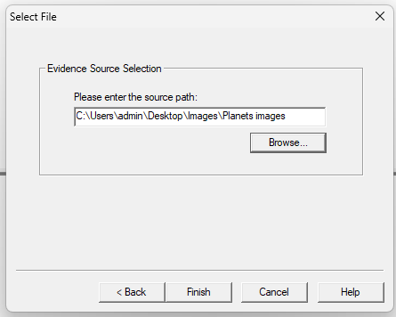

**Step 4:  Then finish verify image and click on Add**

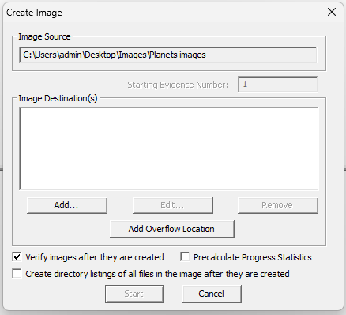

**Step 5: Add evidence information**

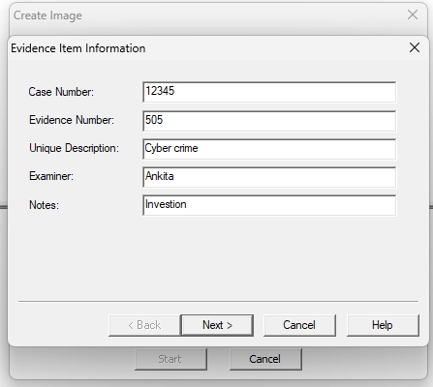

**Step 6: Create image destination AD encryption**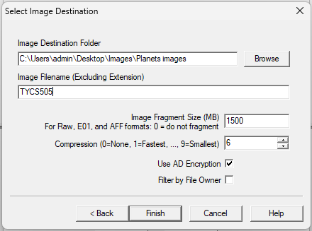

**Step 7: Put AD Encryption Credentials**

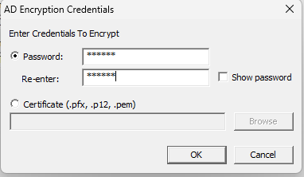

**Step 8: Create Image and click on Start**

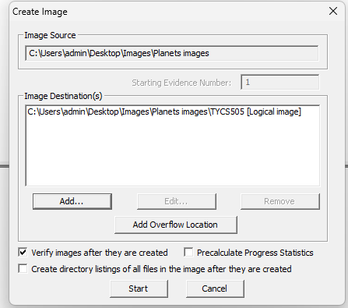\

**Step 9: Image created.**

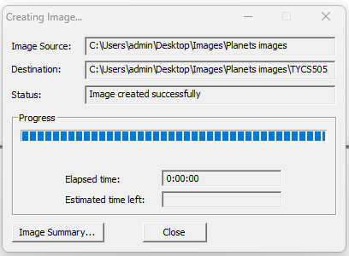

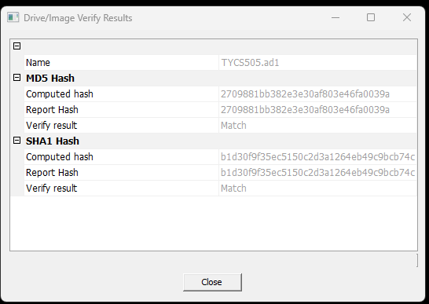

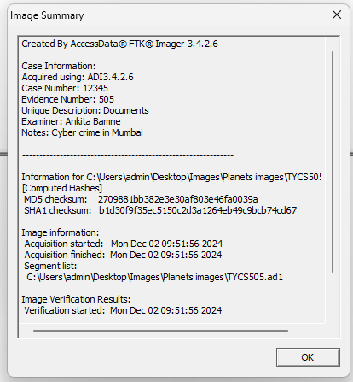

**2)Check Integrity of Data**

**Step 1: Select File and add evidence item**

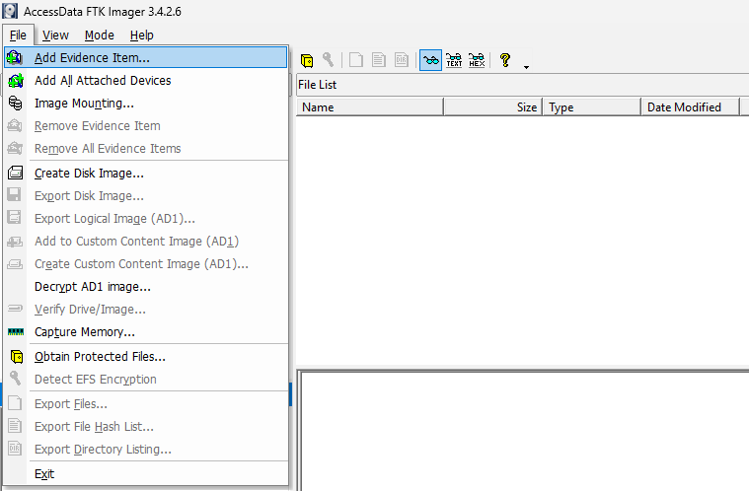

**Step 2: Select source, Image File**

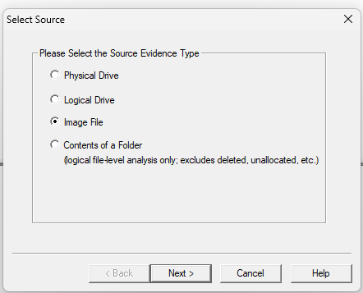

**Step 3: Browse and add ad1 file which you have already created.**

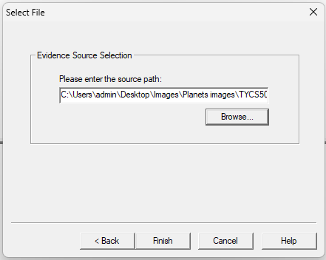

**Step 4: Enter password, in AD Encryption Credentials**

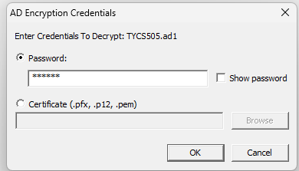

**Step 5: Select evidence Tree and verify drive/Image.**

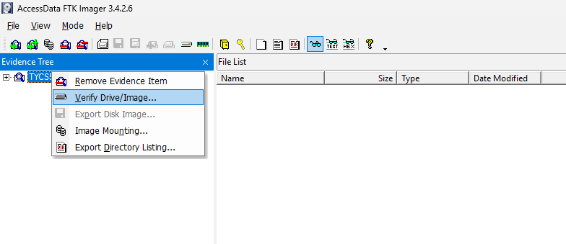

**Step 6: View Results.**



**3)Analyze Forensic Image**

**Autopsy**

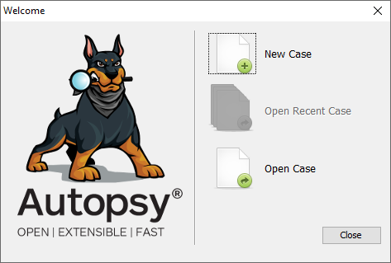

**Aim: Using Sysinternals tools for Network Tracking and Process Monitoring.**

1)Check Sysinternals tools

2)Monitor Live Processes

3)Capture RAM

4)Capture TCP/UDP packets

5)Monitor Hard Disk

6)Monitor Virtual Memory

7)Monitor Cache Memory

**2)Monitor Live Processes**

**STEP 1:** Go to SOFT THEN msc folder then sysinternals folder.

**ProcMon**

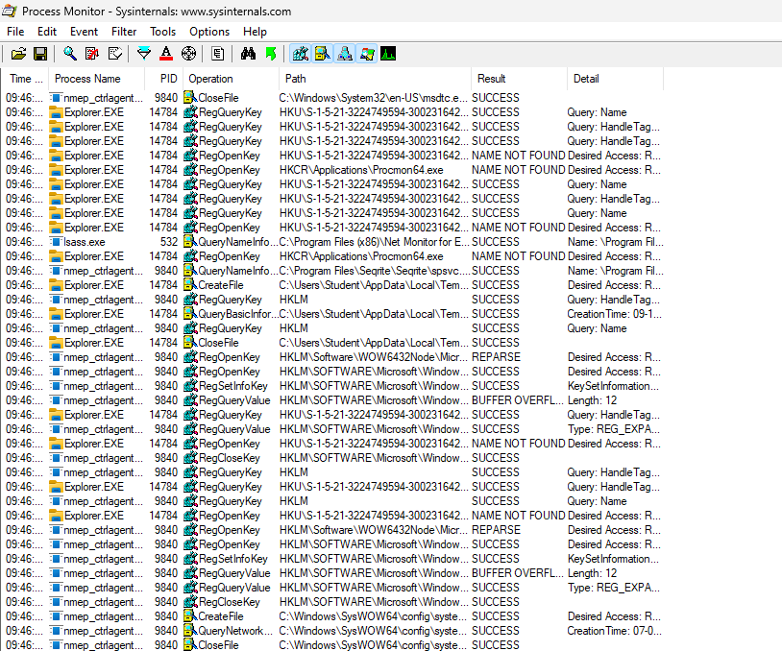

**Step 2:** right click on process that is success select properties

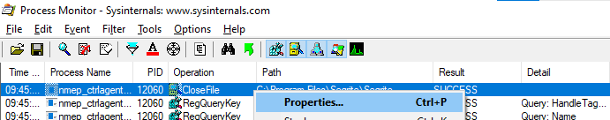

**Step 3:** Event properties details

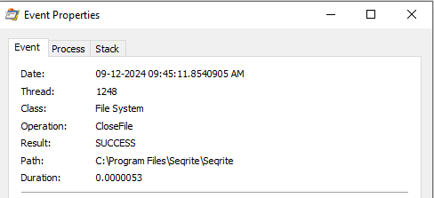

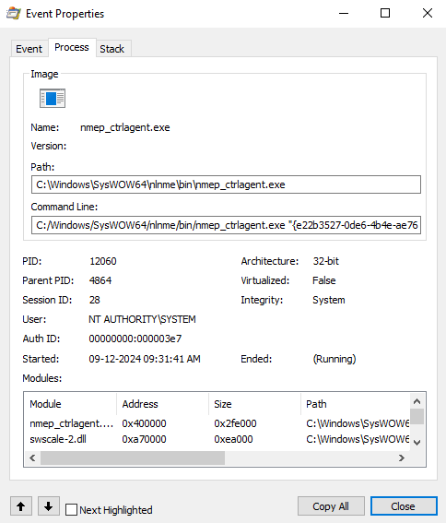

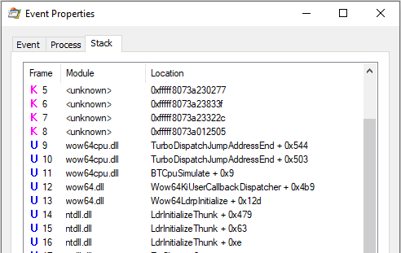

**3)Capture RAM**

Soft -> Sysinternal -> install RamMap application

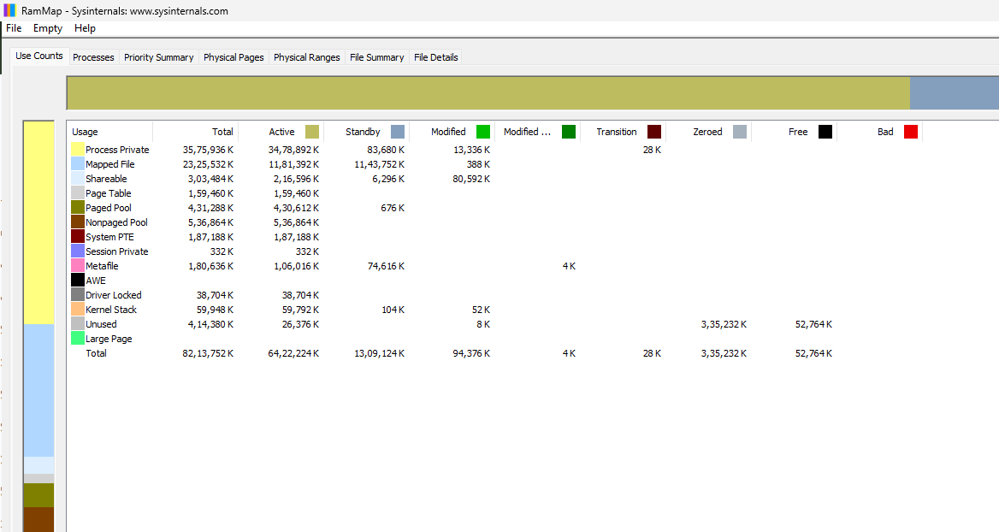

**RamMap Process**

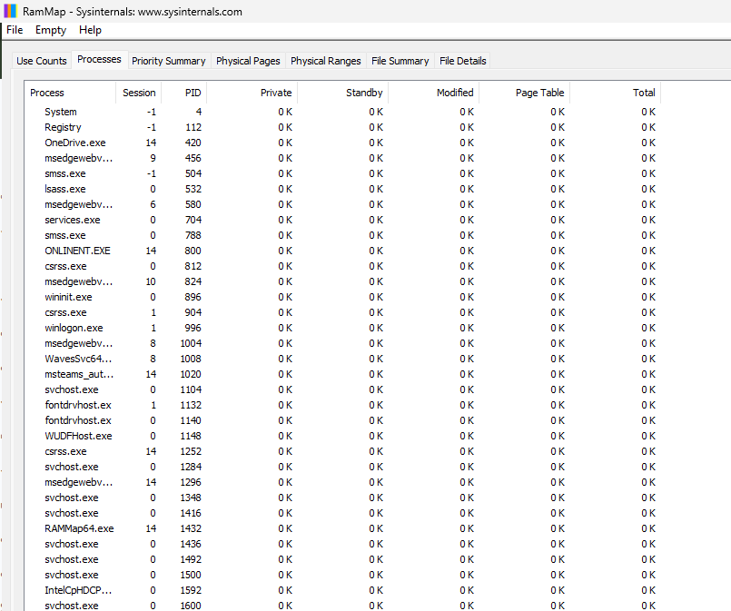

**RamMap Priority**

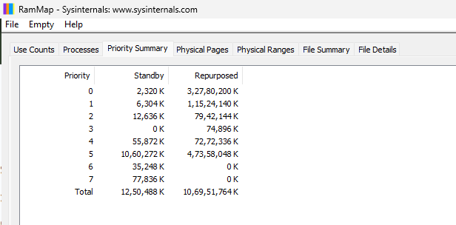

**Physical Pages**

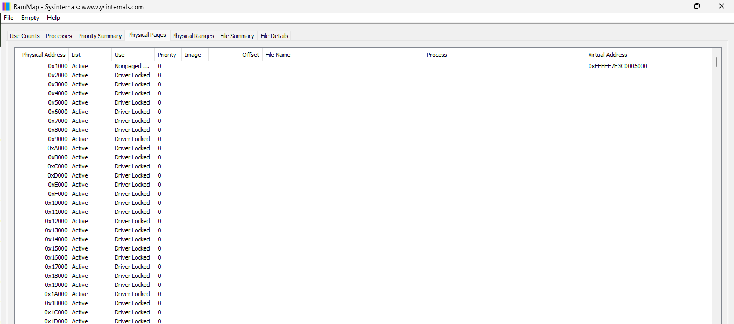

**Physical Ranges**

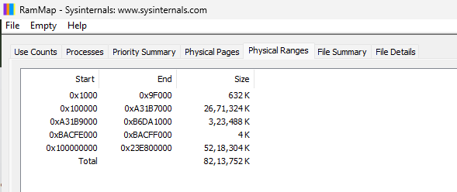

**File summary**

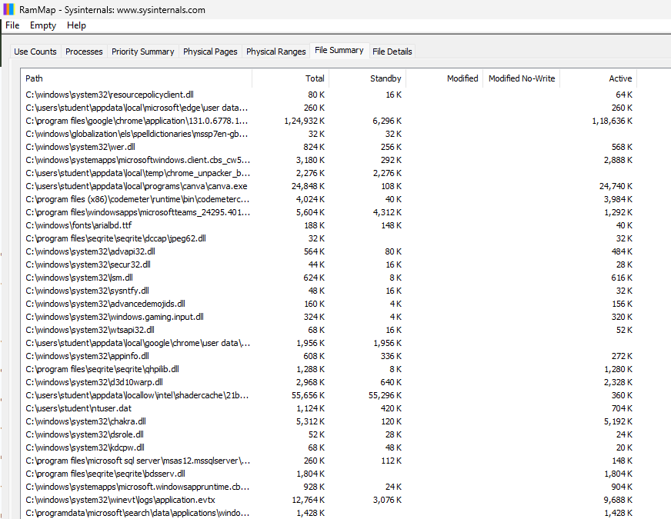

**File Details**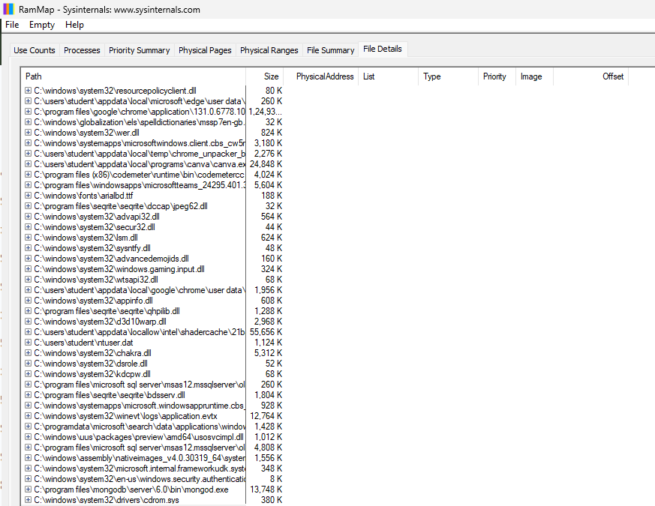

4)Capture TCP/UDP packets

Soft -> Sysinternal -> install tcpview application

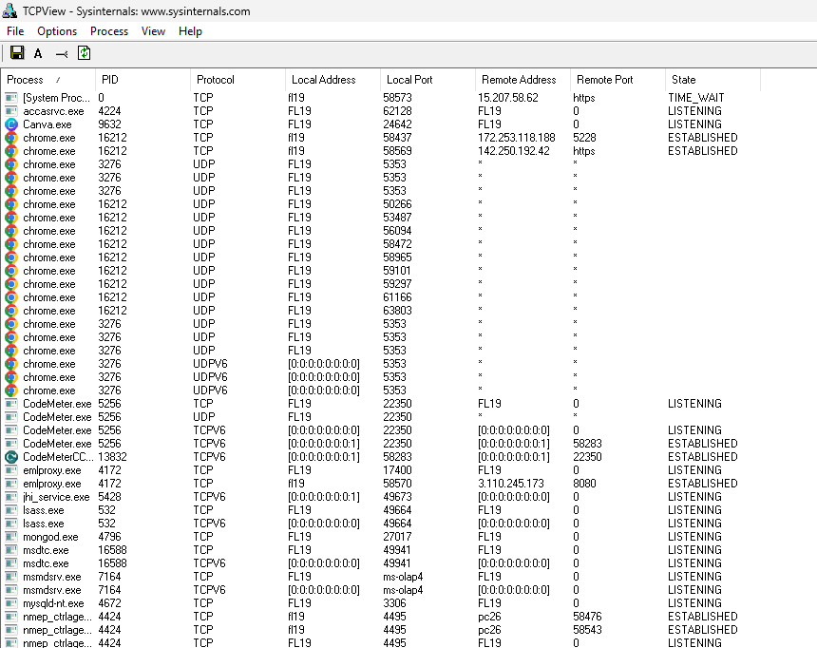

**TcpView**

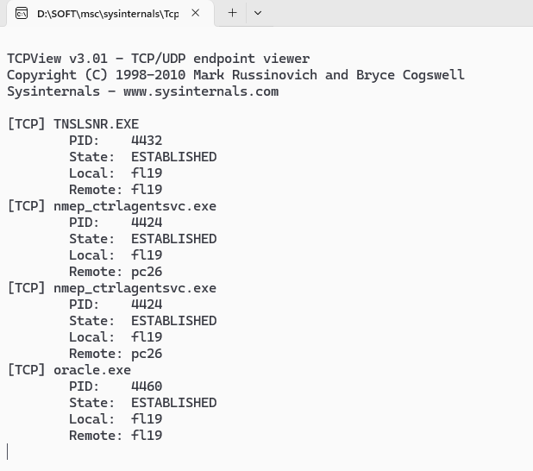

5)Monitor Hard disk

Soft -> Sysinternal -> install diskmon application

**DiskMon**

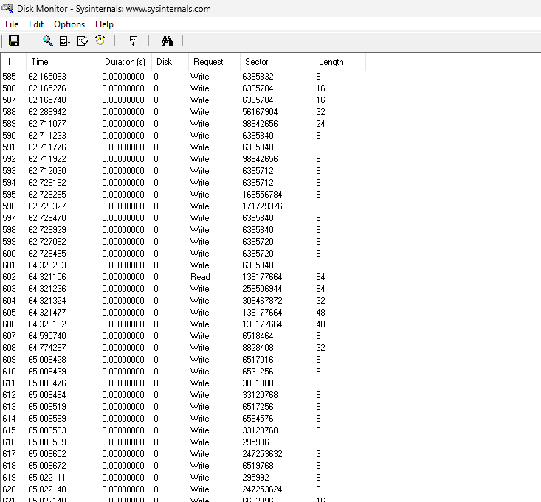

Soft -> Sysinternal -> install **DiskView** application.

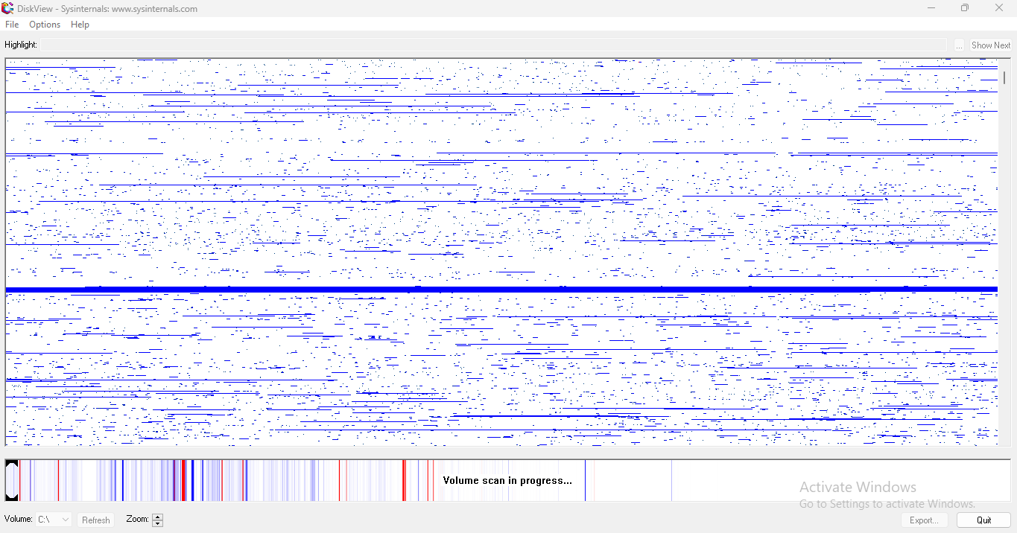

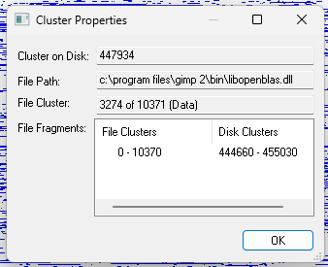

**6.Monitor virtual memory**

Soft -> Sysinternal -> install vmmap application

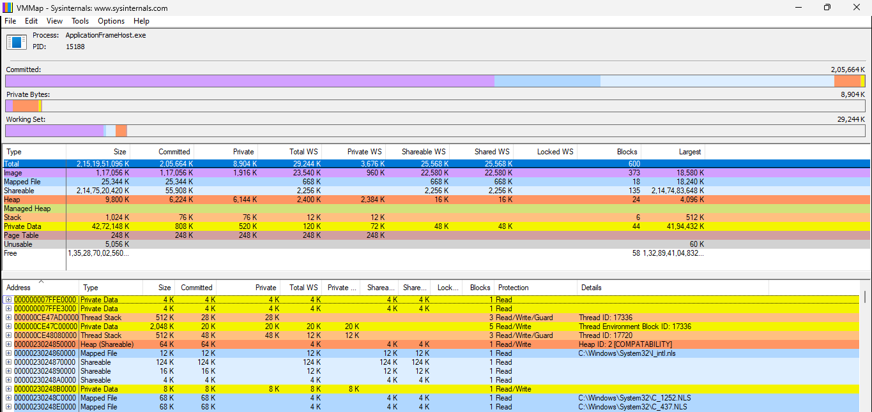

**7.Monitor Cache memory**

Soft -> Sysinternal -> install cacheset application

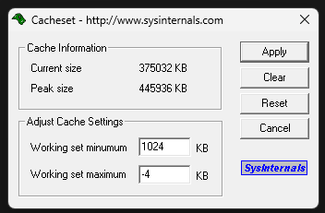

**Aim: Browser History Examiner**

**Step 1: Select repair Browser History Examiner.**

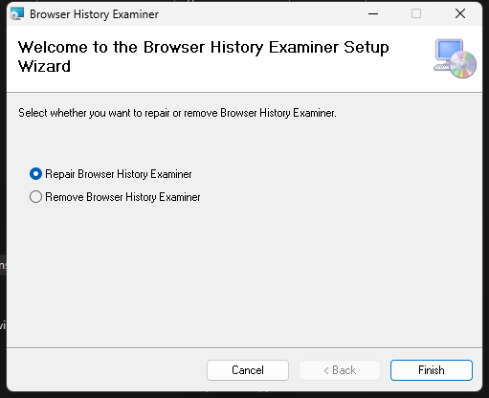

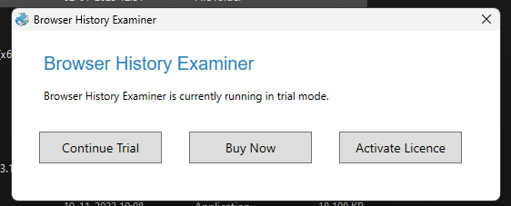

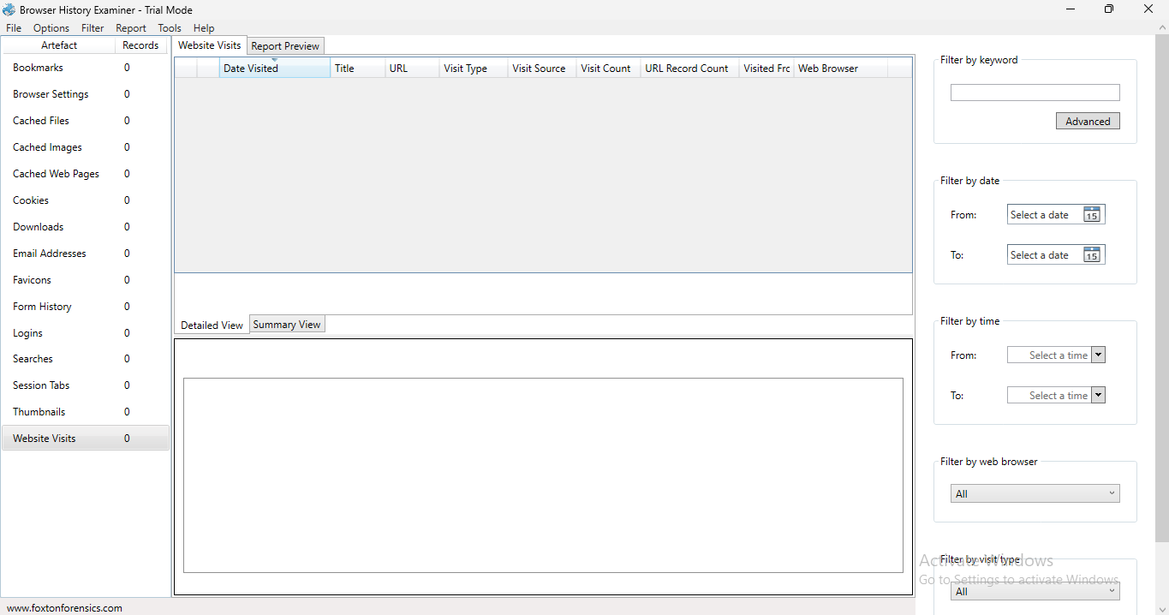

**Step 2: Click file, select capture history.**

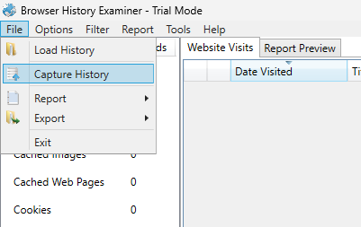

**Step 3: Select capture history from this computer.**

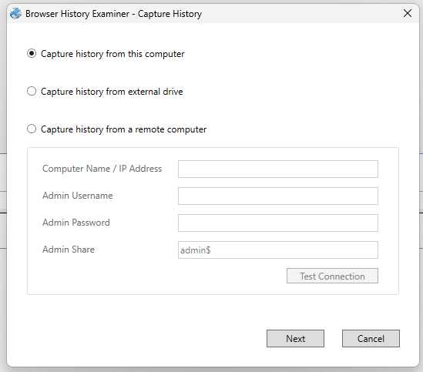

**Step 4: Select browsers, data and give destination path, click capture.**

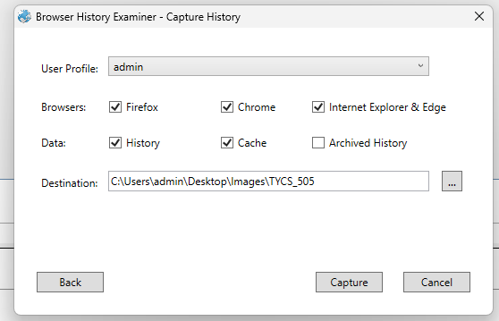

**Step 5: Displays all captured details.**

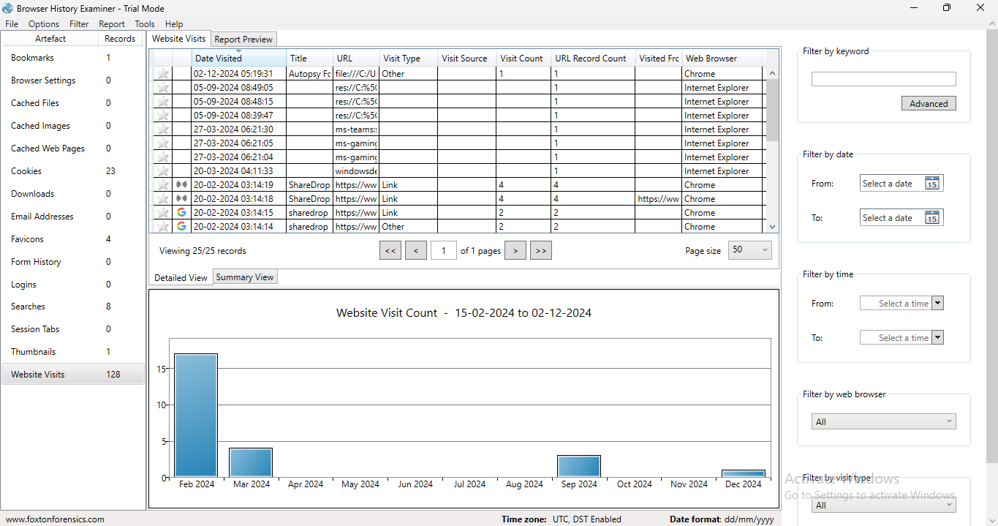

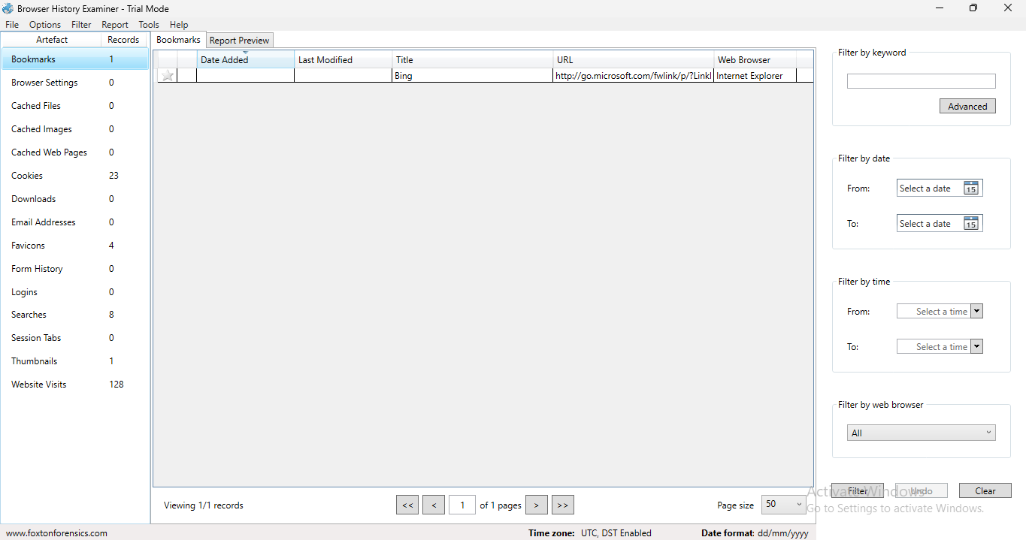

**Step 6: You can view bookmarks, Cookies.**

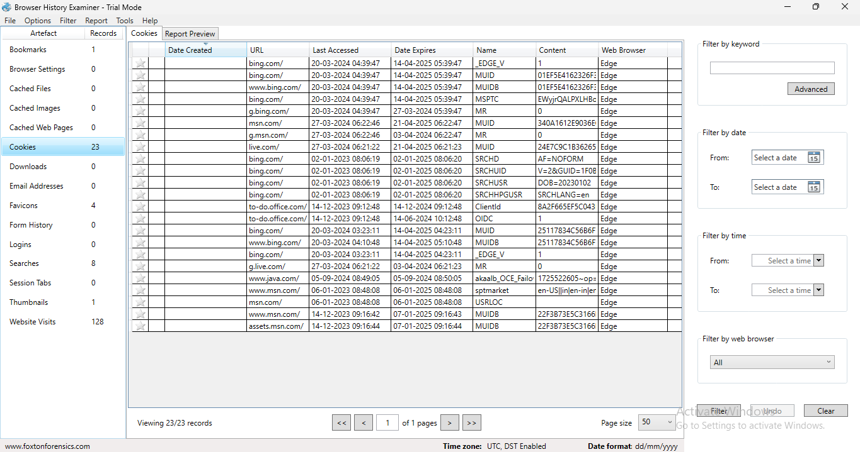

**Step 7: Right click on the records and click on add to report.**

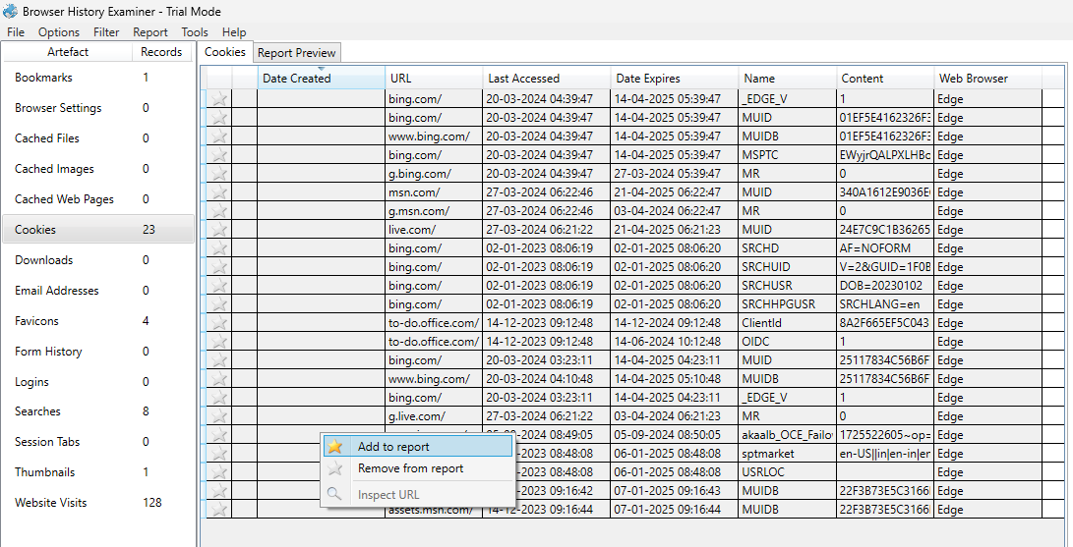

**Step 8: Then go to file click report and save.**

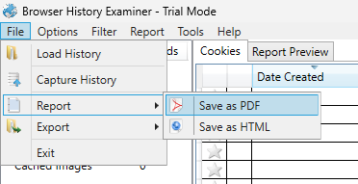

**Step 9: You can preview the report as you saved.**

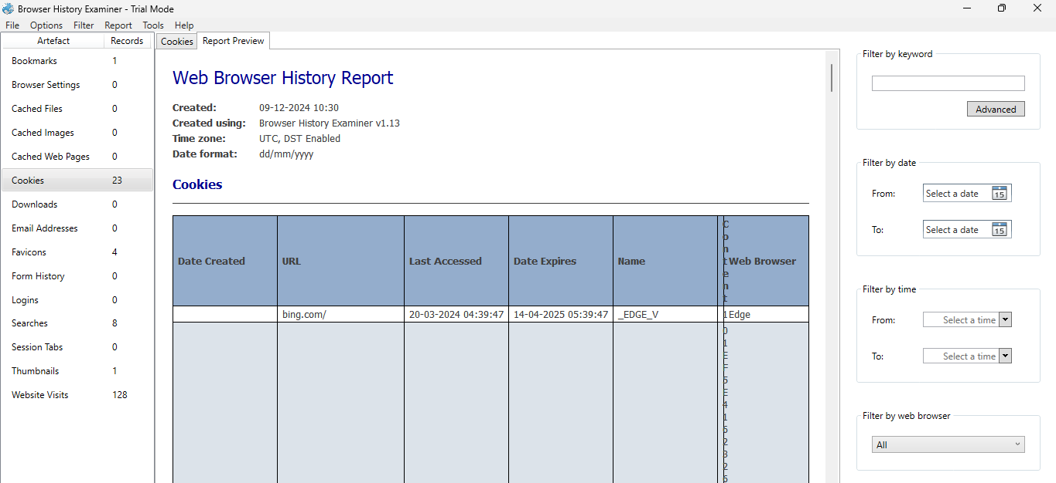

**Aim: Web Browser Forensics**

1)Web browser working

2)Forensics activities on browser

3)Cache/Cookies analysis

4)Last internet activity

**1)Web browser working**

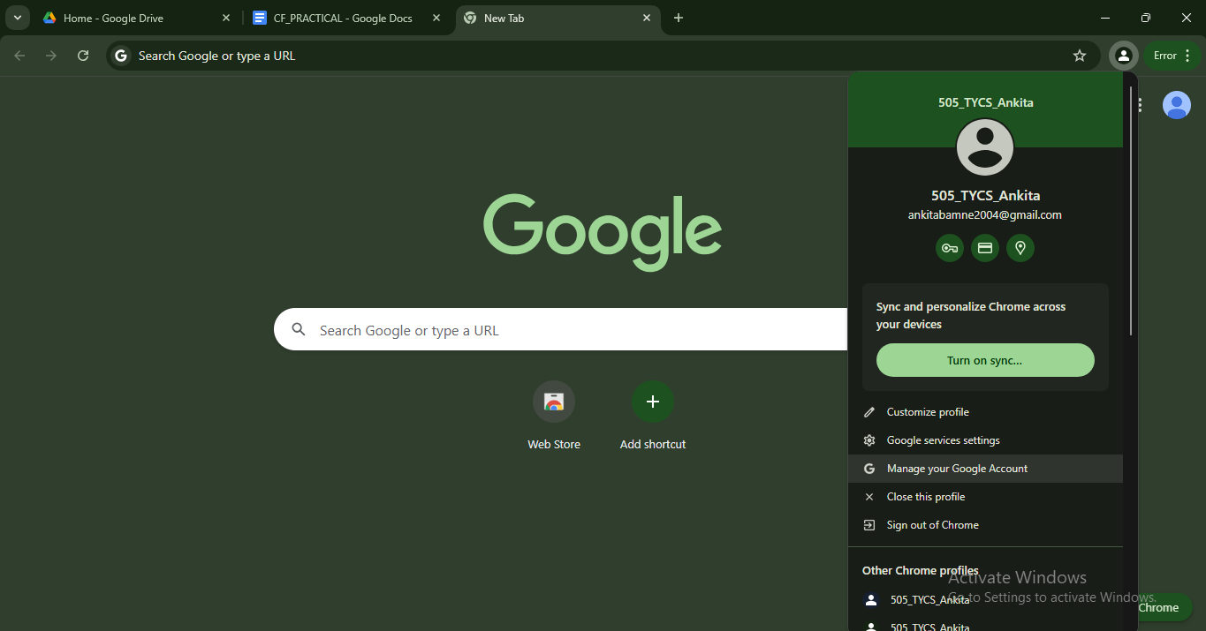

**Forensics activities browser**

**Go to browser setting -> search site setting -> open**

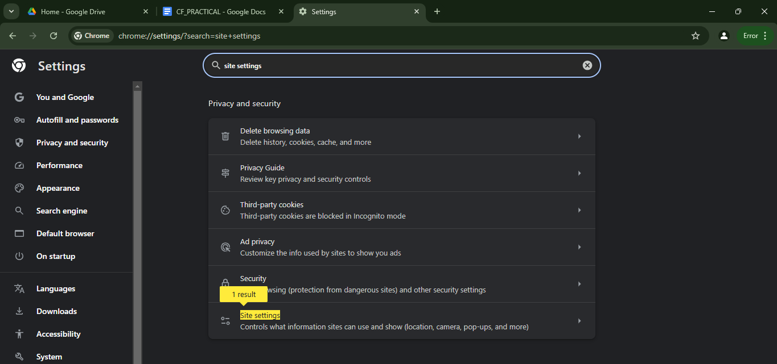

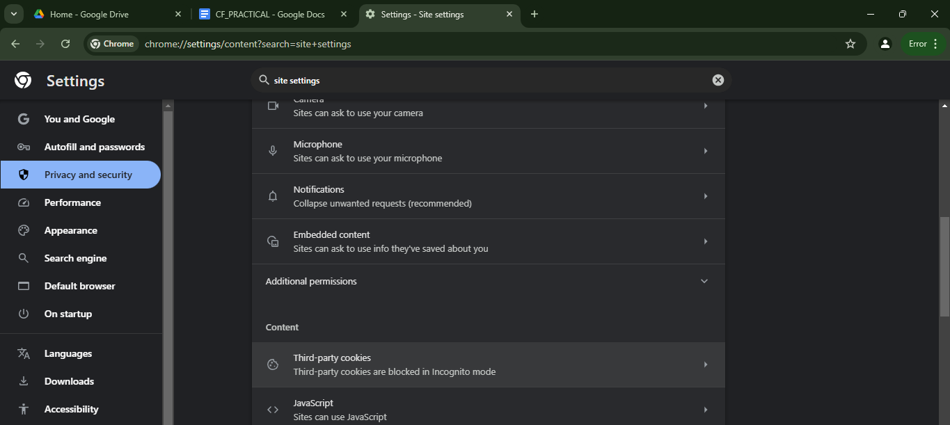

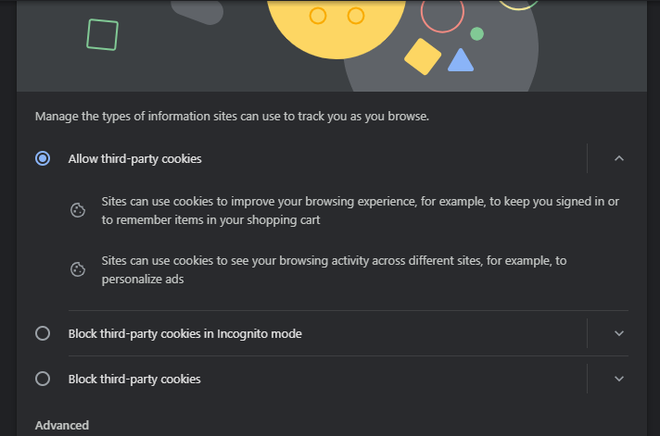

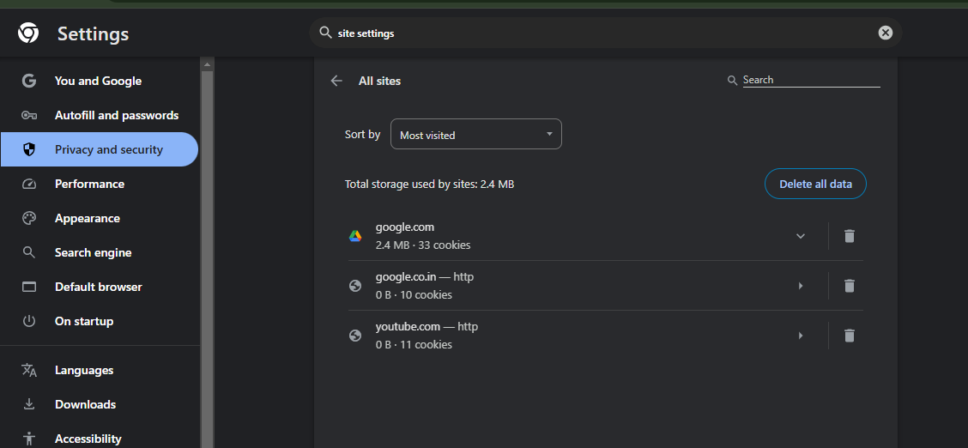

**3) Cache cookies analysis**

**cmd-> run as administrator**

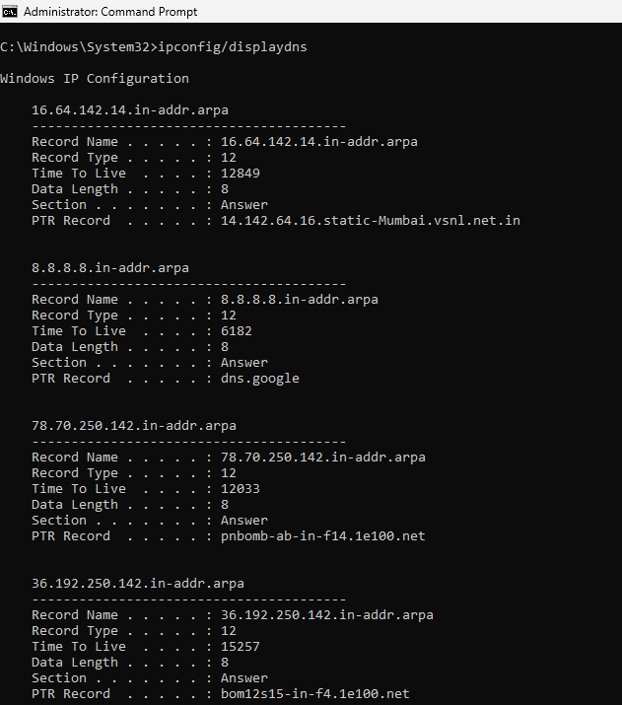

**4)Last internal activity**

**Go to myactivity.google.com**

