Best Waterfalls of Goa
7 min read • 1396 words

Best Waterfalls of Goa - Goa, India
In this article
1. Dudhsagar Falls
2. Kuske Waterfall
3. Savari Waterfall
4. Netravali Waterfall
5. Salaulim Waterfall (Salaulim Dam Spillway)
6. Bamanbudo Waterfall

Introduction
Planning a trip to Goa? This guide to best waterfalls of goa brings together 6 carefully verified destinations: Dudhsagar Falls, Kuske Waterfall, Savari Waterfall, Netravali Waterfall, Salaulim Waterfall (Salaulim Dam Spillway) and Bamanbudo Waterfall.
Every detail below - from timings to prices - is taken from our Goa travel database, so you can plan with confidence and spend less time second-guessing.

Dudhsagar Falls

Scenic view of Dudhsagar Falls, a waterfall in Goa, India
Region | Dharbandora
Entry fee | Sanctuary entry approx Rs 50 + jeep safari approx Rs 400-450 per person (full jeep approx Rs 2400-2500)
Timings | Jeep safari: 6:00 AM - 5:30 PM; ticket counter closes around 2:00 PM; closed during heavy monsoon (mid-June to September)
Best time | October to early June (best flow June-September, but access restricted in peak monsoon)

A spectacular four-tiered waterfall on the Mandovi River at the Goa-Karnataka border, among the tallest waterfalls in India (approx 310 m); reached via jeep safari through Bhagwan Mahavir Wildlife Sanctuary or by trekking along the Castle Rock railway line.

Why Visit
Recommended for Adventure Seekers, Photography, Trekkers. Trek to the falls from Kulem or Castle Rock, or take the forest-department jeep safari; swim (with a life jacket) in the natural pool at the base; birdwatch for hornbills and barbets along the trail.

What Makes It Special
Long a subject of local legend (the name means 'Sea of Milk' from its frothy white cascade); has been a landmark since colonial-era railway surveys of the Braganza Ghats in the 19th century.

Best Time to Visit
The best time to visit is October to early June (best flow June-September, but access restricted in peak monsoon).

Nearby Attractions
Nearby you can also explore Bhagwan Mahavir Wildlife Sanctuary & Mollem National Park (~3.5 km).

Travel Tip
Wear non-slip footwear; check whether the waterfall/trek is open, since access can close in heavy monsoon; carry water and a change of clothes if swimming.

Kuske Waterfall

Scenic view of Kuske Waterfall, a waterfall in Goa, India
Region | Sanguem
Entry fee | Free
Timings | 8:00 AM - 5:00 PM
Best time | Jun-Sept

Kuske Waterfall, also known as Kuskem Waterfall, is a beautiful seasonal waterfall located near Kuskem village in Sanguem Taluka, South Goa. Nestled amidst the lush forests of the Western Ghats, the waterfall is surrounded by rich greenery, rolling hills, and a tranquil natural environment, making it an ideal destination for nature lovers and trekking enthusiasts. During the monsoon season, the waterfall comes alive with a strong flow of crystal-clear water, creating a refreshing and picturesque landscape.

Why Visit
Recommended for Nature Lovers, Trekkers. Trekking, Photography, Sightseeing

What Makes It Special
Kuske Waterfall is a natural waterfall located in the Sanguem region of South Goa, surrounded by the lush greenery of the Western Ghats. It is known for its peaceful environment, rocky landscape, and natural beauty.

Best Time to Visit
The best time to visit is Jun-Sept.

Travel Tip
Wear sturdy footwear and avoid slippery rocks.

Savari Waterfall

Scenic view of Savari Waterfall, a waterfall in Goa, India
Region | Sanguem
Entry fee | Free
Timings | 8:00 AM - 5:00 PM
Best time | Jun-Sept

Savari Waterfall is a picturesque seasonal waterfall located in Sanguem Taluka, South Goa, surrounded by the lush forests of the Western Ghats. Hidden amidst dense greenery, the waterfall offers a peaceful retreat for nature lovers, trekkers, and photographers. During the monsoon season, rain-fed streams create a spectacular cascade that flows over rocky terrain, enhancing the scenic beauty of the surrounding landscape and providing a refreshing natural escape.

Why Visit
Recommended for Nature Lovers, Trekkers. Trekking, Photography, Sightseeing

What Makes It Special
Savari Waterfall is a natural waterfall located in the Sanguem region of South Goa, surrounded by the greenery and forests of the Western Ghats. It is known for its scenic beauty, flowing streams, and peaceful natural surroundings.

Best Time to Visit
The best time to visit is Jun-Sept.

Travel Tip
Stay on marked paths and respect wildlife.

Netravali Waterfall
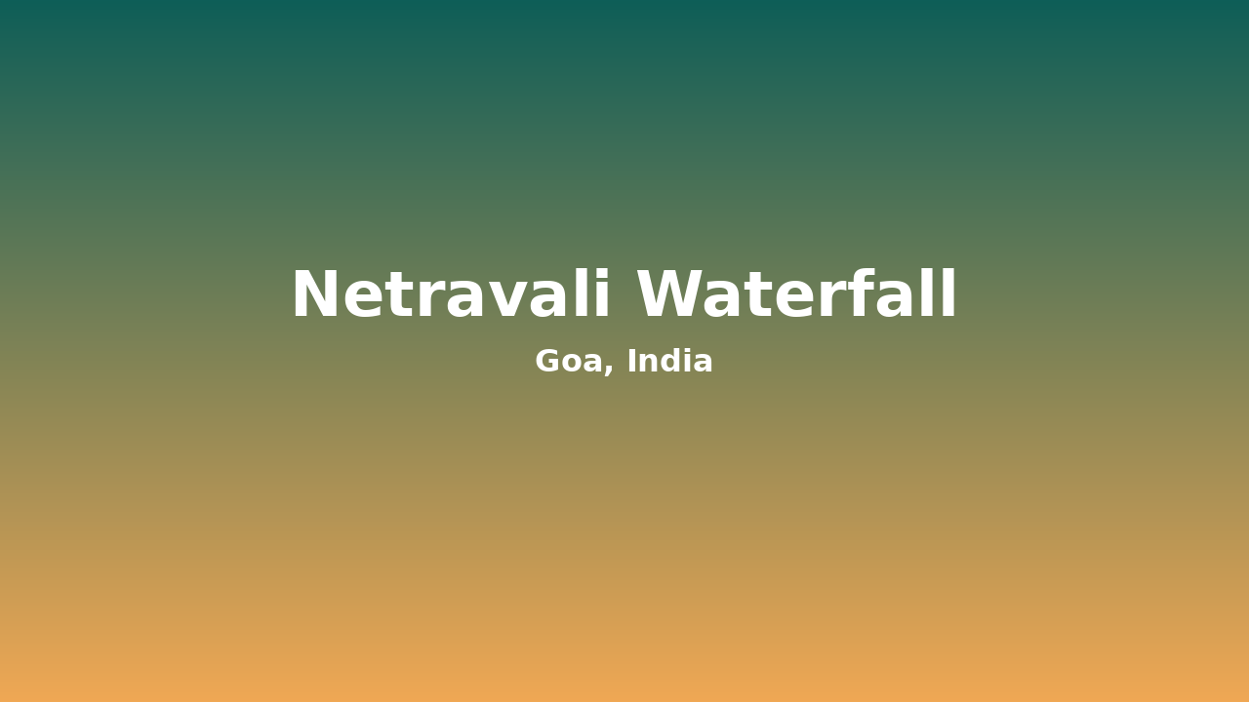
Scenic view of Netravali Waterfall, a waterfall in Goa, India
Region | Sanguem
Entry fee | Free
Timings | 8:00 AM - 5:00 PM
Best time | Jun-Sept

Netravali Waterfall is a beautiful seasonal waterfall located in Netravali village, Sanguem Taluka, South Goa, within the Netravali Wildlife Sanctuary. Surrounded by dense evergreen forests, rolling hills, and rich biodiversity, the waterfall offers a peaceful and refreshing escape into nature. During the monsoon season, the waterfall flows with great force, creating a spectacular cascade that attracts nature lovers, trekkers, photographers, and wildlife enthusiasts.

Why Visit
Recommended for Nature Lovers, Trekkers. Trekking, Photography, Sightseeing

What Makes It Special
Netravali Waterfall is a beautiful natural waterfall located in Netravali village, Sanguem taluka, South Goa. It is surrounded by dense forests and the scenic landscape of the Western Ghats, making it an important eco-tourism destination in Goa.

Best Time to Visit
The best time to visit is Jun-Sept.

Travel Tip
Enjoy nature responsibly and dispose of waste properly.

Salaulim Waterfall (Salaulim Dam Spillway)
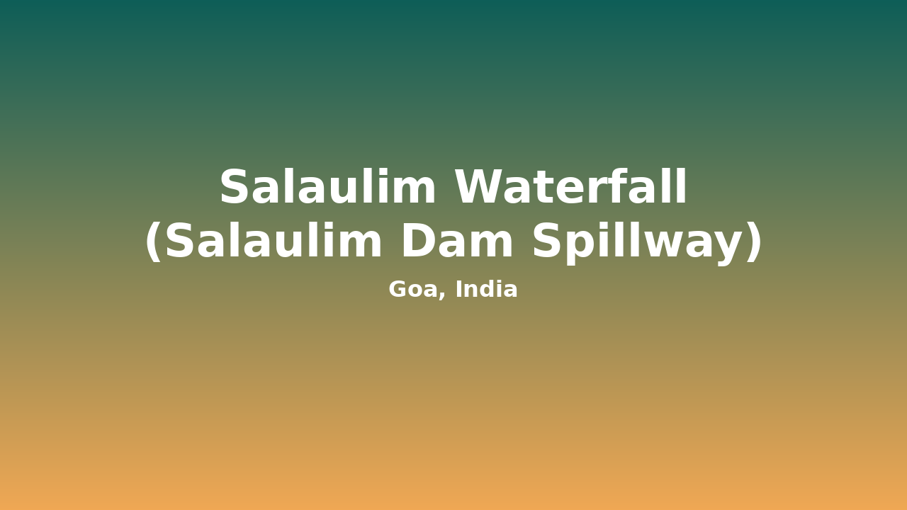
Scenic view of Salaulim Waterfall, a waterfall in Goa, India
Region | Sanguem
Entry fee | Free
Timings | 8:00 AM - 5:00 PM
Best time | Jul-Oct

Salaulim Waterfall, commonly seen during the monsoon at the Salaulim Dam in Sanguem Taluka, South Goa, is a seasonal attraction created when excess water is released through the dam's spillway. Surrounded by green hills, forests, and the scenic reservoir, the waterfall offers breathtaking views and is a popular destination for nature lovers, photographers, and visitors seeking a peaceful getaway. The powerful flow of water during the rainy season creates a spectacular sight and enhances the natural beauty of the area.

Why Visit
Recommended for Nature Lovers, Trekkers. Trekking, Photography, Sightseeing

What Makes It Special
Salaulim Waterfall is a natural attraction located near the Salaulim Dam in Sanguem taluka, South Goa. It is formed by the overflow of water from the Salaulim Dam, especially during the monsoon season, creating a scenic cascade surrounded by greenery.

Best Time to Visit
The best time to visit is Jul-Oct.

Travel Tip
Follow safety signs and enjoy the viewpoint responsibly.

Bamanbudo Waterfall

Scenic view of Bamanbudo Waterfall, a waterfall in Goa, India
Region | Canacona
Entry fee | Free
Timings | 8:00 AM - 5:00 PM
Best time | Oct-Mar

Bamanbudo Waterfall is a scenic natural waterfall located in Gaondongrem village, Canacona, South Goa. It is situated along the lush green landscapes of the Western Ghats and is known for its easy accessibility, peaceful surroundings, and natural beauty. The waterfall flows over rocky terrain, creating a beautiful cascade surrounded by forests and greenery.

Why Visit
Recommended for Nature Lovers, Trekkers. Trekking, Photography, Sightseeing

What Makes It Special
Bamanbudo Waterfall is a natural waterfall located in Gaondongrem village, Canacona, South Goa, surrounded by the forests and hills of the Western Ghats. The waterfall has been a part of the regionâs natural landscape for generations and holds importance as a local natural heritage site.

Best Time to Visit
The best time to visit is Oct-Mar.

Travel Tip
Carry drinking water and keep the area clean.

How to Reach
- Kuske Waterfall: By road: Accessible by road via state highways; taxis and private vehicles available. | Nearest railhead: Auto-rickshaws, taxis and local buses available nearby (subject to location). | Local transport: Nearest major railway station depends on destination; taxi/bus required for onward travel.
- Savari Waterfall: By road: Accessible by road via state highways; taxis and private vehicles available. | Nearest railhead: Auto-rickshaws, taxis and local buses available nearby (subject to location). | Local transport: Nearest major railway station depends on destination; taxi/bus required for onward travel.
- Netravali Waterfall: By road: Accessible by road via state highways; taxis and private vehicles available. | Nearest railhead: Auto-rickshaws, taxis and local buses available nearby (subject to location). | Local transport: Nearest major railway station depends on destination; taxi/bus required for onward travel.
- Salaulim Waterfall (Salaulim Dam Spillway): By road: Accessible by road via state highways; taxis and private vehicles available. | Nearest railhead: Auto-rickshaws, taxis and local buses available nearby (subject to location). | Local transport: Nearest major railway station depends on destination; taxi/bus required for onward travel.
- Bamanbudo Waterfall: By road: Accessible by road via state highways; taxis and private vehicles available. | Nearest railhead: Auto-rickshaws, taxis and local buses available nearby (subject to location). | Local transport: Nearest major railway station depends on destination; taxi/bus required for onward travel.

Best Time to Visit Goa
- Dudhsagar Falls: October to early June (best flow June-September, but access restricted in peak monsoon)
- Kuske Waterfall: Jun-Sept
- Savari Waterfall: Jun-Sept
- Netravali Waterfall: Jun-Sept
- Salaulim Waterfall (Salaulim Dam Spillway): Jul-Oct
- Bamanbudo Waterfall: Oct-Mar

Budget Tips
- Dudhsagar Falls: Sanctuary entry approx Rs 50 + jeep safari approx Rs 400-450 per person (full jeep approx Rs 2400-2500)
- Kuske Waterfall: Free
- Savari Waterfall: Free
- Netravali Waterfall: Free
- Salaulim Waterfall (Salaulim Dam Spillway): Free
- Bamanbudo Waterfall: Free

Responsible Tourism Tips
Respect local customs, carry your rubbish out with you, avoid single-use plastic and stay on marked paths.

Frequently Asked Questions

What is the most popular option in this guide?
Dudhsagar Falls leads our list based on visitor popularity in the dataset.

When is the best time to visit Dudhsagar Falls?
October to early June (best flow June-September, but access restricted in peak monsoon).

When is the best time to visit Kuske Waterfall?
Jun-Sept.

When is the best time to visit Savari Waterfall?
Jun-Sept.

When is the best time to visit Netravali Waterfall?
Jun-Sept.

When is the best time to visit Salaulim Waterfall (Salaulim Dam Spillway)?
Jul-Oct.

Conclusion
From Dudhsagar Falls to Bamanbudo Waterfall, Goa rewards curious travellers. Pick a few favourites, travel respectfully and enjoy the trip.

SEO & Publishing Details
Internal notes for the content team - remove before publishing.
SEO title | Best Waterfalls of Goa
Primary keyword | Best Waterfalls of Goa
Slug | best-waterfalls-of-goa
Meta description | Explore the waterfalls of goa: Dudhsagar Falls, Kuske Waterfall and more. Verified timings, best seasons and practical travel tips to plan your trip.
Reading time | 7 minutes
Word count | 1396
Keyword density | 0.57%
SEO score | 88/100
Editorial quality score | 88/100

Secondary keywords
- Goa travel guide
- things to do in Goa
- visit Goa
- waterfall in Goa
- nature in Goa

Long-tail keywords
- best time to visit waterfalls of goa
- how to reach waterfalls of goa
- waterfalls of goa with family
- waterfalls of goa on a budget
- waterfalls of goa travel guide

Tags
- Best Waterfalls of Goa
- Goa
- Goa travel guide
- things to do in Goa
- visit Goa

