LAB ASSIGNMENT – 8
DATE: 30/03/2026
ANKITA BISWAS
UG/02/BTCSECSF/2023/019
Q1. Display all flights.
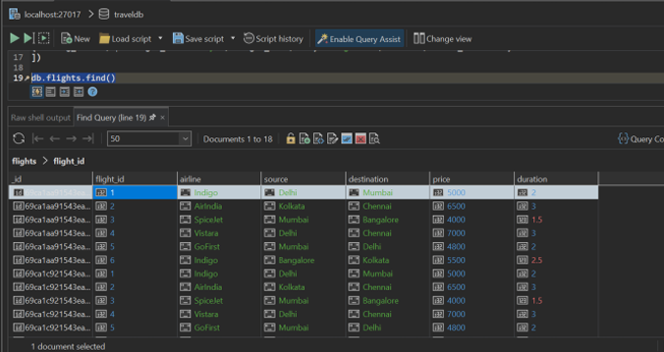
Q2. Display passenger_name and city from bookings.

Q3. Find flights where source is Delhi.
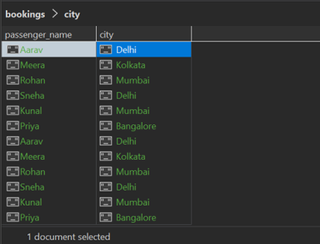
Q4. Find bookings where seats = 1. 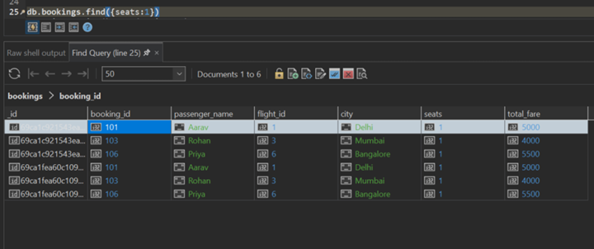
Q5. Sort flights by price in ascending order.
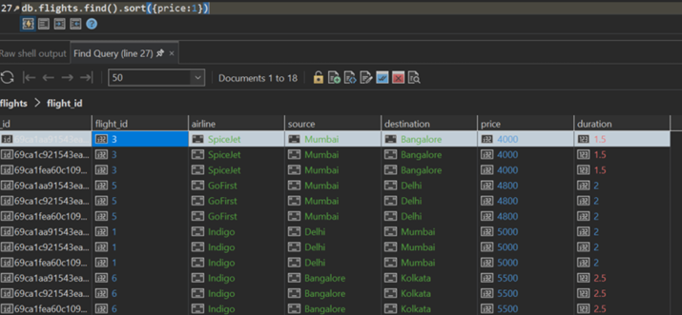
Q6. Display top 2 bookings with highest total_fare.
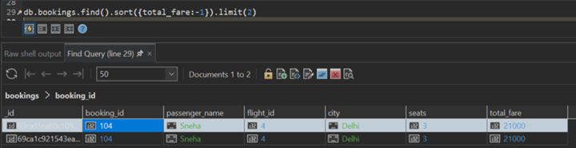
Q7. Find flights where price is greater than 5000.
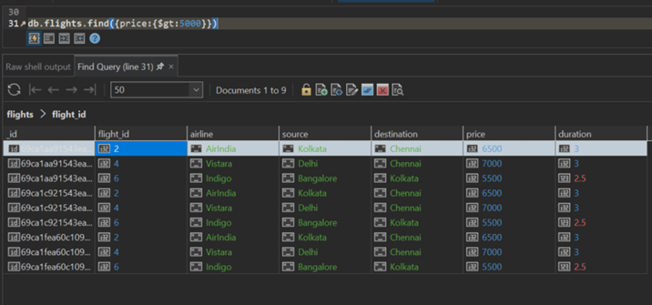
Q8. Display flights where destination is not Chennai.
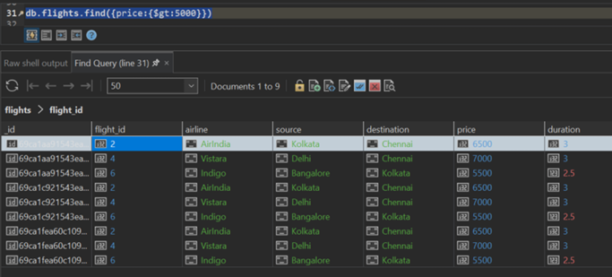
Q9. Find bookings where seats are between 1 and 2.
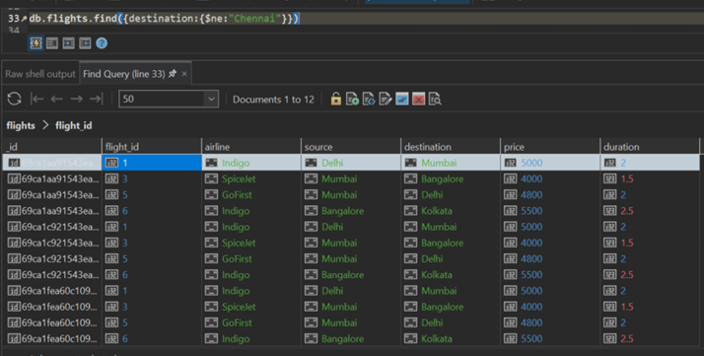
Q10. Update price by +500 for flights of airline "Indigo".
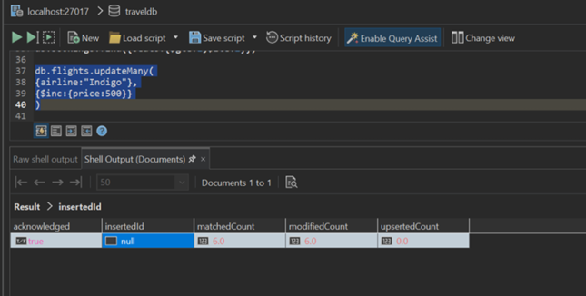
Q11. Delete bookings where seats are greater than 2.
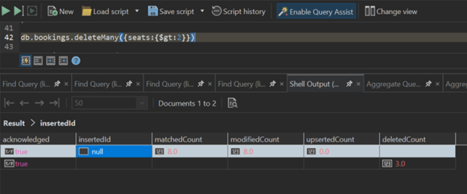
Q12. Find total fare collected city-wise.
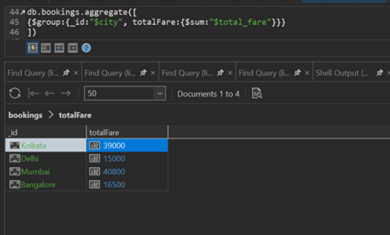
Q13. Find average flight price per airline.
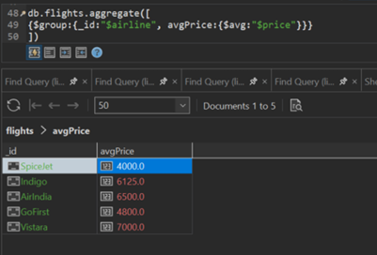
Q14. Display airlines where average price is greater than 5500.
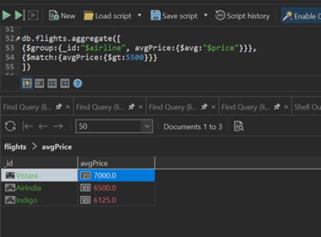
Q15. Find maximum total_fare among bookings for each city.
