LAB ASSIGNMENT – 1
DATE: 05/01/2024
ANKITA BISWAS
UG/02/BTCSECSF/2023/019
Q1. Create a database named collegeDB and switch to it.
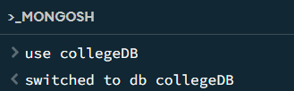
Q2. Create a collection named students in the collegeDB database.
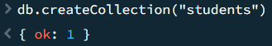
Q3. Insert one document into the students collection with the following fields:
• name
• rollNo
• department
• age
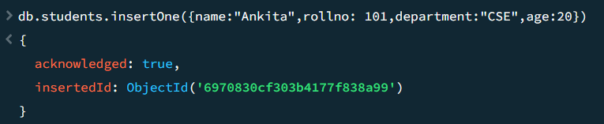
Q4. Insert four more documents into the students collection with different
values.
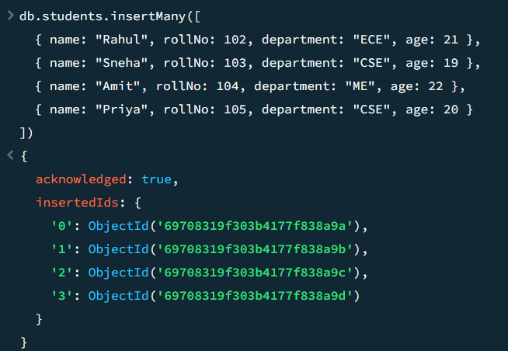
Q5. Display all documents present in the students collection.
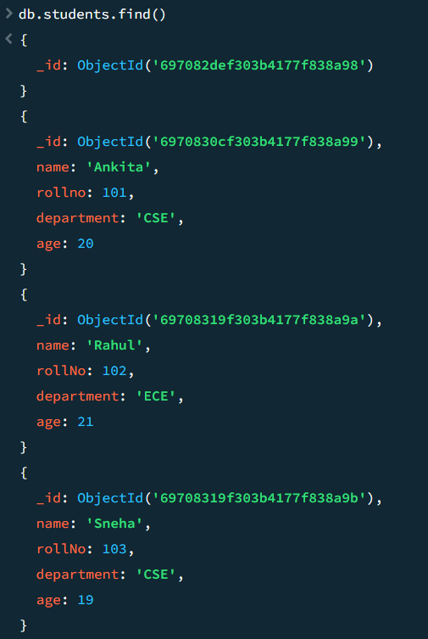
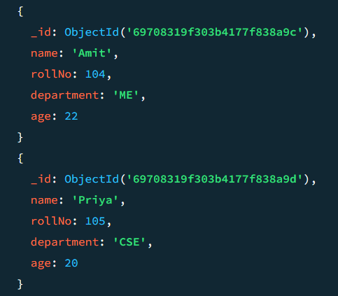
Q6. Display only those students who belong to the CSE department.
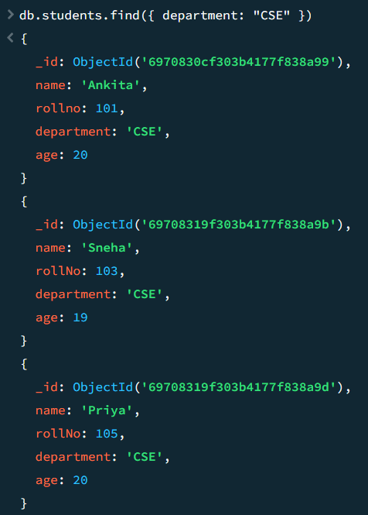
Q7. Update the age of one student (any one) to a new value.
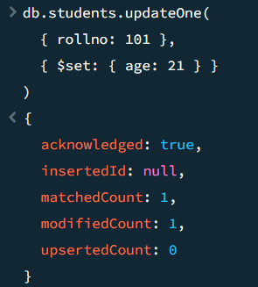
Q8. Delete one document from the students collection using any condition.
