https://github.com/chaitanya7x/wad

**Angular commands**

**npm –**version

npm install -g @angular/cli @latest

ng new practical

yes

cd practical

ng serve

yes

src…..app

app.component.html

app.component.ts…..copy code

**app.component.html :**

<h1>{{title}}</h1>

<input type="text" #name placeholder="Enter your name:" name="Name"><br>

<input type="number" #contact placeholder="Enter your contact no:" name="Contact"><br>

<input type="text" #address placeholder="Enter your Address:" name="Address"><br>

<input type="email" #email placeholder="Enter your Email:" name="Email"><br>

<input type="password" #password placeholder="Enter your Password:" name="Password"><br>

<button (click) = getValue(name.value,contact.value,address.value,email.value)>Register</button>

<h1>My Register Data</h1><br>

Name:{{displayName}}<br>

Contact No:{{displayContact}}<br>

Address:{{displayAddress}}<br>

Email:{{displayEmail}}<br>

**app.component.ts :**

import { Component } from '@angular/core';

import { RouterOutlet } from '@angular/router';

@Component({

  selector: 'app-root',

  standalone: true,

  imports: [RouterOutlet],

  templateUrl: './app.component.html',

  styleUrl: './app.component.css'

})

export class AppComponent {

  title = 'My Registration Form';

  displayName = '';

  displayContact = '';

  displayAddress = '';

  displayEmail = '';

  getValue(name:string,contact:string,address:string,email:string){

    this.displayName=name;

    this.displayContact=contact;

    this.displayAddress=address;

    this.displayEmail=email;

  }

}

**Terminal Commands :**

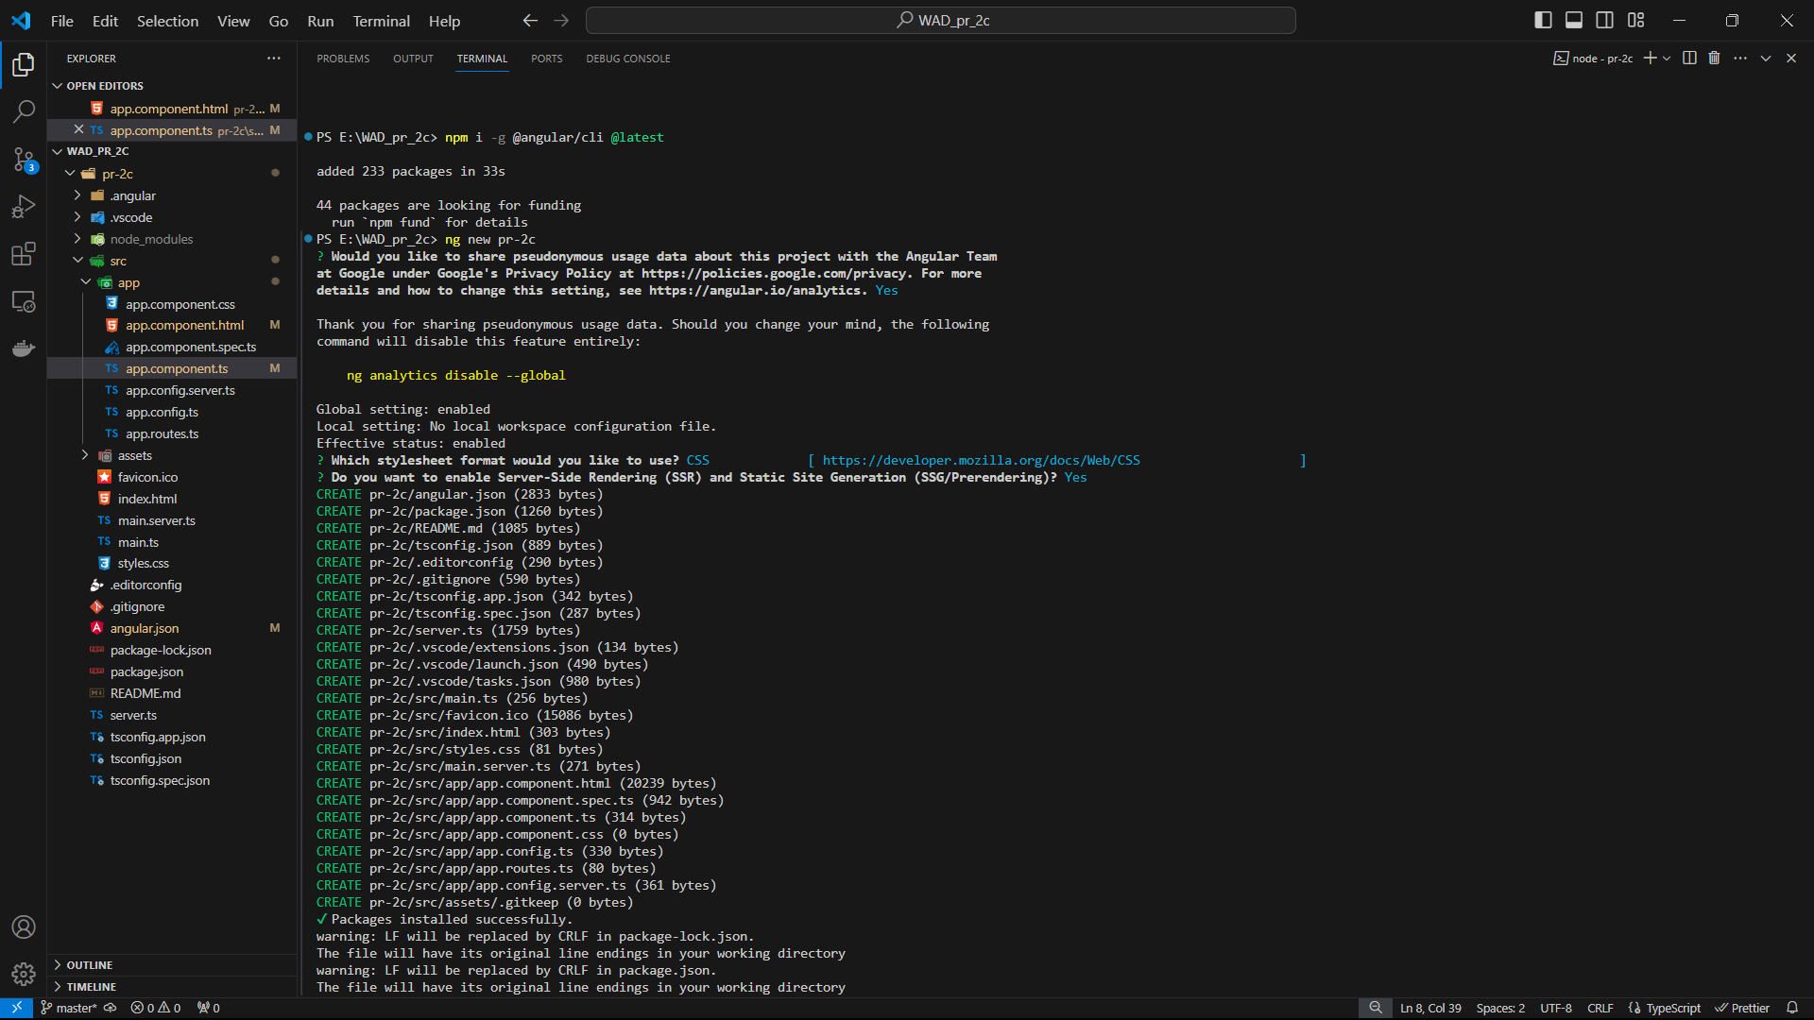

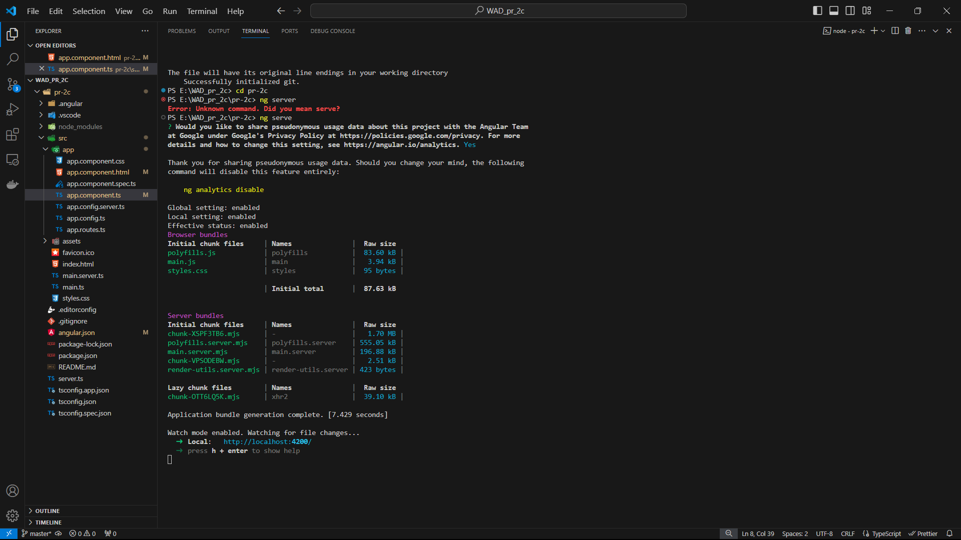

**Output :**

