1. checking top 5 rows

code - df_tracks.head()

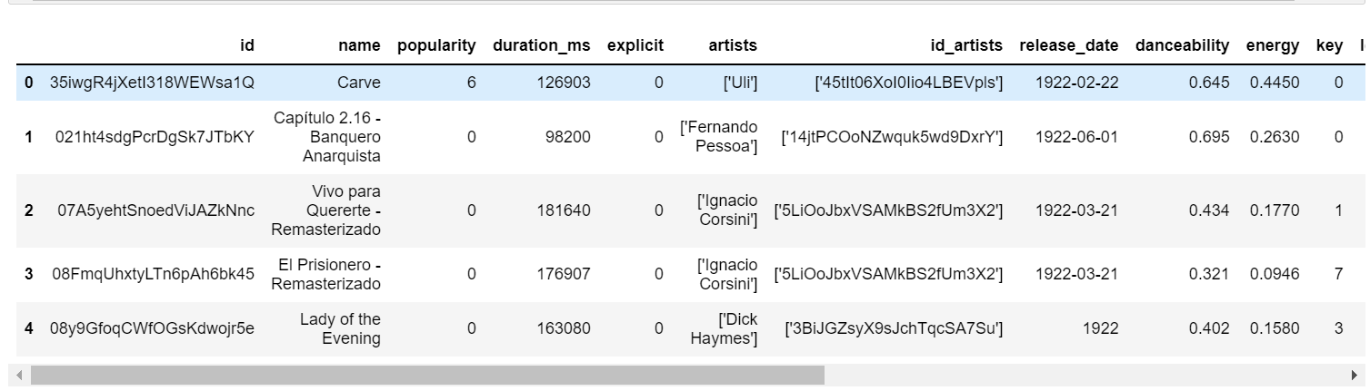

1. checking data info

code - df_tracks.info()

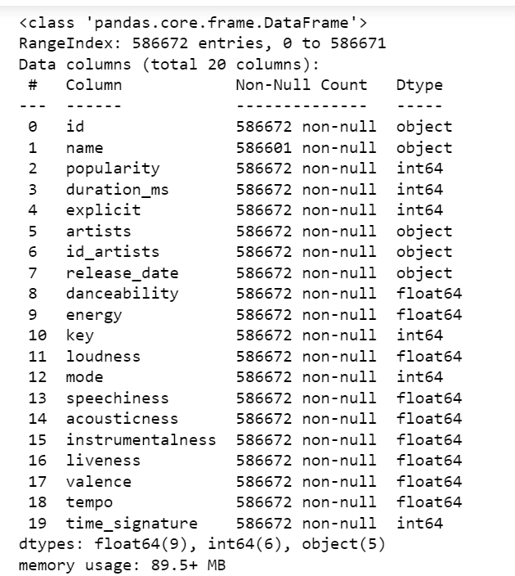

1. Selecting 10 most popular songs present on spotify

Code - most_popular = df_tracks.sort_values(by = 'popularity',ascending=False).head(10)

most_popular

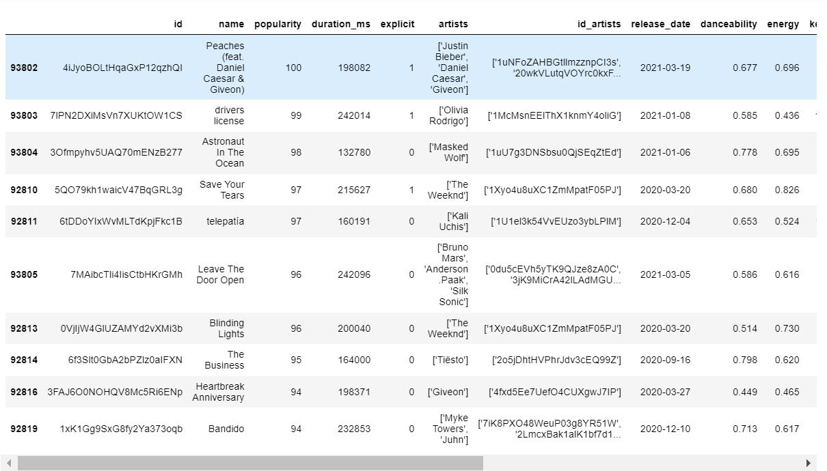

1. Least popular 10 songs present on spotify having popularity < 10

Code - least_popular = df_tracks.query('popularity<10', inplace=False).sort_values('popularity', ascending=True)

least_popular[:10]

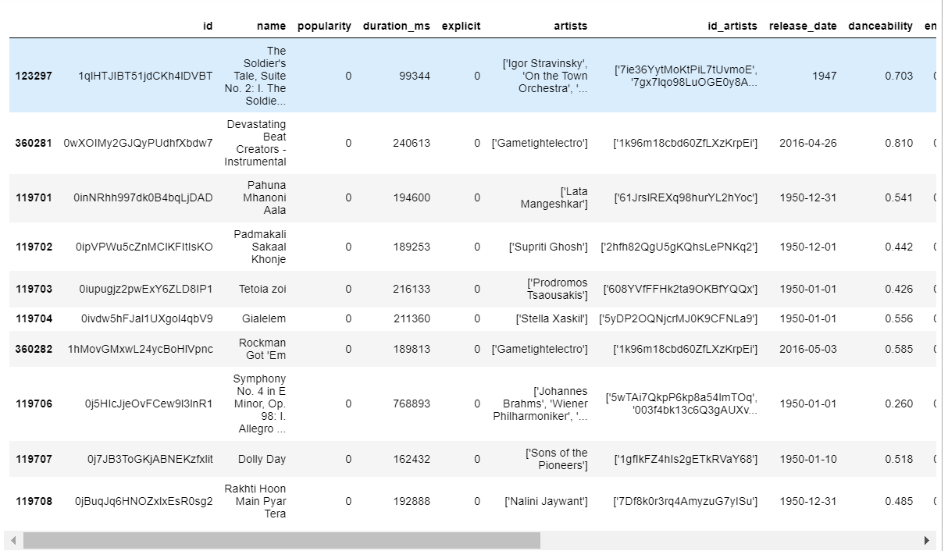

1. setting 'release_date' column to index and changing it's datatype to datetime

code - df_tracks_new = df_tracks.set_index('release_date')

df_tracks_new.index = pd.to_datetime(df_tracks_new.index)

df_tracks_new.head()

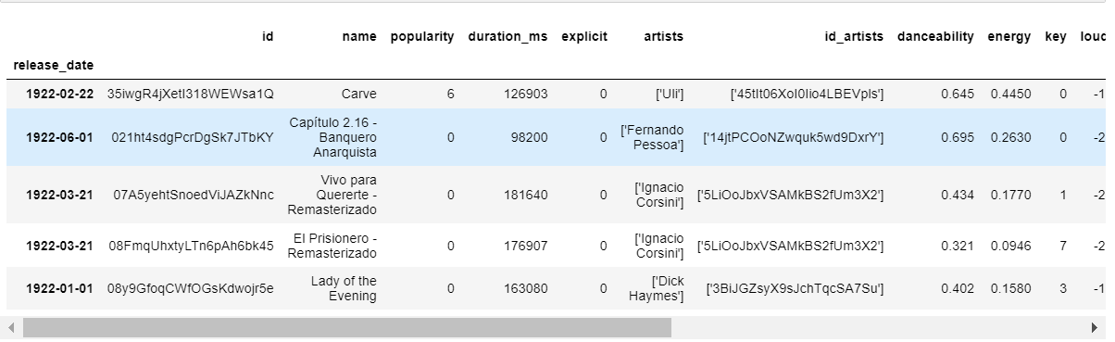

1. selecting the songs released on '1922-02-22'

code - df_tracks_new.loc['1922-02-22', ['name','artists']]

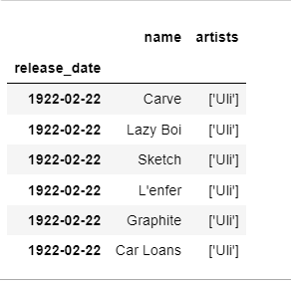

1. create a new column duration for time in seconds from column duration_ms

code - df_tracks_new["duration"] = df_tracks_new["duration_ms"].apply(lambda x: round(x/1000))

df_tracks_new.drop('duration_ms', inplace=True, axis=1)

df_tracks_new.head()

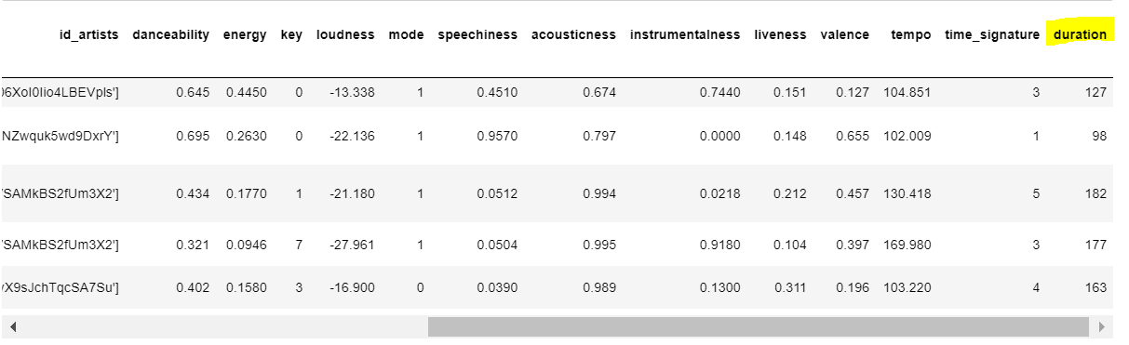

1. Taking a sample of 1% of total data and plotting a scatter plot b/w loudness and energy

code - sample_df = df_tracks_new.sample(int(0.01*len(df_tracks_new)))

print(len(sample_df))

fig = plt.figure(figsize = [10,5])

ax = fig.add_axes([0,0,1,1])

ax.set_title("Correlation b/w loudness and energy",fontsize=15)

ax.set_xlabel("Energy")

ax.set_ylabel("Loudness")

ax.scatter(x = sample_df['energy'], y = sample_df['loudness'])

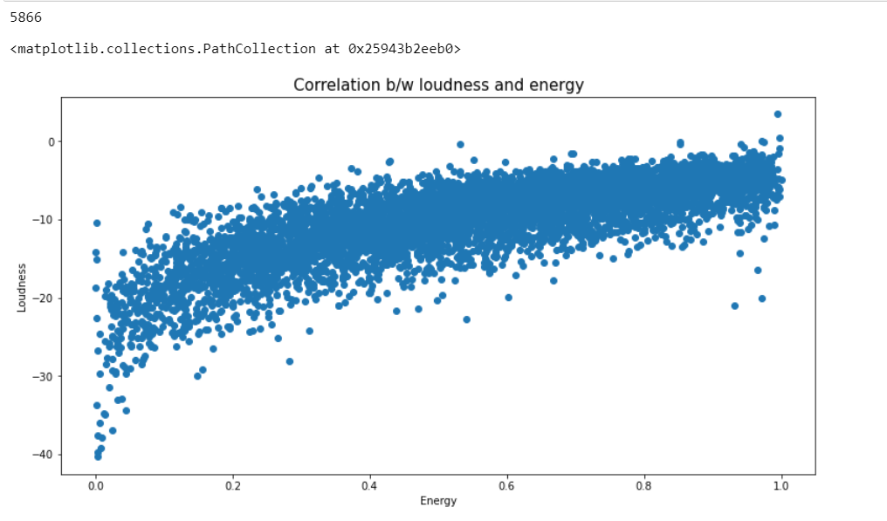

1. plot a histogram for no of songs released per year

code **-** df_tracks_new = df_tracks_new.reset_index()

df_tracks_new['year'] = df_tracks_new['release_date'].dt.year

fig = plt.figure(figsize=[12,8])

ax = fig.add_axes([0,0,1,1])

ax.set_title("No of songs released per year",fontsize=15)

ax.set_xlabel("Year")

ax.hist(df_tracks_new['year'],bins=40, rwidth=0.9)

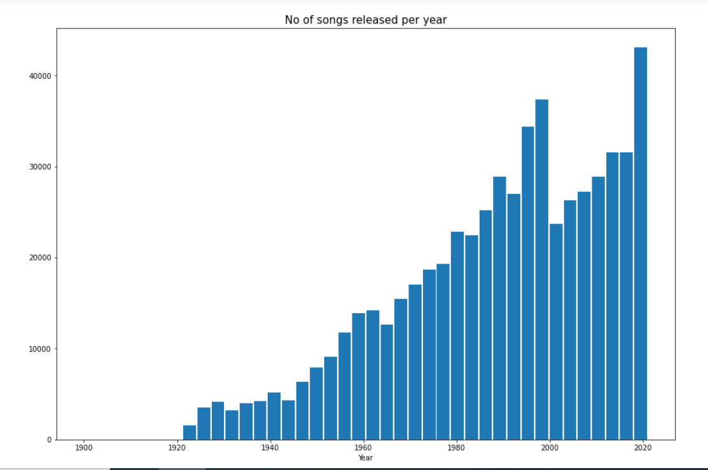

1. plot a line chart for average duration of songs over the years

code - dr = df_tracks_new.duration

fig = plt.figure(figsize=[10,6])

ax = fig.add_axes([0,0,1,1])

ax.set_title("Duration VS year",fontsize=15)

fig = sns.lineplot(x=df_tracks_new.year , y=dr)

