My feedback/suggestions divided in 3 sections along with screenshots are mentioned blow.

Time spent for this task: 2 hours

**Usability:**

1. Field “Whether power supply address is same as billing address *” if selected No, opens a section for billing address. It should have clear Title as “Billing Address” to avoid ambiguity.

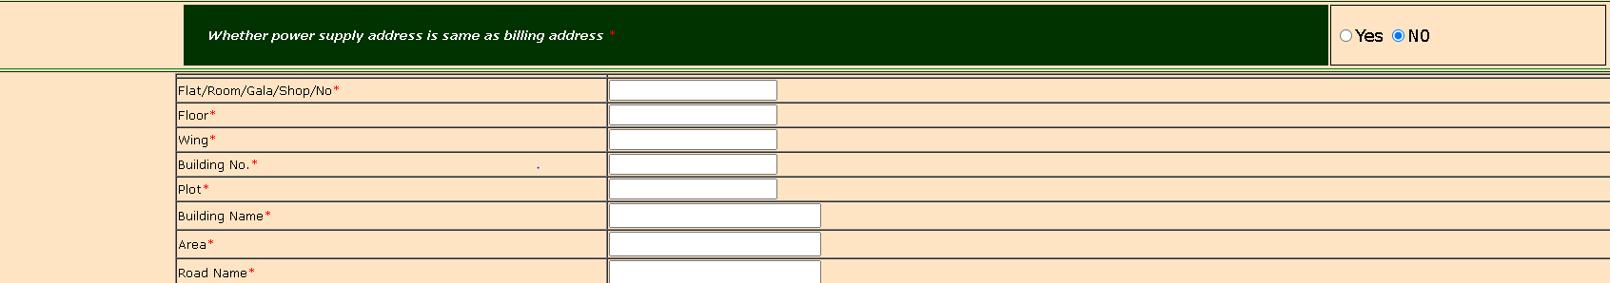

1. Grammatical error in section header for “Upload Required Documents”



1. Registration process sections should have been in pipeline format instead of all together on the same page. Form would be much more user-friendly if one section opens only after completion of previous section, keeping only one current section on the page, instead of having all located sequentially on the same page.

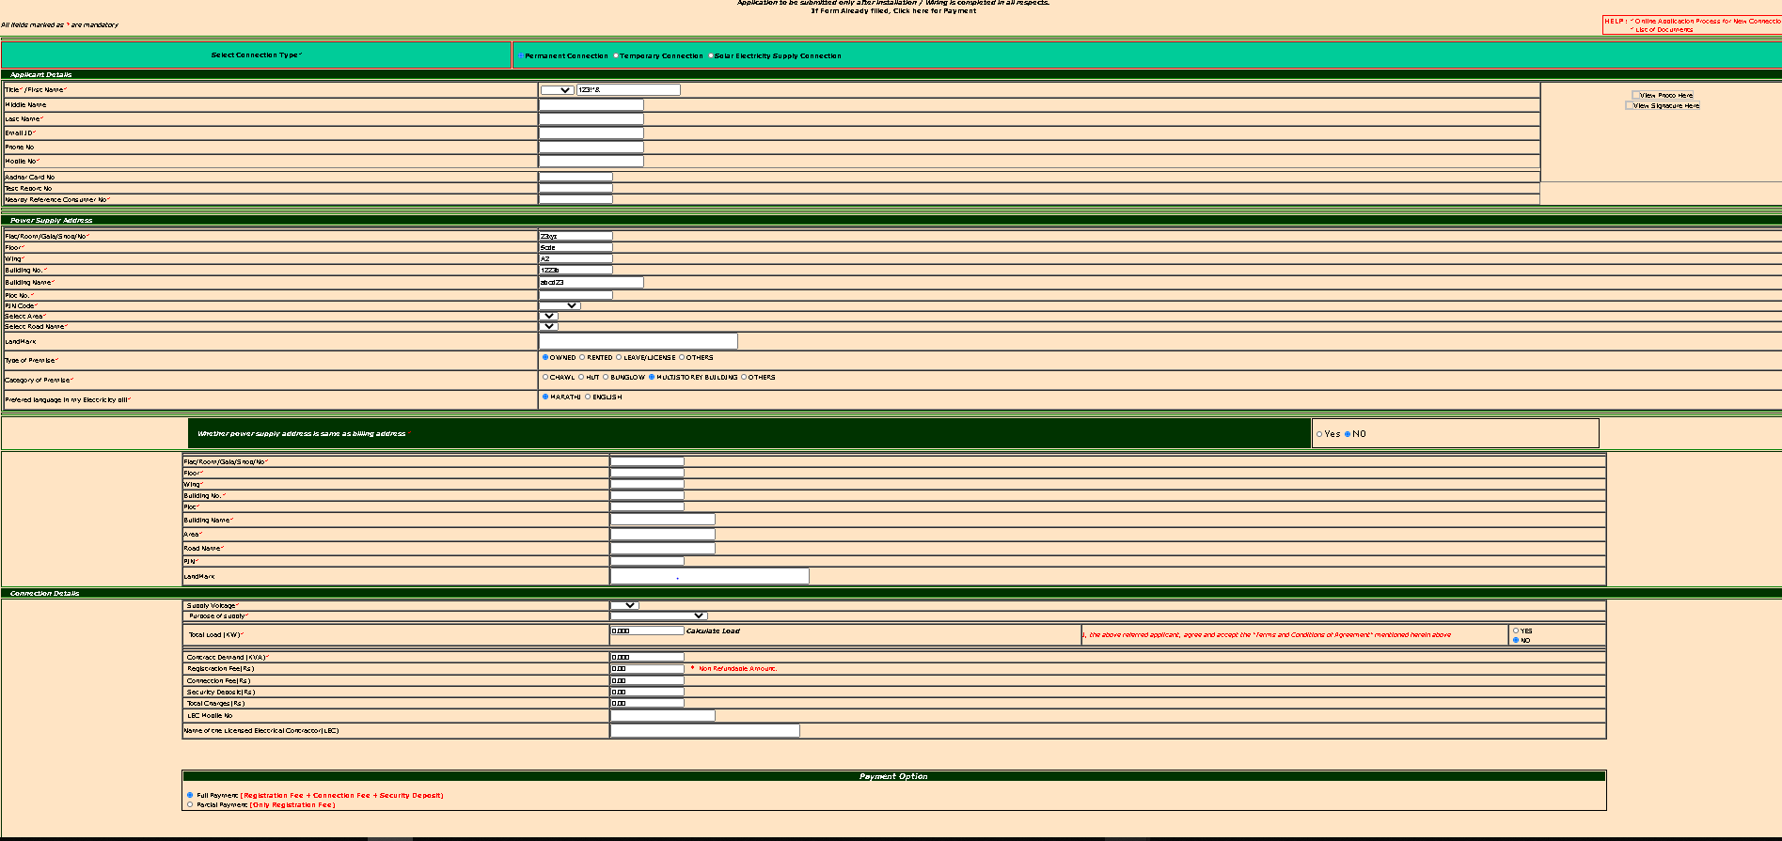

1. Generate OTP button should have mobile number input field near it, for better usability.



1. “Terms and Conditions” should be placed at the end of the registration, not in between such as under “Connection Details”

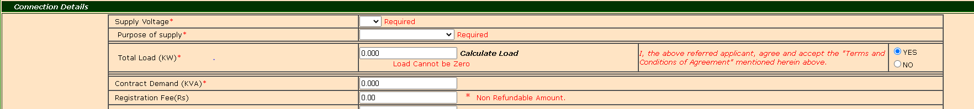

**Functionality:**

1. First Name, Middle Name, Last Name fields should not accept numbers and characters while taking input from user, instead of showing warning later after parsing the input. This locking validation technique is already used for mobile number field, where user cannot enter letters.



1. Entering e-mail id removes warning from all the above incorrect input fields.



1. Wing, Building No, and Building names are all redundant fields, accepting both numbers and letters. Floor number and Building number fields should only accept numbers, no letters and characters should be allowed, because we already have a “Wing” filed present. For example, if Building is named B4, “B” represents wing and “4” represents number of the building.

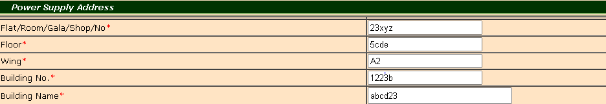

1. Only jpeg or jpg files are allowed while uploading photos, but uploading a “.png” file did now show any errors or warning, while image was not uploaded successfully.



1. Even after uploading .jpg photo, upload was not successful and it did not show any errors.

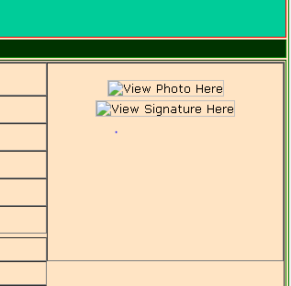

**UI/UX:**

1. No warning messages for validations if incorrect inputs given for fields under Billing Address section:

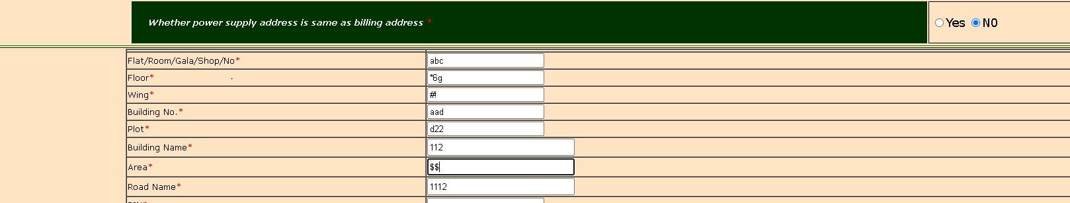

1. Instead of table format bordered rows, independent labels and input boxes would have been preferred.



1. Registration form design UI should preferably in white background color with black text and red warnings, as per general standard designs.



1. This clickable field should be a button :



1. Better color-schemes would make UI more user-friendly.

