UNLOX
MINOR PROJECT ASSESSMENT
RECONNAISSANCE &
INFORMATION GATHERING
October Batch | Information Gathering & Reconnaissance Phase
Tools: Netcraft, Webalizer, Shodan, Subdomain Enumeration, Burp Suite

Project overview
This report follows the five assigned tasks in the supplied assessment brief. It explains the objective, method, evidence to collect, interpretation and security recommendations for each task. The report is written in a practical student style and is designed to be completed in an authorised training lab.
Important: no target domain, live scan result, Shodan result, Webalizer statistic or Burp capture was supplied with the assessment PDF. To avoid inventing evidence, this report includes safe procedures, report tables and screenshot placeholders. Run the approved lab exercises and replace each placeholder with your own real output.

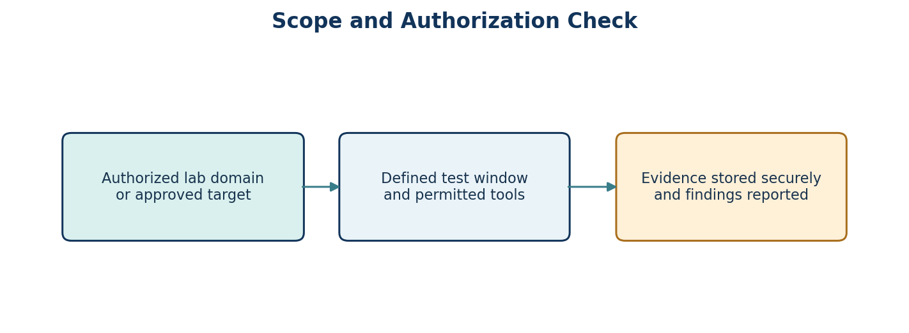

Contents
- Scope, authorization and evidence handling
- Task 1 — Passive reconnaissance with Netcraft
- Task 2 — Web server log analysis with Webalizer
- Task 3 — Asset discovery with Shodan
- Task 4 — Subdomain enumeration
- Task 5 — Traffic interception and analysis with Burp Suite
- Conclusion and submission checklist

Scope, authorization and evidence handling
The assessment explicitly limits work to educational use in an isolated lab or against targets for which written permission has been obtained. Use only the domain, server, lab application and time window approved by the instructor. Do not run tools against unrelated public systems, and do not attempt to access accounts or data that are not part of the lab.
Record before testing | What to enter
Approved target/domain | [Enter mentor-approved lab target]
Proof of authorization | [Course lab instructions / written approval reference]
Allowed tools | Netcraft, Webalizer, Shodan, approved subdomain tool, Burp Suite
Testing window | [Date and time approved by mentor]
Evidence location | [Local assessment folder; avoid public sharing]

For every task, record the exact command or tool settings, save a screenshot/export, and add a short explanation of what the evidence shows. Redact credentials, session cookies, personal information and unrelated IP addresses before sharing the report.
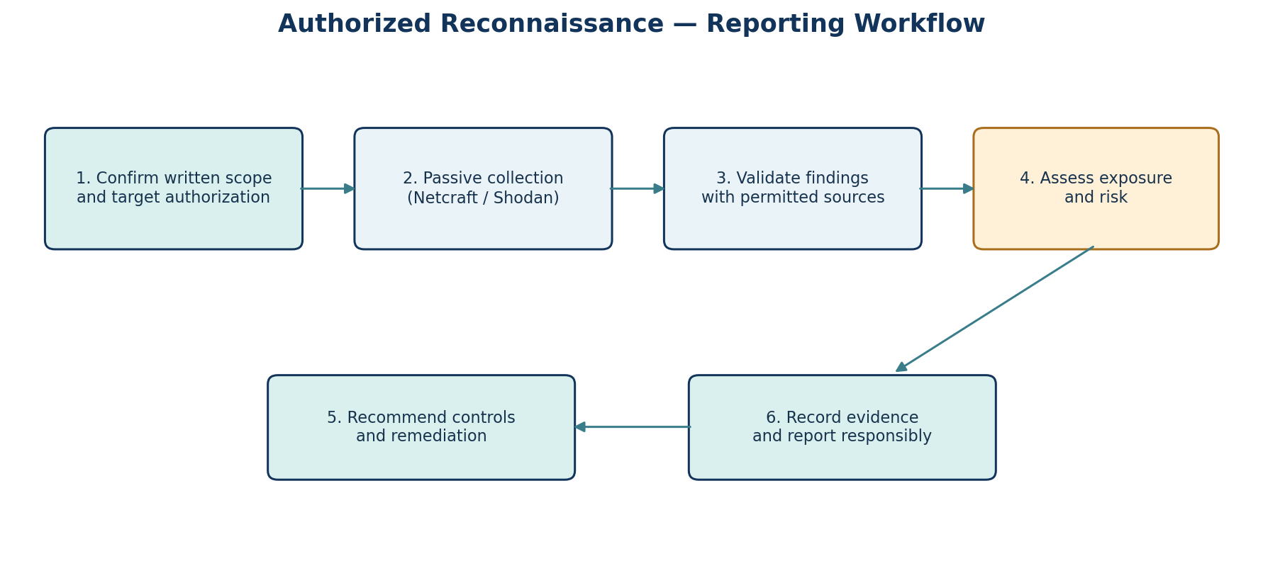

TASK 1 — PASSIVE RECONNAISSANCE WITH NETCRAFT

Objective and method
The goal is to collect publicly visible information about an authorised target and summarise its hosting and technology footprint without attempting exploitation. Netcraft can show information such as hosting provider, network owner, IP address and server technology when available. Results can change over time, so record the date of collection.

Procedure
- 1. Confirm the exact domain approved for the exercise. Do not substitute a third-party website.
- 2. Open Netcraft Site Report and enter the approved domain.
- 3. Record the hosting provider, network owner, IP address and server location if shown.
- 4. Note web server software, operating system hints, CMS or other technology detections only when the report actually lists them.
- 5. Capture a screenshot or export of the Site Report, including the date and target name.
- 6. Summarise what an attacker could learn from this public information alone, without making unsupported claims about exploitability.

Evidence table
Field | Observed result (fill from your report) | Security interpretation
Target domain | [Approved target] | Confirms scope
Hosting provider / network owner | [Record actual result] | May identify provider responsible for hosting
IP address / server location | [Record actual result] | Helps map public infrastructure; location may be approximate
Web server / OS hints | [Only if reported] | Version disclosure can help defenders prioritise patch review
CMS / technologies | [Only if reported] | Known technology should be inventoried and kept updated

Summary and risk rating
Use a cautious rating based on evidence, not assumptions. Publicly visible technology information is not automatically a vulnerability. A higher concern would require corroborating evidence such as an outdated version confirmed by a reliable source and a clear security impact.
Finding | Likelihood | Impact | Suggested priority | Reason
[Evidence-based finding] | Low / Medium / High | Low / Medium / High | Low / Medium / High | [Explain using observed evidence]

[Insert Netcraft Site Report screenshot/export here.]
Written analysis: [In 4–6 sentences, explain the actual hosting and technology findings, what can reasonably be inferred, and what cannot be concluded from passive data alone.]

TASK 2 — WEB SERVER LOG ANALYSIS WITH WEBALIZER

Objective
Webalizer analyses web-server access logs and creates HTML reports of usage patterns. The aim is to identify traffic volume, common visitors, popular pages, HTTP status codes and unusual patterns. The assignment allows a local Apache/Nginx lab or sample access log, so use only logs supplied for the lab or generated on your own test server.

Procedure
- 1. Identify the authorised lab server and the exact access-log file. Common locations vary by distribution and web server.
- 2. Configure Webalizer to read that log and generate its HTML report in a lab output directory.
- 3. Open the report and record total requests, unique visitors/IPs if available, top requested URLs and HTTP status code counts.
- 4. Inspect repeated 404 responses, bursts of requests or an unusually high request count from one IP. Treat these as leads for review, not proof of an attack.
- 5. Compare the timestamps and request paths with the lab scenario, if supplied. Do not label traffic malicious without supporting evidence.

Interpretation table
Metric | Result from Webalizer | What it may mean
Total requests | [Enter value] | Overall request volume for the report period
Unique sites/visitors | [Enter value] | Approximate distinct clients; proxies/NAT can affect this
Most requested pages | [Enter paths] | Commonly used pages or automated retrieval targets
HTTP 2xx responses | [Enter count] | Successful responses
HTTP 3xx responses | [Enter count] | Redirects or moved resources
HTTP 4xx responses | [Enter count] | Client errors; 404s may be typos, stale links or probing
HTTP 5xx responses | [Enter count] | Server-side failures that may need investigation

How to assess suspicious patterns
- A single IP with many requests may be a scanner, monitoring service, shared proxy or busy legitimate user. Check the request rate, paths and user-agent before concluding.
- Repeated 404 requests for common sensitive paths may indicate automated discovery, but could also come from broken links or routine scanners.
- A 5xx increase can indicate application or server errors; correlate with server error logs before attributing it to hostile activity.
[Insert screenshot of Webalizer HTML report and relevant summary/statistics tables.]
Short note on anomalies: [Describe the actual pattern, relevant timestamps/IPs, why it appears unusual, and what additional log evidence would be needed.]
Recommended response: preserve the original log, verify the finding with additional logs, apply rate limits or filtering only where justified, patch exposed services, and continue monitoring.

TASK 3 — ASSET DISCOVERY WITH SHODAN

Objective and scope
Shodan indexes internet-facing services and can help a defender understand what public services are visible for an approved organisation or lab asset. Use only the organisation, IP range or public-facing lab server specifically assigned by the mentor. Search results are snapshots and may be stale, so validate important findings against an authorised source.

Procedure
- 1. Write down the approved organisation/domain/IP range and the permitted search scope.
- 2. Use Shodan filters such as port, organisation or domain only as permitted by the lab instructions. Do not expand the search to unrelated organisations.
- 3. Record the host/IP, open port, service/product, reported version and banner information shown by Shodan.
- 4. Identify potentially unexpected services or old version disclosures. Do not attempt login, exploitation or intrusive validation unless the instructor has explicitly authorised it.
- 5. Cross-check at least one relevant finding against Task 1 passive reconnaissance data when possible.
- 6. Recommend a mitigation for the highest-priority evidence-based exposure.

Exposure inventory
Host / IP | Port / service | Observed banner/version | Evidence date | Risk / reason | Mitigation
[Authorised asset] | [Actual port/service] | [Actual Shodan result] | [Date] | [Explain why exposure matters] | [Restrict, patch, disable or monitor]
[Authorised asset] | [Actual port/service] | [Actual Shodan result] | [Date] | [Explain using evidence] | [Recommended control]

Risk prioritisation guide
Example finding | Potential concern | Defensive recommendation
Unneeded remote administration service exposed | Increased attack surface | Restrict by VPN/allowlist; disable if unnecessary
Service banner reveals old software version | May help attackers identify outdated components; version alone does not prove vulnerability | Verify installed version and vendor advisories; patch if affected
Unexpected database/service port visible | May expose sensitive service to internet | Limit access to approved hosts; bind to private interface where possible
TLS or certificate configuration concern | Could weaken trust or encryption if confirmed | Review certificate, protocol and cipher configuration using approved checks

[Insert screenshot/export of the authorised Shodan query and results. Hide API keys and unrelated assets.]
Finding summary: [State the highest-risk confirmed exposure, evidence supporting the rating, uncertainty/limitations, and a practical mitigation.]

TASK 4 — SUBDOMAIN ENUMERATION

Objective
The goal is to identify subdomains of an authorised domain using at least two different techniques, then validate whether discovered names resolve and whether web services respond. Use the approved domain only. A discovered name is not automatically a vulnerability, and a subdomain should not be treated as a live host until validated.

Technique A: tool-based discovery
Use the exact enumeration tool and command approved for your lab (for example, Sublist3r, Amass or Subfinder if installed). Save the tool output to a file and record the command used. Do not run broad scans outside the assigned domain.
subfinder -d <approved-domain> -silent -o subdomains_tool.txt
The command above is an example for an authorised lab only; replace <approved-domain> with the exact approved domain. If your instructor requires another tool, use that tool and record its version and options.

Technique B: passive source / certificate transparency
Cross-check names using a passive source permitted by the course, such as certificate transparency logs or a DNS data source. Record the source and date. Passive sources can contain old names, duplicates and names that no longer resolve.

Validation steps
sort -u subdomains_tool.txt > subdomains_unique.txt
while read -r host; do printf "%s " "$host"; dig +short "$host"; done < subdomains_unique.txt
For a web validation, use the approved HTTP status checker or a restrained curl request against the listed lab names. Avoid high-volume probing. Record DNS results and HTTP status codes, including cases where no address or response is returned.

Subdomain inventory
Subdomain | Discovery source | DNS result | HTTP status | Live? | Notes / risk
[host.approved-domain] | Tool / passive source | [A/AAAA/CNAME or none] | [200/301/403/404/none] | Yes / No / uncertain | [evidence-based note]
[host.approved-domain] | Tool / passive source | [actual result] | [actual result] | Yes / No / uncertain | [evidence-based note]

Forgotten-host review
A forgotten development, staging or test host may be a concern if it is publicly reachable and lacks normal maintenance or access controls. Confirm ownership and purpose with the system owner before recommending changes. The recommended response is to remove unused DNS records, restrict non-production systems, require authentication where appropriate, patch services and include all active hosts in the asset inventory.
[Insert screenshot of tool output and a separate screenshot or text export showing DNS/HTTP validation.]

TASK 5 — TRAFFIC INTERCEPTION & ANALYSIS WITH BURP SUITE

Objective and safe lab setup
Burp Suite can act as an intercepting proxy so a trainee can inspect HTTP requests and responses generated by a browser. This task must be performed only against the intentionally vulnerable local lab application supplied by the course (for example, DVWA, WebGoat, Web Security Academy lab, or another approved app). Do not intercept other people’s traffic or use real accounts.

Procedure
- 1. Start Burp Suite and use a local proxy listener such as 127.0.0.1:8080 if that is the lab configuration.
- 2. Configure a dedicated browser profile to use that proxy. Install Burp’s CA certificate only in the dedicated lab browser/profile and remove it after the exercise if it is no longer needed.
- 3. Open the approved local training application and capture a harmless request such as loading a page or submitting test credentials made specifically for the lab.
- 4. Send the captured request to Repeater and change one benign parameter to observe how the response differs. Keep tests within the lab’s allowed scope.
- 5. If the assignment includes Intruder, use only a small, harmless wordlist against the lab application and observe response differences; do not run password attacks against real services.
- 6. Save the Burp project or export selected requests/responses after removing cookies, tokens, passwords and other sensitive values.
- 7. Explain what Proxy, Repeater and (if used) Intruder contributed to the manual testing.

Observation table
Module | What to record | Observation
Proxy | Request method, path, headers, parameters and response status | [Describe captured lab request]
Repeater | Which single test parameter was changed and what response changed | [Describe actual result]
Intruder (if authorised) | Small lab-only payload set and response differences | [Describe actual result or mark not used]

Example report wording
“I captured a request from the approved training application using Burp Proxy. I reviewed the request method, path, headers and parameters, then sent it to Repeater to compare the response after changing one test value. The observation was limited to the lab application. This demonstrated how a proxy can help inspect application behaviour, but it does not by itself prove a vulnerability; a security conclusion requires a reproducible result and a clear impact.”

Evidence and safety
[Insert screenshot of Burp Proxy history with sensitive fields redacted.]
[Insert screenshot of Repeater request/response comparison from the lab.]
Do not include live session cookies, authorization headers, passwords, personal data or tokens in the final report. A .burp project file may contain sensitive traffic; submit it only through the instructor-approved channel.

Conclusion
The five tasks provide a structured introduction to reconnaissance and information gathering. Netcraft and Shodan help describe publicly visible infrastructure, Webalizer helps interpret web traffic logs, subdomain enumeration improves asset inventory, and Burp Suite helps inspect web requests in a controlled application. These tools are most useful when their results are recorded carefully and interpreted with context.
The main lesson is that a tool output is evidence, not a complete conclusion. Findings should be validated, risk should be explained in terms of likelihood and impact, and recommendations should be practical: reduce unnecessary exposure, keep software updated, restrict administrative services, review logs and maintain an accurate inventory of internet-facing assets.

Final submission checklist
- Cover page completed with student and mentor details.
- Written authorization and target scope recorded.
- Task 1 Netcraft screenshot/export and analysis added.
- Task 2 Webalizer report screenshots and traffic interpretation added.
- Task 3 Shodan query/results and exposure inventory added.
- Task 4 at least two subdomain discovery techniques and validation evidence added.
- Task 5 Burp Proxy/Repeater evidence added from the approved lab.
- All screenshots are real outputs from the authorised lab, with sensitive data redacted.
- Tool settings/commands, date, observations and recommendations are documented.
- Report reviewed and exported to PDF if required by the instructor.

