MINI PROJECT REPORT
IDOR, CORS & FILE UPLOAD SECURITY
October Batch | Minor Project Assessment — Part 2
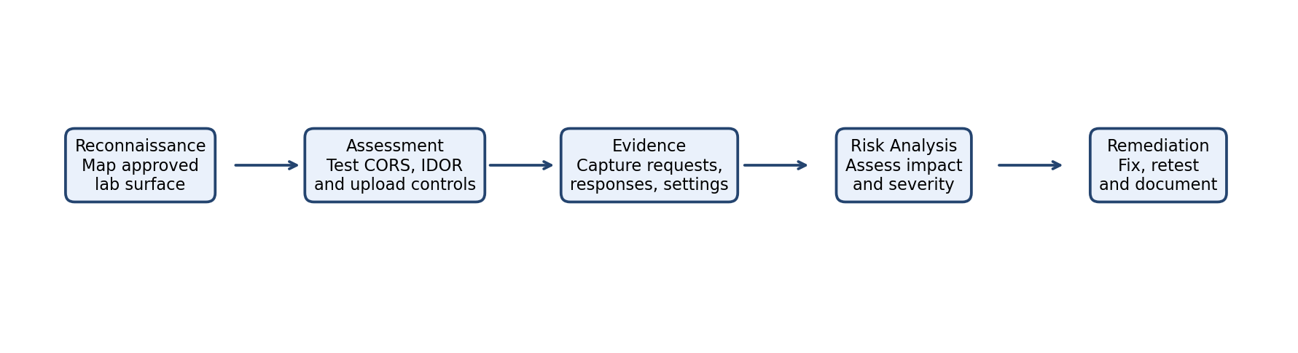
Name – Ankita Debnath

Project Details
Project | IDOR, CORS & File Upload Security
Assessment | October Batch — Part 2
Vulnerability areas | CORS Misconfiguration, API IDOR/BOLA, Unrestricted File Upload
Tasks | 5
Submission evidence | Written report, lab screenshots, Burp request/response pairs

Contents
- Executive Summary
- 1. Scope, Authorization and Methodology
- 2. Task 1 — CORS Misconfiguration Assessment
- 3. Task 2 — API-Level IDOR (BOLA) Testing
- 4. Task 3 — Unrestricted File Upload: Filter Assessment
- 5. Task 4 — File Upload Impact and Containment Review
- 6. Task 5 — Consolidated Findings and Remediation Roadmap
- 7. Conclusion
- Appendix A — Evidence Templates
- Appendix B — Original Defensive Code Examples

Executive Summary
This mini-project assesses three common web-application security weaknesses: permissive Cross-Origin Resource Sharing (CORS), broken object-level authorization (IDOR/BOLA), and unrestricted file upload. It follows the five tasks in the supplied October Batch assessment brief. The work is intended for an isolated lab or an explicitly authorized target only.
The report provides a repeatable assessment method, evidence templates, risk analysis and defensive code patterns. Actual vulnerability status must be completed from the learner’s own lab observations; no real test results are assumed in this report.

1. Scope, Authorization and Methodology
Scope: one intentionally vulnerable lab application/API, two lab user accounts, and a file-upload module. Suitable environments named in the assessment brief include a DVWA extension, a custom test API, or PortSwigger Web Security Academy CORS labs.
Authorization: perform all testing only inside the assigned lab/VM or against systems covered by written permission. Do not access real users’ data, execute uploaded files, deploy a web shell, or test unrelated systems. Use synthetic accounts and harmless test files.
Method: (1) confirm scope and baseline behaviour; (2) vary one input at a time; (3) capture request/response evidence; (4) record expected versus observed behaviour; (5) assess impact; (6) recommend a fix; and (7) retest.

2. Task 1 — CORS Misconfiguration Assessment
Objective: determine whether the application trusts origins too broadly and whether credentialed cross-origin responses could be exposed.
Procedure: In Burp Suite Repeater, send the same harmless API request while changing only the Origin header. Use (a) the approved application origin, (b) an unrelated test origin such as https://attacker.example.test, and (c) the literal Origin: null. Record Access-Control-Allow-Origin, Access-Control-Allow-Credentials, and Vary in each response. Do not attempt to collect another person’s data.
Interpretation: a strong warning sign is arbitrary Origin reflection combined with Access-Control-Allow-Credentials: true. Trusting null may also be unsafe depending on the application’s threat model. CORS is a browser-enforced access policy; it is not a substitute for authentication or authorization.
Safe impact explanation: if a browser sends an authenticated request with credentials and the server grants the requesting origin permission to read the response, a hostile page may be able to read data available to the victim’s session. Describe this scenario in the report; do not host a victim-targeting page or collect real information.
Remediation: maintain an exact allowlist of trusted scheme/host/port origins; reject unknown and null origins; never reflect arbitrary Origin values; allow credentials only where required; return Vary: Origin when responses vary by origin; restrict methods and headers; and protect sensitive endpoints with normal authorization.
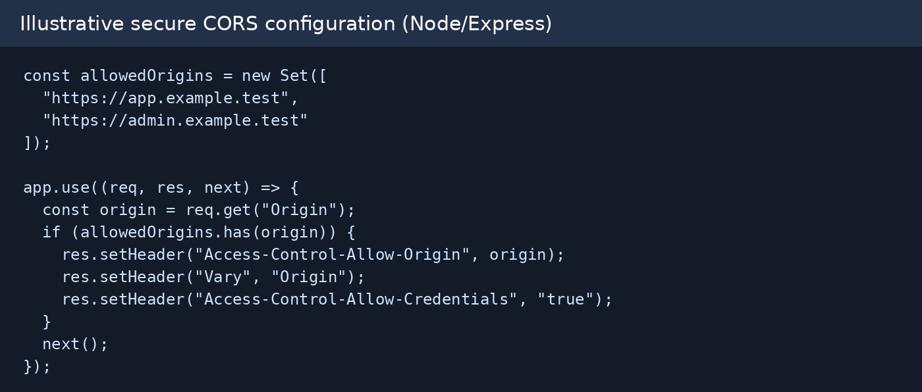
Figure 1. Original illustrative defensive CORS configuration; adapt to the lab framework.

3. Task 2 — API-Level IDOR (BOLA) Testing
Objective: verify that each API object is authorized for the currently authenticated user, rather than relying only on an object identifier.
Procedure: create two synthetic lab accounts, User A and User B, each with a harmless test object. Log in as A and capture a request for A’s object. In the lab, replay the request while changing only the object ID to B’s known test object ID. Then authenticate as B and confirm object ownership independently. For collection endpoints, inspect whether results are scoped to the authenticated user.
Evidence: preserve the two account identities (redacted tokens), endpoint and method, object IDs, status codes, and a minimal response excerpt. Do not include passwords, session cookies, bearer tokens, personal information, or unrelated records in the submission.
Root cause: the server accepts a client-supplied object ID without verifying that the authenticated principal owns the object or has an explicit role-based permission to access it. Hiding IDs in the UI or using unpredictable IDs does not fix authorization.
Remediation: enforce ownership/role checks on every object read, update, delete and download operation. Scope database queries to the authenticated user where possible. Deny by default, return a consistent 403/404 response, and test both single-object and list endpoints.
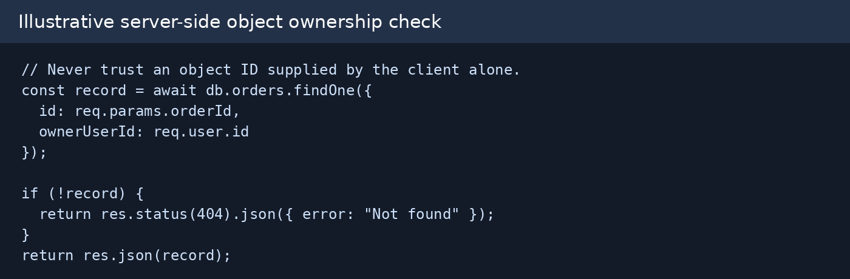
Figure 2. Original illustrative server-side ownership check.

4. Task 3 — Unrestricted File Upload: Filter Assessment
Objective: evaluate whether upload controls rely on weak file-name or request metadata checks. Use harmless inert test files only; never execute an uploaded file.
Procedure: first upload a clearly disallowed harmless test file and record the baseline rejection. Then, within the designated lab, test the three categories required by the brief: double-extension naming, extension case manipulation, and Content-Type header relabelling in Burp Repeater. Do not include executable content or payloads. Record whether the server blocks, accepts, or quarantines each attempt.
Why weak checks fail: a filename suffix can be ambiguous; case-sensitive checks may be inconsistent; and the Content-Type header is supplied by the client and can be changed. These values are not proof of a file’s actual format.
Defensive controls: allow only business-required formats; validate file signatures (magic bytes) and parse the file with safe libraries; enforce size limits; generate random server-side names; store uploads outside the web root or in isolated object storage; disable script execution; scan/quarantine where appropriate; and apply least-privilege filesystem permissions.

5. Task 4 — File Upload Impact and Containment Review
Objective: reason about the potential impact of a successful filter bypass without executing any uploaded file.
Impact analysis: if an upload directory executes scripts, an attacker might cause server-side code execution. If uploaded files are publicly accessible, they may also enable stored malicious content, phishing, malware hosting, or content replacement. These are conditional risks; actual impact depends on server configuration, file handling and access controls.
Inspection checklist: (1) Is the upload directory outside the web root? (2) Is script execution disabled at the web-server/container level? (3) Are file signatures and parsed content validated? (4) Are names randomized and paths generated server-side? (5) Are files stored with least privilege? (6) Are size limits, malware scanning and audit logs configured? Mark each item Present, Absent or Not Verified based on lab inspection.
Priority containment: disable execution in upload storage; move files outside the web root; enforce server-side allowlisting plus signature/content validation; randomize names and prevent path control; isolate storage and permissions; apply size limits and scanning; and monitor upload events. These controls should contain a bypass even if a front-end filter fails.
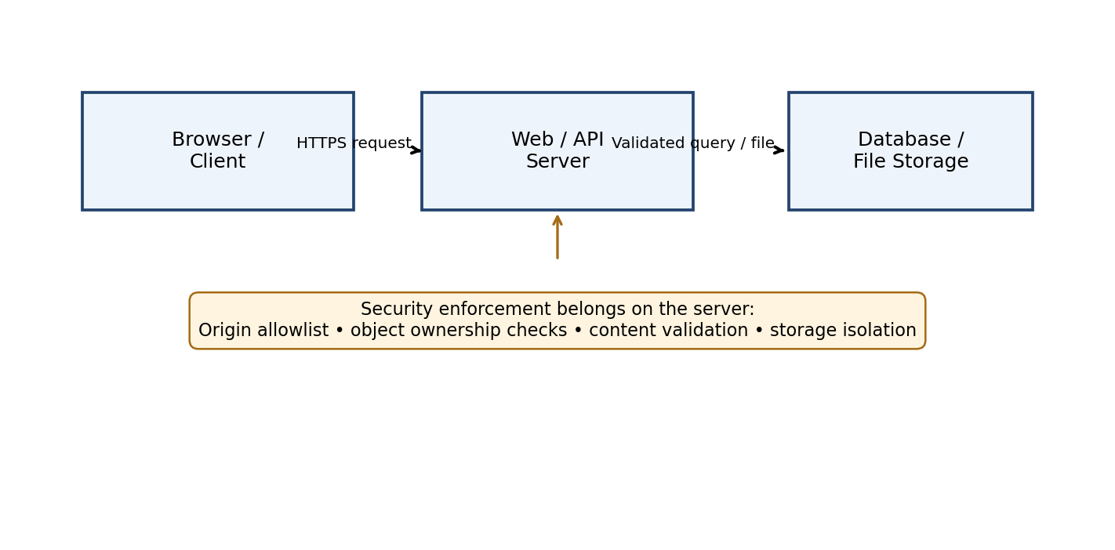
Figure 3. Original security architecture concept showing server-side enforcement.

6. Task 5 — Consolidated Findings and Remediation Roadmap
Because no lab screenshots or observed responses were included with the supplied brief, the following are assessment hypotheses and severity starting points, not confirmed findings. Replace the status and severity after completing the lab tests.

7. Conclusion
The assessment demonstrates why web security must be enforced server-side. CORS controls which browser origins can read responses; object-level authorization controls which records a user may access; and upload security must validate content and isolate storage. The strongest design uses multiple independent controls so that a single weak filter does not lead to compromise.
The work builds on the reconnaissance modules named in the assessment brief—Netcraft, Webalizer, Shodan, subdomain enumeration and Burp Suite—by moving from identifying the application surface to validating access-control and upload protections on authorized lab targets.

Finding Summary and Severity Matrix
Finding | Evidence to verify | Starting severity* | Potential impact | Priority fix
CORS origin trust | Origin header response matrix | High if arbitrary origin + credentials | Authenticated response readable cross-origin | Exact origin allowlist
IDOR / BOLA | A/B cross-account request pair | High if another user’s object is returned | Unauthorized disclosure or modification | Server-side ownership/role check
Upload filter weakness | Three safe test outcomes | Medium–High depending on storage/execution | Untrusted content stored or served | Content validation + isolation
Upload execution exposure | Server config inspection | Critical/High if scripts execute | Possible server-side code execution | Disable execution; store outside web root
*Severity is provisional. Final ratings must reflect verified exploitability, data sensitivity, reachability and business impact.

Prioritized Remediation Roadmap
P0 — Immediate: Disable script execution in upload storage; move uploads outside the web root; block unauthorized object access; remove arbitrary credentialed CORS reflection.
P1 — Short term: Implement exact CORS allowlists; enforce object ownership and role checks on every API operation; validate file signatures and parsed content.
P2 — Medium term: Randomize stored filenames; apply least-privilege storage permissions, size limits, scanning/quarantine, and security logging.
P3 — Continuous: Add regression tests for cross-origin policy, cross-account API access, upload validation and containment; review configuration after deployments.

Appendix A — Evidence Templates
Replace every bracketed field with evidence captured from your authorized lab. Redact credentials, cookies, tokens and personal data.

A1. CORS Origin Test Matrix
Origin tested | ACAO response | ACAC response | Vary: Origin | Observation
Approved lab origin | [Record observed value] | [Record observed value] | [Record observed value] | [Record observed value]
Unrelated test origin | [Record observed value] | [Record observed value] | [Record observed value] | [Record observed value]
null | [Record observed value] | [Record observed value] | [Record observed value] | [Record observed value]
Screenshot slot: [Insert Burp Repeater request/response screenshots for each Origin value here.]

A2. IDOR Cross-Account Evidence
Session | Object ID requested | Expected result | Observed status/body | Conclusion
User A | [A object ID] | A’s object returned | [Observed] | [Pass/Fail]
User A | [B test object ID] | Denied / not found | [Observed] | [Pass/Fail]
User B | [A test object ID] | Denied / not found | [Observed] | [Pass/Fail]
Screenshot slot: [Insert redacted side-by-side Burp requests/responses for User A and User B.]

A3. File Upload Test Matrix
Technique | Harmless test input | Outcome | Evidence / explanation
Direct disallowed type | [benign test file] | [Blocked/Accepted] | [Screenshot + reason]
Double extension | [non-executable test file with test suffix pattern] | [Blocked/Accepted] | [Screenshot + reason]
Case manipulation | [case-varied benign suffix] | [Blocked/Accepted] | [Screenshot + reason]
Content-Type relabel | [same benign file; header changed] | [Blocked/Accepted] | [Screenshot + reason]
Screenshot slot: [Insert the four redacted upload request/response captures. Do not upload or execute scripts or web shells.]

A4. Upload Containment Checklist
Control | Status (Present/Absent/Not Verified) | Evidence / notes
Upload directory outside web root | [Select] | [Record lab evidence]
Script execution disabled | [Select] | [Record lab evidence]
Magic-byte/content validation | [Select] | [Record lab evidence]
Random server-generated filename | [Select] | [Record lab evidence]
Least-privilege storage permissions | [Select] | [Record lab evidence]
File-size limit | [Select] | [Record lab evidence]
Malware scanning/quarantine | [Select] | [Record lab evidence]
Upload audit logging | [Select] | [Record lab evidence]

Appendix B — Original Defensive Code Examples
These are original illustrative defensive examples, not evidence of code running in the supplied lab. Review and adapt them to the framework used by your lab.
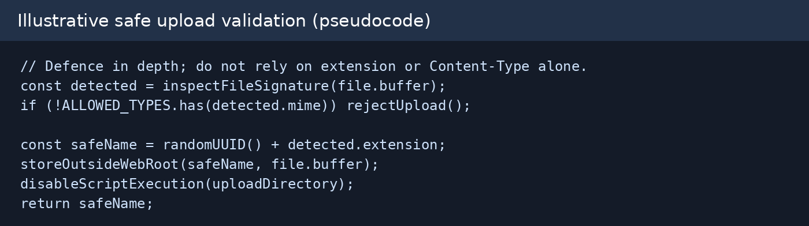
Figure 4. Upload validation pseudocode: signature validation, generated names, isolated storage and execution disabled.

References
- Supplied assessment brief: Minor Project Assessment Part 2 — IDOR, CORS & File Upload, October Batch, pp. 1–3.
- OWASP Web Security Testing Guide — Cross Origin Resource Sharing (CORS) testing.
- OWASP API Security Top 10 — API1: Broken Object Level Authorization (BOLA).
- OWASP File Upload Cheat Sheet — upload validation and storage controls.
- PortSwigger Web Security Academy — CORS and access-control learning labs.
Note: External references are listed as further reading; the task scope and deliverables above follow the supplied PDF.

