Q1. Write a query to find those customers with their name and those salesmen with their name and city who lives in the same city.

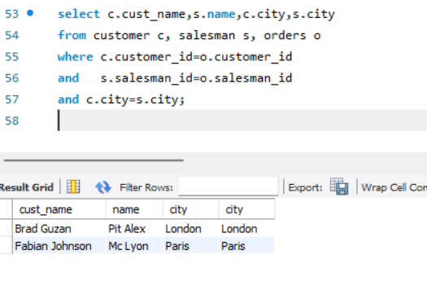

Q2. Write a SQL statement to find the names of all customers along with the salesmen who works for them.

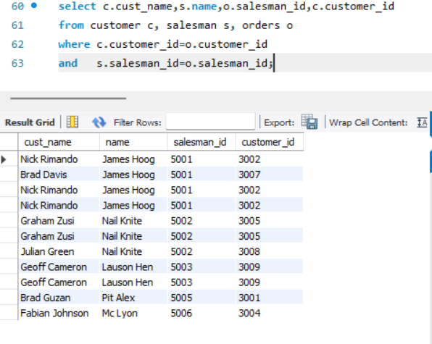

Q3. Write a SQL statement to display all those orders by the customers not located in the same cities where their salesmen lives

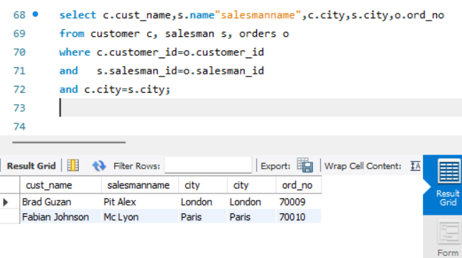

Q4. Write a SQL statement that find out each order number followed by the name of the customers who made the order.

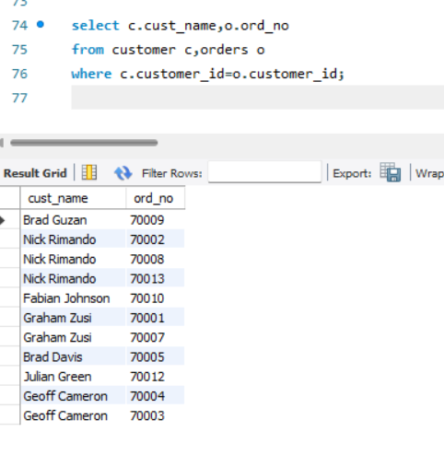

Q5. Write a SQL statement that short out the customer and their grade who made an order. Each of the customer must have a grade and served by at least a salesman, who belongs to a city.

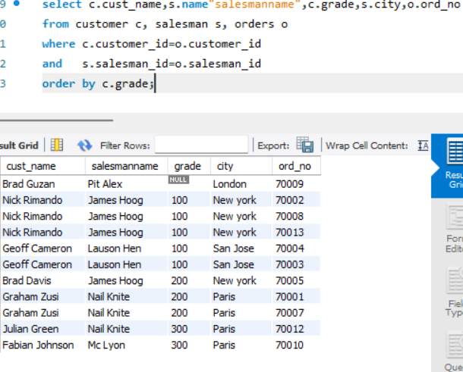

Q6. Write a query that produces all customers with their name, city, salesman and commission, who served by a salesman and the salesman works at a rate of commission within 12% to 14%.

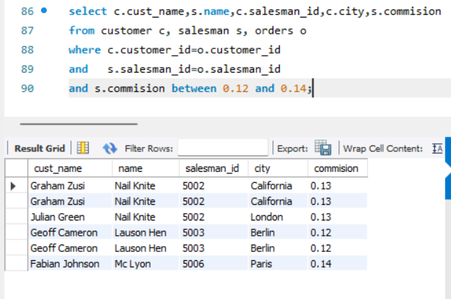

Q7. Write a SQL statement that produces all orders with order number, customer name, commission rate and earned commission amount for those customers who carry their grade more than 200 and served by an existing salesman.

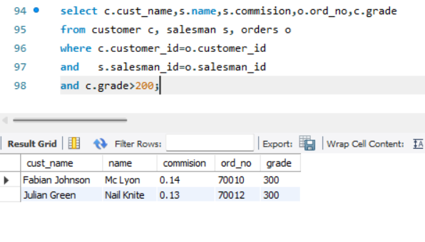

Q8. Write a SQL statement to make a list with order no, purchase amount, customer name and their cities for those orders which order amount between 500 and 2000.

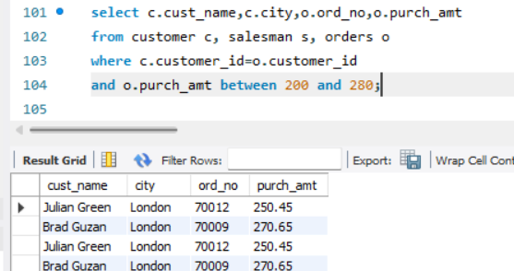

Q9.Write a SQL statement to know which salesman are working for which customer.

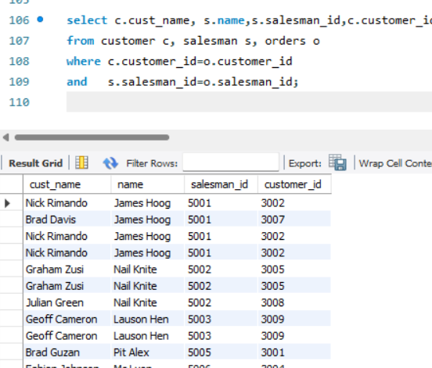

Q10. Write a SQL statement to find the list of customers who appointed a salesman for their jobs who gets a commission from the company is more than 12%.

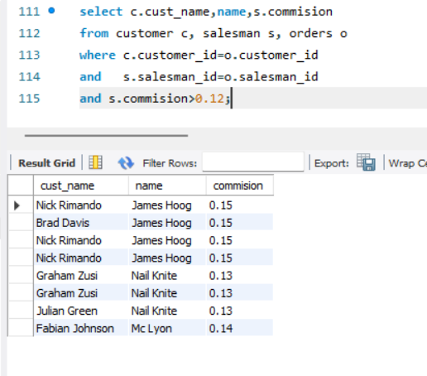

Q11. Write a SQL statement to find the list of customers who appointed a salesman for their jobs who does not live in same city where there customer lives, and gets a commission is above 12% .

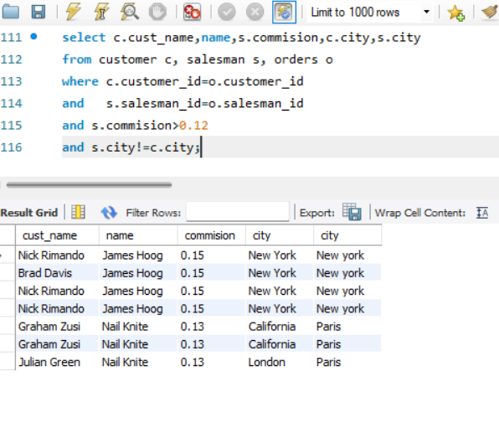

Q12. Write a SQL statement to find the details of a order i.e. order number, order date, amount of order, which customer gives the order and which salesman works for that customer and how much commission he gets for an order.

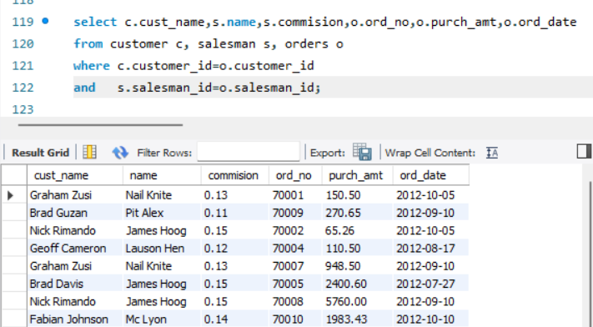

Q13. Write a SQL statement to make a join within the tables salesman, customer and orders in such a form that the same column of each table will appear once and only the relational rows will come.

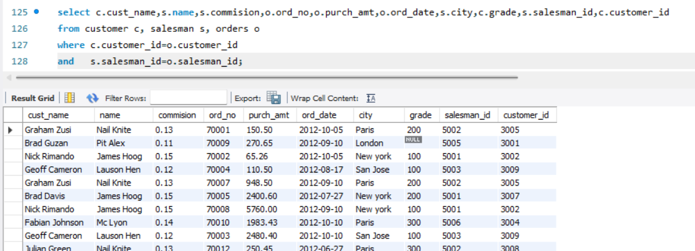

Q14. Write a SQL statement to make a list in ascending order for the customer who works either through a salesman or by own.

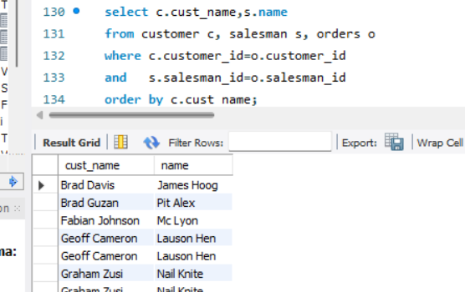

Q15. Write a SQL statement to make a list in ascending order for the customer who holds a grade less than 300 and works either through a salesman or by own.

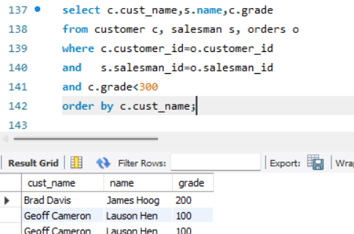

Q16. Write a SQL statement to make a report with customer name, city, order number, order date and order amount in ascending order according to the order date to find that either any of the existing customer have placed no order or placed one or more orders.

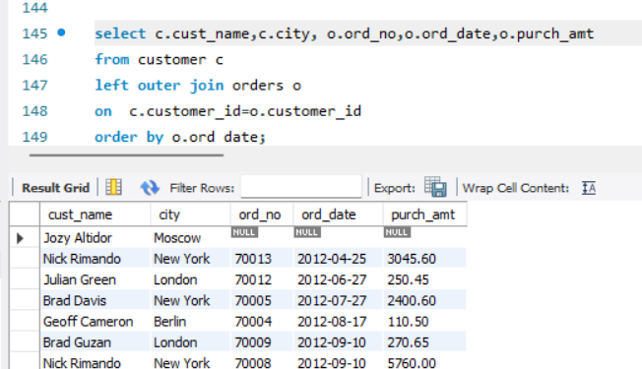

Q17. Write a SQL statement to make a report with customer name, city, order number, order date, order amount salesman name and commission to find that either any of the existing customer have placed no order or placed one or more orders by their salesman or by own.

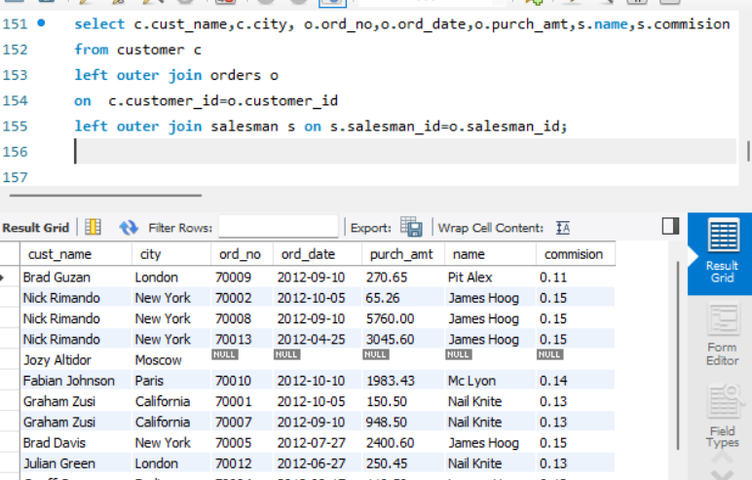

Q18. Write a SQL statement to make a list in ascending order for the salesmen who works either for one or more customer or not yet join under any of the customer.

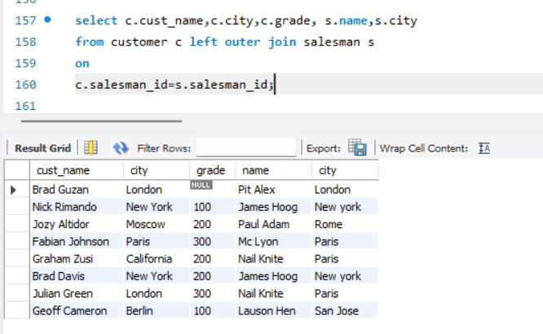

Q19. Write a SQL statement to make a list for the salesmen who works either for one or more customer or not yet join under any of the customer who placed either one or more orders or no order to their supplier.

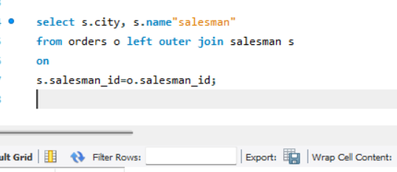

Q20. Write a SQL statement to make a list for the salesmen who either work for one or more customer or yet to join any of the customer. The customer, may have placed, either one or more orders on or above order amount 2000 and must have a grade, or he may not have placed any order to the associated supplier.

