Git:
Git is command line software built on linux
Open source tool
Github is built on -”Git”

Github:
GitHub is an online platform used to store, manage, and share code using Git. It helps developers collaborate on projects, track changes, and work together from anywhere.
Commands:
- git version
Shows the installed Git version on your system.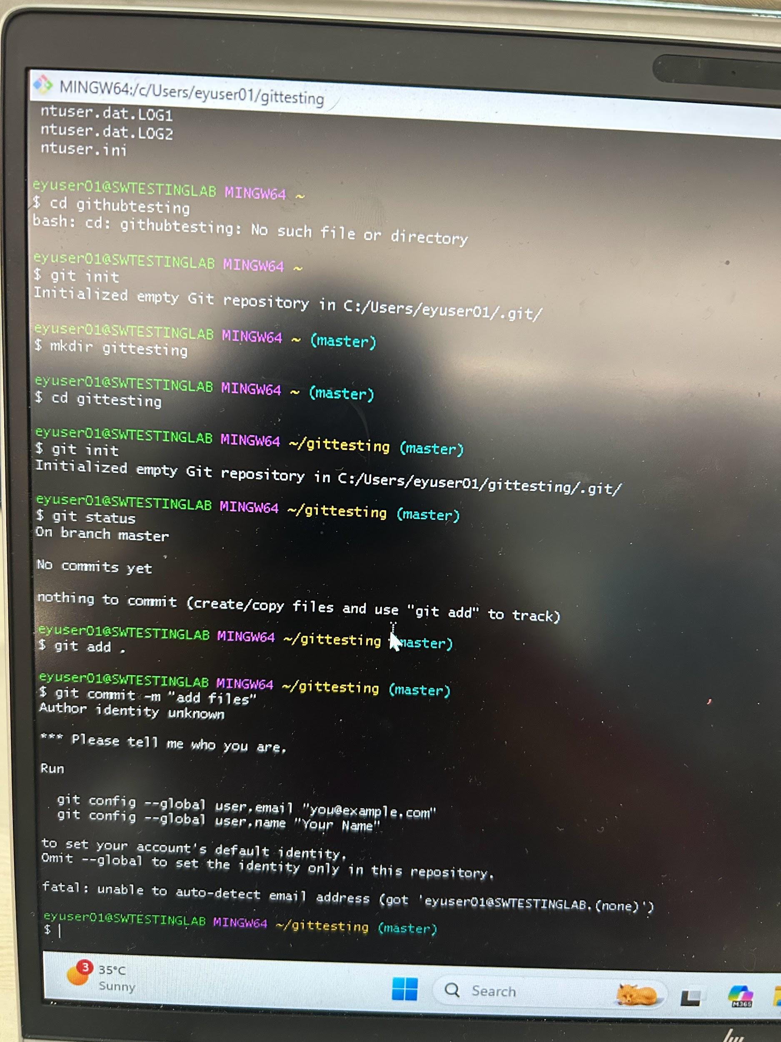
- git --version
Also shows the Git version. Both commands do the same thing.
- mkdir githubtesting
Creates a new folder or directory named githubtesting.
- cd githubtesting
Changes the current directory to the githubtesting folder.
- git init
Initializes a new Git repository in the folder. It creates a hidden .git folder to track project changes.
- git status
Shows the current state of the repository such as the current branch, files added or not added, and changes waiting to be committed.

