PACSES custom VB.NET Data Access Layer (DAL) Method Generator

Overview

PACSES has created a custom VB.NET code Data Access Layer generator to wrap pre-existing package/stored procedures for a given package owner. This Windows Forms utility uses the DeriveParameters method of the OracleCommandBuilder Class in the Oracle.DataAccess.Client namespace to probe a given package/stored procedure signature. From this information, a VB.NET method is constructed. Two features of note are the reverse name lookup and expansion of DPW standardized Oracle stored procedure and parameter naming, and the extraction of DPW required “DBA comments” for the stored procedure.

Code generated conforms to the PACSES Data Access Layer Runtime (DALRuntime) implementation.

Sample output

The syntax that is generated falls into three categories
- Comments section; summary and parameters list
- Sample calling code snippet shown in the comments remarks section
- Method

Consider the generated code included here:

Comments

''' <summary>
''' Wrapper for usp_get_case_class
''' Description : This sp gets the Case Classification details used in the initial screen
''' </summary>
''' <param name="identificationWorker"></param>
''' <param name="numberPage"></param>
''' <param name="sizePage"></param>
''' <param name="recordsTotal"></param>
''' <param name="ds"></param>

Calling code snippet
''' <remarks>
''' Dim identificationWorker As String
''' Dim numberPage As Decimal
''' Dim sizePage As Decimal
''' Dim recordsTotal As Decimal
''' Dim ds As Dataset = New DataSet()
''' DAL.GetCaseClassification(identificationWorker, numberPage, sizePage, recordsTotal, ds)
''' </remarks>

Method
Public Shared Sub GetCaseClassification(ByVal identificationWorker As String, ByVal numberPage As Decimal, ByVal sizePage As Decimal, ByRef recordsTotal As Decimal, ByRef ds As DataSet)
Dim database As New DataSourceFactory
Dim dataProvider As BaseDataProvider = DirectCast(database.GetProvider(Enumerations.DataSource.PACSES), BaseDataProvider)
Dim command As DbCommand = dataProvider.GetStoredProcCommand("csv_app_pkg.pkg_pim_2.usp_get_case_class")
Try
dataProvider.AddInParameter(command, "p_worker_id", DbType.String, identificationWorker)
dataProvider.AddInParameter(command, "p_page_number", DbType.Decimal, numberPage)
dataProvider.AddInParameter(command, "p_page_size", DbType.Decimal, sizePage)
dataProvider.AddOutParameter(command, "p_total_records", DbType.Decimal, 0)
dataProvider.AddOutParameter(command, "cur_out", DbType.Object, 0)
ds = dataProvider.ExecuteDataSet(command)
recordsTotal = dataProvider.GetParameterValue(command, "p_total_records")
Catch ex As Exception
' ExceptionManager.HandleException(ex)
Throw
End Try
End Sub

Reverse lookup of database standard abbreviations
DPW enforces a set of naming standards for its RDBMS implementations. One of the cornerstones of this implementation is the standard abbreviations list. (http://bis.dpw.state.pa.us/edd/abbr.aspx)

The basic rules state:
- Words seven characters or more are abbreviated according to a published list of abbreviations
- Stored procedure names are
  - descriptive and meaningful
  - start with the literal usp_
  - read left to right (get case detail)
- Column names and parameters
  - Read left to right
  - Include a “class word” (NAM, TXT, ADR, etc.)

Given these rules and the list of standard abbreviations, it is possible to generate variable and method names that conform to the VB.NET naming standard; which basically states “names are descriptive and meaningful” and “no abbreviations allowed.”

Thus a stored procedure named “usp_get_case_class” should be called using a method named “GetCaseClassification.” A column named “idn_object_busns” is named “p_idn_object_busns” when used as a parameter, can be expanded to “businessObjectIdentifier.”

Samples of abbreviations and values that include “worker”:
Description | Abbreviation
INCOME MAINTENANCE WORKER | IMW
CASEWORKER | CW
WORKER COMPENSATION | WC
SEASONAL FARM WORKER | SFW
MEDICAL ASSISTANCE FOR WORKERS WITH DISABILITIES | MAWD

Note that the word worker itself is 6 characters long and not abbreviated.

Using the utility

As of August 3, 2009, there is no distributable or pre-packaged release. To use the utility, one must have the PACSES standard developer’s image (Jan 2009.) This procedure assumes familiarity with Microsoft toolkit currently in use on the PACSES project.

Getting the application

Open Visual Studio 2008
Click File -> Open -> Project/Solution …

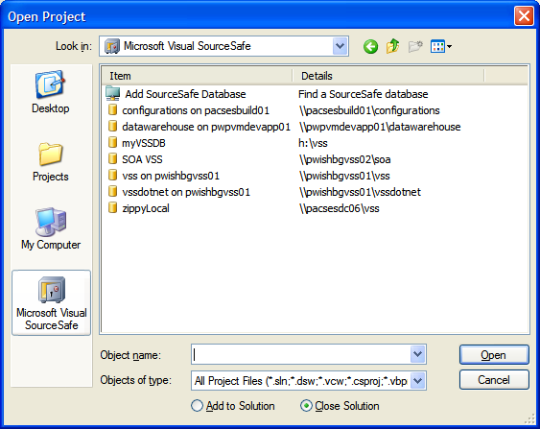

Choose Microsoft Visual SourceSafe
Choose \\pacsesdc06\vss from the dialog
Click Open

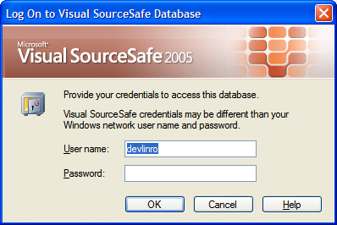

Enter your Windows account and Click OK

Click Projects -> tools -> deriveparameters

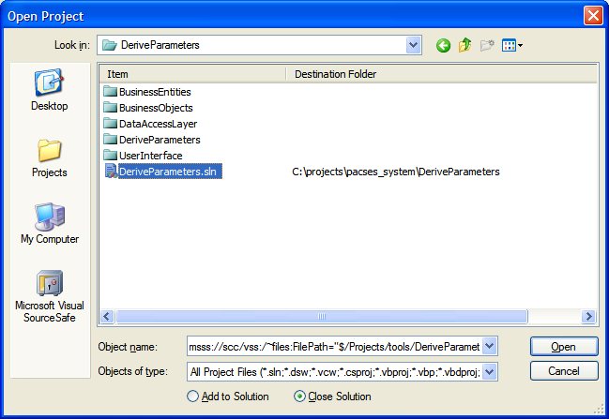

Choose the deriveparameters.sln and use C:\projects\pacses_system\DeriveParameters as the destination folder

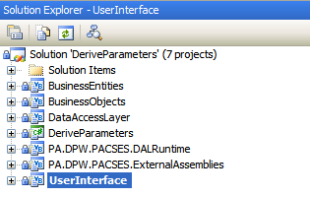

In the solution explorer, select the UserInterface project as the startup project.

Configuration

Note: To function properly, the package owner user must have created the package “pkg_genr_data_access_layer” (found in solution items) in the data source of the connection strings. The default package owner Oracle account and data source are csp_app_pkg and csp_dev respectively.

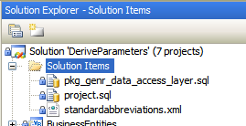

The default connection string for the package access is:
<add name="PACSESDatabase" connectionString="user ID=csv_app_pkg;password=***;data source=csp_dev;" providerName="ORACLE.ODP.NET.Client" />

There is a corresponding entry in the appSettings section of the app.config which should match the connectionStrings entry:
<add key="connectionString" value="user id=csv_app_pkg; password=***; data source=csp_dev"/>

To make sure the current config settings are used:
- Make sure you have specified a “Debug” build
- From the menu select build - > and rebuild solution

Generating VB.NET code from stored procedures
In VS 2008, from the menu select Debug -> Start debugging (or use F5)

A low grade dialog appears

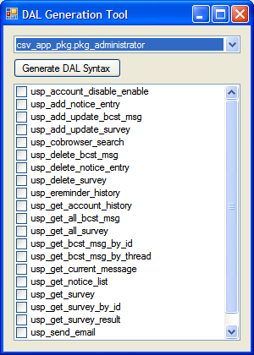

The drop down holds the names of all the packages that might be used to generate DAL methods. Note: Oracle permissions and synonyms can make for inconsistent results.

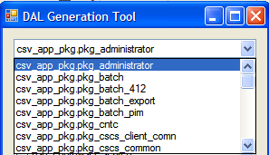

The check box list displays the corresponding stored procedures in that package:
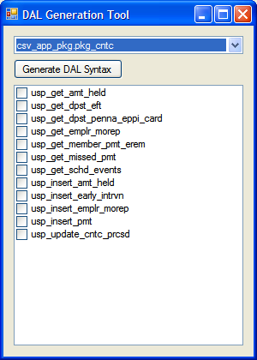 | 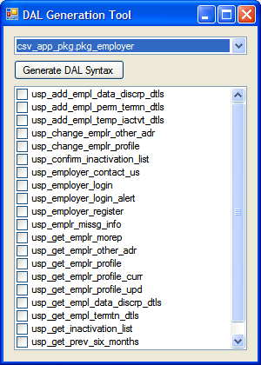
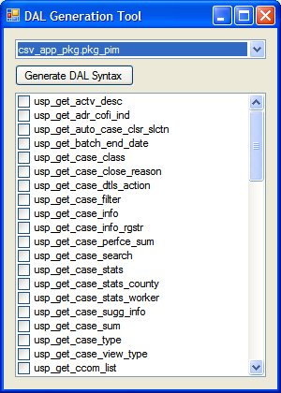 | 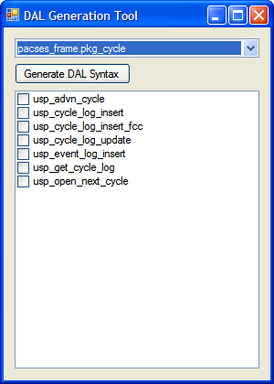

Individual stored procedures are selected for syntax generation by using the checkboxes. If no stored procedures are selected, methods are generated for every stored procedure in the package.

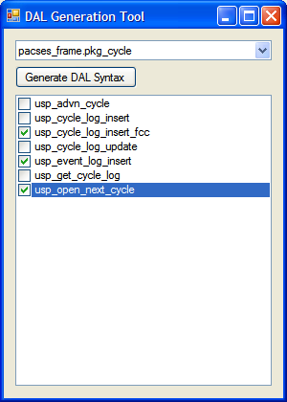

Example: Three stored procedures select for DAL generation.

Once selections are made, click the Generate DAL Syntax button.
The stored procedure selection pane and the push-button disappear and a progress bar appears. (not shown)

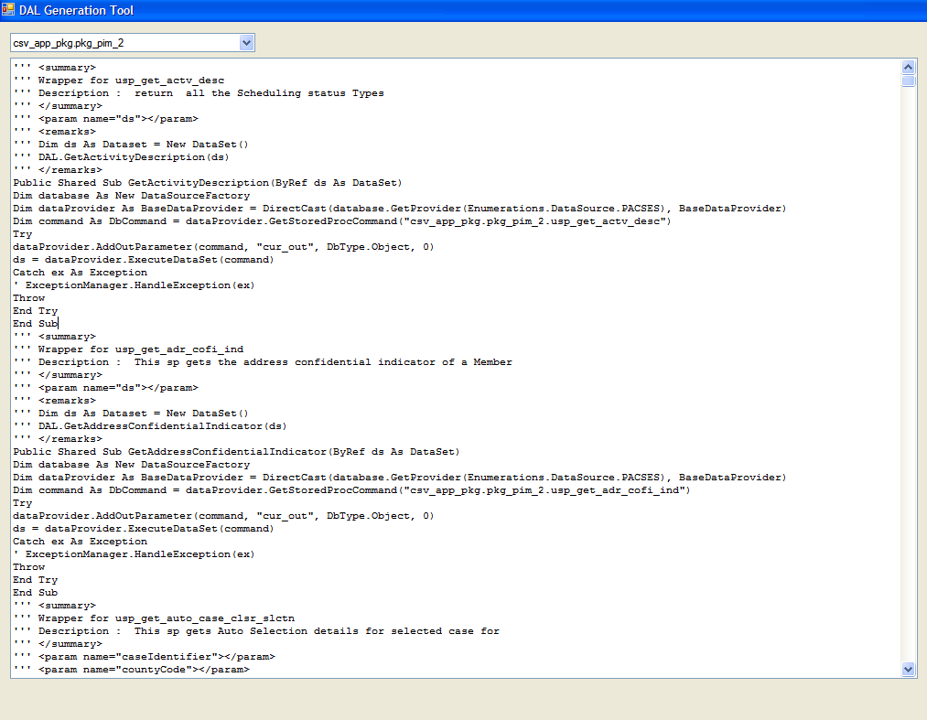

Once the process is completed, the generated syntax appears in a large scrollable text area. Note: It may be necessary to maximize the application.

Implementing generated syntax

The current version of the DAL generator does not know about business objects that might need the data pulled by the call, nor the nature of the class(es) that need the generated syntax. For the purposes of this document, the Visual Studio project that uses the generated syntax is DataAccessTest and a class named SampleDataAccess.

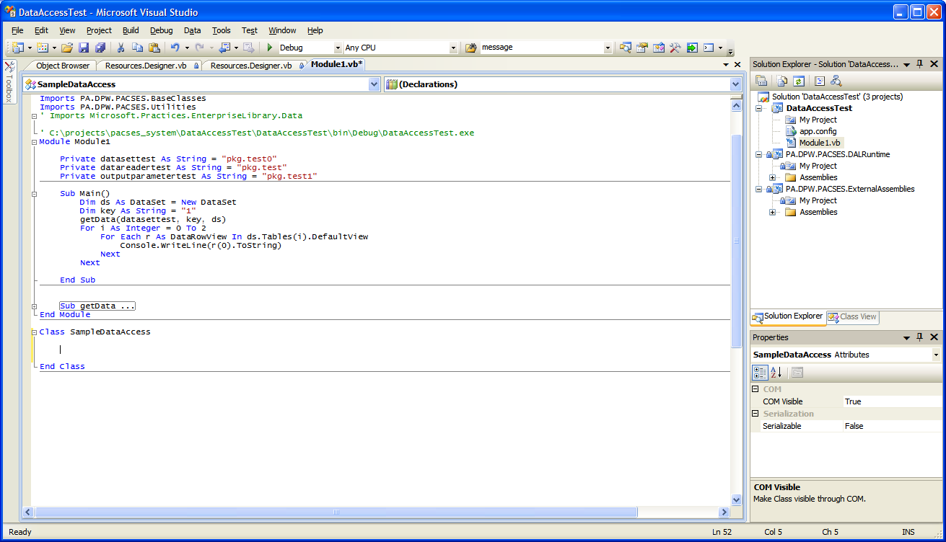

Copy and paste the method(s) required into the class –

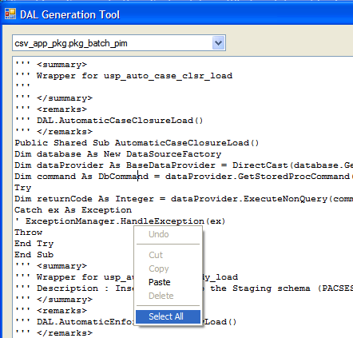

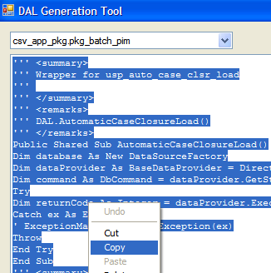

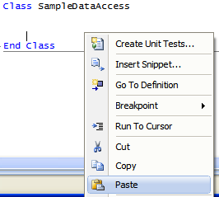

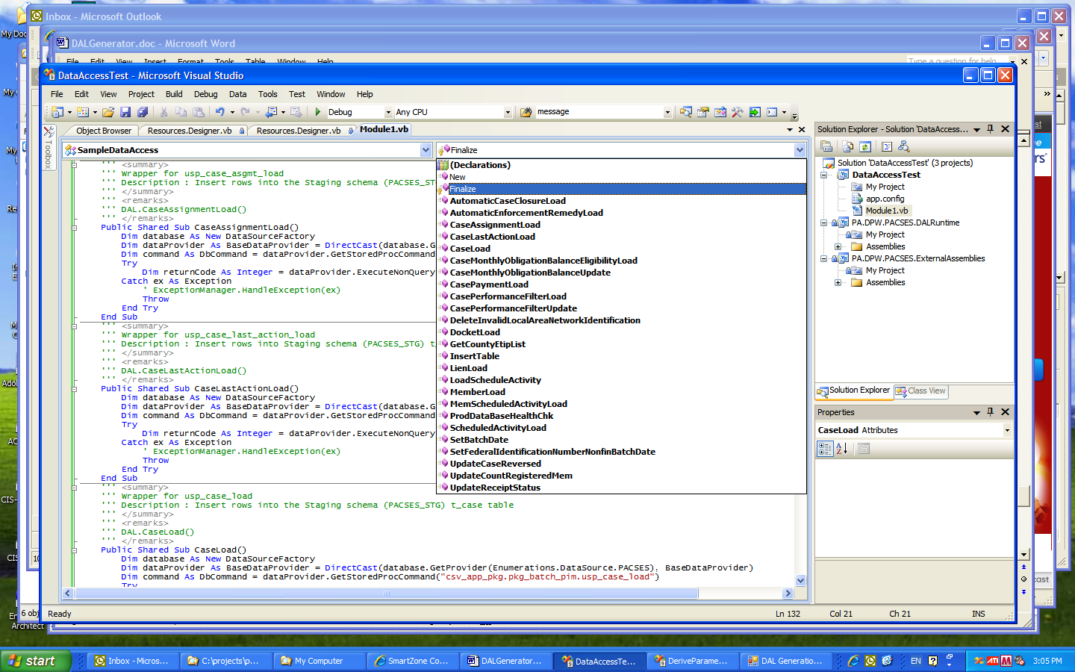

A Data Access Layer (DAL) is a layer of a computer program which provides simplified access to data stored in persistent storage of some kind, such as an entity-relational database. This data access layer is used in turn by other program modules to access and manipulate the data within the data store without having to deal with the complexities inherent in this access.

