PACSES custom VB.NET WCF service Generator

Overview

PACSES has created a custom VB.NET code WCF service generator to expose pre-existing package/stored procedures for a given package owner as methods. This Windows Forms utility uses the DeriveParameters method of the OracleCommandBuilder Class in the Oracle.DataAccess.Client namespace to probe a given package/stored procedure signature. From this information, VB.NET Data access, custom business entities, business objects, service interface and methods are constructed. A feature of note is the reverse name lookup and expansion of DPW standardized Oracle package, stored procedure and parameter naming.

Code generated conforms to a vanilla n-tier .NET app implementation.

Sample output

The files generated fall into six categories
- Business Entities tailored to the underlying stored procedure’s input/output parameters (Figure 2)
- Data Access Layers (Figure 3)
- Business Objects (w/ or w/o Caching option) (Figure 4)
- Service Interface (Figure 5)
- Service methods (Figure 6)
- App config entries for method level cache configuration/duration (Figure 7)

Sample of generated code based on pacses_frame.pkg_auth (Authorization) after being added to the target solution/projects in Visual Studio.

Figure 1 – stored procedure | Figure 2 – business entity
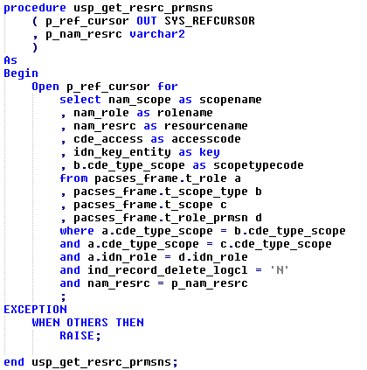 | 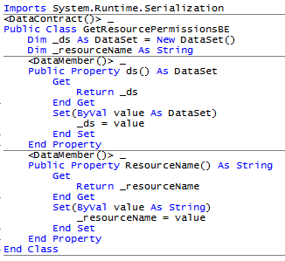

Figure 3 – data access Note PACSES uses a wrapper for EL/ODP.

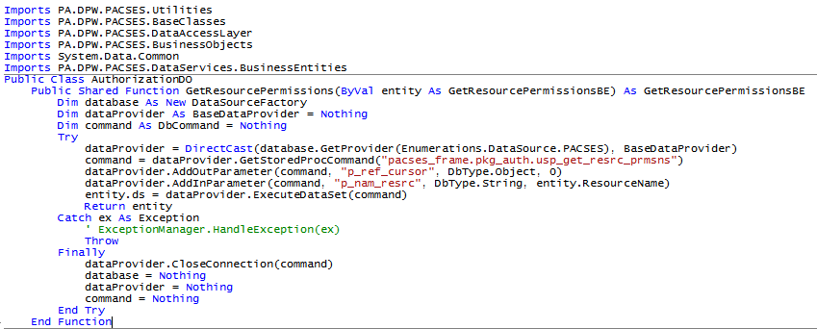

Figure 4 – business object w/ caching

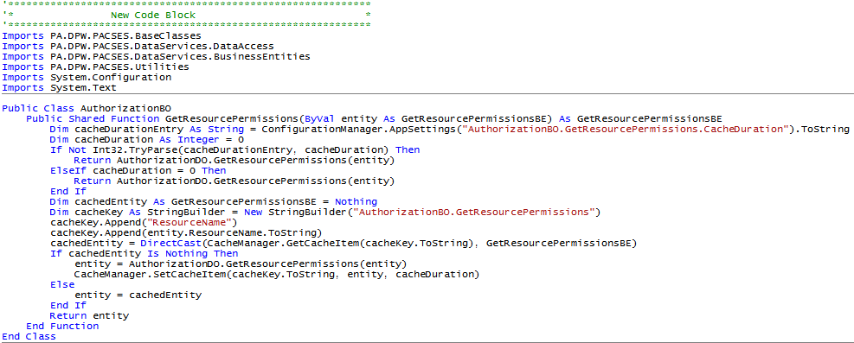

Figure 5 – service interface

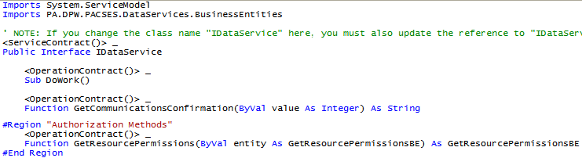

Figure 6 – service

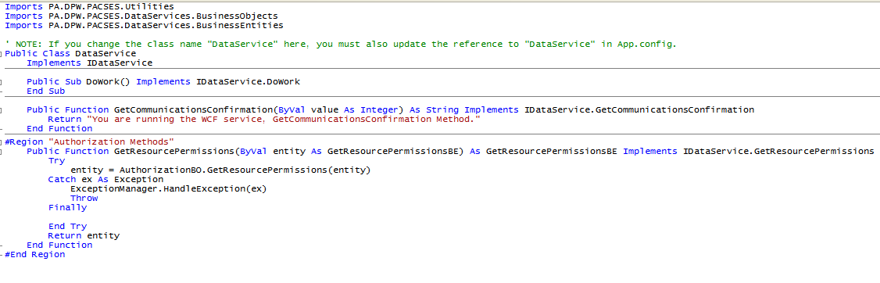
Figure 7 – cache duration configuration entries for the app/web config file

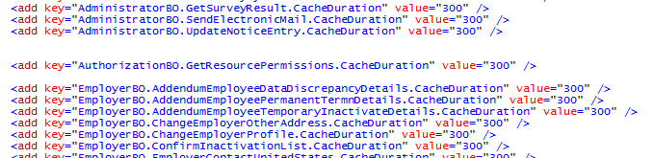

Reverse lookup of database standard abbreviations
DPW enforces a set of naming standards for its RDBMS implementations. One of the cornerstones of this implementation is the standard abbreviations list. (http://bis.dpw.state.pa.us/edd/abbr.aspx)

The basic rules state:
- Words seven characters or more are abbreviated according to a published list of abbreviations
- Stored procedure names are
  - descriptive and meaningful
  - start with the literal usp_
  - read left to right (get case detail)
- Column names and parameters
  - Read left to right
  - Include a “class word” (NAM, TXT, ADR, etc.)

Given these rules and the list of standard abbreviations, it is possible to generate variable and method names that conform to the VB.NET naming standard; which basically states “names are descriptive and meaningful” and “no abbreviations allowed.”

Thus a stored procedure named “usp_get_case_class” should be called using a method named “GetCaseClassification.” A column named “idn_object_busns” is named “p_idn_object_busns” when used as a parameter, can be expanded to “businessObjectIdentifier.”

Samples of abbreviations and values that include “worker”:
Description | Abbreviation
INCOME MAINTENANCE WORKER | IMW
CASEWORKER | CW
WORKER COMPENSATION | WC
SEASONAL FARM WORKER | SFW
MEDICAL ASSISTANCE FOR WORKERS WITH DISABILITIES | MAWD

Note that if the word itself is 6 characters long or less it is not abbreviated. The lookup is dependent on an XML file defined in the config. The file PACSES exports from MS Access looks like this:

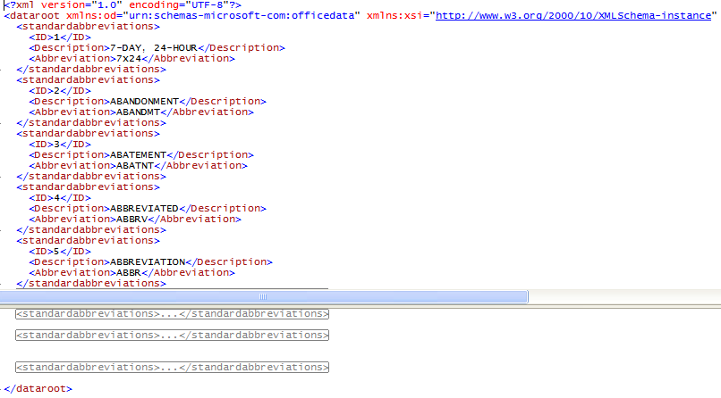

Using the utility

As of June 18, 2010, there is no distributable or pre-packaged release. To use the utility, one must have the PACSES standard developer’s image (Jun 2010.) This procedure assumes familiarity with Microsoft toolkit currently in use on the PACSES project.

Getting the application

Open Visual Studio 2008
Click File -> Open -> Project/Solution …

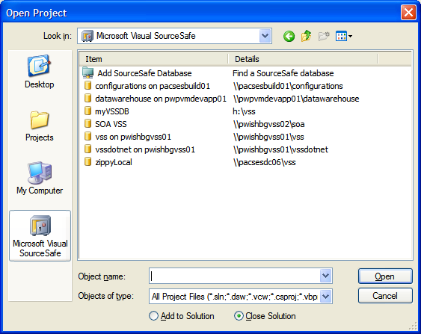

Choose Microsoft Visual SourceSafe
Choose \\pacsesdc06\vss from the dialog
Click Open

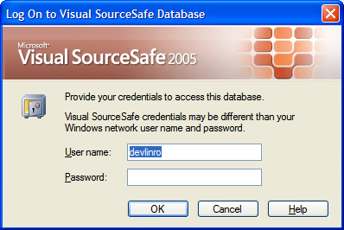

Enter your Windows account and Click OK

Click Projects -> tools -> deriveparameters

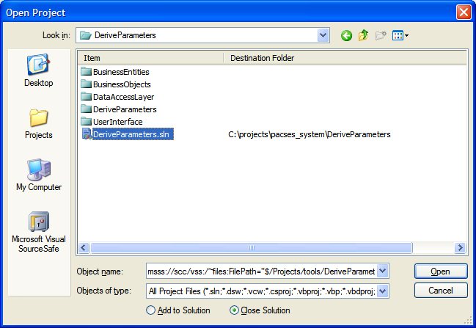

Choose the deriveparameters.sln and use C:\projects\pacses_system\DeriveParameters as the destination folder

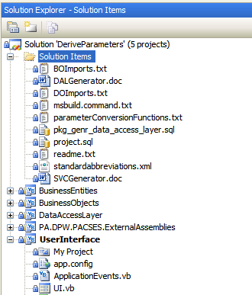

In the solution explorer, select the UserInterface project as the startup project.

Configuration

Note: To function properly, the package owner user must have created the package “pkg_genr_data_access_layer” (found in solution items) in the data source of the connection strings. The default package owner Oracle account and data source are csp_app_pkg and csp_dev respectively.

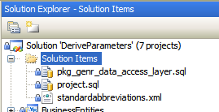

The default connection string for the package access is:
<add name="PACSESDatabase" connectionString="user ID=csv_app_pkg;password=***;data source=csp_dev;" providerName="ORACLE.ODP.NET.Client" />

There is a corresponding entry in the appSettings section of the app.config which should match the connectionStrings entry:
<add key="connectionString" value="user id=csv_app_pkg; password=***; data source=csp_dev"/>

Specify a code output folder. Note: if the folder does not exist, create it manually.
<add key="codeOutputFolder" value="C:\projects\pacses_system\DeriveParameters\CodeOutput\" />

Specify Caching implementation as “shared”, “on” or “off”. Note: caching on/shared is a PACSES exclusive implementation that uses the PACSES.Utilities.CacheManager wrapper.
<add key="cacheImplementation" value="on"/>

Two text files BOImports.txt and DOImports.txt are used to include the proper statements for your target solution. For the purposes of this document, the target solution looks like this:
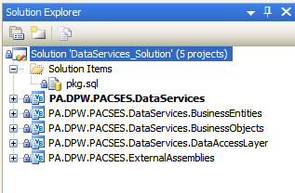

PACSES utilizes some project wide assemblies (PA.DPW.PACSES.*) Alter the imports text files to match your target implementation:

DOImports.txt
Imports PA.DPW.PACSES.Utilities
Imports PA.DPW.PACSES.BaseClasses
Imports PA.DPW.PACSES.DataAccessLayer
Imports PA.DPW.PACSES.BusinessObjects
Imports System.Data.Common
Imports PA.DPW.PACSES.DataServices.BusinessEntities

BOImports.txt
Imports PA.DPW.PACSES.BaseClasses
Imports PA.DPW.PACSES.DataServices.DataAccess
Imports PA.DPW.PACSES.DataServices.BusinessEntities
Imports PA.DPW.PACSES.Utilities
Imports System.Configuration
Imports System.Text

Generating VB.NET code from stored procedures
In VS 2008, from the menu select Debug -> Start debugging (or use F5)

A low grade dialog appears

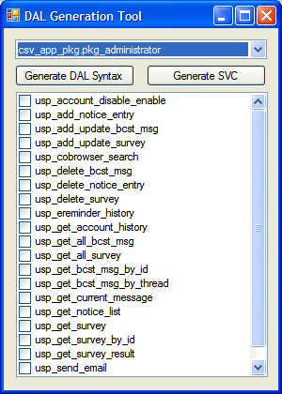

The drop down holds the names of all the packages that might be used to generate WCF methods. Note: Oracle permissions and synonyms can make for inconsistent results.

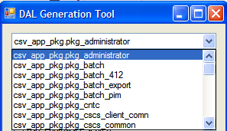

The check box list displays the corresponding stored procedures in that package:

Individual stored procedures are selected for syntax generation by using the checkboxes. If no stored procedures are selected, methods are generated for every stored procedure in the package.

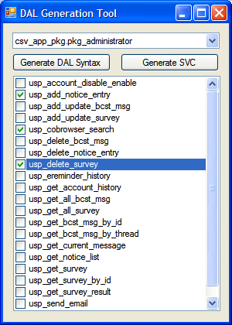

Example: Three stored procedures selected for WCF service generation.

Once selections are made, click the Generate SVC Syntax button. The stored procedure selection pane and the push-button disappear and a progress bar appears.

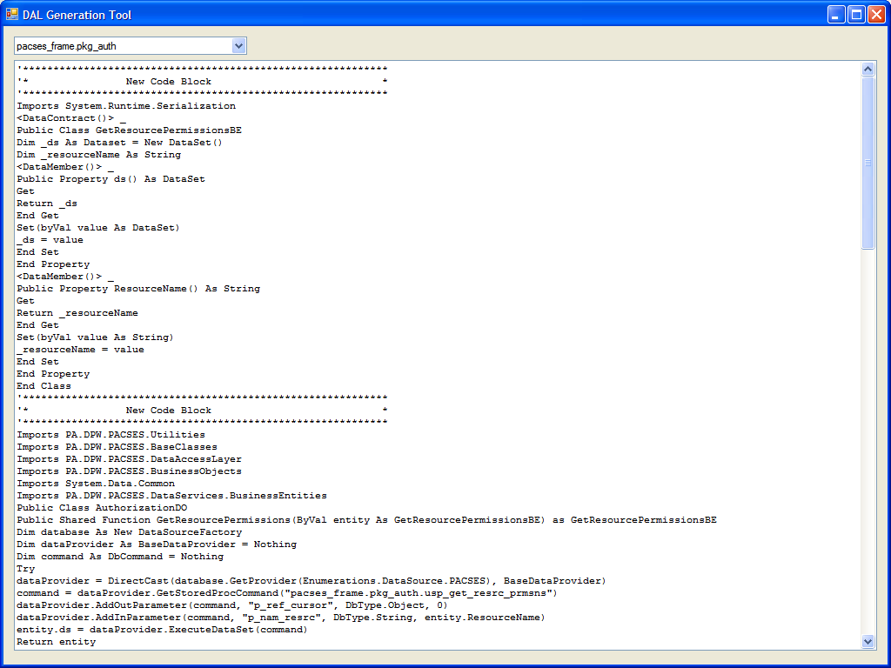

Once the process is completed, the generated syntax appears in a large scrollable text area. Note: It may be necessary to maximize the application. This window is for easy reference and contains all generated code. The generated code files. Config, BE, DO, BO, etc are also saved to the folder specified in the config file (key="codeOutputFolder")

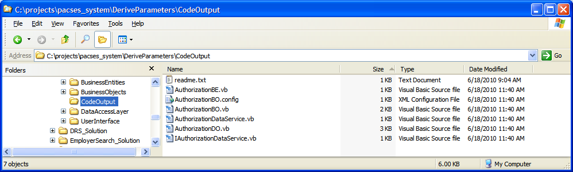

In this example, the package pkg_auth is used, and thus files generated are named Authoriztion*.*

AuthorizationBE.vb – copy this file or code found therein to your target project/class. There is one BE per stored procedure/method and the BEs are named after the stored procedure. (See figure 2 – business entity)

AuthorizationBO.config – this contains the config entries for cache duration values. Copy these into the target config and customize the values as required. Note: A cache duration value of 0 bypasses caching.
AuthorizationBO.vb – The business object methods implement caching by default, but this can be overridden in the config. When no caching is possible (no output parameters) no syntax is written. Cache duration of 0 bypasses caching. (See figure 4 – business object)

AuthorizationDO.vb – Contains calling code for Oracle database using PACSES Data Access Layer wrapper for EL. (See figure 3 – data access…)

AuthorizationDataService.vb – Contains the exposed methods available in the service. (See figure 6 – service) Note: you may or may not have a service that you will be augmenting with this generated code. By default, the generator creates code for class [package name]DataService.

IAuthorizationDataService.vb – contains method signatures for the interface. (See figure 5 – service interface) Note: you may or may not have a service that you will be augmenting with this generated code. By default, the generator creates code for interface I[package name]DataService. This may be overridden in the config.

Implementing generated syntax
The BE, BO and DO files are intended to establish or replace files of the same name in your target solution’s projects. It is also an option to copy and paste code from the pane into the class –

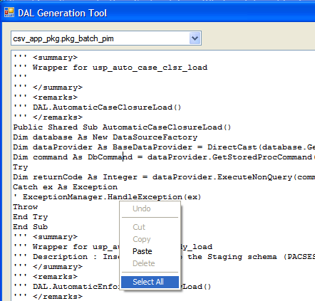

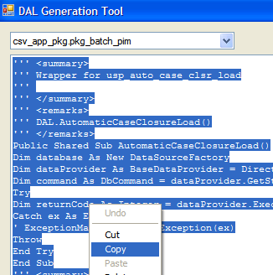

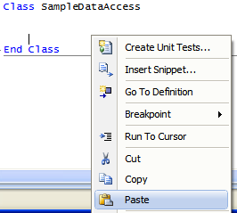

Warnings and Disclaimers

The reverse lookup depends heavily on proper naming and use of the database abbreviations and PL/SQL coding standards. Deviation from the standards produces ambiguous and incorrect class, method and property names.

The same stored procedure name used in multiple packages will results in a method name collision in the services. The same applies for package owners.

The reverse lookup may generate a .NET reserved word or other ambiguous declarations. No effort has been made to avoid this.

The utility does not and cannot take into account every variation in implementation. It’s primary focus is on how PACSES does things.

