**OPERATING SYSTEMS LAB 1**

**Q1.**

PROGRAM:

#include<stdio.h>

#include<unistd.h>

#include<stdlib.h>

#include <sys/types.h>

#include <sys/stat.h>

#include <unistd.h>

#include<string.h>

#include <fcntl.h>

void match_pattern(char *argv[])

{

int fd,r,j=0;

char temp,line[100]; int lineno=0;

memset(line,0,sizeof(line));

if((fd=open(argv[2],O_RDONLY)) != -1)

{

while((r=read(fd,&temp,sizeof(char)))!= 0)

{

if(temp!='\n')

{

line[j]=temp;

j++;

}

else

{

lineno++;

line[j]='\0';

if(strstr(line,argv[1])!=NULL)

printf("%d\t%s\n",lineno,line);

memset(line,0,sizeof(line));

j=0;

}

}

}

}

int main(int argc,char *argv[])

{

struct stat stt;

if(argc==3)

{

if(stat(argv[2],&stt)==0)

match_pattern(argv);

else

{

perror("stat()");

exit(1);

}

}

}

OUTPUT:

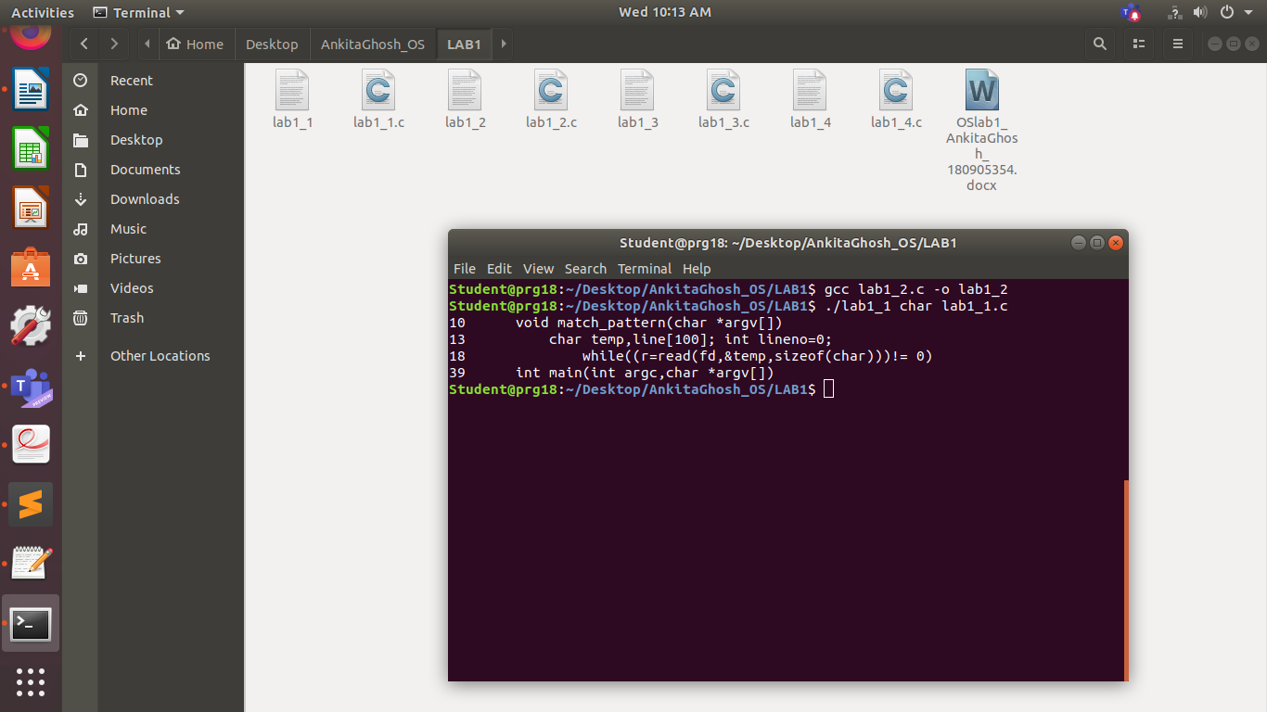

**Q2.**

PROGRAM:

#include<stdio.h>

#include<unistd.h>

#include<stdlib.h>

#include <sys/types.h>

#include <sys/stat.h>

#include <unistd.h>

#include<string.h>

#include <fcntl.h>

void print_lines(int argc,char *argv[])

{

int fd,r,j=0;

int lineno=0; char temp,line[100];

int count;

for(int i=1;i<argc;i++)

{

if((fd=open(argv[i],O_RDONLY)) != -1)

{

printf("Filename: %s\n",argv[i]);

count=0;

while((r=read(fd,&temp,sizeof(char)))!= 0)

{

if(temp!='\n')

{

line[j]=temp;

j++;

}

else

{

lineno++; count++;

line[j]='\0';

if(lineno%20==0)

{

printf("%d\t%s\n",count,line);

printf("Enter a key to see more lines: ");

char c = getchar();

}

else

{

printf("%d\t%s\n",count,line);

}

memset(line,0,sizeof(line));

j=0;

}}

}}

}

int main(int argc,char *argv[])

{

print_lines(argc,argv);

}

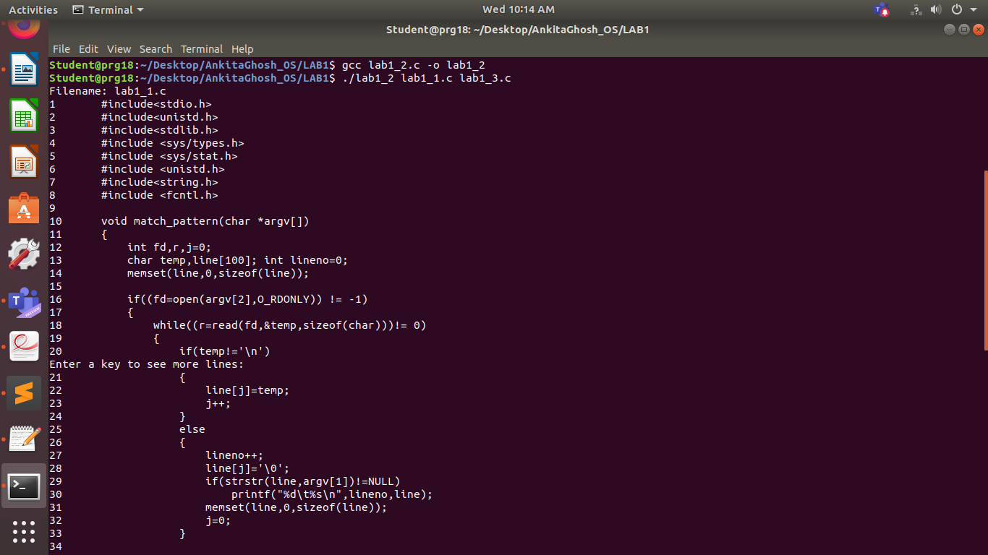OUTPUT:

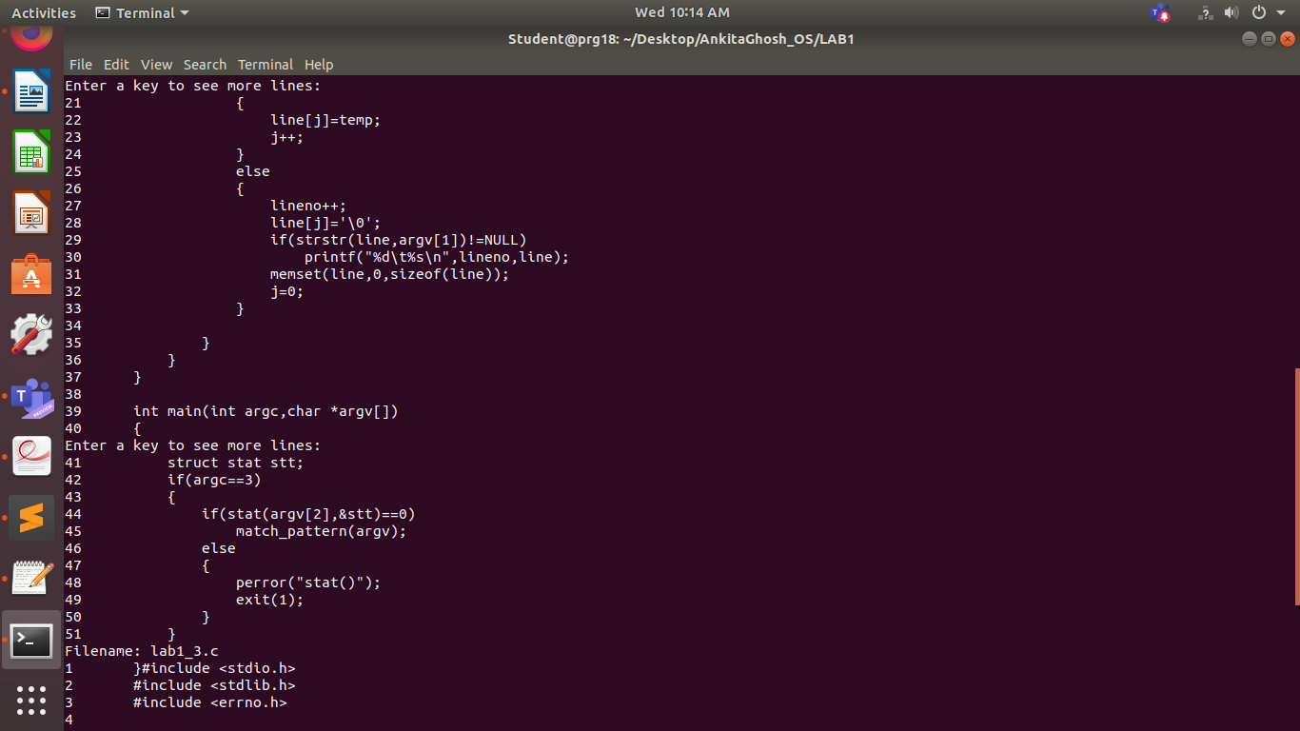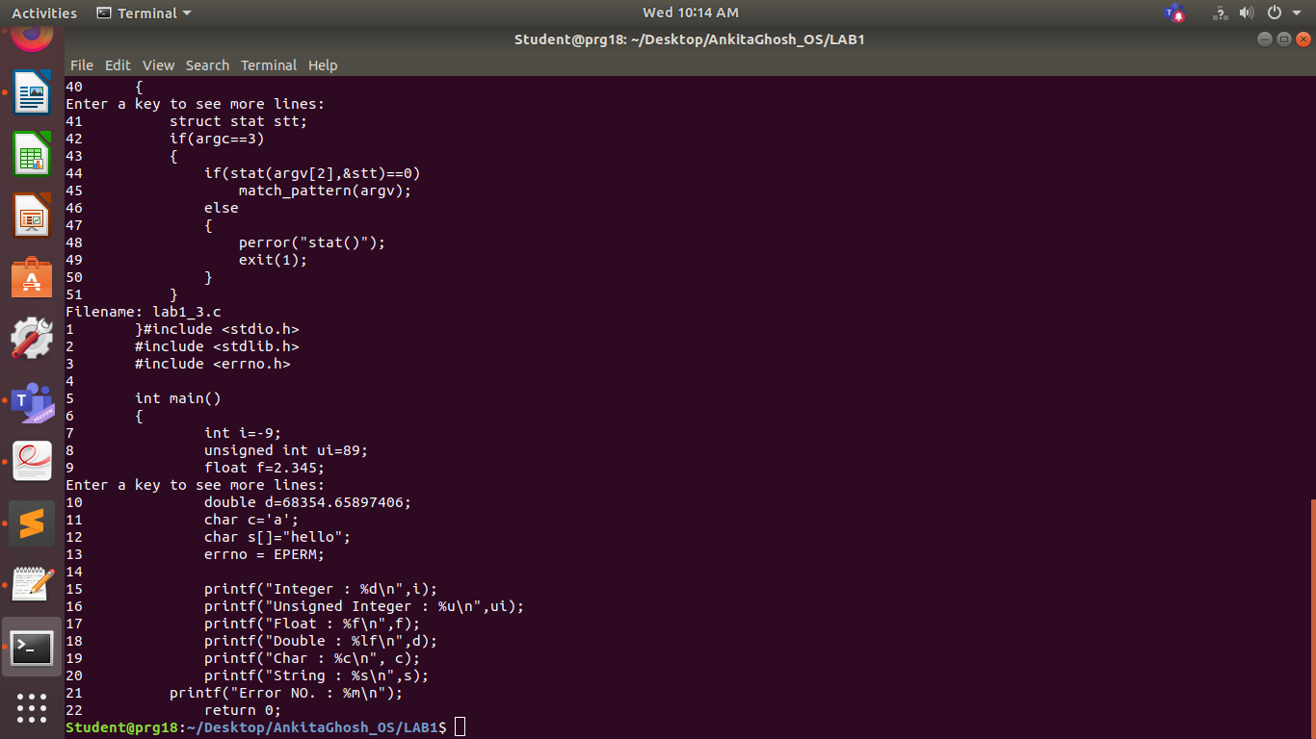

**Q3.**

PROGRAM:

#include <stdio.h>

#include <stdlib.h>

#include <errno.h>

int main()

{

int i=-9;

unsigned int ui=89;

float f=2.345;

double d=68354.65897406;

char c='a';

char s[]="hello";

errno = EPERM;

printf("Integer : %d\n",i);

printf("Unsigned Integer : %u\n",ui);

printf("Float : %f\n",f);

printf("Double : %lf\n",d);

printf("Char : %c\n", c);

printf("String : %s\n",s);

printf("Error NO. : %m\n");

return 0;

}

OUTPUT:

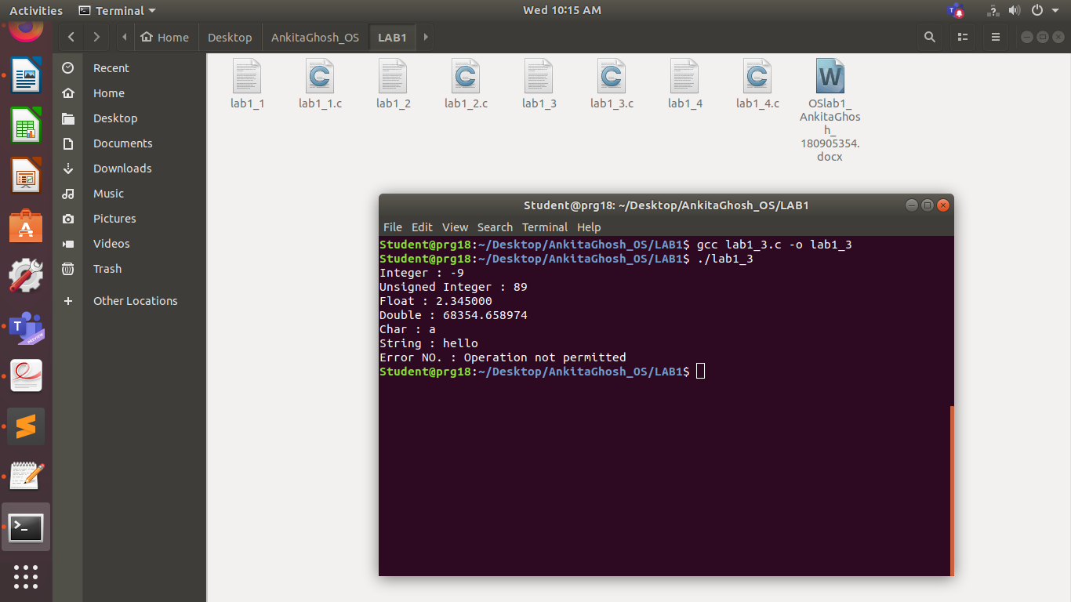

**Q4.**

PROGRAM:

#include <stdio.h>

#include <unistd.h>

#include <sys/types.h>

#include <fcntl.h>

#include <stdlib.h>

int main(int argc, char const *argv[])

{

char src[100], dst[100];

printf("Enter source name: ");

scanf(" %s", src);

printf("Enter dest name: ");

scanf(" %s", dst);

int sfd = open(src, O_RDONLY);

int dfd = open(dst, O_RDWR | O_CREAT, 0640);

char buffer[1];

while ((read(sfd, buffer, 1)) > 0) {

write(dfd, buffer, 1);

}

return 0;

}

OUTPUT:

