**OPERATING SYSTEM LAB 2**

**Q1.**

PROGRAM:

#include <sys/types.h>

#include <sys/stat.h>

#include <unistd.h>

#include <stdio.h>

#include <stdlib.h>

#include <dirent.h>

#include <time.h>

#include <pwd.h>

#include <grp.h>

int main(int argc, char* argv[])

{

DIR *thedirectory;

struct dirent *thefile;

struct stat thestat;

char buf[512];

thedirectory = opendir(argv[1]);

while((thefile = readdir(thedirectory)) != NULL)

{

sprintf(buf, "%s/%s", argv[1], thefile->d_name);

stat(buf, &thestat);

printf( (thestat.st_mode & S_IRUSR) ? " r" : " -");

printf( (thestat.st_mode & S_IWUSR) ? "w" : "-");

printf( (thestat.st_mode & S_IXUSR) ? "x" : "-");

printf( (thestat.st_mode & S_IRGRP) ? "r" : "-");

printf( (thestat.st_mode & S_IWGRP) ? "w" : "-");

printf( (thestat.st_mode & S_IXGRP) ? "x" : "-");

printf( (thestat.st_mode & S_IROTH) ? "r" : "-");

printf( (thestat.st_mode & S_IWOTH) ? "w" : "-");

printf( (thestat.st_mode & S_IXOTH) ? "x" : "-");

printf("\t%ld ", thestat.st_nlink);

printf("%zu",thestat.st_size);

printf(" %s", thefile->d_name);

printf(" %s", ctime(&thestat.st_mtime));

}

closedir(thedirectory);

}

OUTPUT:

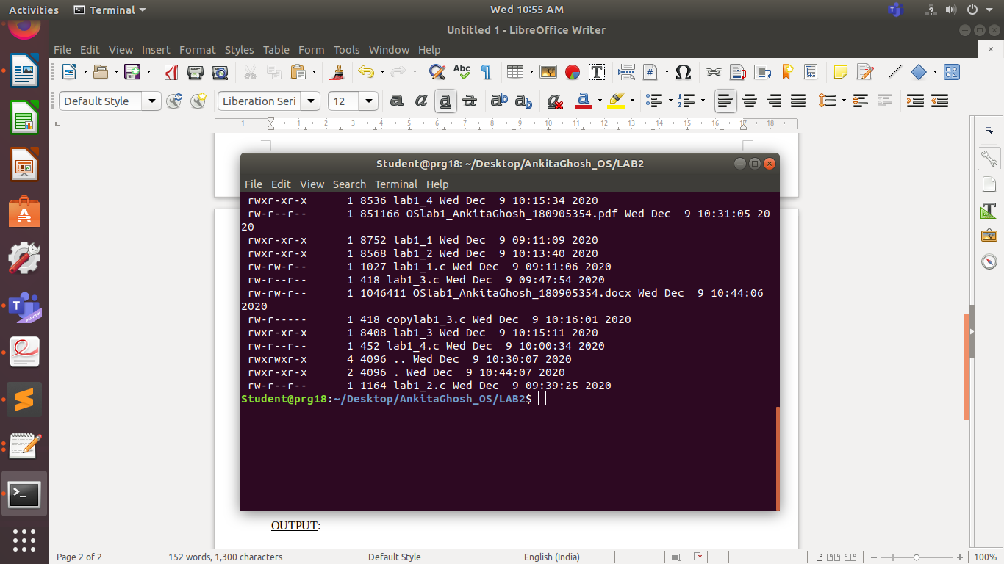

**Q2.**

PROGRAM:

#include <unistd.h>

#include <stdio.h>

#include <dirent.h>

#include <string.h>

#include <sys/stat.h>

#include <stdlib.h>

void printdir(char *dir, int depth) {

DIR *dp;

struct dirent *entry;

struct stat statbuf;

if((dp = opendir(dir)) == NULL) {

fprintf(stderr, "cannot open dir: %s\n", dir);

return;

}

chdir(dir);

while((entry = readdir(dp)) != NULL) {

lstat(entry->d_name, &statbuf);

if(S_ISDIR(statbuf.st_mode)) {

if(strcmp(".", entry->d_name) == 0 || strcmp("..", entry->d_name) == 0) continue;

printf("%*s%s/\n", depth,"",entry->d_name);

printdir(entry->d_name, depth+4);

} else {

printf("%*s%s\n", depth,"", entry->d_name);

}

}

chdir("..");

closedir(dp);

}

int main(int argc, char* argv[]){

if(argc != 2) {

printf("Invalid args. Only enter required directory.");

}

printdir(argv[1], 0);

return 0;

}

OUTPUT:

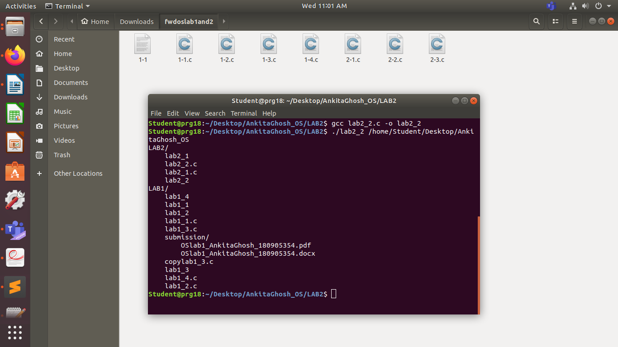

**Q3.**

PROGRAM:

APT(Advanced Package Tool) is a command line tool that is used for easy interaction with the dpkg packaging system and it is the most efficient and preferred way of managing software from the command line for Debian and Debian based Linux distributions like Ubuntu.

We use the command **apt list --installed** to obtain list of all packages across various Linux distributions. For Ubuntu,Debian specifically we can use the command **dkpg -l**. Some commands for other distributions are:

* RPM-based distributions (Fedora, RHEL, etc): rpm -qa
* pkg*-based distributions (OpenBSD, FreeBSD, etc): pkg_info
* Portage-based distributions (Gentoo, etc): equery list
* pacman-based distributions (Arch Linux, etc): pacman -Q
* Cygwin: cygcheck --check-setup --dump-only *
* Slackware: slapt-get --installed

OUTPUT:

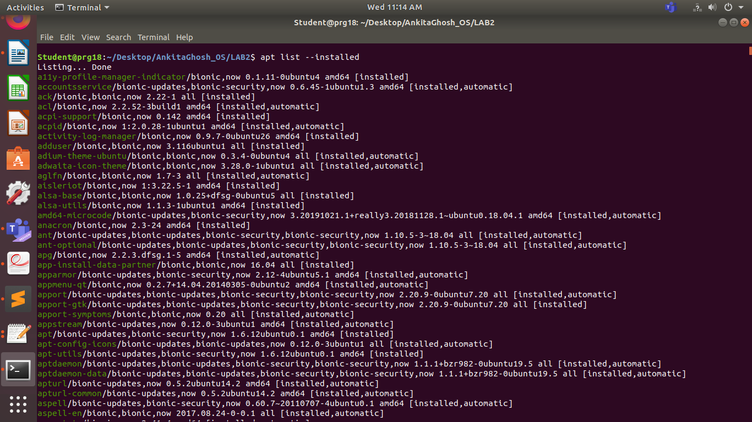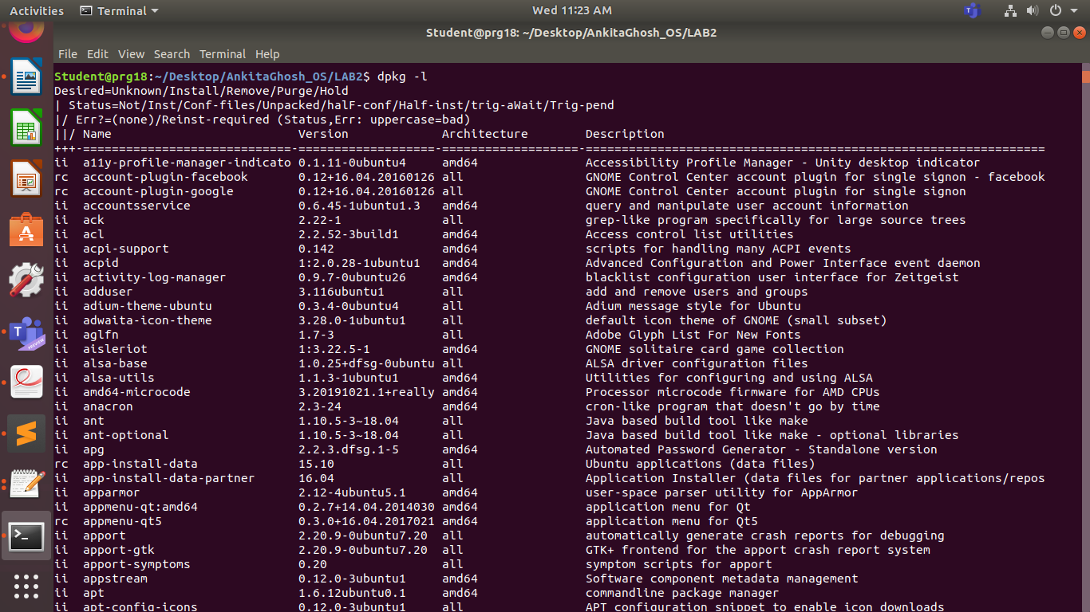

**Q4.**

PROGRAM:

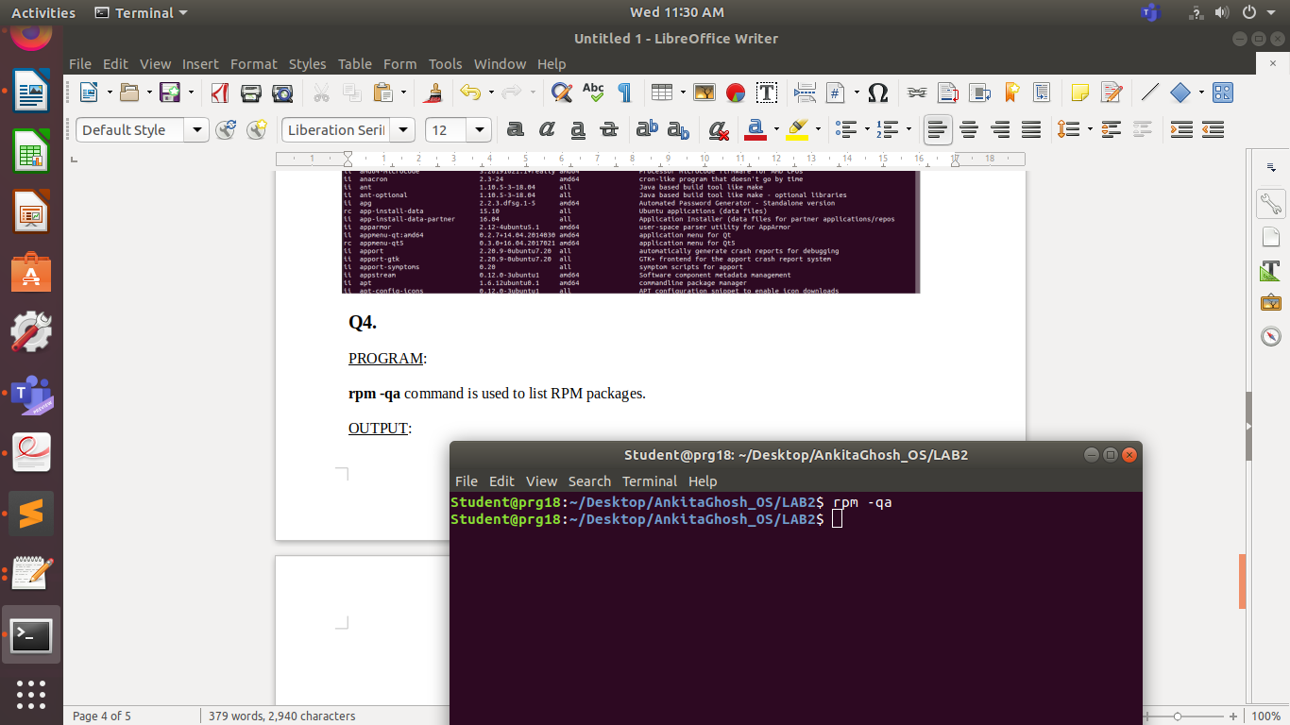**rpm -qa** command is used to list RPM packages. We do not get any output on executing rpm -qa command as there are no rpm packages installed.  
  
OUTPUT: