ChatBot

We know the idea of chatbots can be a little intimidating.But the truth is, robots aren’t here to take over the world. They’re here to make life easier.Taking on the burden of time-consuming tasks, and allowing you to better serve your customers in ways that matter most.

## **What Are Chatbots?**

Chatbots are programs built to automatically engage with received messages. Chatbots can be programmed to respond the same way each time, to respond differently to messages containing certain keywords and even to use machine learning to adapt their responses to fit the situation.

The key things of chatbots are:

* To get a quick answer to questions
* To resolve a complaint or problem
* To get a more detailed answer to a query
* Finding a human customer service agent

ADVANTAGES

### 1. Save Time & Money

### 2. Generate Leads & Revenue

### 3. Guide Users to Better Outcomes

### 4. Provide ‘After Hours’ Support

### 5. Engage Users in a Unique Way

### **Make a dialog flow account**

<https://dialogflow.com>

***Dialog flow***

* Dialog Flow is a Google-owned developer of human–computer interaction technologies based on natural language conversations.
* NATURAL LANGUAGE PROCESSING
* keyword matching,understand human speech to derive intents and meanings.
* Transform natural language to json objects.
* STARTED AS API.AI AND ACQUIRED BY GOOGLE, SPEAKTOIT

Api.ai allows [Internet of Things](https://en.wikipedia.org/wiki/Internet_of_Things) developers to include natural language voice interfaces in their products.[[6]](https://en.wikipedia.org/wiki/Dialogflow#cite_note-6) Assistant and Speaktoit websites now redirect to api.ai's [website](http://api.ai/), which redirects to the Dialog flow [website](https://dialogflow.com/).

* USED FOR MAKING SIMPLE CHATBOT.
* Decision tree
* Machine learning
* Intelligent agent

***Server***

* It uses nodejs.
* Used to get data/ responses (for queries) from conversation and generate an API call to get specific info from data source.
* Can also be used for processing all queries and uses dialog low to generate responses

#### **Components of Dialog Flow**

* Intents
* Contexts
* Entities

#### ***INTEGRATIONS***

Have integrations with chat platforms so we can deploy any of these chat platform

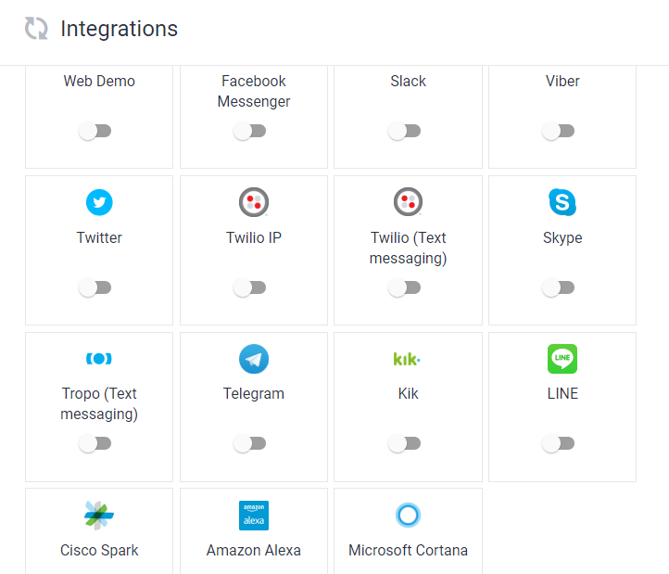

### **Create agent**

***Agent***

* An [agent](https://dialogflow.com/docs/agents) is essentially the container or project and it contains [intents](https://dialogflow.com/docs/intents), [entities](https://dialogflow.com/docs/entities), and the responses you want to deliver to your user.
* A Dialog flow agent represents the conversational interface of your application, device, or bot.

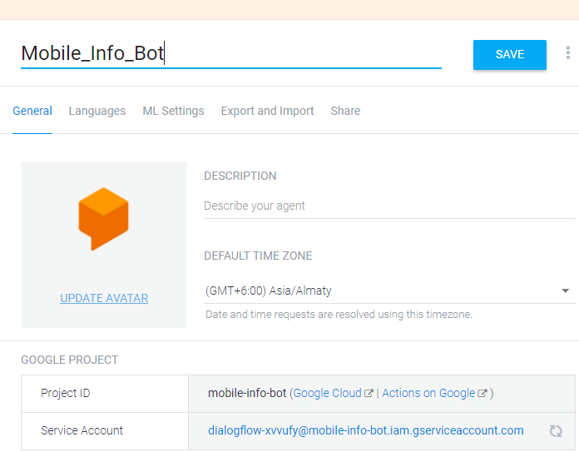

### **Create Intents**

Dialog flow matches user input to a specific intent.

***Intents***

* An intent represents a mapping between what a user says and what action should be taken by your software.

Intent interfaces have the following sections:

* **Training Phrases**

*To make sure your agent matches user input as often as possible, it’s important to provide your agent with enough data. The greater the number of natural language examples in the* ***Training Phrases*** *section of* [***Intents***](https://dialogflow.com/docs/intents)*, the better the classification accuracy.*

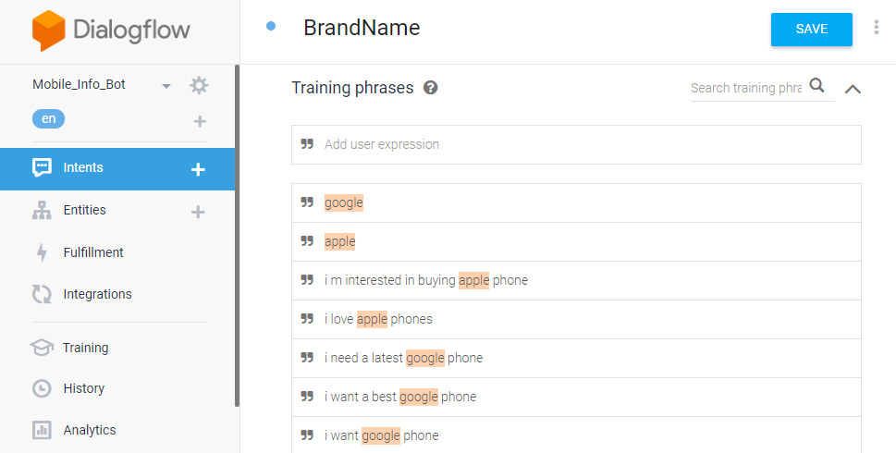

* **Action**

*Parameters are specific values extracted from a user's request when entities are matched. The values captured by parameters can be used in fulfillment, or in building a response. If you mark parameters as required, Dialogflow will prompt the user if their values were not extracted from their initial request.*

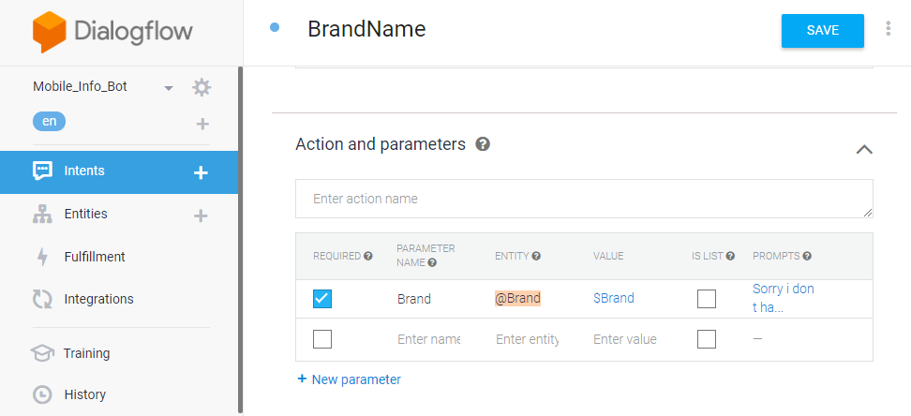

* **Response**

*Respond to your users with a simple message, or build custom rich messages for the integrations you support.*

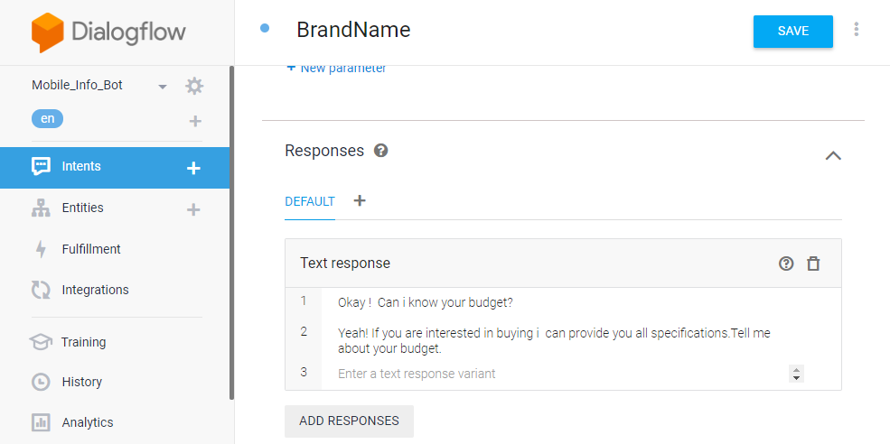

* **Contexts**

*Contexts represent the current context of a user's request.*

*This is helpful for differentiating phrases which may be vague or have different meanings depending on the user’s preferences, geographic location, the current page in an app, or the topic of conversation. Contexts can be used to structure non-linear conversations.*

* An [intent](https://dialogflow.com/docs/intents) maps what a user says with what your agent does.

Intents for matched and unmatched inputs:

* Determines how to handle responses.
  + Parameters to save.

*Parameters are specific values extracted from a user's request when entities are matched. The values captured by parameters can be used in fulfillment, or in building a response. If you mark parameters as required, Dialog flow will prompt the user if their values were not extracted from their initial request.*

* + Make call to fulfillment or not.

**Fulfillment**

*Call a web service to connect your back-end*

*Send intent, parameters and context to your Cloud function or*

*a web service. Execute necessary logic and respond back with a written, spoken or visual response.*

*Dialog flow* ***fulfillment*** *allows you to connect Dialog flow's natural language understanding and processing to your own systems, APIs and databases. Using fulfillment, you can surface commands and information from your services to your users through a natural conversational interface.*

* + Establish context to guide conversation.

***Contexts*** *represent the current context of a user's request. This is helpful for differentiating phrases which may be vague or have different meanings depending on the user’s preferences, geographic location, the current page in an app, or the topic of conversation. Contexts can be used to structure non-linear conversations*

* Fallack intent to handle unmatched input.

### Add Entities

*Entities*

* Entities are powerful tools used for extracting [parameter values](https://dialogflow.com/docs/actions-and-parameters#parameters) from natural language inputs. Any important data you want to get from a user's request, will have a corresponding entity.
* There are 3 types of entities:
  + [System](https://dialogflow.com/docs/entities#system_entities) entities (defined by Dialogflow)
  + [Developer](https://dialogflow.com/docs/entities#developer_entities) entities (defined by a developer)
  + [User](https://dialogflow.com/docs/entities#user_entities) entities (built for each individual end-user in every request).

Each of these can be classified as:

* + - Mapping entities (having reference values)
    - Enum entities(having no reference values)
    - Composite entities(containing other entities with aliases and returning object type values).

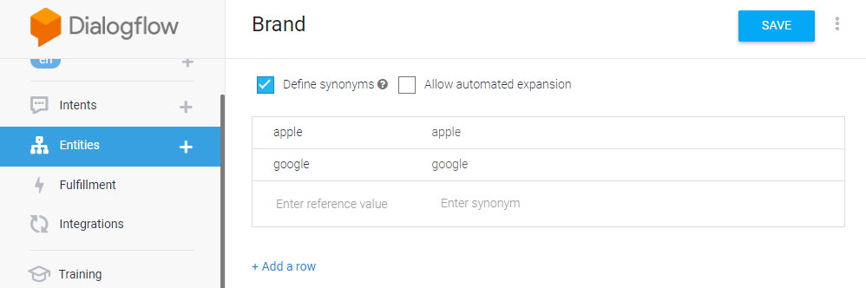

## Training Tool

* Training tool that allows you to analyze conversation logs with your agent and add annotated examples to relevant intents in bulk.
* Whenever a user provides input, that input is recorded in the conversation logs along with the number of times that input was successfully or unsuccessfully matched to an intent. These logs can help you discover gaps in your conversation setup.
* The Unmatched number means the conversation contains the displayed number of interactions in which the user said something that wasn't matched to an intent.

### Unmatched inputs are marked by an exclaimation mark .You can assign unmatched inputs to intents in two ways:

* + - * Add inputs to one of the existing intents.
      * Create a new intent with this input.

### Add to matched intent

### Clicking the check check icon will add the phrase to the matched intent's training phrases.

### Add to Default Fallback intent (Negative examples)

* + - * If the input works as a [negative example](https://dialogflow.com/docs/intents#negative_examples), click on the cancel icon not_interested right below the check button. This will add the input to the Training Phrases for the Default Fallback Intent.

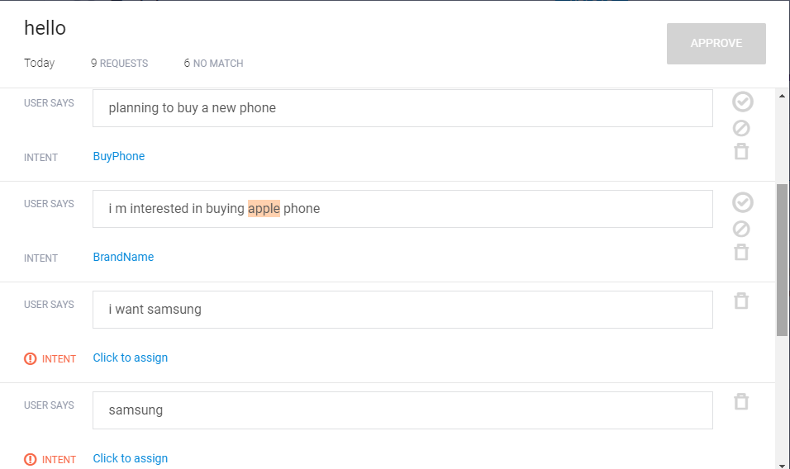

## Flow of chatbot.

**AGENT**

1. Enter the name of agent.
2. Specify language.
3. Add agent.
4. Enable small talk from the left column.
   1. It automatically give default basic responses.

**INTENT**

1. Name the intent.
2. Under training phase
   1. Add enough user expressions.
3. Under response phase
   1. Add respective text responses.
4. Save the intent.
5. The gear icon on the top left spins means the machine is learning from the inputs given and will provide suitable responses later
6. Now it will save all the training part his will be seen at the bottom right corner where it says “agent training completed”.

**ENTITIES**

1. Add entities to get the important parameters from the user input.

**REFERENCES:**

<https://www.youtube.com/watch?v=DkZmVLHoCLo>

<https://www.youtube.com/watch?v=Yjji510scI0&list=PLj-LOoBjYq6d3yZwhY6BJBtufuFYpJpu-&index=1>

<https://dialogflow.com/docs/getting-started/basics>

<https://www.youtube.com/watch?v=gWNUg_v25dw&t=5s>